Email to State representatives

Dear Colleagues,

  - Thank you for your submissions on our remoteness classification. We received submissions from all States and these are now on our website:
http://www.cgc.gov.au/index.php/gst-inquiries/50-2015-review/157-remoteness-classification
  - State views are summarised in the table below.
  - In discussing this issue with the Commission we have come to the view that we should set out for States our approach to assessing the impact of geography on State fiscal capacities and identify where further information might see a change of position.
Table 1 Summary of views of States on remoteness classification.
 | Definition of Darwin  and Hobart | Permeability of borders | Truncation of distances | Population basis
NSW | Capital cities | Impermeable | Don't truncate | —
Vic | Regional cities | Permeable | Don't truncate | Usual resident
Qld | Capital cities | Permeable | Don't truncate | Test which is better
WA | Capital cities | Permeable | Don't truncate | Usual resident
SA | Capital cities | Permeable | Don't truncate | Both (a)
Tas | Regional cities | Permeable | Don't truncate | Both (a)
ACT | Regional cities | Permeable | Don't truncate | —
NT | Capital cities for some aspects,  regional cities for other aspects | Permeable | Don't truncate | Usual resident
SARIA | Capital cities | Impermeable | Don't truncate | Usual resident
ARIA | Regional cities | Permeable | Truncate | Place of enumeration
(a) South Australia and Tasmania acknowledged that different definitions would better reflect the service delivery model in different categories.

Explaining Staff Views
  - We consider that the geography requirements for the 2014 Update and the 2015 Review are not the same. For the 2014 Update we will use the 2011 Census data to derive an updated version of SARIA, so that we will continue to apply 2010 Review methodology, with the latest available data, to the Update.
  - However, in the context of the 2015 Review, we can consider which geography captures material differences between States in the simplest reliable way.
  - This consideration occurs against the background where (if still appropriate) some geographic factors are handled outside the geographic classification. In particular
- If interstate wage differentials have a material impact, they would apply to whole States
- If administrative scale is retained, it would provide an allowance for those size independent State functions like a parliament, departmental head office, museum etc.
  - It also occurs against a background where the choice of geography might facilitate some simplification. For example a separate allowance for interstate non-wage costs might be less material in ARIA, which would already treat some locations as less accessible than in SARIA.
  - Taking on board the majority State view, which supports some changes in the elements of the geography, we consider that if we are to change, ARIA offers the potential to be the simplest reliable geography.
  - We also see some benefits in adopting a geography which is being used by a growing number of data producers, but this does not drive our preference for ARIA over a reworked SARIA.
  - We believe that it is accepted that where someone lives has an impact on the cost of providing services to them, and on their demand for services. We would like to group areas with similar costs and use patterns to test if they have a material impact on State fiscal capacities and if so incorporate them into the appropriate GST distribution.
  - We consider that a geography based on the size of the city in which a person lives, or how far away from different sized cities a person lives, is the appropriate way of grouping like persons. Other differences among people such as socio demographic status would be captured through other allowances.
  - We recognise that all States have to deliver ‘capital city’ functions and consider that this is reflected through the existing administrative scale assessment (making no judgement on its appropriate size post 2015)
  - We have not seen evidence that living in a capital city, as opposed to a city of the same size, has a material impact on service delivery costs or use patterns (other than for capital city functions). In the case of Darwin in 2010 we recognised that its inpatient use profile was not that of other capital cities and more akin to a city of its size (we treated it according to its ARIA classification).
  - As a consequence we are attracted to a geography which recognises city size and distance from other cities and towns, rather than one which places emphasis on ‘State capitals’. Box 1 provides the examples we have been able to analyse.
  - Our terms of reference require us to ensure that the GST distribution process does not have the effect of unwinding the recognition of educational disadvantage embedded in the National Education Reform Agreement (NERA) funding arrangements. We note that locational disadvantage in NERA is recognised using ARIA geography. For example, we note that schools in Darwin, Cairns and Whyalla will receive similar school location loadings, on the basis of being outer regional schools. This also leads us to favour ARIA.
  - In constructing a geography the possible impact of cross border cities also needs to be considered. We note that all but one State considers that cross border cities can impact on use and cost rates (and prefer a permeable geography). We consider that the post 2015 geography should capture this impact and this is one reason for us favouring ARIA.
  - We consider that unless justified by the unique needs of the Commission, data should conform to ABS protocols. In the case of a geographic classification we do not see a particular need that would justify moving away from the ABS practice on truncation or of defining city populations. This also leads us to favour ARIA.
BOX 1 - Evidence
States were divided in their consideration of how we should treat Darwin and Hobart. Victoria, Tasmania and the ACT consider that they should be considered regional cities. The Northern Territory considered that in some ways they should be considered capitals, in other aspects they should be considered regional centres. The other 4 States considered they should be considered capital cities, largely because the evidence we had presented was not compelling.

We have based this primarily upon private hospital use (as recognised in the Admitted patients assessment for Darwin), Medicare bulk billing rates and year 12 completion rates. These suggest that the use pattern of certain services in Hobart and Darwin are more consistent with the use patterns of similar sized cities than they are with the use patterns in larger cities. We have been able to control for differences in socio-demographic composition in relation to Year 12 completion rates and include the amended figure below.

We acknowledge that neither Medicare bulk billing rates nor year 12 completion rates reflect State service provision patterns that we measure in our assessments, nor do they fully control for other differences between cities (factors other than city size may explain the apparent differences that we are attributing to city size). However, it is not possible to find policy neutral measures of difference in use patterns for State services. Therefore we have identified evidence which suggests that, in some aspects of the way people use services, Hobart and Darwin are more similar to regional cities than to capital cities. We have not been able to identify any pattern where the people of Hobart and Darwin are similar to other capital cities and different to cities of comparable size.
Figure 1 Year 12 non-Indigenous completion rates, standardised by SEIFA quintiles
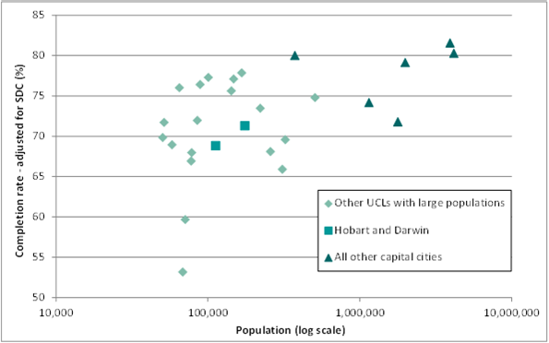
Source: 2011 Census

Process
  - We intend to confirm a choice of geography with the Commission at its meeting in July and this will then form the basis of a geography post 2015 and data requests associated with the review.
  - We have put our thinking on the choice of geography into the broader context of recognising differences among States so that States can understand how the choice of geography fits with some other parts of our thinking on the assessment process.
  - Based on what States have said, we would need substantive new evidence that capital cities exert use and cost influences over and above their size ( socio demographics are elsewhere captured) to change our advice to the Commission. Similarly we would need strong argument that fiscal equalisation mandates a variation from usual ABS practice on truncation and population bases.
  - If States believe that they have evidence or strong arguments we would like to receive it by mid July.

Cheers,

Tim Carlton
Tim.Carlton@cgc.gov.au
6229 8893

