### Australian Capital Territory

This fact sheet provides a summary of the major causes of change in relative fiscal capacity since the 2019 Update, as well as an overview of circumstances that have affected expenditure and revenue.

#### Fiscal circumstances

The Australian Capital Territory (ACT) has the fourth weakest fiscal capacity among the States. It has below average capacity to raise revenue across most revenue bases.

The ACT is unable to levy taxes on Commonwealth agencies, including on payrolls and land, and has no mining industry. The ACT also receives a below average share of Commonwealth payments.

These effects on the ACT’s fiscal capacity are partly offset by its below average expense requirement, which reflects its highly urbanised population with a below average share of Indigenous people and a low level of non-Indigenous disadvantage, and its below average investment requirement.

Illustrative GST, ACT, 2020‑21

|  |  |  |
| --- | --- | --- |
|  | $m | $pc |
| Equal per capita share | 1,144 | 2,598 |
| Effect of assessed: |  |  |
| Expenses | -195 | -442 |
| Investment | -92 | -208 |
| Net borrowing | -6 | -13 |
| Revenue | 376 | 854 |
| Commonwealth payments | 91 | 206 |
| Illustrative GST | 1,319 | 2,995 |

Note: Table may not add due to rounding. For expenses and investment, a negative sign indicates below average costs, which reduces a State’s GST requirement. For net borrowing, revenue and Commonwealth payments, a negative sign indicates above average revenue raising capacity, which also reduces a State’s GST requirement.

|  |
| --- |
| **Key reasons why fiscal capacities differ between States**   * The uneven distribution of mining activity and production due to underlying differences in distribution of mineral reserves across Australia. * Differences in the spatial distribution (or dispersion) of their populations. * States with a greater than average share of population in less accessible regions face higher than average service delivery and infrastructure costs. * States with large, densely populated cities face higher than average urban public transport costs. * Variation in the value of property sales. States with higher property values and volume of turnover have a greater capacity to raise revenue from taxes imposed on the transfer of property. * Differences in the number of Indigenous people in their populations. States with a greater than average share of Indigenous people in the population face higher than average service delivery costs. |

#### Change in fiscal capacity

The ACT’s fiscal capacity has strengthened due to lower assessed investment needs, lower assessed costs of providing health and justice services and revisions to State natural disaster relief expenses. These changes were partly offset by an increase in assessed administrative scale costs and growth in the value of mining production in other States that reduced its relative capacity to raise revenue.

Compared with 2019‑20, the ACT’s GST share will fall from 2.1% to 2.0%. Growth in the GST pool does not offset the impact of the ACT’s improved fiscal capacity, and its GST entitlement in 2020‑21 will fall by $49 million, or 3.6%.

Change in illustrative GST distribution since the 2019 Update, ACT

|  |  |  |
| --- | --- | --- |
|  | $m | $pc |
| New population | 5 | 11 |
| Growth in GST available | 46 | 105 |
| Changes in relative fiscal capacity | -99 | -226 |
| Method changes | -74 | -168 |
| Data revisions | -19 | -44 |
| State circumstances | -6 | -14 |
| Total change | -49 | -110 |

Note: Table may not add due to rounding.

Since the 2019 Update, there have been changes in some of the assessment methods used by the Commission, revisions to some of the data used in the assessments, and changes in economic and demographic circumstances.

Main changes for ACT, 2020 Review

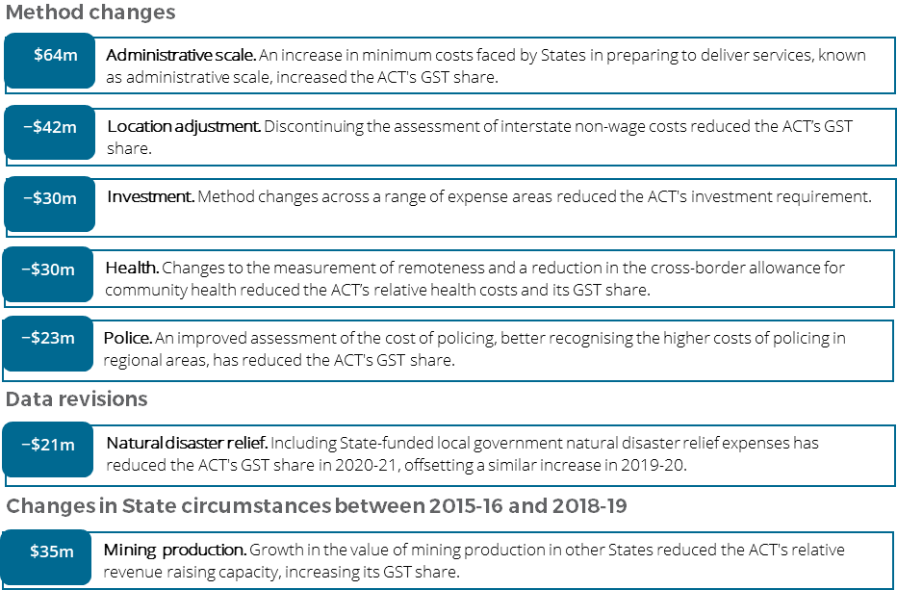

For more information about these changes, see Volume 1 of the 2020 Review final report.