### New South Wales

This fact sheet provides an overview of circumstances that have affected expenditure and revenue, as well as a summary of the major causes of change in relative fiscal capacity since the 2019 Update.

#### Fiscal circumstances

New South Wales is the State with the second strongest fiscal capacity. Its below average expense requirement reflects a below average share of people living in more remote areas, economies of scale in administration and above average non-State provision of health services.

New South Wales also has an above average capacity to raise revenue, with a high value of property sales and taxable land, and above average taxable payrolls.

Those effects on its fiscal capacity are partly offset by its above average investment requirement, mainly for urban transport, and a below average share of Commonwealth payments.

Illustrative GST, New South Wales, 2020‑21

|  |  |  |
| --- | --- | --- |
|  | $m | $pc |
| Equal per capita share of GST revenue | 21,567 | 2,598 |
| Effect of assessed: |  |  |
| Expenses | -1,144 | -138 |
| Investment | 89 | 11 |
| Net borrowing | 22 | 3 |
| Revenue | -1,079 | -130 |
| Commonwealth payments | 376 | 45 |
| Illustrative GST | 19,832 | 2,389 |

Note: Table may not add due to rounding. For expenses and investment, a negative sign indicates below average costs, which reduces a State’s GST requirement. For net borrowing, revenue and Commonwealth payments, a negative sign indicates above average revenue raising capacity, which also reduces a State’s GST requirement.

|  |
| --- |
| **Key reasons why fiscal capacities differ between States**   * The uneven distribution of mining activity and production due to underlying differences in distribution of mineral reserves across Australia. * Differences in the spatial distribution (or dispersion) of their populations. * States with a greater than average share of population in less accessible regions face higher than average service delivery and infrastructure costs. * States with large, densely populated cities face higher than average urban public transport costs. * Variation in the value of property sales. States with higher property values and volume of turnover have a greater capacity to raise revenue from taxes imposed on the transfer of property. * Differences in the number of Indigenous people in their populations. States with a greater than average share of Indigenous people in the population face higher than average service delivery costs. |

#### Change in fiscal capacity

New South Wales’ fiscal capacity has weakened due to an increase in its assessed costs of providing urban public transport services, as well as below average growth in the value of property sales and a fall in its relative capacity to raise mining revenue due to growth in the value of mining production in other States. These changes were partially offset by changes to the scope of the stamp duty assessment, above average growth in its taxable land values, and revisions to State natural disaster relief expenses.

New South Wales’ reduced fiscal capacity will see its GST share increase from 27.8% to 29.3%. Combined with pool growth, its GST entitlement in 2020‑21 will rise by $1,640 million, or 9.0%.

Change in illustrative GST distribution since the 2019 Update, New South Wales

|  |  |  |
| --- | --- | --- |
|  | $m | $pc |
| New population | -3 | 0 |
| Growth in GST available | 612 | 74 |
| Changes in relative fiscal capacity | 1,031 | 124 |
| Method changes | 711 | 86 |
| Data revisions | -275 | -33 |
| State circumstances | 595 | 72 |
| Total change | 1,640 | 198 |

Note: Table may not add due to rounding.

Since the 2019 Update, there have been changes in some of the assessment methods used by the Commission, revisions to some of the data used in the assessments, and changes in economic and demographic circumstances.

Main changes for New South Wales, 2020 Review

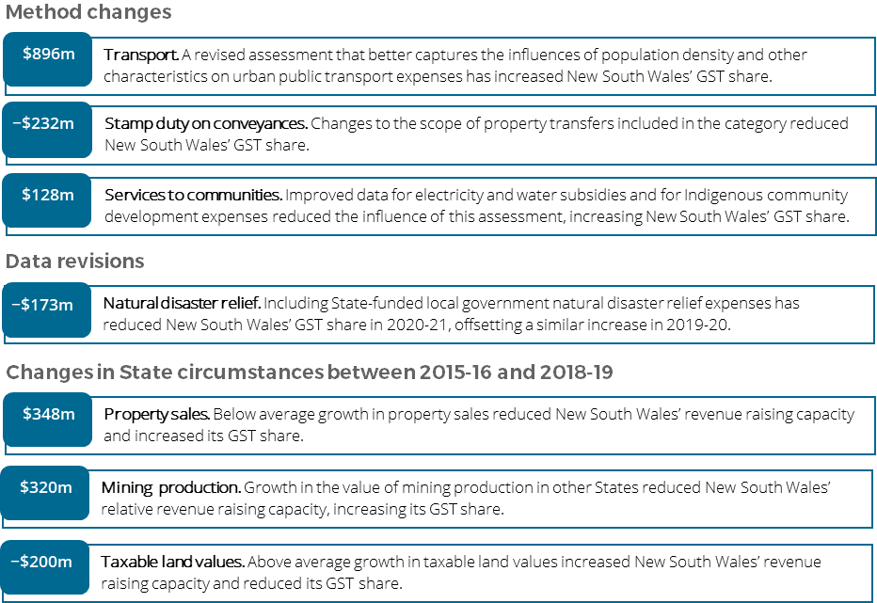

**For more information about these changes, see Volume 1 of the 2020 Review final report.**