### South Australia

This fact sheet provides a summary of the major causes of change in relative fiscal capacity since the 2019 Update, as well as an overview of circumstances that have affected expenditure and revenue.

#### Fiscal circumstances

South Australia’s fiscal capacity is the third weakest. It has below average capacity to raise revenue from mining production, property sales, taxable payrolls and taxable land values.

It also has above average expense requirements, reflecting its above average level of non‑Indigenous disadvantage and diseconomies of scale in administration.

Those effects on its fiscal capacity are partially offset by an above average share of Commonwealth payments and its below average investment requirement due to below average growth in service user populations.

Illustrative GST, South Australia, 2020‑21

|  |  |  |
| --- | --- | --- |
|  | $m | $pc |
| Equal per capita share | 4,603 | 2,598 |
| Effect of assessed: |  |  |
| Expenses | 181 | 102 |
| Investment | -405 | -229 |
| Net borrowing | 60 | 34 |
| Revenue | 2,057 | 1,161 |
| Commonwealth payments | -236 | -133 |
| Illustrative GST | 6,259 | 3,533 |

Note: Table may not add due to rounding. For expenses and investment, a negative sign indicates below average costs, which reduces a State’s GST requirement. For net borrowing, revenue and Commonwealth payments, a negative sign indicates above average revenue raising capacity, which also reduces a State’s GST requirement.

|  |
| --- |
| **Key reasons why fiscal capacities differ between States**   * The uneven distribution of mining activity and production due to underlying differences in distribution of mineral reserves across Australia. * Differences in the spatial distribution (or dispersion) of their populations. * States with a greater than average share of population in less accessible regions face higher than average service delivery and infrastructure costs. * States with large, densely populated cities face higher than average urban public transport costs. * Variation in the value of property sales. States with higher property values and volume of turnover have a greater capacity to raise revenue from taxes imposed on the transfer of property. * Differences in the number of Indigenous people in their populations. States with a greater than average share of Indigenous people in the population face higher than average service delivery costs. |

#### Change in fiscal capacity

South Australia’s fiscal capacity has strengthened due to an increase in its share of Commonwealth payments, lower assessed costs of providing urban public transport and school services, a lower investment requirement, revisions to State natural disaster relief expenses and above average growth in property sales. These changes were partially offset by a reduced capacity to raise mining revenue relative to other States.

Compared with 2019‑20, the South Australia’s share of GST will decrease from 10.1% to 9.3%. Growth in the GST pool does not offset the impact of South Australia’s improved fiscal capacity, and its GST entitlement will fall by $332 million, or 5.0%.

Change in illustrative GST distribution since the 2019 Update, South Australia

|  |  |  |
| --- | --- | --- |
|  | $m | $pc |
| New population | -53 | -30 |
| Growth in GST available | 220 | 124 |
| Changes in relative fiscal capacity | -499 | -282 |
| Method changes | -274 | -154 |
| Data revisions | -53 | -30 |
| State circumstances | -172 | -97 |
| Total change | -332 | -188 |

Note: Table may not add due to rounding.

Since the 2019 Update, there have been changes in some of the assessment methods used by the Commission, revisions to some of the data used in the assessments, and changes in economic and demographic circumstances.

Main changes for South Australia, 2020 Review

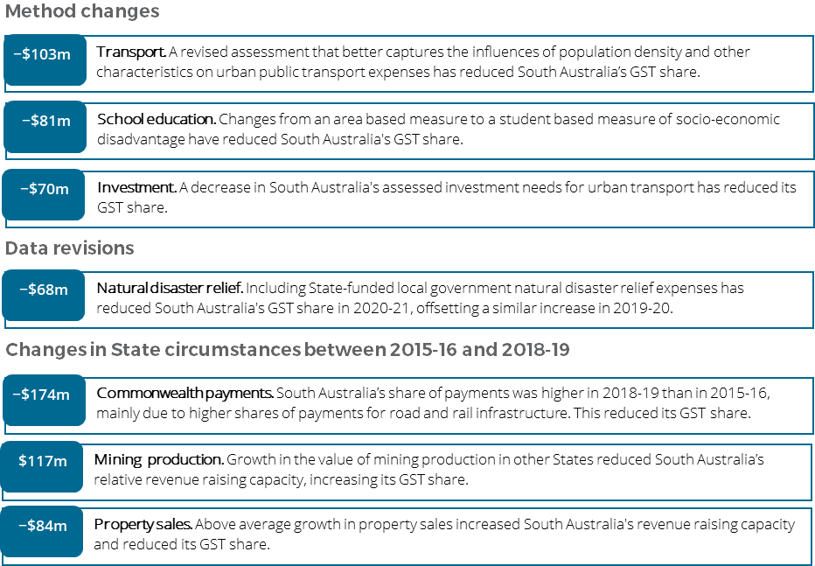

**For more information about these changes, see Volume 1 of the 2020 Review final report.**