### Tasmania

This fact sheet provides a summary of the major causes of change in relative fiscal capacity since the 2019 Update, as well as an overview of circumstances that have affected expenditure and revenue.

#### Fiscal circumstances

Tasmania is the State with the second weakest fiscal capacity. It has well below average revenue raising capacity, with well below average mining production, value of property sales, taxable payrolls and taxable land values.

In addition, Tasmania faces above average service delivery costs due to above average shares of people in regional areas, an above average level of non‑Indigenous disadvantage and diseconomies of scale in administration.

These effects on its fiscal capacity are partially offset by a below average investment requirement due to below average growth in service user populations.

Illustrative GST, Tasmania, 2020‑21

|  |  |  |
| --- | --- | --- |
|  | $m | $pc |
| Equal per capita share | 1,414 | 2,598 |
| Effect of assessed: |  |  |
| Expenses | 725 | 1,332 |
| Investment | -129 | -237 |
| Net borrowing | 11 | 21 |
| Revenue | 755 | 1,387 |
| Commonwealth payments | -89 | -163 |
| Illustrative GST | 2,688 | 4,937 |

Note: Table may not add due to rounding. For expenses and investment, a negative sign indicates below average costs, which reduces a State’s GST requirement. For net borrowing, revenue and Commonwealth payments, a negative sign indicates above average revenue raising capacity, which also reduces a State’s GST requirement.

|  |
| --- |
| **Key reasons why fiscal capacities differ between States**   * The uneven distribution of mining activity and production due to underlying differences in distribution of mineral reserves across Australia. * Differences in the spatial distribution (or dispersion) of their populations. * States with a greater than average share of population in less accessible regions face higher than average service delivery and infrastructure costs. * States with large, densely populated cities face higher than average urban public transport costs. * Variation in the value of property sales. States with higher property values and volume of turnover have a greater capacity to raise revenue from taxes imposed on the transfer of property. * Differences in the number of Indigenous people in their populations. States with a greater than average share of Indigenous people in the population face higher than average service delivery costs. |

#### Change in fiscal capacity

Tasmania’s fiscal capacity has weakened due to higher assessed administrative scale costs, an increase in the cost of admitted patient, police and other services in regional areas, and a lower relative capacity to raise mining revenue and land tax. These changes were partly offset by above average growth in the value of property sales.

Tasmania’s weaker fiscal capacity will see its GST share rise from 3.7% to 4.0%. Combined with pool growth, its GST entitlement in 2020‑21 will rise by $271 million, or 11.2%.

Change in illustrative GST distribution since the 2019 Update, Tasmania

|  |  |  |
| --- | --- | --- |
|  | $m | $pc |
| New population | -10 | -19 |
| Growth in GST available | 81 | 149 |
| Changes in relative fiscal capacity | 200 | 367 |
| Method changes | 141 | 259 |
| Data revisions | 14 | 25 |
| State circumstances | 45 | 83 |
| Total change | 271 | 497 |

Note: Table may not add due to rounding.

Since the 2019 Update, there have been changes in some of the assessment methods used by the Commission, revisions to some of the data used in the assessments, and changes in economic and demographic circumstances.

Main changes for Tasmania, 2020 Review

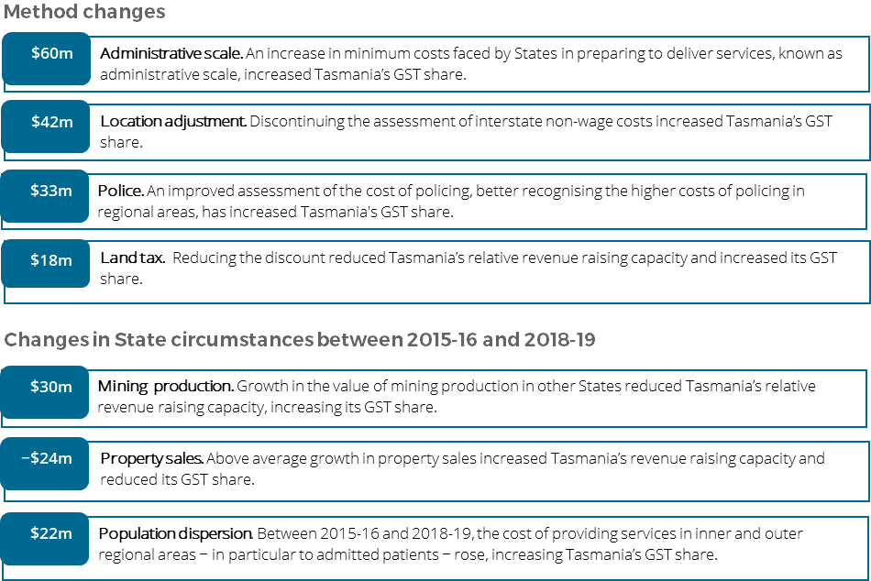

For more information about these changes, see Volume 1 of the 2020 Review final report.