

**2017 UPDATE**

**AN ADDITIONAL NEW ISSUE FOR THE 2017 UPDATE - LAND TAX ASSESSMENT**

**STAFF DISCUSSION PAPER  
CGC 2017-01-S**

**30 January 2017**

|  |  |
| --- | --- |
| Paper issued | 30 January 2017 |
| Commission contact officer | Jeff Evans, 02 6229 8856, [jeffrey.evans@cgc.gov.au](mailto:jeffrey.evans@cgc.gov.au) |
| Submissions sought by | Submissions should be emailed in Word format to [secretary@cgc.gov.au](mailto:secretary@cgc.gov.au) by 6 February 2017.  Submissions of more than 10 pages in length should include a summary section. |
| Confidential material | It is the Commission’s normal practice to make State submissions available on its website under the CC BY licence, allowing free use of content by third parties.  Creative Commons - CC BY Attribution  Further information on the CC BY licence can be found on the [Creative Commons website](https://creativecommons.org/licenses/by/3.0/) (http://www.creativecommons.org).  Confidential material contained in submissions must be clearly identified or included in separate attachment/s, and details provided in the covering email. Identified confidential material will not be published on the Commission’s website. |

* 1. States impose land tax on residential investment, commercial and industrial land. Mostly they impose the tax on a landholder’s aggregated value of taxable land. The Commission’s capacity measure is a State’s total value of taxable land, aggregated by landholder. State Revenue Offices (SROs) provide these data disaggregated across 15 value ranges.
  2. In this update, Queensland has provided a new distribution of land values by value range for 2016, to replace the distribution it estimated in 2009 for the 2010 Review, and which was used in subsequent updates. This new distribution is very different from its old distribution (Figure 1). There is more value at low value ranges and less value at high value ranges.
  3. The old distribution by value range was estimated. The new distribution has been constructed using land value data provided by the State Valuer General’s office, although some estimation is required at the lower value end as values below $0.6 million are not taxed. These additional data have become available to the State Revenue Office as a result of a system upgrade. This approach is more consistent with that used by other States to estimate their value distributions.

Figure Comparison of Queensland’s distributional patterns, 2009 and 2016

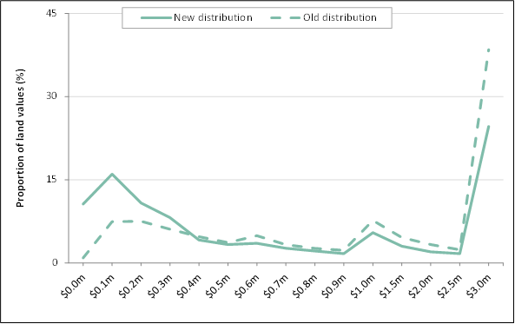

Source: State Revenue Office data.

* 1. Queensland says the new distribution is mainly due to a slow shift in values that has taken place since 2009 and the availability of data on which to calculate the shares of properties in each value range.
  2. The new distribution appears to be more representative of Queensland’s current property market than the old distribution for the following reasons.
* Applying Queensland’s legislated rates to its distribution of taxable land values using the new distribution and the old distribution, the new distribution produced revenue raising that better aligns with its actual collections.
* Figure 2 shows the 2016 data are more similar to the distributional pattern of other States than the 2009 data (shown in Figure 3), particularly for the top band of $3 million, the band with the highest effective tax rate.
* The median value of properties in Brisbane is low compared with those in Sydney, Melbourne, Perth, Canberra and Darwin, and only above those in Adelaide and Hobart. It has become increasingly below the average since 2013 (ABS, Residential Property Price Indexes: Eight Capital Cities, Mar 2015, Cat No 6416.0).
* The value distribution adjustment (VDA) for Queensland implied by the 2009 distribution would suggest property values 37.9% above average — the highest of any State. Its VDA implied by the 2016 distribution is slightly below average, more consistent with its relative property values. Also, Queensland’s VDA using the new distribution is more consistent with its VDA for conveyance duty. Note: A VDA compares a State’s actual distribution of values to the average distribution.
* One of the reasons Queensland gave for the increase in the low value ranges is the increase in the proportion of apartments. The proportion of residential building approvals that are apartments increased from 19% in 2009-10 to 35% in 2015‑16 (ABS, Queensland Building Approvals data).
* The last Valuer General’s data by value range available to the Commission (2008 data) indicated that Queensland had over 50% of its property values in the ranges $0.3 million and below. These data are not aggregated by land holder and are therefore not directly comparable with SRO data. However, the adjustments for joint owners would not be expected to substantially reduce this proportion.

Figure Comparison of State distributional patterns, 2016

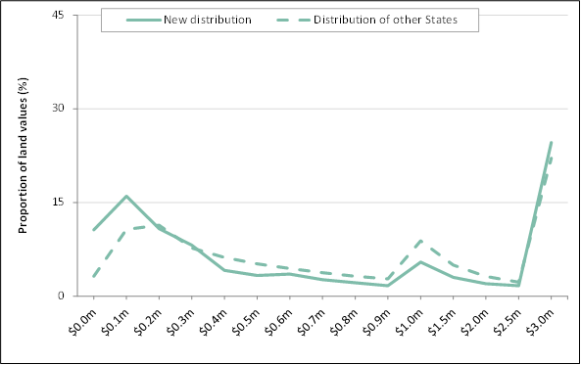

Source: State Revenue Office data.

Figure Comparison of State distributional patterns, 2009

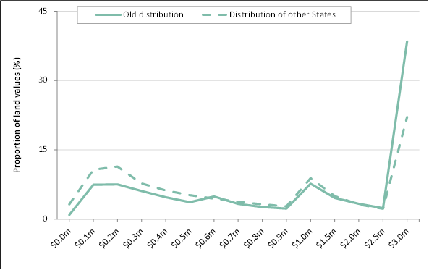

Source: State Revenue Office data.

* 1. As Queensland’s new distribution of land values by value range for 2015‑16 appears to provide a better indication of current conditions than applying its previous (2009) distribution, the issue for the Commission is what distribution the Commission should use for the earlier two assessment years. The options for those years are:
* to retain the old distribution in both years
* to use the new distribution in both years
* to transition from the old distribution to the new distribution.
  1. The last option would be implemented by assuming an even transition from 2009-10 to 2015‑16 (the last year of the 2017 Update). That would imply the distributions for each assessment year as shown in Table 1.
  2. Table 2 shows the redistribution of GST revenue for each approach, along with the difference in the GST distributions between the 2016 and 2017 Updates of the alternative approaches.
  3. While there are reasons to support each of the three options above, the staff inclination is to recommend to the Commission that it use the transition approach to obtain value distributions for the first two assessment years. We are seeking State views on the value distribution that should be used in those two years.

Table Transitioning from the old distribution to the new distribution

|  |  |  |  |  |  |  |  |
| --- | --- | --- | --- | --- | --- | --- | --- |
|  | Distribution for assessment year | | | | | | |
| Value range | 2009-10 | 2010-11 | 2011-12 | 2012-13 | 2013-14 | 2014-15 | 2015-16 |
|  | % | % | % | % | % | % | % |
| $0.0m to $0.1m | 0.9 | 2.5 | 4.2 | 5.8 | 7.4 | 9.0 | 10.6 |
| $0.1m to $0.2m | 7.4 | 8.9 | 10.3 | 11.7 | 13.2 | 14.6 | 16.0 |
| $0.2m to $0.3m | 7.5 | 8.1 | 8.6 | 9.2 | 9.7 | 10.3 | 10.8 |
| $0.3m to $0.4m | 6.1 | 6.4 | 6.8 | 7.1 | 7.5 | 7.8 | 8.2 |
| $0.4m to $0.5m | 4.7 | 4.6 | 4.5 | 4.4 | 4.3 | 4.2 | 4.1 |
| $0.5m to $0.6m | 3.7 | 3.6 | 3.6 | 3.5 | 3.4 | 3.4 | 3.3 |
| $0.6m to $0.7m | 4.9 | 4.7 | 4.5 | 4.2 | 4.0 | 3.8 | 3.6 |
| $0.7m to $0.8m | 3.3 | 3.2 | 3.1 | 3.0 | 2.9 | 2.8 | 2.7 |
| $0.8m to $0.9m | 2.6 | 2.5 | 2.5 | 2.4 | 2.3 | 2.2 | 2.2 |
| $0.9m to $1.0m | 2.3 | 2.2 | 2.1 | 2.0 | 1.9 | 1.8 | 1.7 |
| $1.0m to $1.5m | 7.7 | 7.3 | 6.9 | 6.6 | 6.2 | 5.8 | 5.5 |
| $1.5m to $2.0m | 4.6 | 4.3 | 4.1 | 3.8 | 3.6 | 3.3 | 3.0 |
| $2.0m to $2.5m | 3.3 | 3.1 | 2.9 | 2.7 | 2.5 | 2.2 | 2.0 |
| $2.5m to $3.0m | 2.4 | 2.3 | 2.2 | 2.0 | 1.9 | 1.8 | 1.7 |
| $3.0m and above | 38.5 | 36.2 | 33.9 | 31.5 | 29.2 | 26.9 | 24.6 |

Source: Commission calculation using State provided data.

Table Difference in GST distribution compared with the 2016 Update

|  |  |  |  |  |  |  |  |  |  |
| --- | --- | --- | --- | --- | --- | --- | --- | --- | --- |
|  | NSW | Vic | Qld | WA | SA | Tas | ACT | NT | Redist |
|  | $m | $m | $m | $m | $m | $m | $m | $m | $m |
| GST redistribution from EPC - 2016 Update (a) | 38 | -176 | -8 | -250 | 227 | 89 | 56 | 24 | 434 |
|  |  |  |  |  |  |  |  |  |  |
| GST redistribution from EPC - 2017 Update | | |  |  |  |  |  |  |  |
| 2009 in first two years   and 2016 in last year | -155 | -149 | 117 | -216 | 234 | 88 | 56 | 25 | 520 |
| 2016 distribution only | -241 | -221 | 327 | -257 | 228 | 87 | 55 | 24 | 719 |
| Transition | -219 | -202 | 273 | -246 | 229 | 87 | 55 | 24 | 668 |
|  |  |  |  |  |  |  |  |  |  |
| Difference from 2016 Update | |  |  |  |  |  |  |  |  |
| 2009 in first two years   and 2016 in last year | -193 | 26 | 125 | 33 | 7 | -1 | 0 | 1 | 194 |
| 2016 distribution only | -279 | -45 | 335 | -8 | 1 | -2 | -1 | 0 | 336 |
| Transition | -257 | -26 | 281 | 3 | 2 | -2 | -1 | 0 | 286 |

(a) This is the 2016 Update redistribution indexed forward by the change in the GST pool and population

between 2016‑17 and 2017‑18.

Source: Commission calculation.