### Victoria

This fact sheet provides a summary of the major causes of change in relative fiscal capacity since the 2019 Update, as well as an overview of circumstances that have affected expenditure and revenue.

#### Fiscal circumstances

Victoria has the third highest fiscal capacity. Its expense requirement is well below average, which reflects its below average shares of government school enrolments, Indigenous people and people living in remote areas, as well as economies of scale in administration.

Expense effects on Victoria’s fiscal capacity are partly offset by its below average revenue raising capacity, mainly due to below average mining production.

Victoria also has an above average requirement for investment in urban transport, reflecting above average population growth in Melbourne.

Illustrative GST, Victoria, 2020‑21

|  |  |  |
| --- | --- | --- |
|  | $m | $pc |
| Equal per capita share | 17,752 | 2,598 |
| Effect of assessed: |  |  |
| Expenses | -4,689 | -686 |
| Investment | 263 | 38 |
| Net borrowing | -174 | -25 |
| Revenue | 2,763 | 404 |
| Commonwealth payments | 1,152 | 169 |
| Illustrative GST | 17,068 | 2,498 |

Note: Table may not add due to rounding. For expenses and investment, a negative sign indicates below average costs, which reduces a State’s GST requirement. For net borrowing, revenue and Commonwealth payments, a negative sign indicates above average revenue raising capacity, which also reduces a State’s GST requirement.

|  |
| --- |
| **Key reasons why fiscal capacities differ between States**   * The uneven distribution of mining activity and production due to underlying differences in distribution of mineral reserves across Australia. * Differences in the spatial distribution (or dispersion) of their populations. * States with a greater than average share of population in less accessible regions face higher than average service delivery and infrastructure costs. * States with large, densely populated cities face higher than average urban public transport costs. * Variation in the value of property sales. States with higher property values and volume of turnover have a greater capacity to raise revenue from taxes imposed on the transfer of property. * Differences in the number of Indigenous people in their populations. States with a greater than average share of Indigenous people in the population face higher than average service delivery costs. |

#### Change in fiscal capacity

Victoria’s fiscal capacity has strengthened due to reduced investment needs, lower assessed costs of providing urban public transport, revisions to State natural disaster relief expenses, and above average growth in property sales. These changes were partly offset by a fall in its relative capacity to raise mining revenue, a lower share of Commonwealth payments and downward revisions to the value of property sales in earlier years.

Victoria’s increased fiscal capacity will reduce its GST share from 25.7% to 25.2%. Combined with pool growth, its GST entitlement in 2020‑21 will rise by $269 million, or 1.6%.

Change in illustrative GST distribution since the 2019 Update, Victoria

|  |  |  |
| --- | --- | --- |
|  | $m | $pc |
| New population | 111 | 16 |
| Growth in GST available | 569 | 83 |
| Changes in relative fiscal capacity | -410 | -60 |
| Method changes | -802 | -117 |
| Data revisions | 113 | 16 |
| State circumstances | 279 | 41 |
| Total change | 269 | 39 |

Note: Table may not add due to rounding.

Since the 2019 Update, there have been changes in some of the assessment methods used by the Commission, revisions to some of the data used in the assessments, and changes in economic and demographic circumstances.

Main changes for Victoria, 2020 Review

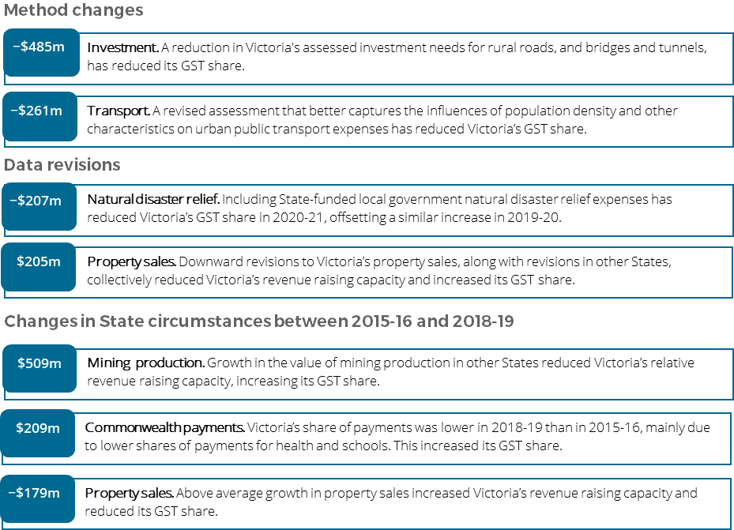

**For more information about these changes, see Volume 1 of the 2020 Review final report.**