27 February 2015

The Hon Joe Hockey MP  
Treasurer  
Parliament House  
CANBERRA ACT 2600

Dear Treasurer

In your letter of 23 December 2014 you asked the Commission to consider the treatment of GST relativities in relation to large and volatile revenue sources. Specifically you sought advice on a possible approach that would mitigate the negative effects of revenue volatility and ensure that States’ shares of GST in the year are appropriate for their fiscal circumstances in that year.

These issues were also raised by Western Australia in the course of the Commission’s 2015 Methodology Review, and we consulted States on them as part of the review process. Our consideration of these issues and our conclusions are addressed in our 2015 Review report.

We have carefully considered if the current system could be modified to both achieve HFE and have a GST distribution in the application year which more closely reflects the fiscal capacities of States in that year. While several approaches were explored, we do not recommend any as appropriately meeting the HFE objective.

We have concluded that using three year averaging, applied consistently to all assessments, provides the most reliable, practical and fair outcome consistent with achieving HFE over a run of years (albeit with a lag since reliable data are only available on a historical basis). This approach balances competing considerations of practicality, data reliability, contemporaneity and policy neutrality, and predictably smooths payment flows over time.

In the attached paper we present analysis of the issues, a discussion of the alternative approaches that we considered and States’ views on this issue.

Our findings are based on retaining HFE as the objective of the GST distribution – we have not considered alternative objectives which we consider are matters for determination by Governments. However, if Governments wish, for any reason, to adopt relativities providing a higher GST share to Western Australia, with a consequent lower share for other States, illustrative relativities are provided in that paper.

Yours sincerely

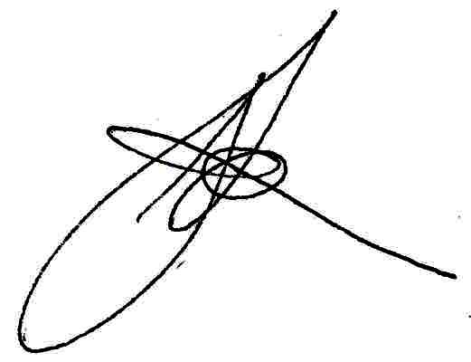

G J Smith  
Chairperson