**Why states get different shares**

**of GST**

Research paper 2

October 2021

**Copyright**

© Commonwealth of Australia 2021

With the exception of the Commonwealth Coat of Arms, all material presented in this document is provided under Creative Commons Attribution 4.0 (https://creativecommons.org/licenses/by/4.0/) licence. The details of the relevant licence conditions are available on the Creative Commons website as is the full legal code for CC BY 4.0 International (<https://creativecommons.org/licenses/by/4.0/legalcode>).

Creative Commons - Attribution

**Attribution**

The recommended attribution for this document is Commonwealth Grants Commission, Research paper 2: Why states get different shares of GST.

**Contact us**

Inquiries regarding the use of this document should be directed to secretary@cgc.gov.au.

**Internet**

A copy of this paper is available on the Commission’s website (http://www.cgc.gov.au).

## Summary

An important feature of Australia’s federation is that the Commonwealth provides untied financial support to the states and territories (states). Since 2000, the Commonwealth has used revenue from the Goods and Services Tax (GST) to fund these transfers.

GST allocation reflects states’ different needs. This is known as horizontal fiscal equalisation.

States vary in their costs of providing services, as well as the amount of revenue they are able to access to pay for these services. The Commission uses evidence to estimate these differences.

The Commission determines the amount each state needs to spend, and the revenue each can access. A state with a small gap between the amount it needs to spend and the revenue it can access needs a smaller share of GST. A state with a large gap needs a larger share.

As the GST pool in a given year is fixed, needs are calculated on a relative basis. A change in the relative expenditure needs or revenue raising capacity of any one state will affect the GST allocation of all states.

Key reasons for differing GST shares include the following.

* Mining resources provide a state with the ability to raise revenue from royalties. These resources are distributed unevenly across states.
* Property prices affect a state’s ability to raise revenue from stamp duty on conveyances and land tax. Property prices differ between states and the pattern can change over time.
* Where people live, their Indigenous status and their socio-economic status are important influences on the cost of providing government services. States have different proportions of these groups of people.
* The level of wages in a state affects its ability to raise revenue via payroll tax, while also affecting its cost of providing services. The two effects work in different directions.
* States with growing populations require more investment in schools, hospitals, public transport and road infrastructure.
* States that receive lower levels of Commonwealth payments, relative to other states, need more GST to fund their services.
* States with high spending on natural disasters receive more GST.
* New arrangements for GST distribution ensure that a state’s GST share cannot fall below a given level. Notwithstanding this change, most states’ GST shares are strongly influenced by their particular economic, demographic and social circumstances.

## Introduction

This paper explains how state circumstances differ, and how this drives states’ differing shares of the GST pool. It explains:

* how the Commission measures states’ different needs
* the main drivers of different needs across the country.

### The basis of GST distribution to the states

Australia has a well-established system of horizontal fiscal equalisation, where state governments are given a similar ability to fund services to their residents. The Commonwealth Grants Commission (the Commission) is an independent agency that considers each state’s circumstances and identifies how much of the GST pool it requires. It assesses the circumstances of one state *relative* to the circumstances of the others. This means that if some states can raise less revenue than others with the same effort, they are given more GST revenue. The same is true where some states face higher service delivery costs.

In 2018 the Australian Parliament legislated a change in the arrangements for distributing GST to the states. The transition to the new approach commenced in 2021-22.[1]

Previously, equalisation gave each state the fiscal capacity of the fiscally strongest state to provide services.

* The new equalisation arrangements ensure that each state’s GST relativity is at least as high as the relativity of the fiscally stronger of New South Wales or Victoria (referred to as the ‘standard state’). This means no state will receive less GST per person than the standard state.

### Calculating states’ different needs

The Commission estimates the amount states would need if they are to have the same capacity to provide services, and the revenue each could access with the same revenue effort (such as taxes and royalties, and Commonwealth payments for specific purposes). A state with a small gap between the amount it needs to spend and the revenue it can access will need a smaller share of GST. A state with a large gap will need a larger share.

As outlined in Figure 1, the Northern Territory has a large gap (more than $12,000 per person), largely because of its high expense needs. Western Australia has a small gap, largely because of its high revenue raising capacity.

Figure 1 Estimated assessed state budgets per capita, 2021-22

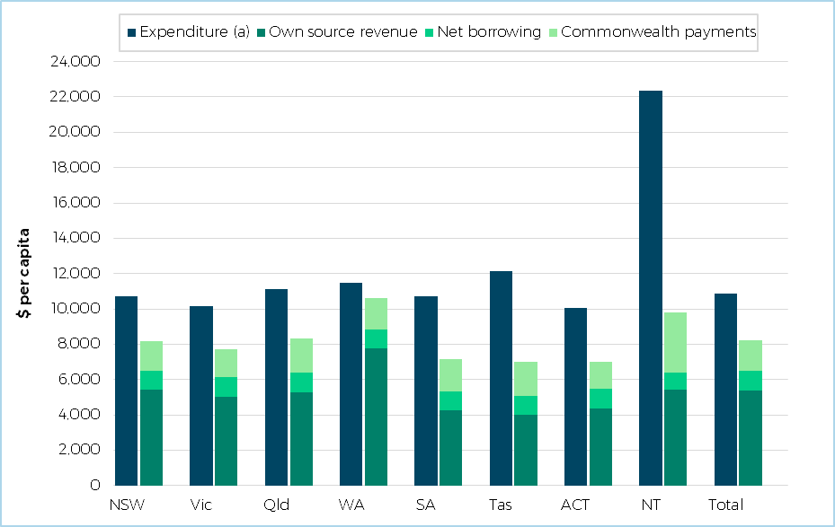

Note: These are assessed expenditures, own-source revenue and net borrowing, and actual Commonwealth payments.

The CGC uses data from previous years to calculate the GST required in any given year. This paper looks at trends over time in the GST distribution. Dates refer to the year of the GST allocation. Therefore, references to 2021-22 refer to the 2021 Update calculations determining GST distributed in 2021‑22, based on the circumstances prevailing in 2017‑18, 2018-19, 2019-20.

(a) Includes expenses and investment.

Source: Commission calculation, 2021 Update.

States’ characteristics differ, and this affects their cost of providing services. The Commission estimates **expenditure and investment** requirements across state government services, including schools, health, housing, roads, and public transport.

Where people live, Indigenous status and socio-economic status influence the cost of providing state services. For example, it is more costly to provide school education to children living in remote areas of Australia. South Australia has a higher proportion of these children than New South Wales. This means that the average school education cost per student is lower in New South Wales than in South Australia. All other things being equal, South Australia requires a higher share of GST than New South Wales in recognition of the higher costs of school education in South Australia.

Other significant influences on expenses are wage costs, head office overhead costs and urban transport costs.

The Commission also considers each state’s capacity to raise **revenue**. This includes taxes, royalties, fees, fines, and dividends from government corporations. It also covers most Commonwealth payments for specific purposes, such as National Health Reform funding and Quality Schools Funding payments.

The major sources of state tax revenue are mining royalties, payroll tax, stamp duty on conveyances and land tax. For each tax base, the Commission calculates how much each state would raise if it adopted the average revenue raising effort of all states.

Commonwealth specific purpose payments are included because they contribute to state services that would otherwise be funded from state budgets.

Various economic shocks, such as natural disaster recovery spending, can also influence state shares of GST. These effects will generally flow through the Commission’s assessments via the data used. However, the COVID-19 pandemic is having a substantial impact on state budgets and the situation is still evolving. The Commission published an occasional paper in 2020, *The impact of the COVID-19 pandemic on GST distribution* which considered the circumstances at that time in more detail.

The Commission brings this analysis together to calculate how much GST each state would need to give it the same capacity as other states to provide services.[2] As the GST pool in a given year is fixed, this goal requires that GST shares are calculated on a *relative* basis. For example, as iron ore is concentrated in Western Australia, an increase in the price of this mineral will increase the relative revenue raising capacity of Western Australia. It will simultaneously reduce the revenue raising capacity of all other states, increasing their shares of the GST.

## Why states need different GST shares

### Mining resources are distributed unevenly

Natural resources provide a state with the ability to raise revenue from royalties.

Iron ore is the largest source of mining revenue for states and is concentrated in Western Australia. The second major source of mining revenue is coal, which is concentrated in Queensland and New South Wales. These two resources account for around 80% of the mining royalties raised by states (Table 1). The remaining minerals are also concentrated in Western Australia and Queensland. Relative to its population share, the Northern Territory has above average capacity to raise mining revenue, from gold, and oil and gas. In contrast, the ACT has no capacity to raise revenue from mining.

Table 1 Share of value of production and royalty revenue by mineral, 2019-20

|  |  |  |  |  |  |  |  |  |  |
| --- | --- | --- | --- | --- | --- | --- | --- | --- | --- |
|  | NSW | Vic | Qld | WA | SA | Tas | ACT | NT | Royalty revenue |
|  | % | % | % | % | % | % | % | % | $m |
| Iron ore | 0 | 0 | 0 | 99 | 1 | 0 | 0 | 0 | 7,577 |
| Coal | 33 | 3 | 64 | 1 | 0 | 0 | 0 | 0 | 5,017 |
| Remaining minerals | 9 | 5 | 23 | 44 | 10 | 2 | 0 | 7 | 2,732 |

Source: State data returns, 2021 Update.

The difference in mining resources and production between states is the most important driver of GST redistribution. In 2021-22, states other than Western Australia, Queensland and the Northern Territory received about $8 billion of GST revenue because of their lower capacity to raise mining revenue.

There has been a similar pattern over the last decade. The impact has increased in the last 3 years due to higher iron ore prices and increased production. Figure 2 illustrates how much less GST is required by states with an above average capacity to raise revenue from mining than if an equal per capita (EPC) distribution of these revenues was used in calculating required GST shares. Above average iron ore and coal production in Western Australia and Queensland respectively has led to these states having lower GST needs over the last decade. The Northern Territory also has above average capacity to raise these revenues but to a lesser extent.

Figure 2 Lower GST needs of states with above average capacity to raise mining revenue

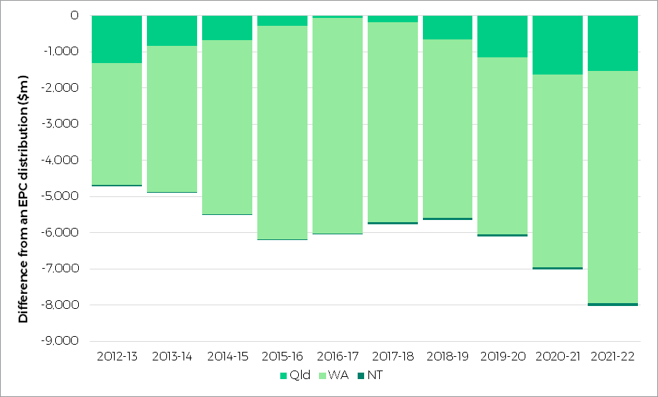

Note: This figure shows how much less GST is required by states with an above average capacity to raise revenue from mining than they would receive if an EPC distribution of these revenues was used in calculating required GST shares.

Source: Commission calculation.

### Property prices affect states’ abilities to raise revenue

Property prices affect a state’s ability to raise revenue from stamp duty on conveyances and land tax.

Property prices differ between states and property markets can change over time. Over the last decade, New South Wales and, to a lesser extent, Victoria and the ACT have had higher property prices than other states (Figure 3).

Figure 3 Median price of established house transfers in capital cities

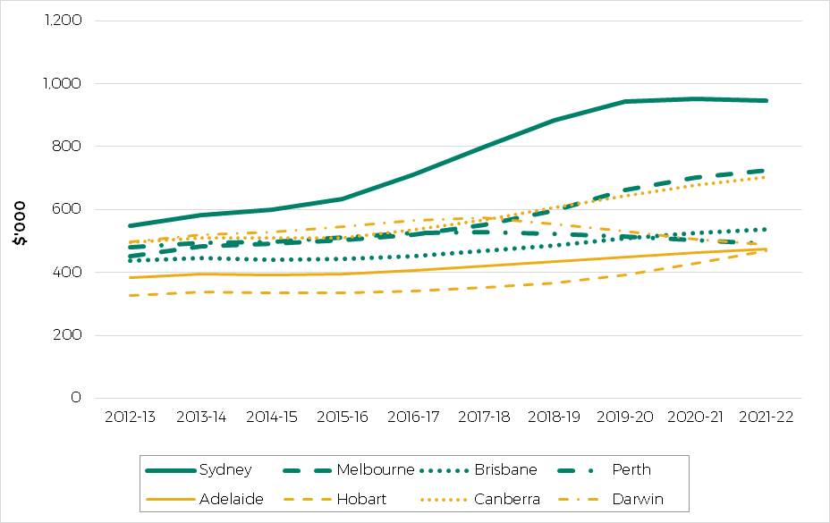

Note: The vertical axis shows the average median price for the three years used in each inquiry. For example, the 2021 Update shows the average median price for 2017-18 to 2019-20.

Source: ABS 6416.0 Residential Property Price Indexes: Eight Capital Cities, December 2020.

### Stamp duty on conveyances differs between states

Property values and the number of property transfers drive states’ capacities to raise revenue from stamp duty on conveyances.

High property prices in New South Wales and, to a lesser extent, Victoria, boost their capacity to raise revenue from stamp duty on conveyances. While the ACT has high property prices, it has lower property turnover.[3] Taken in total, it has slightly below average capacity to raise revenue from stamp duties on conveyances. All other states have below average capacity. This means that assessing the capacity of states to raise revenue from stamp duties on conveyances increases the GST share for all states other than New South Wales and Victoria.

The strong growth in property prices in New South Wales and Victoria has had an increasing impact on GST distribution over the majority of the last decade. This impact has declined in the last two years (Figure 4).

Figure 4 Lower GST needs of states with above average capacity to raise revenue from stamp duty on conveyances

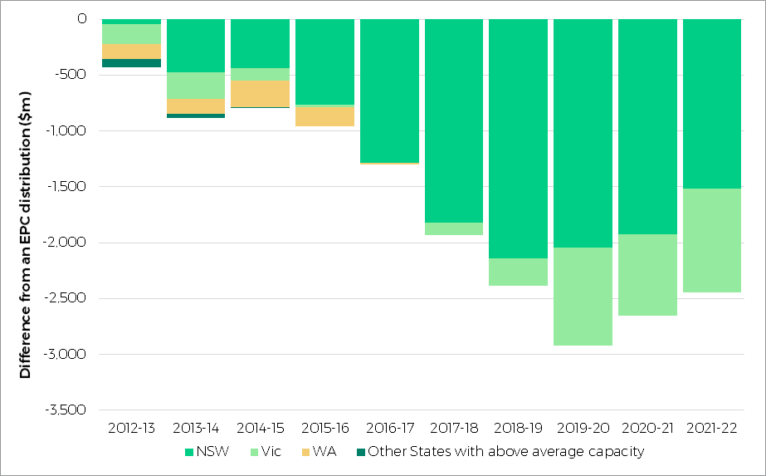

Note: This figure shows how much less GST is required by states with an above average capacity to raise revenue from stamp duty on conveyances than they would receive if an EPC distribution of these revenues was used in calculating required GST shares.

Source: Commission calculation.

### Taxable land values vary between states

Land tax is imposed on the value of commercial, industrial and residential land. Therefore, states’ relative capacities to raise revenue from land tax depends on the value of land.

There have been strong increases in taxable land value in New South Wales and, to a lesser extent, Victoria (Figure 5). This has reduced their need for GST.

Figure 5 Lower GST needs of states with above average capacity to raise revenue from land tax

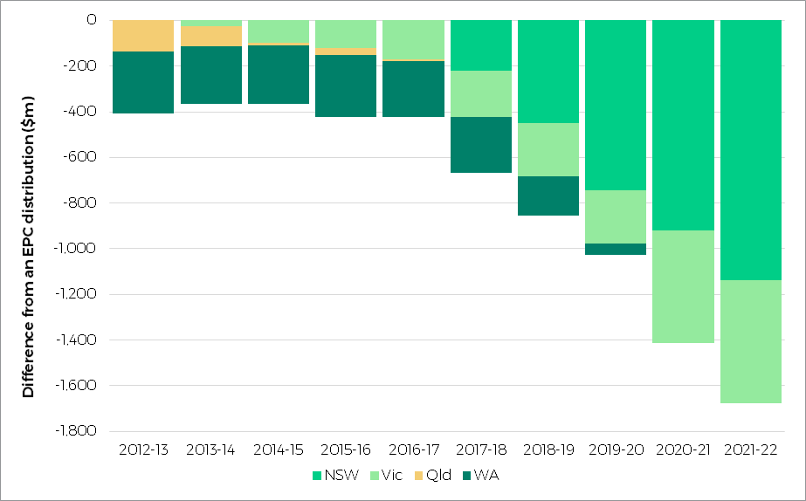

Note: This figure shows how much less GST is required by states with an above average capacity to raise revenue from land tax than they would receive if an EPC distribution of these revenues was used in calculating required GST shares.

Source: Commission calculation.

### Socio-demographic characteristics vary between states

Where people live, their Indigenous status and their socio-economic status are important influences on the cost of providing government services.

For example, Aboriginal and Torres Strait Islander people tend to use health services more than non-Indigenous people. Other services, such as welfare and housing services, help disadvantaged people. In remote areas, public services may fill the gap in private sector alternatives that are more readily available in capital cities.

These characteristics affect states’ needs because they have different proportions of these groups of people (Figure 6).

Figure 6 State population shares: ratios relative to the average, December 2019

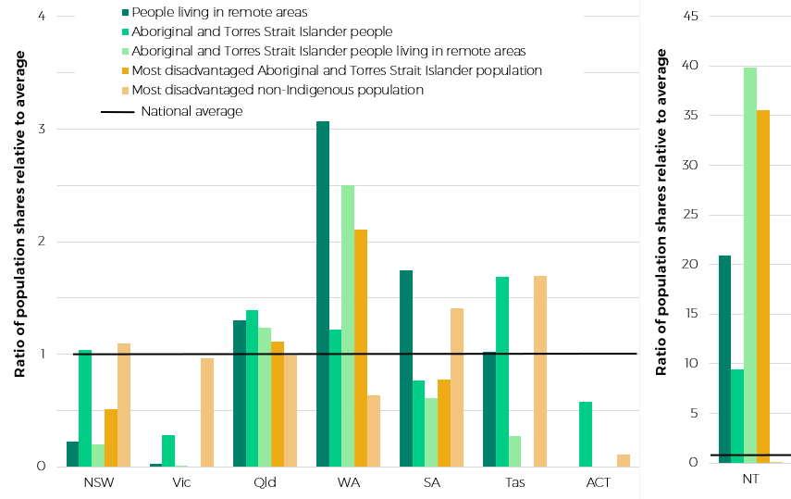

Note: This figure shows the ratio of population shares relative to the national average. A ratio below the average (below 1) means the state has a smaller share of the population group than average. A ratio of 10 means the state has 10 times the average share of a population group.

Source: Commission calculation using disaggregated ABS estimated resident population at June 2019, scaled to total ERP at December 2019.

Figure 6 shows that states’ shares of different population groups vary significantly. The magnitude of variation in the Northern Territory is an outlier. It has over 20 times the average share of people living in remote areas, almost 10 times the share of Indigenous people, and 40 times the average share of Indigenous people living in remote areas. Queensland, Western Australia, South Australia, and Tasmania also have above average shares of two or more of the population groups shown in Figure 6. New South Wales and Victoria have few people living in remote areas, and the ACT has no remote areas.

Socio-economic disadvantage is also a key driver of need. States spend comparatively more providing services to a socio-economically disadvantaged person, especially in schools, justice and health.

Australia’s Aboriginal and Torres Strait Islander populations are, on average, much more disadvantaged than the non-Indigenous population, and use state services at significantly higher rates. The Commission uses a separate measure of disadvantage for Indigenous and non-Indigenous populations. This approach, in conjunction with disaggregating by remoteness, has meant that needs are assessed among relatively comparable groups of Indigenous people. The increased identification among the less disadvantaged and urban Indigenous population, has affected the GST allocation associated with this group, but has not affected the GST allocation associated with the most disadvantaged and remote Indigenous populations.

In 2021-22 socio-demographic characteristics increased the GST shares of Queensland, Western Australia, South Australia, Tasmania and the Northern Territory by nearly $6 billion when compared with an EPC distribution of expenditure (Figure 7).

Figure 7 Higher GST needs of states due to their socio-demographic profiles

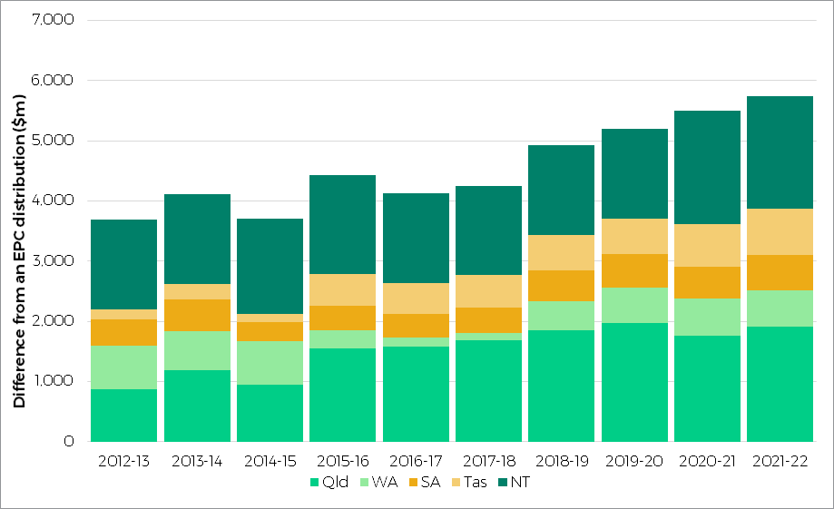

Note: This figure shows how much more GST is required by states with above average needs due to socio-demographic characteristics than they would receive if these needs were not separately assessed (if these needs were assumed to be EPC).

Source: Commission calculation.

### Wages differ across states

The level of wages in a state affects its ability to raise revenue and its cost of providing services. The two effects exert opposing influences on the GST distribution.

Employees in New South Wales, Western Australia, the ACT and the Northern Territory had above average wages between 2010 and 2020 (Table 2). Differences in wages are due to the composition of industry and occupations in each state, the characteristics of workers (such as experience and qualifications) and labour market differences (comparable employees receiving different wages in different states).

Table 2 Median weekly earnings for employees, average of 2011 to 2020 (a)

|  |  |  |  |  |  |  |  |  |  |
| --- | --- | --- | --- | --- | --- | --- | --- | --- | --- |
|  | NSW | Vic | Qld | WA | SA | Tas | ACT | NT | Avg |
|  | $ | $ | $ | $ | $ | $ | $ | $ | $ |
| Median weekly earnings for employees | 1,021 | 985 | 999 | 1,113 | 951 | 903 | 1,252 | 1,174 | 1,014 |

(a) Data in August of each year.

Source: ABS, 6333.0 Characteristics of Employment, Australia, August 2020.

Wage levels affect states’ capacities to raise revenue from payroll tax. They also affect the cost of providing public sector services, as wages represent close to 65% of total public sector costs. These two effects mirror each other, so states with above average wages are generally able to raise relatively more revenue from payroll but face higher wage bills when providing public services. On their own these effects have a large impact on GST shares. For example, in 2021-22 assessments of payroll tax and wage costs distributed $1.3 billion and $975 million respectively away from an EPC distribution of GST shares. However, in combination these assessments redistributed only $578 million away from an EPC distribution of GST shares.

### Payroll tax increases revenue capacity

Over the last decade, New South Wales and Western Australia have had above average capacity to raise revenue from payroll tax. This is mainly due to above average wages and the presence of large businesses. The Northern Territory has also experienced an above average capacity to raise revenue from payroll tax in recent years. The overall redistributive impact of this category has decreased over the last two years.

Figure 8 Lower GST needs of states with above average capacity to raise revenue from payrolls

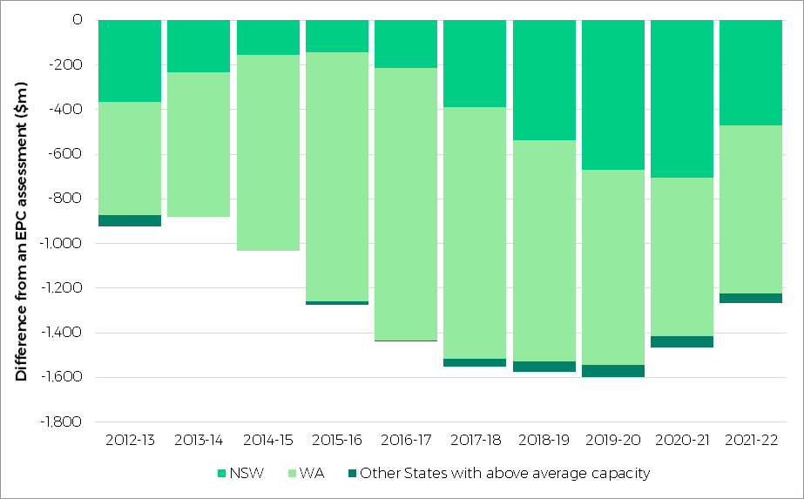

Note: This figure shows how much less GST is required by states with an above average capacity to raise revenue from payroll tax than they would receive if an EPC distribution of these revenues was used in calculating required GST shares.

Source: Commission calculation.

### Wage costs increase the cost of service delivery

Public sector employees in different states earn different wages, partly due to differences in labour markets beyond the control of state governments. This affects the cost of providing services in each state.

The Commission estimates the impact of influences on public sector wage costs beyond the control of state governments. It uses an econometric model of private sector wage costs as a proxy for public sector wages while controlling for differences in education, industry, experience and other attributes that affect wage levels.

For payroll taxation, states with above average wages require a lower share of GST. For wages, states with above average wages require a higher share of GST (New South Wales, Western Australia, the ACT and the Northern Territory).

Figure 9 Higher GST needs of states with above average wages

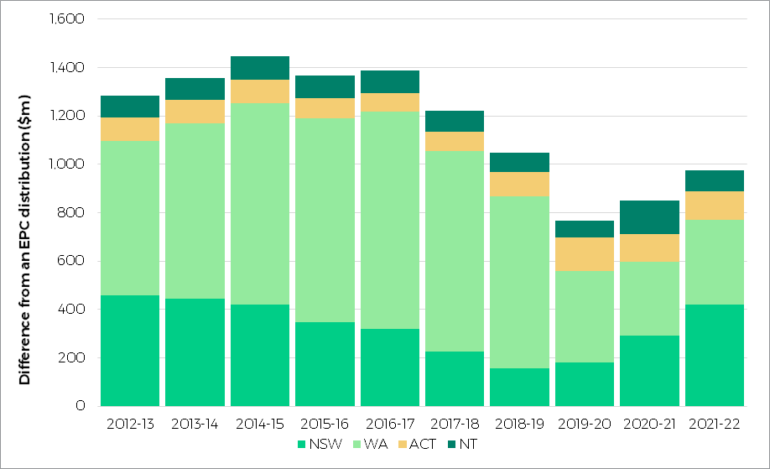

Note: This shows how much more GST is required by states with high assessed wage costs than they would receive if these needs were not separately assessed (if these wage costs were assumed to be equal).

Source: Commission calculation.

### Population growth drives infrastructure spending

Population growth drives spending on schools, hospitals, public transport and road infrastructure. States with growing populations require more investment. How a state’s population growth compares to average population growth across all states will influence its GST share.

Victoria experienced the fastest population growth in recent years (see Figure 10). In contrast, the population growth rates of Western Australia and the Northern Territory significantly declined, and Queensland’s population growth also declined. The other states’ population growth was stable. This means that Victoria has needed to invest more in infrastructure to serve its growing population than has been required in other states.

Figure 10 Population growth by state (3 year average annual growth rate)

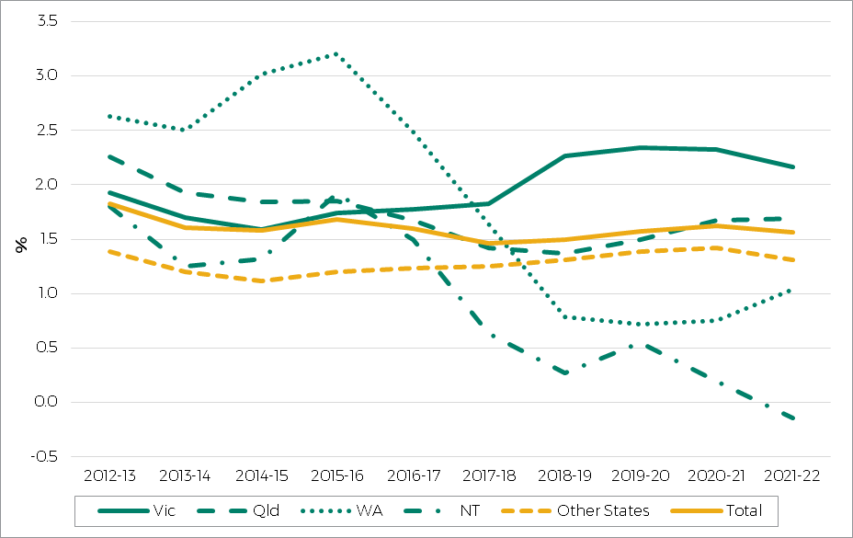

Source: ABS data.

Figure 11 shows the GST needs of states due to above average population growth over the last decade. In early years, Western Australia and Queensland needed more GST because of their relatively high population growth. From 2017-18 Victoria’s population grew faster, leading to a greater need for GST.

Figure 11 Higher GST needs of states due to population growth

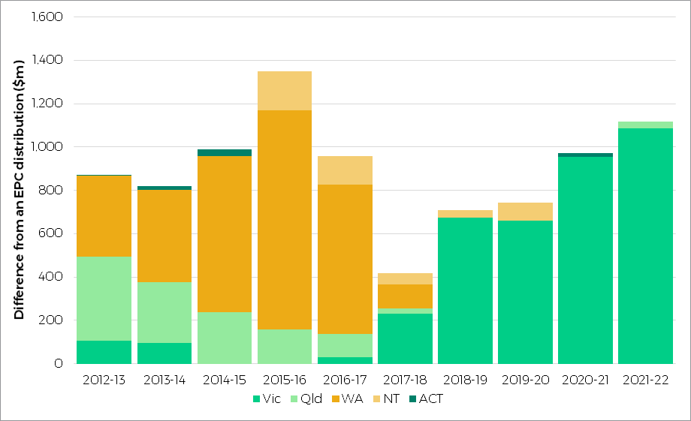

Note: This figure shows how much more GST is required by states with above average population growth than they would receive if these needs were not separately assessed (if population growth was assumed to be equal).

Source: Commission calculation.

### Commonwealth payments are unevenly distributed

States that receive lower levels of Commonwealth payments[4] relative to other states will need more GST to fund their services, other things being equal.

Over the last decade (Figure 12), Queensland, South Australia, Tasmania and the Northern Territory have received above average levels of Commonwealth payments, which has reduced their need for GST. New South Wales, Victoria and the ACT have received below average levels, which has increased their GST needs. Western Australia has received close to its population share of Commonwealth payments, so this has had little effect on its GST share.

The smaller distributions in the middle of the last decade were due to a combination of lower amounts of Commonwealth payments and a more even distribution of payments between states. The increases in redistribution that followed were mainly driven by the unequal distribution of payments among the states. Queensland and the Northern Territory’s shares of Commonwealth payments grew faster than those of other states.

The growth in the total amount of Commonwealth payments also had an impact. Larger amounts of total Commonwealth payments will generally lead to proportionally larger impacts on GST distribution.

Figure 12 GST needs due to different shares of Commonwealth payments

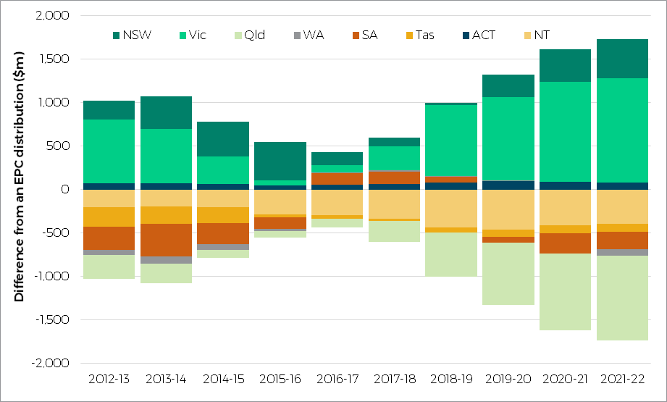

Source: Commission calculation.

### Natural disaster relief spending reflects needs

States with high spending on natural disaster relief receive more GST.

The Commonwealth Government directly supports states with the financial burden of natural disasters. It provides up to 75% of their spending on relief and recovery.

States also receive, in additional GST, the amount they spend on natural disasters that is above the national average level of spending.

Over the last decade, Queensland received most of the GST distributed to states for above average natural disaster relief expenses, receiving at least $200 million more in GST than its population share in most years. The three years from 2015-16 to 2017-18 stand out. In each of these inquiries, Queensland’s GST share increased by $600-$900 million due to its high spending on natural disaster relief. Expenses over this period included relief and repair efforts for some of the worst cyclones in recent years, such as the Queensland floods of 2010‑11, Cyclone Yasi in 2011 and Cyclone Marcia in 2015. The delay between the disaster and its impact on the GST distribution is due to lags in rebuilding infrastructure and reporting expenses after natural disasters.

## Conclusion

As in many countries, Australia provides support to sub-national governments to equalise, to some degree, the capacity for these governments to provide services.

The Commission estimates expenditure and investment requirements across state government services. Where people live, Indigenous status and socio-economic status influence the cost of providing state services. Other significant influences on expenses are wage costs, head office overhead costs and urban transport costs.

The Commission also considers each state’s capacity to raise revenue. This includes taxes, royalties, fees, fines, and dividends from government corporations. It also considers Commonwealth payments made to the states.

State circumstances vary in relation to each of these elements, and this drives their differing shares of the GST pool. An understanding of a state’s changing revenue capacities and costs of providing services relative to other states is key to understanding changes in GST shares. Analysis in this paper demonstrates how various state circumstances have affected GST shares over the last decade. The elements discussed in this paper have been the largest drivers of differences in these shares.

## Appendix 1

Table A1-1 Drivers of difference from an equal per capita distribution of GST, 2021-22

|  |  |  |  |  |  |  |  |  |  |
| --- | --- | --- | --- | --- | --- | --- | --- | --- | --- |
|  | NSW | Vic | Qld | WA | SA | Tas | ACT | NT | Redist |
|  | $m | $m | $m | $m | $m | $m | $m | $m | $m |
| EFFECTS OF REVENUE RAISING CAPACITY | |  |  |  |  |  |  |  |  |
| Mining | 2,852 | 3,913 | -1,534 | -6,417 | 743 | 254 | 266 | -77 | 8,029 |
| Property sales | -1,517 | -928 | 799 | 830 | 553 | 163 | 8 | 91 | 2,444 |
| Taxable land values | -1,139 | -536 | 829 | 159 | 417 | 154 | 100 | 16 | 1,676 |
| Taxable payrolls | -472 | 79 | 532 | -753 | 427 | 192 | 37 | -42 | 1,266 |
| Other revenue effects | 123 | 122 | -61 | -107 | -109 | -11 | 36 | 7 | 288 |
| TOTAL REVENUE | -153 | 2,650 | 564 | -6,287 | 2,031 | 752 | 447 | -5 | 6,445 |
| EFFECTS OF EXPENSE REQUIREMENTS |  |  |  |  |  |  |  |  |  |
| Sociodemographic composition (SDC) |  |  |  |  |  |  |  |  |  |
| Population dispersion | -1,573 | -1,395 | 891 | 538 | 93 | 506 | -222 | 1,162 | 3,190 |
| Indigenous status | 118 | -1,879 | 818 | 227 | -160 | 139 | -73 | 810 | 2,112 |
| Non-Indigenous disadvantage | 27 | -193 | 209 | -204 | 392 | 140 | -259 | -112 | 768 |
| Age | 180 | -66 | -148 | -64 | 169 | -6 | -18 | -46 | 349 |
| Other SDC (a) | -33 | -249 | 142 | 87 | 55 | -29 | -24 | 51 | 336 |
| Total SDC | -1,282 | -3,784 | 1,912 | 584 | 550 | 750 | -596 | 1,865 | 5,661 |
| Urban centre characteristics | 1,153 | 459 | -734 | -281 | -263 | -195 | -59 | -81 | 1,612 |
| Administrative scale | -587 | -411 | -230 | 69 | 173 | 322 | 323 | 341 | 1,228 |
| Wage costs | 421 | -203 | -220 | 349 | -393 | -158 | 119 | 85 | 975 |
| Student populations (b) | -367 | -231 | 184 | 310 | -19 | 35 | 100 | -13 | 630 |
| Other expenses | -407 | -678 | 391 | 437 | 111 | 80 | -79 | 145 | 1,164 |
| TOTAL EXPENSES | -1,068 | -4,848 | 1,302 | 1,469 | 159 | 834 | -191 | 2,342 | 6,107 |
| INVESTMENT |  |  |  |  |  |  |  |  |  |
| Capital requirement | -257 | 1,085 | 33 | -363 | -349 | -55 | -20 | -74 | 1,118 |
| Capital improvements | 86 | -495 | 84 | 187 | -33 | -31 | -137 | 338 | 696 |
| Cost of construction | 112 | -517 | -12 | 340 | -30 | -44 | 12 | 139 | 603 |
| Net borrowing | 114 | -245 | -50 | 62 | 76 | 13 | 2 | 28 | 295 |
| TOTAL INVESTMENT | 55 | -171 | 55 | 225 | -336 | -118 | -142 | 432 | 767 |
| Total expense and investment | -1,013 | -5,019 | 1,358 | 1,694 | -176 | 716 | -333 | 2,773 | 6,542 |
| Commonwealth payments | 450 | 1,201 | -974 | -71 | -204 | -88 | 81 | -395 | 1,733 |
| Total effect of fiscal capacities | -715 | -1,168 | 947 | -4,664 | 1,650 | 1,381 | 195 | 2,374 | 6,547 |
| Effect of new HFE arrangements (c) | -218 | -179 | -142 | 629 | -51 | -17 | -12 | -11 | 629 |
| TOTAL | -933 | -1,346 | 805 | -4,035 | 1,600 | 1,363 | 183 | 2,363 | 6,314 |

Note: For further explanation of what each effect includes see the supporting information for the 2021 Update on the Commission’s website.

(a) Other sociodemographic composition (SDC) includes the effects of age, Indigenous disadvantage, household size, State contributions to the NDIS and the full effect of SDC in Commonwealth funding for government schools.

(b) Student populations include both the size of the school student population and the government/non-government mix of students.

(c) Effect of change in relativities due to new arrangements. The effect of top-up to pool is not separately identified in this table, as the entire table uses a consistent, topped-up pool.

Source: Commission calculation.

1. The Commission has published an occasional paper on *New arrangements for distributing GST*, which describes the new approach in more detail.
2. A complete table of the drivers of differences in State assessed fiscal capacities for 2021-22 is shown at Appendix 1. The CGC uses data from previous years to calculate the GST required in any given year. This paper looks at trends over time in the GST distribution. Dates refer to the year of the GST allocation. Therefore, references to 2021-22 refer to 2021 Update calculations determining GST distributed in 2021-22, based on the circumstances prevailing in 2017 18, 2018-19, 2019-20.
3. In 2012, the ACT started phasing out stamp duty and introducing higher land taxes to compensate for the loss in revenue. The Commission’s assessment assumes all states follow average policy, so this policy change does not affect its GST share.
4. Commonwealth payments that do not impact on GST relativities have been excluded from this analysis. Payments are excluded if they are for purposes outside state responsibility (such as for aged care or local government services), support services where the CGC has not identified an appropriate assessment (such as environmental expenditure), or where explicitly directed by the federal Treasurer (such as the Disability Care Australia Fund).