**States’ GST needs over a decade**

June 2022

**States’ GST needs over a decade**

Research paper 4

Research Paper 4

**Copyright**

© Commonwealth of Australia 2022

With the exception of the Commonwealth Coat of Arms, all material presented in this document is provided under Creative Commons Attribution 4.0 (https://creativecommons.org/licenses/by/4.0/) licence. The details of the relevant licence conditions are available on the Creative Commons website as is the full legal code for CC BY 4.0 International (<https://creativecommons.org/licenses/by/4.0/legalcode>).

Creative Commons - Attribution

**Attribution**

The recommended attribution for this document is Commonwealth Grants Commission, Research Paper No. 4: States’ GST needs over a decade.

**Contact us**

Inquiries regarding the use of this document should be directed to secretary@cgc.gov.au.

**Internet**

A copy of this paper is available on the Commission’s website (http://www.cgc.gov.au).

# Summary

Each state receives a different per person share of GST revenue. This reflects their different revenue-raising capacities and different costs of providing services.

The Commonwealth Grants Commission (the Commission) takes *relative* needs into account when assessing how much GST each state needs. This means that a state’s GST share could rise or fall because of a change in another state’s GST needs. For example, strong growth in Western Australia’s mining revenue capacity over the past decade has reduced the relative revenue‑raising capacities of the other seven states, increasing their GST needs.

Some of the main changes in the GST needs of each state over the past decade include:

* New South Wales’ GST needs have risen sharply since 2018-19 and are now higher than average.
* Victoria’s GST needs have remained lower than average across the decade.
* Queensland’s GST needs have fluctuated, while remaining higher than average.
* Strong mining revenue capacity has resulted in Western Australia having GST needs that are much lower than average.
* South Australia’s above‑average GST needs have been driven by its low revenue‑raising capacity.
* Tasmania’s above‑average GST needs reflect its low revenue‑raising capacity, as well as its high expenditure needs.
* The Australian Capital Territory’s (ACT’s) GST needs have been greater than average and relatively stable.
* The Northern Territory’s above-average GST needs reflect its high expenditure needs.

# Introduction

Each year, the Commonwealth Treasurer asks the Commission to provide recommendations for the distribution of the Goods and Services Tax (GST) pool among the states and territories (states). The objective is to provide states with a similar fiscal capacity to provide services to their communities.

States’ economic, social and demographic characteristics differ, and this affects their revenue‑raising capacities and the expenditure needed to provide services. Drivers of differences in states’ revenue capacities include mineral royalties, land values, property transactions and payroll taxes. Expenditure needs differ for reasons such as socio‑demographic characteristics, wage pressures, and rates of population growth. States also receive different levels of Commonwealth payments. Where these payments affect the revenue available for state service delivery, the Commission takes them into account when assessing GST needs.

The approach used by the Commission ensures that states with below‑average revenue‑raising capacity, or above‑average service costs, receive a higher per person share of GST revenue. Conversely, states with a greater capacity to raise revenue or lower service costs receive a smaller per person share of GST revenue. Allocating GST in this way brings states’ fiscal capacities closer together.

In March 2022, the Commission released its [2022 Update](https://www.cgc.gov.au/publications/2022-update) on the recommended GST revenue sharing relativities for 2022-23.

This paper provides an overview of each state’s GST needs over the past decade, and the main reasons for changes[1]. The box on page 3 provides definitions for key terms used throughout the paper.

In 2018, the Parliament legislated changes to GST distribution. Under these changes, 2022‑23 is the second year in a six-year transition away from GST distribution based solely on the Commission’s assessment of states’ fiscal capacities. Because this paper focuses on state fiscal capacities, the impact of the 2018 legislated arrangements is not included in the analysis[2].

# Terms used in this paper

**GST needs**: the distribution of the GST pool that would provide states with a similar fiscal capacity to provide services to their communities.

**Revenue‑raising capacity**: the revenue a state would raise if it were to apply average policies to its revenue base and raise revenue at the average level of efficiency.

**Expense and investment needs**: the spending a state would incur on services and investments if it were to follow average policies and operate at average efficiency.

**Commonwealth payments**: payments to states by the Commonwealth to support state services or investments that are included in the Commission’s assessment of GST needs. These payments influence a state’s capacity to provide state services or investments and therefore impact the distribution of GST[3].

**Fiscal capacity**: a measure of a state’s ability to provide services, including infrastructure, to its population if it operated at average efficiency and raised revenue from its own revenue bases at average rates, and taking account of the Commonwealth payments it receives.

**Above (below) average needs**: the amount of GST a state requires that is greater (smaller) than the amount it would receive if GST was distributed on an equal per capita (EPC) basis.

**Update**: an annual report prepared by the Commission outlining recommended relativities to be used to distribute GST revenue among the states. The annual Update refers to the distribution of GST in the forthcoming fiscal year. For example, the 2022 Update refers to the GST distribution in 2022‑23. The Commission averages three years of data (from 2017-18 to 2020-21 in the 2022 Update) to calculate its recommended relativities.

**Review**: a report prepared by the Commission, usually in five-year intervals, containing a comprehensive review of the methods used to calculate GST needs. The 2020 Review contained the revised methods to be applied from 2020‑21 until the next Review.

## New South Wales

### New South Wales’ GST needs have risen sharply since 2018-19, and are now higher than average

The effect on New South Wales’ GST needs over the past decade from changes in revenue‑raising capacity, expense and investment needs, and Commonwealth payments is shown in Figure 1. Lines above zero (shaded area) indicate where GST needs are greater than average.

New South Wales’ net GST needs (solid line) were less than average until the 2022 Update. For the first time since the introduction of the GST on 2000‑01, it had above‑average GST needs.

Figure 1 New South Wales’ GST needs relative to average

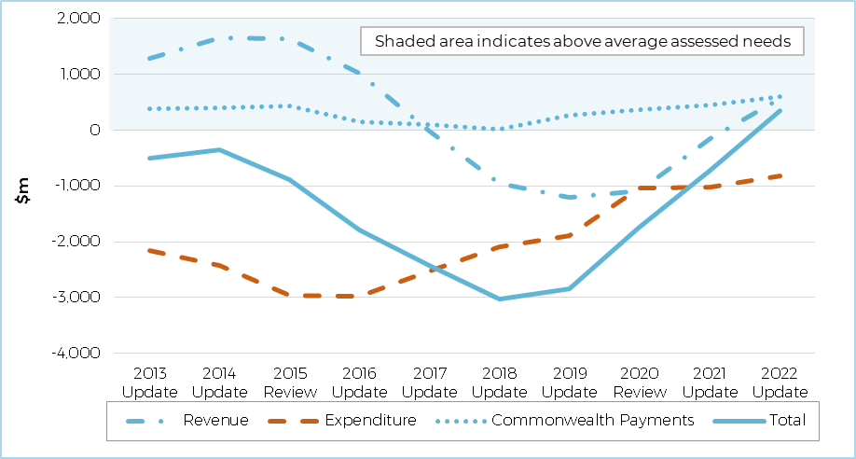

Note: Assessed GST is the GST that a state would require if it followed average policies and operated at average efficiency, taking into account its relative advantages and disadvantages in revenue collection and service provision. It does not take into account the changes introduced under the 2018 legislated arrangements.

Source: Commission calculation.

Changes in New South Wales’ GST needs can mainly be explained by changes in its relative **revenue‑raising capacity**. Revenue‑raising capacity was less than average until the 2017 Update, then greater than average until the 2022 Update, when it fell to less than average again.

* The increasing value of Western Australia’s iron ore production has been the largest single influence on fluctuations in New South Wales’ GST needs over the decade. Prior to the 2016 Update, New South Wales’ relative capacity to raise mining revenue was falling as a result of strong growth in iron ore prices and increased iron ore production in Western Australia. This increased New South Wales’ GST needs. Increased value of coal production in New South Wales combined with reduced iron ore prices in Western Australia saw a rise in New South Wales’ relative revenue raising capacity from the 2017 Update, which reduced its GST needs. Strong growth in the value of Western Australia’s iron ore production in recent years has again reduced New South Wales’ relative capacity to raise mining revenue and increased its GST needs.
* In contrast to its capacity to raise mining revenue, over the past decade New South Wales has had an above‑average, and increasing, capacity to collect stamp duty. This reflects the relative strength of its property market. A strong rise in property prices in New South Wales substantially increased its stamp duty capacity and reduced its GST needs. Although capacity to collect stamp duty fell between 2018 and 2021, it rose again in the 2022 Update.
* Above‑average growth in land values since 2017 and taxable payrolls from 2015 to 2020 also reduced New South Wales’ GST needs.

New South Wales has had below-average **expense and investment needs** over the decade, although these needs have been rising since the 2015 Review.

* The relatively small proportion of New South Wales’ population living in regional or remote areas has been the main reason for its below‑average expense and investment needs.
* Increasing population growth between the 2015 and 2018 Updates, and a higher share of natural disaster relief expenses from the 2018 Update, contributed to rising expense and investment needs. Revisions to the Commission’s urban transport assessment in the 2020 Review included the introduction of urban centre characteristics such as population density. These revisions resulted in an increase in New South Wales’ GST needs.

New South Wales’ share of **Commonwealth payments** has consistently been smaller than its population share. A smaller per person share of these payments generally means a state has relatively fewer funds available for state service delivery, resulting in a greater need for GST revenue.

## Victoria

### Victoria’s GST needs have remained lower than average over the decade

The effect on Victoria’s GST needs over the past decade from changes in revenue‑raising capacity, expense and investment needs, and Commonwealth payments is shown in Figure 2.

While revenue and expenditure needs have diverged, Victoria’s net GST needs (solid line) have remained lower than average over the past decade. Victoria’s GST needs rose slightly until the 2018 Update, then declined for the rest of the decade.

Figure 2 Victoria’s GST needs relative to average

Note: Assessed GST is the GST that a state would require if it followed average policies and operated at average efficiency, taking into account its relative advantages and disadvantages in revenue collection and service provision. It does not take into account the changes introduced under the 2018 legislated arrangements.

Source: Commission calculation.

Victoria has had below‑average **revenue‑raising capacity** over the decade.

* The largest single reason has been its below‑average capacity to collect mining revenue. The growing value of iron ore production in Western Australia caused Victoria’s relative mining capacity to fall prior to the 2016 Update, increasing its GST needs. This trend was reversed in 2018 and 2019 with a decline in iron ore prices. Strong growth in the value of Western Australia’s iron ore production in recent years has again reduced Victoria’s relative mining capacity, raising its GST needs.
* The impact of mining capacity on GST needs has been partially offset by relative increases in other sources of state taxation revenue, due to strong growth in property and labour markets.

Victoria has consistently had below‑average **expense and investment needs**.

* Its relatively low proportion of Indigenous people is the largest single reason for these needs being lower than average. Over the decade, increased spending nationally on Indigenous services has lowered the GST needs of states with below‑average Indigenous populations. Another reason for Victoria’s below‑average expense needs is the low proportion of its population living in regional or remote areas, compared to other states.
* From 2016 to 2021, accelerating population growth increased Victoria’s investment needs. However, a decline in the population growth rate associated with the COVID‑19 pandemic led to a fall in Victoria’s investment needs in the 2022 Update.

Victoria’s share of **Commonwealth payments** has been smaller than its population share and has fallen since 2015. A smaller per person share of these payments generally means a state has relatively fewer funds available for state service delivery, resulting in a greater need for GST revenue.

## Queensland

### Queensland’s GST needs have fluctuated, while remaining higher than average

The effect on Queensland’s GST needs over the past decade from changes in revenue‑raising capacity, expense and investment needs, and Commonwealth payments is shown in Figure 3.

Queensland’s net GST needs (solid line) have remained above the national average over the past decade. Its GST needs were increasing up to 2017; then declined sharply until 2020, when they started to rise again.

Figure 3 Queensland’s GST needs relative to average

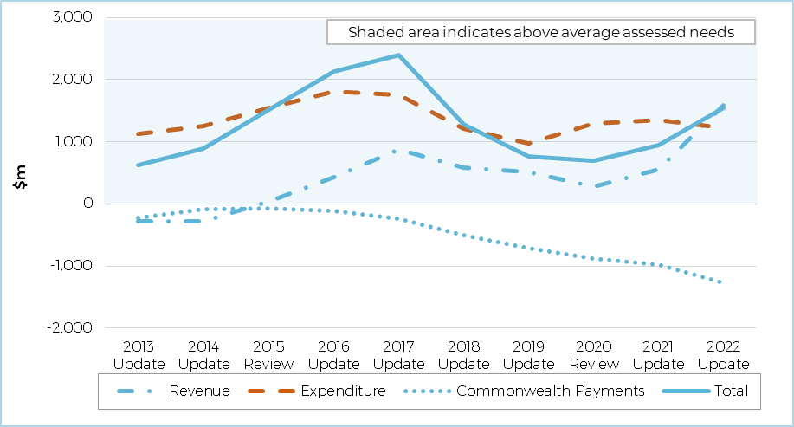

Note: Assessed GST is the GST that a state would require if it followed average policies and operated at average efficiency, taking into account its relative advantages and disadvantages in revenue collection and service provision. It does not take into account the changes introduced under the 2018 legislated arrangements.

Source: Commission calculation.

Queensland’s **revenue‑raising capacity** has fallen over the decade.

* Increases in Queensland’s GST needs up to the 2016 Update largely reflected the decline in its relative mining revenue capacity. This was a consequence of the rise in value of Western Australia’s iron ore production. From 2016 to 2020, the growing value of coal production in Queensland, and the decline in iron ore prices in 2018 and 2019, increased Queensland’s relative mining revenue capacity. Since 2020, strong growth in iron ore prices, and in turn Western Australia’s mining revenue, has again reduced Queensland’s relative mining revenue capacity.
* As Queensland’s property market has not kept pace with the increase in property values in New South Wales and Victoria since 2015, its relative capacity to raise land tax and stamp duty has fallen.

Queensland’s **expense and investment** **needs** have consistently been greater than average over the past decade.

* This is primarily due to large Indigenous and regional and remote populations, which have higher expenditure needs. The variation in Queensland’s expenditure needs over the past decade reflects fluctuations in its need for natural disaster relief; movements in relative wage costs; and changes in population growth, which affect its investment needs.

Ten years ago, Queensland’s **Commonwealth payments** were close to its population share. They have since risen to be above its population share as a result of greater Commonwealth funding for road and rail infrastructure, health and schools. A larger per person share of these payments generally means a state has relatively more funds available for state service delivery, resulting in a lower need for GST revenue.

## Western Australia

### Strong mining revenue capacity has resulted in Western Australia having GST needs that are much lower than average

The effect on Western Australia’s GST needs over the past decade from changes in revenue‑raising capacity, expense and investment needs, and Commonwealth payments is shown in Figure 4.

While Western Australia’s expenditure needs have been greater than average over the past decade, its strong revenue‑raising capacity has resulted in it having below-average GST needs (solid line). There have been some fluctuations, largely reflecting volatility in the value of iron ore production.

Figure 4 Western Australia’s GST needs relative to average

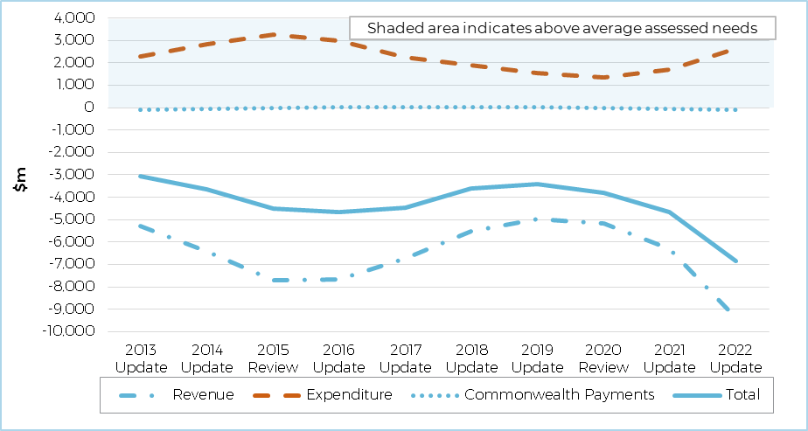

Note: Assessed GST is the GST that a state would require if it followed average policies and operated at average efficiency, taking into account its relative advantages and disadvantages in revenue collection and service provision. It does not take into account the changes introduced under the 2018 legislated arrangements.

Source: Commission calculation.

Western Australia’s below‑average GST needs are mainly explained by its exceptionally strong **revenue‑raising capacity**.

* An above‑average capacity to collect mining revenue, especially from iron ore, has had the largest influence on Western Australia’s GST needs over the decade. Prior to the 2016 Update, increases in the price and production of iron ore resulted in a significant increase in Western Australia’s mining revenue capacity, which in turn lowered its GST needs. Between 2017 and 2019, Western Australia’s GST needs rose due to the combined impact of the increase in the value of coal production in New South Wales and Queensland and lower iron ore prices. Strong growth in iron ore prices in recent years has again increased Western Australia’s relative mining revenue capacity, lowering its GST needs.
* Prior to the 2017 Update, Western Australia had an above‑average capacity to collect stamp duty from property sales. Between the 2016 and 2019 Updates, strong growth in the property markets in other states, compared with the property market in Western Australia, resulted in a significant fall in its relative capacity to raise stamp duty. Land values have followed a similar pattern since 2017, with a consequent decline in Western Australia’s relative ability to raise land tax.
* A relatively strong labour market, and associated ability to raise revenue from payroll tax, contributed to Western Australia’s below‑average GST needs in the first half of the decade. However, below‑average growth in the labour market relative to other states resulted in a decline in Western Australia’s relative capacity to raise payroll tax revenue from 2016 until 2020. Together, low growth in property and labour markets partially offset the effect of strong growth in mining revenue capacity.

Western Australia’s **expense and investment** **needs** have consistently been greater than average.

* Western Australia’s relatively dispersed population, greater proportion of Indigenous people and relatively high wage levels have resulted in its expenditure needs being higher than average over the past decade. Relatively low population growth rates lowered GST needs between 2015 and 2019. This changed in 2020, when relatively high population growth increased investment needs.

Western Australia’s share of **Commonwealth payments** has been close to its population share over the past decade. This means that these payments have had minimal impact on its GST needs.

## South Australia

### South Australia’s above‑average GST needs have been driven by its low revenue‑raising capacity

The effect on South Australia’s GST needs over the past decade from changes in revenue‑raising capacity, expense and investment needs, and Commonwealth payments is shown in Figure 5.

South Australia’s net GST needs (solid line) have remained greater than average. GST needs increased until 2019, before falling slightly.

Figure 5 South Australia’s GST needs relative to average

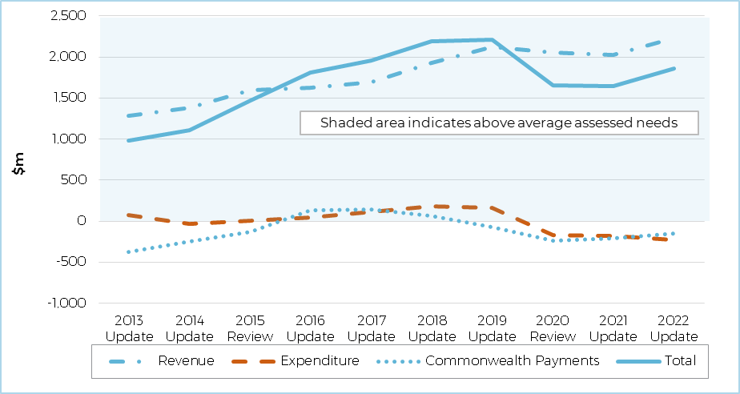

Note: Assessed GST is the GST that a state would require if it followed average policies and operated at average efficiency, taking into account its relative advantages and disadvantages in revenue collection and service provision. It does not take into account the changes introduced under the 2018 legislated arrangements.

Source: Commission calculation.

South Australia has had below‑average **revenue‑raising capacity** over the decade.

* This has been driven by below‑average mining capacity, relatively low land values and relatively low payrolls.
* Mining revenue in some other states has generally risen across the decade, particularly in Western Australia in response to strong growth in the value of iron ore production. This has meant that South Australia’s relative capacity to raise mining revenue has fallen, which has increased its GST needs.
* Until 2019, relatively low growth in the property market in South Australia (compared to New South Wales and Victoria) reduced its capacity to collect stamp duty, increasing its GST needs. In 2020 and 2021 a relative recovery in South Australia’s property market largely offset continuing relative falls in its mining and land tax revenue capacities. Below‑average growth in the value of Victoria’s property sales in the 2022 Update reduced the GST needs of other states, including South Australia.

South Australia’s **expense and investment** **needs** remained close to the average over the decade.

* South Australia has high service delivery costs associated with its relatively high levels of socio-economic disadvantage and older population. These high costs have been offset by low wage costs, and by slower population growth, which results in less need for investment.
* In the 2020 Review, the Commission expanded its urban transport assessments to capture needs associated with urban centre characteristics beyond urban population. Adelaide’s low population density reduced South Australia’s assessed transport investment needs, and hence its GST needs.

South Australia’s share of **Commonwealth payments** has fluctuated over the decade but has generally been above its population share. A larger per person share of these payments generally means a state has relatively more funds available for state service delivery, resulting in a lower need for GST revenue.

## Tasmania

### Tasmania’s above‑average GST needs reflect its low revenue‑raising capacity, as well as its high expenditure needs

The effect on Tasmania’s GST needs over the past decade from changes in revenue‑raising capacity, expense and investment needs, and Commonwealth payments is shown in Figure 6.

Tasmania’s net GST needs (solid line) have remained above the national average over the past decade. They were stable between 2015 and 2019, but then rose sharply.

Figure 6 Tasmania’s GST needs relative to average

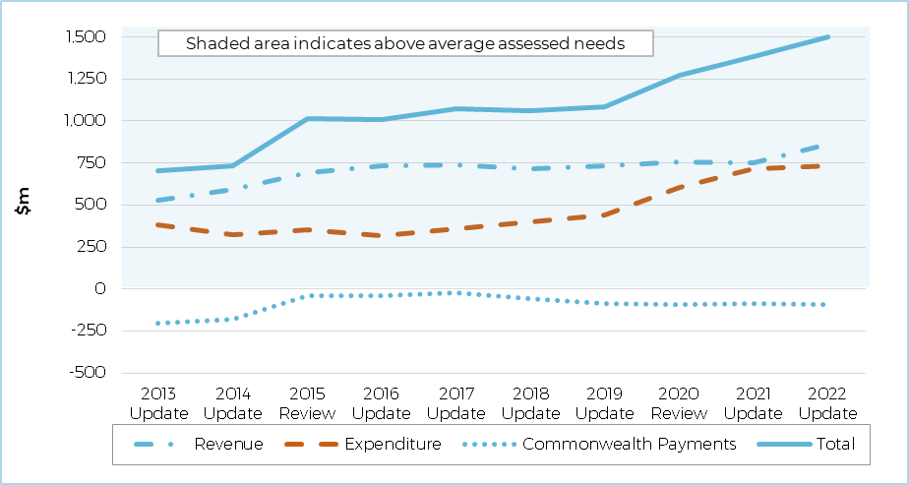

Note: Assessed GST is the GST that a state would require if it followed average policies and operated at average efficiency, taking into account its relative advantages and disadvantages in revenue collection and service provision. It does not take into account the changes introduced under the 2018 legislated arrangements.

Source: Commission calculation.

Tasmania has consistently had the lowest **revenue‑raising capacity** of any state.

* Tasmania has a below‑average capacity to raise mining revenue. Lower land values and payrolls have also reduced its revenue‑raising capacity.
* Over the decade, its mining and land tax capacities have fallen further behind the national average, increasing the need for GST.
* Tasmania’s slow property market growth, compared with New South Wales and Victoria, reduced its relative capacity to collect revenue from stamp duty on property sales, raising GST needs sharply between 2014 and 2018. Tasmania’s relative capacity to raise stamp duty rose from 2019, as property market growth in New South Wales and Victoria slowed. However, the decline in Victoria’s relative property sales in 2020 and 2021 reduced the relative GST needs of other states, including Tasmania.

Tasmania’s **expense and investment** **needs** have remained higher than average over the decade, rising between 2019 and 2021.

* Tasmania’s relatively high proportion of residents living in regional or remote areas[4] has been the main reason for its above‑average expense and investment needs. The minimum costs of running government also represent a high per person expense in Tasmania, increasing its need for GST. These are partially offset by low wages and low costs of delivering urban transport.
* The main reason why Tasmania’s relative expenditure needs have risen is higher growth in national spending on regional services since the 2020 Review. This has raised the GST needs of states with relatively dispersed populations.

Although Tasmania initially had an above‑average share of **Commonwealth payments**, since 2015 its share has been close to its population share. This has meant that these payments have had minimal impact on its GST needs in the second half of the decade.

## Australian Capital Territory

### The ACT’s GST needs have been greater than average and relatively stable

The effect on the ACT’s GST needs over the past decade from changes in revenue‑raising capacity, expense and investment needs, and Commonwealth payments is shown in Figure 7.

The ACT’s GST needs (solid line) have been greater than average over the past decade. Falls in both its revenue capacity and expense needs have offset each other, resulting in its net GST needs remaining broadly stable.

Figure 7 Australian Capital Territory’s GST needs relative to average

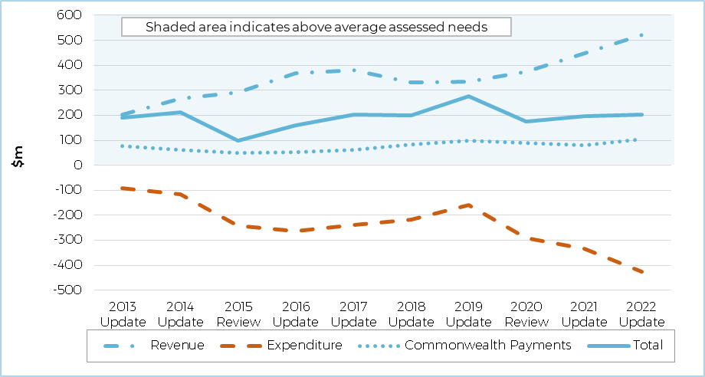

Note: Assessed GST is the GST that a state would require if it followed average policies and operated at average efficiency, taking into account its relative advantages and disadvantages in revenue collection and service provision. It does not take into account the changes introduced under the 2018 legislated arrangements.

Source: Commission calculation.

The ACT has had below‑average, and generally falling, **revenue‑raising capacity** over the decade.

* The ACT has well below-average capacity to raise revenue for two main reasons. First, with no mining industry, the ACT receives GST equivalent to the size of the national average mining revenue, which has grown across the decade except for a slight decline from 2015 to 2018. Second, the Australian Constitution prevents the ACT from taxing the Australian government, a major land holder and employer in the territory. This means that the ACT’s land tax and payroll tax capacities are much lower than average.
* The ACT’s relative capacity to raise stamp duty fell until the 2017 Update, mainly as a result of strong growth in the New South Wales and Victorian property markets. The ACT’s relative capacity to raise stamp duty has generally risen since the 2017 Update due to above‑average growth in the value of property sales. By 2022, the ACT had slightly above‑average capacity in stamp duty on conveyances: the only state revenue stream where this was the case.

The ACT’s **expense and investment needs** have remained lower than average, and have been declining since the 2019 Update.

* The ACT has no population in regional or remote areas, a smaller than average indigenous population, and a smaller than average disadvantaged population. It also has lower than average costs for urban transport. However, it has persistently high wage costs and high administrative scale needs.
* As the ACT has less population dispersion than other states, higher national spending on providing services in regional areas since the 2020 Review has reduced its expenditure needs.

The ACT’s share of **Commonwealth payments** has been smaller than its population share over the decade. A smaller per person share of these payments generally means a state has relatively fewer funds available for state service delivery, resulting in a greater need for GST revenue.

## Northern Territory

### The Northern Territory’s above‑average GST needs reflect its very high expense and investment needs

The effect on the Northern Territory’s GST needs over the past decade from changes in revenue‑raising capacity, expense and investment needs, and Commonwealth payments is shown in Figure 8.

The Northern Territory’s GST needs (solid line) have been far above the Australian average. This reflects the high cost of providing services. Its revenue capacity has been around the average of all states.

Figure 8 Northern Territory’s GST needs relative to average

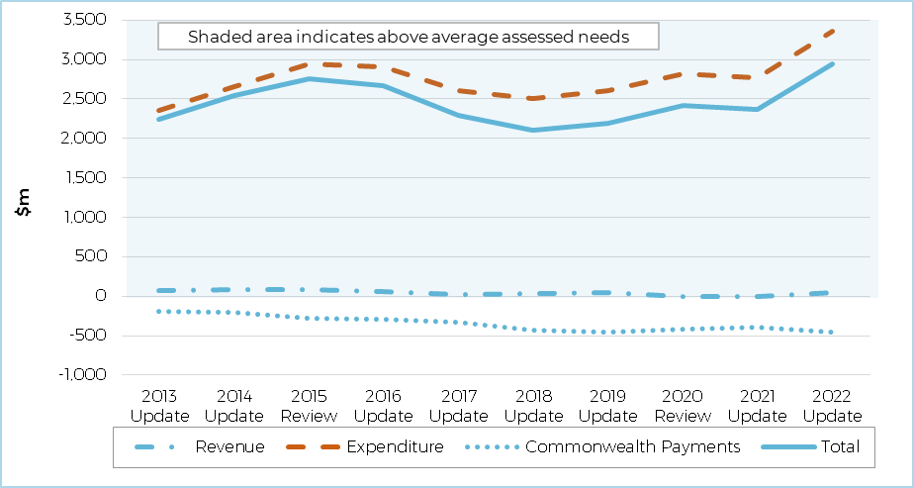

Note: Assessed GST is the GST that a state would require if it followed average policies and operated at average efficiency, taking into account its relative advantages and disadvantages in revenue collection and service provision. It does not take into account the changes introduced under the 2018 legislated arrangements.

Source: Commission calculation.

The Northern Territory has had average **revenue‑raising capacity** over the decade. Developments that lowered its revenue‑raising capacity in some areas have been offset by others that increased it.

* The Northern Territory has generally had the second strongest mining revenue capacity per person, after Western Australia. Across the decade, the Northern Territory’s value of mining production has grown, reducing its GST needs. In recent years, growth in the value of Western Australian iron ore production has been broadly mirrored by similar proportional growth in the value of the Northern Territory’s mining production. While mining has had a variable effect on the GST needs of most states, the effect on the Northern Territory has been relatively stable since around 2017.
* The Northern Territory’s relative capacity to raise stamp duty and payroll tax have broadly offset each other. Its stamp duty capacity fell in the years to 2018, reflecting strong growth in property values in Victoria and New South Wales, before rising again. Its payroll tax base had the opposite pattern.

Changes in the Northern Territory’s GST needs mainly reflect changes in its **expense and investment needs**. These have fluctuated over the decade but have always been greater than average.

* The Northern Territory’s large Indigenous and remote populations are the main reasons for its high cost of service delivery.
* Fluctuations in expense and investment needs over the decade reflect whether national spending on populations in remote areas and Indigenous people has grown faster or more slowly than spending on other groups. This in turn affected the GST needs of states with large Indigenous populations.
* The Northern Territory’s population growth has slowed. Early in the decade, it experienced around the national average growth, but this slowed later in the decade and fell from 2018. Low population growth rates compared to other states reduced the Northern Territory’s relative need for investment.

The Northern Territory’s share of **Commonwealth payments** has consistently been larger than its population share over the decade. A larger per person share of these payments generally means a state has relatively more funds available for state service delivery, resulting in a lower need for GST revenue.

# Conclusion

States’ economic, social and demographic characteristics affect their abilities to raise revenue and their costs of providing services. The Commission takes into account *relative* revenue‑raising capacity, expense and investment needs, and share of Commonwealth payments when assessing the GST needs of each state. As a result, changes in one state’s GST needs may be due to its own circumstances, or to changing circumstances in other states.

States’ overall GST needs have fluctuated over the past decade. However, whether a state has a greater or lesser need for GST than its population share has generally remained consistent. The exception is New South Wales, which had below‑average GST needs until the 2022 Update, when its GST needs were above its population share. This is shown in Figure 9, noting that GST needs are shown in nominal dollars.

Figure 9 All state GST needs relative to average

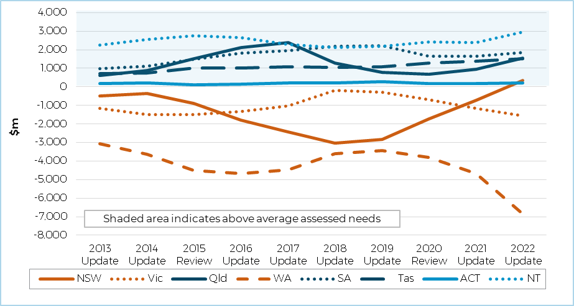

Note: Assessed GST is the GST that a state would require if it followed average policies and operated at average efficiency, taking into account its relative advantages and disadvantages in revenue collection and service provision. It does not take into account the changes introduced under the 2018 legislated arrangements.

Source: Commission calculation.

Over the decade, Western Australia has maintained the smallest per person need for GST revenue. Although it has high expenditure needs, Western Australia has very strong revenue‑raising capacity. Victoria and, until recently New South Wales, have also generally had lower GST needs than average.

The other states have needed more GST revenue than average. For South Australia and the ACT, this is driven by low revenue‑raising capacity. In the Northern Territory, it is driven by high expenditure needs. Queensland and Tasmania have low revenue‑raising capacity as well as high expenditure needs.

Revenue‑raising capacity for all states has been volatile over the decade, mainly due to shifts in their relative mining revenue capacities. Changes in property and labour markets affected states’ capacities to raise stamp duty, land tax and payroll tax.

Fluctuating relative population growth rates, along with changing spending on Indigenous populations and regional services, have been major drivers of changing expense and investment needs. Natural disasters also caused fluctuations in relative GST needs between states in the middle of the decade.

1. Changes in GST needs are presented in nominal terms throughout the paper.
2. The Commission has published an Occasional paper on [*New arrangements for distributing GST*](https://www.cgc.gov.au/publications/occasional-paper-4-new-arrangements-distributing-gst), which describes the new approach in more detail (<https://www.cgc.gov.au/publications/occasional-paper-4-new-arrangements-distributing-gst>).
3. The Commission will release a Research Paper and Occasional Paper outlining the treatment of Commonwealth Payments. These papers will be available at www.cgc.gov.au
4. Under the Accessibility/Remoteness Index of Australia (ARIA) all of Tasmania is classified as being in a regional or remote area, including the cities of Hobart and Launceston.