**2025 Methodology Review**

Commonwealth payments

consultation paper

June 2023

|  |  |
| --- | --- |
| Paper issued | 27 June 2023 |
| Commission contact officer | Naomi Elliott, 02 62185725, Naomi.Elliott@cgc.gov.au |
| Submissions sought by | 13 October 2023  Submissions should be placed in your private state channel in CGC Engagement Teams, with a post notifying Katrina Baldock.  Submissions should be in Word format and posted in the relevant state channel of the CGC engagement Team. Submissions more than 10 pages in length should include a summary section. |
| Confidential material | It is the Commission’s normal practice to make state submissions available on its website under the CC BY licence, allowing free use of content by third parties.  Creative Commons - CC BY Attribution  Further information on the CC BY licence can be found on the Creative Commons website (http://creativecommons.org).  Confidential material contained in submissions must be clearly identified or included in separate attachment/s, and details provided in the covering email. Identified confidential material will not be published on the Commission’s website. |

Contents

Overview of category 4

Current assessment method — 2020 Review 4

Data used in the assessment 5

Category revenue 6

GST distribution in the 2023 Update 7

What has changed since the 2020 Review? 7

Payments addressing structural disadvantage 7

Implications for assessment 8

Applying the treatment guideline 8

Commonwealth own-purpose expense payments 9

Treatment of Commonwealth payments for pre-existing structural disadvantage 10

Proposed assessment 11

Differences from the 2020 Review approach 11

Proposed assessment structure 11

Consultation 12

## Overview of category

In addition to GST payments, the Commonwealth government provides financial assistance to states and territories (states) in the form of payments for specific purposes. These payments, in total, are similar in size to the GST payments.

Given their importance to state budgets, these Commonwealth payments are taken into account by the Commission when determining each state’s relative fiscal capacity and recommended GST share. If they were excluded, state fiscal capacities would not be similar and states that receive less revenue from Commonwealth payments would be disadvantaged.

Not all Commonwealth payments to states are included in the calculations of assessed needs. Some payments are excluded as they are for Commonwealth or third-party purposes because the Commission does not assess states’ expenditure needs relevant to the payment, or because terms of reference from the Commonwealth Treasurer instruct that they be excluded. In any one year, approximately a fifth of the value of payments are excluded from the GST calculations. This increased to a third in 2021–22 (largely due to COVID-19 related health and business support payments, and natural disaster relief payments).

## Current assessment method — 2020 Review

Commonwealth payments are assessed on an actual per capita basis. That is, each state’s revenue capacity is equal to the value of payments it received.

Not all payments are included in the assessment. In some cases, the Commonwealth Treasurer instructs the Commission through terms of reference to exclude payments from its calculations (known as ‘quarantining’).

The 2020 Review Terms of Reference (which are the same for the 2025 Review) provide more guidance to the Commission on the treatment of Commonwealth payments. They asked the Commission to treat:

* National Specific Purpose Payments, National Health Reform funding, National Housing and Homelessness funding, Quality Schools funding (for government schools) and National Partnership project payments so that they affect the GST relativities
* National Partnership facilitation and reward payments[1] so that they do not affect the GST relativities
* general revenue assistance other than the GST so that they affect the GST relativities.

However, terms of reference also give the Commission discretion to vary the treatment of payments where appropriate, reflecting the nature of the particular payment and the role of state governments in providing particular services.

In exercising its discretion, the Commission uses the following guideline to decide the treatment of payments on a case-by-case basis:

payments which support state services, and for which expenditure needs are assessed, will impact the relativities.

In considering whether needs are assessed for the activity which the payment funds, the Commission considers the main purpose of the payment. In the 2020 Review, the Commission said where the purpose of the payment ‘broadly aligns with the Commission’s expense assessments, the Commission would consider ‘needs are assessed’ for the payment.’

Figure 1 Guideline for the treatment of Commonwealth payments

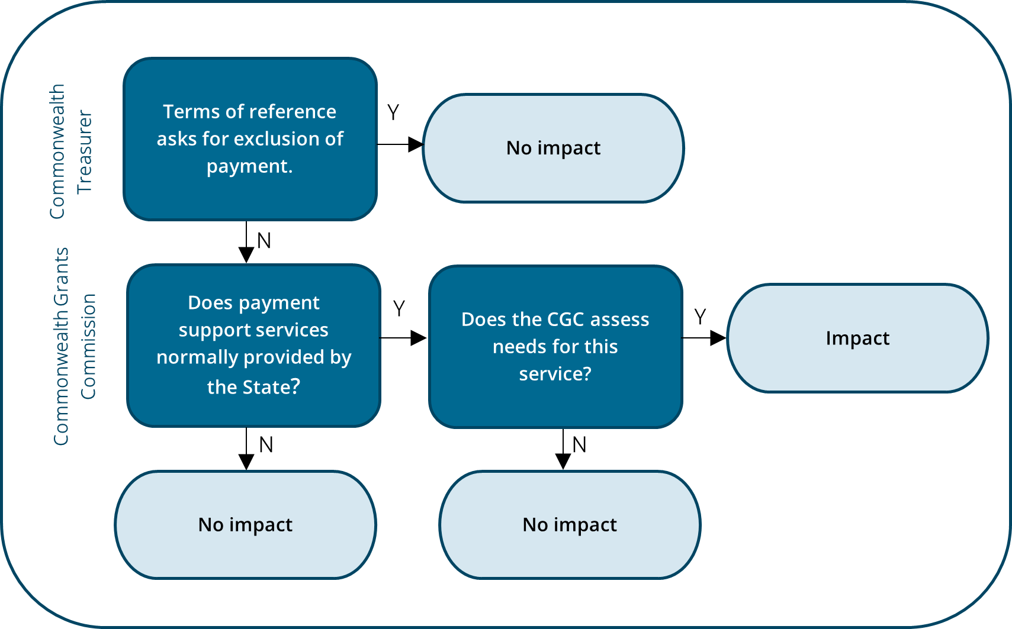

Source: The Commission.

### Data used in the assessment

Data on total revenue received by each state from Commonwealth payments are sourced from the Australian Bureau of Statistics’ Government Finance Statistics and, for the last assessment year, from state revenue offices.[2]

Data on the value of individual payments are sourced each year from the Commonwealth *Final Budget Outcome*, supplemented by data from the National Indigenous Australians Agency and Department of Health for a limited number of Commonwealth own-purpose expenses.[3]

Data from the Department of Infrastructure, Transport, Regional Development and Communications and the Arts are used to split certain infrastructure payments, where a different treatment is applied to different parts of these payments.

### Category revenue

In 2021–22, states received different per capita amounts of the Commonwealth payments that affect the relativities (Table 1).

Table 1 Total Commonwealth payments affecting the relativities, 2021–22

|  |  |  |  |  |  |  |  |  |  |
| --- | --- | --- | --- | --- | --- | --- | --- | --- | --- |
|  | NSW | Vic | Qld | WA | SA | Tas | ACT | NT | Total |
| Total payments ($m) | 13,485 | 9,906 | 10,230 | 5,168 | 3,112 | 1,041 | 671 | 873 | 44,487 |
| Total payments ($pc) | 1,666 | 1,510 | 1,943 | 1,871 | 1,723 | 1,827 | 1,480 | 3,502 | 1,727 |

Source: Commission calculation.

Table 2 shows the breakdown of total Commonwealth contribution to states and the value of payments assessed.

Table 2 Total Commonwealth contribution to states

|  |  |  |  |  |
| --- | --- | --- | --- | --- |
|  | **2018–19** | **2019–20** | **2020–21** | **2021–22** |
| Total Commonwealth contribution to states ($m) | 117,526 | 112,022 | 127,382 | 149,493 |
| Proportion of Commonwealth contribution (%) |  |  |  |  |
| GST | 55.4 | 53.8 | 57.4 | 49.6 |
| Payments impacting the GST relativities | 31.5 | 33.9 | 32.8 | 29.8 |
| Payments that do not impact the GST relativities | 8.1 | 9.7 | 9.5 | 17.3 |
| Payments assessed equal per capita | 4.1 | 1.9 | 0.0 | 2.6 |
| Commonwealth payments treated as own-source revenue | 0.8 | 0.6 | 0.3 | 0.7 |
| Total assessed payments ($m) | 46,563 | 48,920 | 53,921 | 70,363 |
| Proportion of assessed payments (%) |  |  |  |  |
| Payments impacting the GST relativities | 79.5 | 77.7 | 77.5 | 63.2 |
| Payments that do not impact the GST relativities | 20.5 | 22.3 | 22.5 | 36.8 |

Note: Payments assessed equal per capita include out of scope payments and a balancing item which is the difference between *Final Budget Outcome* and Government Finance Statistics state budget data sources. The balancing item can be negative in some years.

Payments treated as own-source revenue are grants in lieu of royalties. This revenue is assessed as part of the mining assessment. In 2018–19 payments also included revenue from the Federal Interstate Registration Scheme. This scheme was subsequently closed.

The increase in proportion of no impact payments in 2021–22 was largely due to COVID-19 related health and business support, and natural disaster relief payments.

Source: Commission calculation.

### GST distribution in the 2023 Update

Table 3 shows the extent to which the assessment moves GST payments away from an equal per capita distribution. In 2023–24, Commonwealth payments distributed $2,108 million ($80 per capita) away from an equal per capita assessment. More GST was directed to states that received below-average per capita Commonwealth payments treated as ‘impact’.

Table 3 GST impact of assessed Commonwealth payments, 2023–24

|  |  |  |  |  |  |  |  |  |  |
| --- | --- | --- | --- | --- | --- | --- | --- | --- | --- |
|  | NSW | Vic | Qld | WA | SA | Tas | ACT | NT | Total Effect |
|  | $m | $m | $m | $m | $m | $m | $m | $m | $m |
| Total ($m) | 606 | 1,273 | -1,343 | -177 | 80 | -54 | 148 | -533 | 2,108 |
| Total ($pc) | 73 | 188 | -247 | -62 | 43 | -92 | 315 | -2,053 | 80 |

Note: These GST impacts reflect the difference between a state’s population share of Commonwealth payments and its actual share. The Commission’s assessment of the expenses funded by the payments also give rise to GST impacts which are included in the relevant expense category. For more information see [Research Paper #5 The framework for the treatment of Commonwealth payments in GST distribution](https://www.cgc.gov.au/publications/research-paper-5-framework-treatment-commonwealth-payments-gst-distribution).

Source: Commission calculation.

Further detail on the scope of payments and the underlying conceptual case for inclusion of payments are explained in volume 2, chapter 5, [Report on GST Revenue Sharing Relativities, 2020 Review.](https://www.cgc.gov.au/reports-for-government/2020-review)

## What has changed since the 2020 Review?

The Commission has used its current guideline for deciding the treatment of Commonwealth payments since the 2015 Review.

Experience suggests that, while the guideline works well for most payments, for a minority of payments making decisions on the appropriate treatment can be difficult and contentious. The difficulties arise for the following reasons.

* There can be considerable overlap between state and Commonwealth spending. This can make it challenging to determine whether the payment is for a state-type service or a Commonwealth purpose.
* It can be difficult to determine whether the broad drivers assessed in an expense assessment cover the often-narrow focus of a payment and therefore, whether relevant state spending needs are assessed.
* A payment may support multiple state services that imply different treatments. It can be challenging to determine which service the payment mostly relates to.

### Payments addressing structural disadvantage

In its submission on [*Consultation paper on* f*iscal equalisation, supporting principles and assessment guidelines*](https://www.cgc.gov.au/reports-for-government/2025-methodology-review/consultation)for the 2025 Review, the Northern Territory raised the issue of Commonwealth payments that address pre-existing structural disadvantage. It said that multiple funding agreements will be reviewed during the 2025 Review period including the National Health Reform Agreement, National School Reform Agreement and National Housing and Homelessness Agreement.

The Northern Territory said such agreements increasingly include elements of funding aimed at addressing pre-existing structural disadvantage, especially entrenched disadvantage for First Nations peoples. The Northern Territory said it was important that the GST treatment of Commonwealth payments does not impede the objectives of such funding.

## Implications for assessment

The Commission’s preliminary view is that there have been no new developments that warrant fundamentally changing the guideline for determining the treatment of Commonwealth payments. Further, adopting a more detailed guideline is unlikely to help resolve issues where there is significant uncertainty as to the purpose of the payment or whether relevant state spending needs have been assessed.

The Commission proposes, however, some additional guidance in cases of significant uncertainty and simplifying the assessment by removing Commonwealth own‑purpose expenses from the scope of payments it considers.

### Applying the treatment guideline

While the application of the guideline operates appropriately in the majority of cases, there is potential to improve the clarity and consistency of treatment for payments where there is substantial uncertainty about the purpose of the payment or whether relevant expenditure needs are assessed. In these limited cases, the Commission’s preliminary view is that it could adopt an ‘impact’ treatment by default. It would remain open to states to make the conceptual case and provide evidence to support ‘no impact’ treatment. Moreover, the states are likely to be in a better position than the Commission to provide information on the use of the payment.[4]

#### Consultation questions

1. Do states agree the guideline for deciding the treatment of Commonwealth payments remains appropriate?
2. Do states agree to a default treatment of ‘impact’ in cases where there is substantial uncertainty about the payment’s purpose or whether relative state expenditure needs are assessed? It remains open to states to provide evidence in support of no impact.

### Commonwealth own-purpose expense payments

There is potential to simplify the assessment by removing Commonwealth own-purpose expense payments from the scope of Commonwealth payments the Commission considers.

In the 2020 Review, the Commission said, conceptually, it should consider all Commonwealth payments, including Commonwealth own-purpose expense payments, that support state services for which needs were assessed. However, the absence of a reliable and comprehensive list of these payments has meant the Commission is only able to include those payments brought to its attention by states or the Commonwealth. Most states have been unable to provide detailed information on the revenue received from Commonwealth own-purpose expense payments.[5]

Commonwealth own-purpose expense payments are payments by the Australian Government in the conduct of its own general government sector activities. Most are, by definition, likely to relate to Commonwealth functions, but some can be for state-type services. The Commonwealth own-purpose expense payments that currently affect the relativities include a ‘rural and other health’ grant made by the Department of Health ($79 million in 2021–22), and multiple small Commonwealth own-purpose expenses for First Nations programs managed by the National Indigenous Australians Agency (totalling $18 million in 2021–22). The total value of these payments has declined over the past 10 years, halving since the 2020 Review. They represented about 0.1% of total Commonwealth payments treated as ‘impact’ in 2020–21.

While the Commission does not apply a materiality threshold to Commonwealth payments, only the rural and other health grants would be material at the Commission’s $40 per capita expense driver threshold (Table 4).[6]

Given the small size of most Commonwealth own-purpose expense payments, the difficulty in comprehensively identifying all such payments, and that most of these payments should be for Commonwealth purposes, the Commission’s preliminary view is to cease including Commonwealth own-purpose expenses in the assessment.

Table 4 Difference from an equal per capita distribution, Commonwealth own-purpose expenses, 2021–22

|  |  |  |  |  |  |  |  |  |  |
| --- | --- | --- | --- | --- | --- | --- | --- | --- | --- |
|  | NSW | Vic | Qld | WA | SA | Tas | ACT | NT | Total |
|  | $pc | $pc | $pc | $pc | $pc | $pc | $pc | $pc | $pc |
| Rural and other health grants | 2.4 | 3.3 | 2.4 | -0.5 | -0.1 | 0.6 | -3.3 | -204.6 | 2.1 |
| Grants for Indigenous purposes to schools education | 0.6 | 0.6 | -0.2 | 0.4 | -0.5 | 0.6 | 0.6 | -33.8 | 0.4 |
| Grants for Indigenous purposes to post-secondary education | -0.1 | 0.0 | 0.0 | 0.0 | 0.0 | 0.0 | 0.0 | -0.7 | 0.0 |
| Grants for Indigenous purposes to other expenses | 0.0 | 0.0 | 0.0 | 0.0 | 0.0 | 0.0 | 0.0 | -0.8 | 0.0 |
| Improving policing in very remote areas | 0.1 | 0.1 | 0.1 | 0.1 | -1.2 | 0.1 | 0.1 | -1.4 | 0.1 |

Note: Multiple small Commonwealth own-purpose expenses have been combined under each Indigenous purposes item.

Source: Commission calculation.

#### Consultation question

1. Do states agree to discontinue the assessment of Commonwealth own-purpose expense payments?

### Treatment of Commonwealth payments for pre-existing structural disadvantage

The Northern Territory raised the issue of the treatment of Commonwealth payments that address pre-existing structural disadvantage in its submission on *Fiscal equalisation, supporting principles and assessment guidelines for the 2025 Review*. The Commission notes that several states face issues relating to pre-existing structural disadvantage.

In seeking to equalise, as far as possible, the fiscal capacities of the states, the Commission takes into account Commonwealth payments to the states. As noted previously, the Commission’s guideline for deciding on the treatment of Commonwealth payments provides that if payments are for a state service and expenditure needs are assessed, then the payment will impact GST relativities. Each payment decision is made by the Commission on a case-by-case basis. If there are overriding policy objectives that should exclude a payment from impacting on the relativities the Commission relies on the Commonwealth Treasurer quarantining these payments through the terms of reference for each annual update of the GST relativities.

The Commission’s preliminary view is that it should apply the existing guideline for deciding on the GST treatment of payments to all Commonwealth payments, including those that might contain elements addressing pre-existing structural disadvantage. The Commission is not well-placed to determine if, and to what extent, a Commonwealth payment is aimed at addressing structural disadvantage. This issue is more appropriately addressed in the terms of reference provided by the Commonwealth Treasurer, which can specify whether a payment should be excluded from the Commission’s assessments.

#### Consultation question

1. Do states agree that the guideline for determining the GST treatment of Commonwealth payments should be applied in cases where payments include elements aimed at addressing pre-existing structural disadvantage?

## Proposed assessment

### Differences from the 2020 Review approach

Subject to state views, the Commission’s preliminary view is to retain the 2020 Review treatment guideline for Commonwealth payments with a default ‘impact’ treatment for payments where there is substantial uncertainty about the purpose of the payment or whether relevant state spending needs are assessed. The Commission proposes to remove Commonwealth own-purpose expenses from the scope of payments it considers.

### Proposed assessment structure

Table 5 shows the proposed structure of the Commonwealth payments assessment.

Table 5 Proposed assessment structure for Commonwealth payments

|  |  |  |  |  |  |  |  |
| --- | --- | --- | --- | --- | --- | --- | --- |
| Component |  | Driver | Influence measured by driver |  |  | Change since 2020 Review? |  |
|  |  |  |  |  |  |  |  |
| Impact payments |  | Actual payments per capita | Recognises that states which receive above-average per capita Commonwealth payments have greater fiscal capacity. |  |  | No |  |

Source: The Commission.

## Consultation

The Commission welcomes state views on the consultation questions identified in this paper (outlined below) and the proposed assessment. State submissions should accord with the 2025 Review framework. States are welcome to raise other relevant issues with the Commission.

1. Do states agree the guideline for deciding the treatment of Commonwealth payments remains appropriate?
2. Do states agree to a default treatment of ‘impact’ in cases where there is substantial uncertainty about the payment’s purpose or whether relative state expenditure needs are assessed? It remains open to states to provide evidence in support of no impact.
3. Do states agree to discontinue the assessment of Commonwealth own-purpose expense payments?
4. Do states agree that the guideline for determining the GST treatment of Commonwealth payments should be applied in cases where payments include elements aimed at addressing pre-existing structural disadvantage?

1. Facilitation and reward National Partnership Payments have not been separately identified in Commonwealth Budgets since 2014–15.
2. Unless otherwise stated, category and component revenue for the first 2 assessment years are sourced from Government Finance Statistics. States provide data for the most recent assessment year because data from the Australian Bureau of Statistics’ Government Finance Statistics collection are not available.
3. The Commission includes some Commonwealth own-purpose expenses that are for state-type services.
4. Payments quarantined by terms of reference would continue to be treated as ‘no impact’.
5. Australian Bureau of Statistics’ Government Finance Statistics does not have a function of government classification code for revenue from Commonwealth grants.
6. Commonwealth Grants Commission, Fiscal equalisation, supporting principles and assessment guidelines consultation paper, April 2023.