**2025 Methodology Review**

Health consultation paper

June 2023

|  |  |
| --- | --- |
| Paper issued | 27 June 2023 |
| Commission contact officer | Annie Abello, 02 6218 5713, Annie.Abello@cgc.gov.au |
| Submissions sought by | 13 October 2023  Submissions should be placed in your private state channel in CGC Engagement Teams, with a post notifying Katrina Baldock.  Submissions should be in Word format and posted in the relevant state channel of the CGC engagement Team. Submissions more than 10 pages in length should include a summary section. |
| Confidential material | It is the Commission’s normal practice to make state submissions available on its website under the CC BY licence, allowing free use of content by third parties.  Creative Commons - CC BY Attribution  Further information on the CC BY licence can be found on the Creative Commons website (http://creativecommons.org).  Confidential material contained in submissions must be clearly identified or included in separate attachment/s, and details provided in the covering email. Identified confidential material will not be published on the Commission’s website. |

Contents

Overview of category 4

Current assessment method – 2020 Review 4

Data used in the assessment 4

Category and component expenses 5

GST distribution in the 2023 Update 7

What has changed since the 2020 Review? 7

There was a COVID-19 pandemic 7

Improved activity data on community mental health services are available 8

An alternative data source is needed to estimate substitutability between emergency departments and non‑state health services 8

Implications for assessment 8

Is there new evidence from the COVID-19 experience that supports changes to the assessment methodology? 8

Can the measure of service use and cost by socio-demographic group in the community and public health assessment be improved? 10

Should an alternative data source be used to update the substitutability level for emergency department services? 17

Proposed assessment 20

Differences from the 2020 Review approach 20

Proposed assessment structure 21

New data requirements 22

Consultation 22

**Attachment A:** Updating non-state sector substitutability levels 23

**Attachment B:** Community health: Additional analysis of direct activity measure 27

**Attachment C:** Alternative proxy indicator of community health activity based on a broader measure of hospital services 29

**Attachment D:** Draft data request: State data on non-hospital patient transport expenses 31

## Overview of category

The health assessment covers state and territory (state) expenditure on public hospitals and community and public health services. The health services include:

* admitted patient services – medical care for public patients admitted in public or private hospitals and land ambulance services
* outpatient services – emergency department and non-admitted patient services (the latter includes non-emergency obstetrics, gynaecology, cardiology, pathology, and radiology and imaging services)
* community and public health services – health services provided in a community setting, public health services, and research and development

Community health centre services – a wide range of services such as nursing and dental services, baby clinics, mental health services, family planning, and alcohol and drug rehabilitation

Public health services – activities for the protection and promotion of health and the prevention of disease, illness or injury. These include organised immunisation, health promotion, screening programs, communicable disease control, and prevention of hazardous and harmful drug use.

* non-hospital patient transport – aero-medical ambulance services and the reimbursement of costs through Patient Assisted Travel Schemes.

## Current assessment method – 2020 Review

In assessing state spending, the method recognises:

* the use and cost of providing public hospital and community health services varies by population group, so that states with concentrations of high use and high-cost groups (older people, First Nations peoples and low socio-economic status) need to spend more than the average
* the geographic dispersion of state populations, with states facing higher costs if they have greater concentrations of people in remote areas, where the costs of delivering health services are higher, people are more reliant on state-provided services and patient transport costs are higher
* the degree to which non-state health services, such as general practitioners, specialists, other private health professionals and Commonwealth-funded Aboriginal Community Controlled Health Services, affect state spending.

The assessment also recognises differences in wage costs between states.

### Data used in the assessment

This assessment uses patient data on national weighted activity units from the Independent Health and Aged Care Pricing Authority for the socio-demographic composition assessment for all hospital components and community health. The national weighted activity unit is a measure of hospital activity that incorporates both usage and cost disaggregated by population characteristics.

The non-state sector assessments use data on Medicare benefits from Services Australia, data on grants to Aboriginal Community Controlled Health Services from the Australian Institute of Health and Welfare, and data on private patient hospital activity from the Australian Institute of Health and Welfare and the Australian Prudential Regulation Authority. Data on service use by residents of a different state (cross-border data) are sourced from the National Health Funding Body.

Health expense data, classified on a Government Finance Statistics basis, are sourced from the Australian Bureau of Statistics for the first 2 assessment years and states for the third assessment year.

Some data used in the health assessment are only updated every 5 years on the assumption that the nature of service provision is stable over time. This includes:

* data used to estimate non-state sector substitutability levels (updates to these data for the 2025 Review are discussed in Attachment A)
* data used to estimate the split between hospital and non-hospital (aero-medical transport and Patient Assistance Travel Schemes) patient transport expenses.

### Category and component expenses

Table 1 shows total state spending on health services, net of user charges (mainly private patient hospital fees). The assessment represents approximately 30% of total state expenditure.

Table Health expenditure, 2018–19 to 2021–22

|  |  |  |  |  |
| --- | --- | --- | --- | --- |
|  | **2018-19** | **2019-20** | **2020-21** | **2021-22** |
| Total expenditure ($m) | 68,788 | 71,703 | 77,496 | 86,830 |
| Proportion of state expenditure (%) | 28.8 | 31.5 | 30.6 | 30.2 |

Source: Commission calculation, 2023 Update.

Table 2 shows total health expenses by state.

Table Health expenditure by state, 2021–22

|  |  |  |  |  |  |  |  |  |  |
| --- | --- | --- | --- | --- | --- | --- | --- | --- | --- |
|  | **NSW** | **Vic** | **Qld** | **WA** | **SA** | **Tas** | **ACT** | **NT** | **Total** |
| Total expenditure ($m) | 24,150 | 22,684 | 18,434 | 9,884 | 5,967 | 2,296 | 1,741 | 1,673 | 86,830 |
| Proportion of state expenditure (%) | 28.2 | 34.0 | 30.9 | 26.2 | 30.8 | 35.1 | 30.5 | 27.1 | 30.2 |

Source: Commission calculation, 2023 Update.

The health category is currently assessed in 5 components. Table 3 shows the size of each component and the factors recognised as influencing state spending for each component.

Table Structure of the health assessment, 2021–22

|  |  |  |  |  |
| --- | --- | --- | --- | --- |
| **Component** | **Component expense** |  | **Driver** | **Influence measured by driver** |
|  | $m |  |  |  |
| Admitted patients | 60,571 (70%) |  | Socio-demographic composition | Recognises that service use and cost vary by age, socio-economic status, remoteness, and Indigenous status. |
|  |  |  | Non-state sector | Recognises that non-state funded health services such as private health insurance funded hospital services affect state health spending. |
|  |  |  | Wage costs | Recognises that differences in wage costs between states affect state health spending. |
| Emergency departments | 6,184 (7%) |  | Socio-demographic composition | Recognises that the use and cost of services vary by age, socio-economic status, remoteness, and Indigenous status. |
|  |  |  | Non-state sector | Recognises that non-state health services, such as general practitioners (GPs), affect state health spending. |
|  |  |  | Wage costs | Recognises that differences in wage costs between states affect state health spending. |
| Non-admitted patients | 8,316 (10%) |  | Socio-demographic composition | Recognises that the use and cost of services varies by age, socio-economic status, remoteness, and Indigenous status. |
|  |  |  | Non-state sector | Recognises that non-state health services, such as specialists and private health professionals affect state health spending. |
|  |  |  | Wage costs | Recognises that differences in wage costs between states affect state health spending. |
| Community and public health | 10,900 (13%) |  | Socio-demographic composition  (12.5% discount) | Recognises that the use and cost of services varies by age, socio-economic status, remoteness, and Indigenous status. |
|  |  |  | Non-state sector | Recognises that non-state health services, such as general practitioners (GPs), affect state health spending. |
|  |  |  | Commonwealth direct grants adjustments | Recognises the impact of Commonwealth grants to Aboriginal Community Controlled Health Organisations. |
|  |  |  | Cross-border | Recognises the net cost that the ACT incurs in providing services to NSW residents. |
|  |  |  | Wage costs | Recognises that differences in wage costs between states affect state health spending. |
| Non-hospital patient transport | 858 (1%) |  | Socio-demographic composition | Recognises that the use and cost of services varies by remoteness. |
|  |  |  | Wage costs | Recognises that differences in wage costs between states affect state health spending. |

Source: Commission calculation, 2023 Update.

### GST distribution in the 2023 Update

Table 4 shows the GST impact of the health assessment in the 2023 Update. It shows the category distributed $2.7 billion ($103 per capita) away from an equal per capita share. This was the most GST distributed by an expense category and the third largest category overall.

Table GST impact of the health assessment, 2023–24

|  |  |  |  |  |  |  |  |  |  |
| --- | --- | --- | --- | --- | --- | --- | --- | --- | --- |
|  | **NSW** | **Vic** | **Qld** | **WA** | **SA** | **Tas** | **ACT** | **NT** | **Total effect** |
|  | **$m** | **$m** | **$m** | **$m** | **$m** | **$m** | **$m** | **$m** | **$m** |
| Admitted patients | -89 | -898 | 98 | 97 | 294 | 275 | -183 | 406 | 1,170 |
| Emergency departments | -87 | -185 | 73 | 54 | 26 | 53 | -23 | 89 | 295 |
| Non-admitted patients | -179 | -139 | 28 | 160 | 56 | 27 | -5 | 52 | 322 |
| Community and public health | -329 | -464 | 199 | 216 | 37 | 164 | -4 | 182 | 798 |
| Non-hospital patient | -70 | -70 | 15 | 65 | 6 | -2 | -4 | 61 | 146 |
| **Total ($m)** | **-755** | **-1,757** | **413** | **591** | **419** | **517** | **-218** | **790** | **2,731** |
| **Total ($pc)** | **-91** | **-259** | **76** | **208** | **226** | **884** | **-464** | **3,038** | **103** |

Source: Commission calculation, 2023 Update.

Further detail on service provision arrangements, the scope of the adjusted budget and the underlying conceptual cases for assessment methods are explained in [volume 2, chapter 15, Report on GST Revenue Sharing Relativities, 2020 Review](https://www.cgc.gov.au/reports-for-government/2020-review).

## What has changed since the 2020 Review?

Health has been an area of change since the 2020 Review. Data improvements in some areas, together with the COVID‑19 experience, are key changes and are discussed below.

In addition, the Commission is aware that there are multiple inquiries under way at both the state and Commonwealth level that may impact on future funding and service provision in the health sector. This includes the Commonwealth’s Strengthening Medicare Taskforce and the Review of National Hospital Funding Agreement. The Commission will continue to monitor the outcomes of inquiries underway and consider any implications for the health assessment.

### There was a COVID-19 pandemic

COVID-19 has been a leading health issue since its onset in 2020. This may have resulted in structural changes to the way states deliver health services or revealed new information on how the health system works. It also drew attention to the limited flexibility the Commission has to respond through a method change to shocks in a timely manner.

### Improved activity data on community mental health services are available

The absence of activity data on community and public health services is an ongoing issue for the health assessment. Since the assessment uses proxy data for service usage and cost, it is important to regularly test whether the proxy remains appropriate and whether new data are available that could improve the assessment.

The Australian Institute of Health and Welfare data on community mental health services continue to improve. This opens up the possibility of developing a direct measure of activity for this element of community health, instead of continuing to rely wholly on hospital data as a proxy.

### An alternative data source is needed to estimate substitutability between emergency departments and non‑state health services

In the 2020 Review, the results of studies using the Australian College of Emergency Medicine definition of general practice type presentations to emergency departments were used to estimate the level of substitutability between emergency department services and non-state services. These studies have not been updated. However, an alternative method developed by the Australian Institute of Health and Welfare considered during the 2020 Review was updated in 2020–21 and may be appropriate to use.

## Implications for assessment

The Commission has identified 3 issues for consideration.

* Does the COVID‑19 experience necessitate an ongoing change in the health assessment?
* Can improvements be made to measures of use and cost by socio-demographic group in the community and public health services assessment?
* Is an alternative data source available to calculate the substitutability level for emergency department services, and should data on substitutability levels be updated between reviews?

### Is there new evidence from the COVID-19 experience that supports changes to the assessment methodology?

COVID-19 may have resulted in changes to some service arrangements that are ongoing and a permanent increase in some costs. The Commission is interested in state views on whether changes are needed to the health assessment given the impact of COVID-19 on health service delivery.

The Commission’s preliminary view is that hospital and non-hospital patient transport assessments remain appropriate in a post-pandemic environment. Data on national weighted activity units in different health service settings are a reliable measure of the use and cost of services by socio-demographic group. While there is lag in the data, at this stage there is no more timely alternative measure of hospital activity.

The community and public health assessment, due to its reliance on a proxy measure of activity based on hospital services, was not able to respond to shocks that affected community and public health services differently to hospital services. The Commission’s preliminary view is that the changes proposed in this paper to the community and public health assessment (second issue) are a start to making the assessment more responsive to developments affecting that part of the health system.

The sudden emergence of COVID-19, and the significant public health response of Commonwealth and state governments, presented a challenge to the existing GST distribution arrangements.

Under the National Partnership on COVID-19 Response, which ran from January 2020 to December 2022, cost sharing arrangements were agreed between Commonwealth and state governments for the additional costs incurred. Each contributed 50% towards costs incurred.

In the 2021, 2022 and 2023 updates the Commission treated the Commonwealth payments under the National Partnership Agreement as no impact. The basis of this decision was that the drivers of state spending on COVID-19 were different to the usual drivers of state health expenses. As such, this spending was not specifically assessed because the existing health assessment methods could not reliably assess state needs for spending on COVID-19.

However, the Commission applied the usual drivers of state health expenses to assess the state funded spending under the National Partnership on COVID-19 Response. This was because any other treatment would involve a method change and the Commission did not have the flexibility to change assessment methods. The long-standing practice has been for methods to be changed only as part of a review, which happens around every 5 years. While this arrangement contributes to the predictability of the GST distribution, it means that horizontal fiscal equalisation outcomes could be compromised when there are sudden shocks, such as a pandemic.

The case for flexibility to change assessment methods in response to major changes in ‘what states do’ will be considered in a subsequent discussion paper. If new public health threats emerge rapidly in the future and the Commission has flexibility to change methods, a key issue will be whether there are alternative data that could be used to assess the impacts on state budgets in a more timely manner. This would include data from states on spending related to the threat as well as data from states and other sources to identify the drivers of the use and cost of services as a result of the public health threat.

In responding to such a situation, more flexibility could be incorporated into the assessment methodology. For example, the Commission could use the state provided health component expense data for the third assessment year rather than assuming all components grow at the same rate as the overall health category. This would allow the assessment to respond better to circumstances that impact the various components of the health system differently.

#### Consultation questions

1. Do states agree that in a post-pandemic environment, the hospital and patient transport assessments remain fit for purpose?
2. Do states agree that the proposed changes to the community and public health assessment in this paper will contribute to making the assessment more responsive to developments affecting this part of the health system?
3. Do states consider the experiences with the COVID-19 pandemic have implications for the health assessment?

### Can the measure of service use and cost by socio-demographic group in the community and public health assessment be improved?

States deliver community health programs classified by the ABS Government Finance Statistics framework into 4 groups (Figure 1). Community mental health services comprise close to 30% of the total community and public health spending. In recent years state expenditure on community mental health services declined for some states, as resources were reallocated to public health during the COVID-19 pandemic. However, anecdotal evidence suggests that demand has dramatically increased since the COVID-19 pandemic so the proportion of state expenditure on this component is expected to increase.

Figure 1 Composition of community and public health expenses



Source: ABS Government Finance Statistics (GFS) by classifications of the functions of government (COFOG).

Fit-for-purpose national data on the use and cost of the various programs that comprise the community and public health component, by population group and location, are not available. Hence, the 2020 Review methodology uses proxy data to estimate activity – national weighted activity unit data on emergency department triage categories 4 and 5 (lower priority cases). The lower priority emergency department services provide treatment for less severe injuries or minor illnesses. These are closer than other emergency department services to the types of primary health services provided in community health centres.

In the 2020 Review, the Commission requested data from states on usage of community health services. Only a limited amount of data was provided. The Commission used the data to provide assurance that the proxy indicator was reasonably reliable. However, the state data could not be used to develop a direct measure of activity.

A problem with using a proxy indicator was highlighted by the COVID-19 pandemic. While there was a large increase and changes in the pattern of state spending on community and public health, the assessment did not reflect this because the emergency department triage data were being driven by different factors (with activity declining in 2019–20).

The following sections present alternative indicators that have been considered.

#### Option 1: Direct measure of activity for community mental health services

The Commission has investigated whether new data from the Australian Institute of Health and Welfare on community mental health are more fit for purpose and reliable than the current proxy. This includes whether the data would better capture changes over time in the use of services.

The Australian Institute of Health and Welfare has activity data on state government funded and operated community mental health services in the National Community Mental Health Care Database. It also includes hospital-based ambulatory care services, such as outpatients and day clinics. The states provide data annually. Data for 2020–21 were released by the Australian Institute of Health and Welfare in November 2022. It estimated that the data captures between 86–100% of all community mental health service contacts in 2020–21.

The National Community Mental Health Care Database has data on service use by demographic characteristics including Indigenous status, age, remoteness, and socio‑economic status. These are all drivers of differences in state spending needs in the current health assessment. It includes service provision information such as contact duration but has no information on the specific type of service provided.

One drawback with the Australian Institute of Health and Welfare community mental health data is the lack of cost weights. As such, the cost of routine/short duration services cannot be differentiated from more complex services and the cost of services performed in major cities cannot be differentiated from services performed in regional and remote areas.

A comparison of the current proxy data (which reflect use and cost weights) and the community mental health data shows that in each data source relative per capita spending for First Nations and non-Indigenous patients as well as the top and bottom socio-economic status brackets are quite similar. There are some differences with respect to age between the current proxy and the community mental health data. The community mental health data show higher per capita community mental health activity for those aged 15–44 than the current proxy (Table B1).

The major difference between the current proxy and the community mental health data is with respect to remoteness (Figure 2). Remoteness is a key driver of cost- weighted activity in the current proxy but is much less of a driver in the community mental health data. This could reflect differences in:

* access to community mental health services in remote areas compared with emergency department services
* differences in the pattern of use for community mental health services compared to emergency department services or
* the lack of cost weights in the community mental health data.

Figure 2 Current community health proxy compared with community mental health activity measures, 2020–21

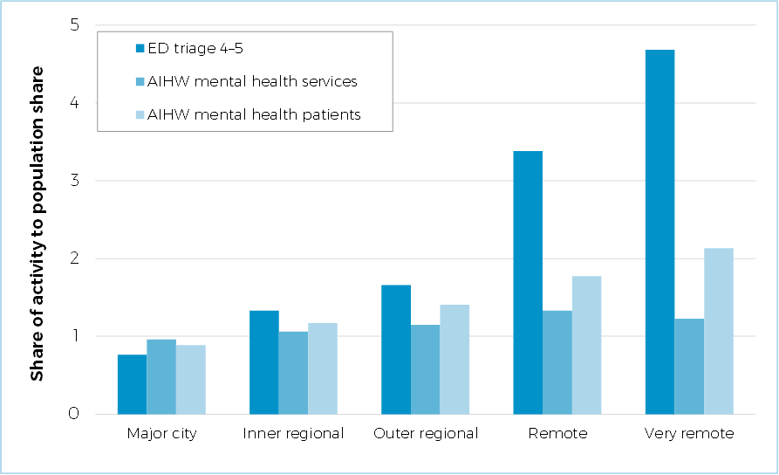

Note: Relative per capita spending is calculated by dividing the share of expenses attributed to each group by their share of total population. Supporting data provided in Appendix B, Table B1.

Source: Commonwealth Grants Commission calculation using Independent Health and Aged Care Pricing Cost Authority data and data from Australian Institute of Health and Welfare, Community mental health care services tables 2020–21.

Options to address the lack of cost weights include:

* applying regional cost and service delivery scale adjustments, based on hospital data[1]

Figure 3 and Table B2 compare the current proxy with the 2 community mental health indicators after applying remoteness adjustments. Applying regional cost and service delivery scale adjustments would bring the measure based on data from the Australian Institute of Health and Welfare closer to the current proxy.

* adjusting for differences in average expenditure by target population (age), using the approach below.

The Australian Institute of Health and Welfare has 2 associated datasets on mental health. The National Community Mental Health Care Database has activity data while the National Mental Health Establishments Database has expenditure data.[2]

The Commission could explore whether the expenditure data can be used to add cost weights to the activity data on number of service contacts/patients.

Figure 3 Current community health proxy compared with community mental health activity measures with remoteness adjustments, 2020–21

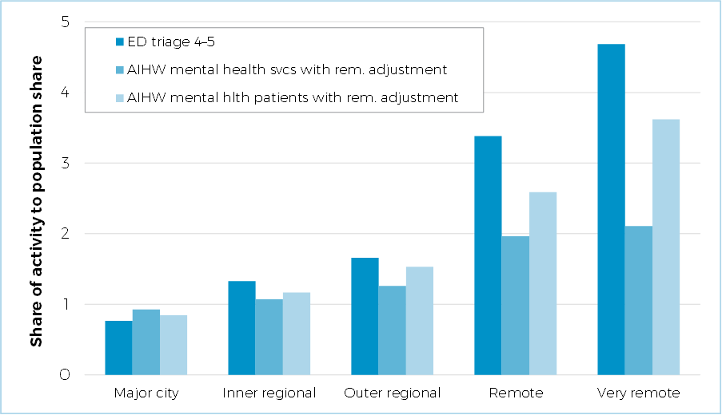

Note: Relative per capita spending is calculated by dividing the share of expenses attributed to each group by their share of total population. Supporting data provided in Appendix B, Table B1.

The AIHW indicators include Commission adjustments for regional costs and service delivery scale based on IHACPA data on remoteness adjustments and relative expenditure on small rural and remote hospitals.

Source: CGC calculation using unpublished IHACPA data; AIHW Mental health services in Australia: Community mental health care 2020–21.

While community mental health services comprise a significant proportion of state spending on community and public health expenses, it would not be sufficient to represent the whole component. The suitability of other Australian Institute of Health and Welfare datasets, such as those on alcohol and drug treatment and dental health were considered. However, these data have limitations. In addition to the lack of cost weights, the data on alcohol and drug treatments are based on a small number of clients, while the data on dental health applies to the total population rather than to community dental health clients.

In the absence of a reliable alternative, the Commission proposes that the current proxy (or an alternative as discussed in the next section) be used for the balance of the community and public health component assessment.

#### Option 2: Alternative proxy indicator of activity based on a broader measure of hospital services

An alternative to using emergency department national weighted activity unit data for triage categories 4 and 5 as the proxy indicator is to expand it to include non‑admitted patient services.[3] Non-admitted patient services include medical consultations and allied health services, which are also similar to community health services. In keeping with the practicality supporting principle, the Commission would only broaden the current proxy measure if there was evidence that the data are fit for purpose and use of the data improves the reliability of the assessment.

Figure 4 shows relative per capita spending based on the current proxy compared with the proposed broader measure for major cities, regional and remote areas. Per capita spending is higher in regional and remote areas based on the current proxy.

Emergency departments are the most accessible parts of the health system. Non‑admitted patient services are not as accessible, with per capita spending also being higher in remote areas but to a much lesser extent (about half of emergency departments). The Commission is seeking state views on whether:

* the emergency department proxy accurately reflects the use of community health services in regional and remote areas or
* the lower per capita spending in regional and remote areas using the expanded proxy better reflects the use of community health services.

A comparison based on other socio‑demographic factors and age is provided in Attachment C.

Figure 4 Current community health proxy compared to broader hospital indicator, 2021–22

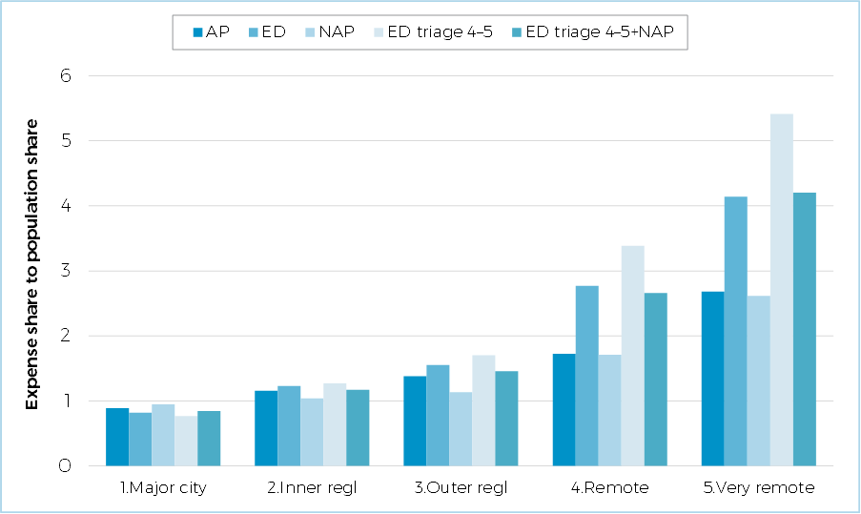

Source: Commission calculation using IHACPA data, ABS GFS expenses and ABS disaggregated population.

The changes discussed here do not involve any change to the drivers of need used in the community and public health assessment. The 2 changes being considered involve the replacement of proxy activity data with a direct measure for community mental health and/or the use of a broader measure of hospital activity as the proxy for all, or a subset of, community and public health.

As such, the Commission’s decision, after consultation with the states, will come down to the merits of the alternative data in providing an accurate and more responsive measure of what states do in community and public health.

The Commission’s preliminary view is to use the Australian Institute of Health and Welfare data on community mental health activity, adjusted to compensate for lack of cost weights, to determine per capita use rates for mental health services for the socio-demographic assessment. It also proposes to expand the current proxy for activity (emergency department triage categories 4 and 5) to include non-admitted patient services, applied to the balance of the component. That is, both Option 1 and Option 2.

Given the need to continue to use a proxy for activity in community and public health services, the Commission’s preliminary view is to continue to apply a discount of 12.5% in the assessment.

#### Consultation questions

Q4. Do states agree to:

* use the Australian Institute of Health and Welfare data on community mental health activity, adjusted to compensate for lack of cost weights, to determine per capita use rates for mental health services?
* expand the current proxy to include non-admitted patient services, applied to the balance of the component?
* continue to apply a discount of 12.5% to the community health socio-demographic assessment?
* hat in a post-pandemic environment, the hospital and patient transport assessments remain fit for purpose?

### Should an alternative data source be used to update the substitutability level for emergency department services?

The health assessment recognises that state spending on health services is influenced by the availability of alternative services provided by the private sector or the Commonwealth (non-state services).

Comparable services provided by both sectors are referred to as ‘substitutable services’, and the proportion of state spending for which there are comparable non‑state sector services is referred to as the ‘substitutability level’.

The substitutability level between state and non-state health services is calculated separately for each of the components in the health assessment. Different indicators are used to measure non-state service use for each component.

The substitutability levels were fixed during the 2020 Review and were not updated. The Commission has observed that substitutability levels changed during the COVID‑19 pandemic. In addition to sudden changes there may also be a change over time, for example due to changes in the level of private health insurance or the availability of non-state services.

The Commission is not proposing changes to the 2020 Review data sources, indicators and method to calculate substitutability levels for any components except emergency departments. The changes for emergency department substitutability levels are discussed below. See Attachment A for an explanation of changes to substitutability levels for the other components from applying the 2020 Review method to more recent data.

#### Substitutability of emergency department services

The method to calculate substitutability assumes that some people presenting to emergency departments with lower urgency presentations could potentially be treated by bulk‑billing general practitioners.

##### Existing method

In the 2015 Review, the substitutability level of 15% for emergency department services was determined based on less severe and less complex emergency department presentations that could have been managed by general practitioners.

During the 2015 Review, one of the consultants engaged to review the substitutability levels for the health assessment advised that clinically derived methodologies, especially when they yield consistent results, should be preferred over the administrative approaches or surveys based on patient perception.

For the 2020 Review, a literature survey was undertaken to determine the proportion of emergency department presentations that could be treated by general practitioners. Based on the earlier advice from the consultant, the Commission settled on the approach used by the Australian College of Emergency Medicine.[4] This was also the preferred approach of the studies surveyed.

Using the proportions of ‘GP-treatable’ presentations estimated by the Australian College of Emergency Medicine method, weighted by the number of emergency department presentations by remoteness, the overall proportion of emergency department presentations that are ‘GP-treatable’ was estimated at 23%.

The Commission used this estimate in the 2020 Review to calculate the proportion of emergency department expenditure on GP-treatable presentations.

* GP-treatable presentations are less costly than more complex and severe emergency department presentations, mainly due to shorter treatment time.
* Independent Health and Aged Care Pricing Authority data indicated that emergency department triage 4 and 5 presentations make up 52% of total emergency department presentations, but only account for 34% of the cost, resulting in a cost to activity ratio of 0.34/0.52=0.65.
* Applying this ratio to the activity level of 23%, the proportion of emergency department expenditure on GP-treatable presentations was estimated to be around 15%.

##### Alternative approach for 2025 Review

Of the methods considered in the 2020 Review, updated estimates are only available for the Australian Institute of Health and Welfare method. As the consultant’s report from the 2015 Review concluded that the Australian Institute of Health and Welfare approach significantly overstates the proportion of GP-treatable presentations, it is not recommended to use the data directly to measure substitutability. Instead, the Australian Institute of Health and Welfare data could be used as a proxy to update the Australian College of Emergency Medicine method.

In 2020–21, the Australian Institute of Health and Welfare released data on lower urgency emergency department presentations. These presentations are defined as patients who had a triage category 4 or 5, did not arrive by ambulance or correctional vehicle and were not admitted to hospital.

The percentage of non-urgent emergency department presentations using the Australian Institute of Health and Welfare method is presented in Table 5.

Table 5 Percentage of total emergency department presentations considered lower urgency by remoteness, AIHW method

|  |  |  |  |
| --- | --- | --- | --- |
|  | Total emergency department presentations | No. lower urgency presentations  AIHW method | % lower urgency presentations  AIHW method |
|  | 000 | 000 | % |
| Major cities | 5,239 | 1,712 | 33 |
| Inner regional | 1,819 | 720 | 40 |
| Outer regional | 866 | 274 | 32 |
| Remote/very remote | 286 | 176 | 62 |
| Total | 8,352 | 2,934 | 35 |

Note: Lower urgency presentations include triage category 4 or 5 patients who did not arrive by ambulance or correctional vehicle and were not admitted to hospital.

Source: Commission calculation based on AIHW data: Use of emergency departments for lower urgency care, 2018-19.

Given the relationship between the Australian Institute of Health and Welfare method and Australian College of Emergency Medicine method at the time of the 2020 Review, the proportion of lower urgency presentations for the ACEM method was estimated at 50% of the AIHW method for major cities and 60% for other remoteness regions. The equivalent proportion of GP-treatable presentations under the Australian College of Emergency Medicine method by remoteness is presented in Table 6. The overall proportion would be 19%.

Table 6 Percentage of total emergency department presentations considered lower urgency by remoteness, ACEM method

|  |  |  |  |
| --- | --- | --- | --- |
|  | Total emergency department presentations | % lower urgency presentations  AIHW method | % lower urgency presentations  ACEM method |
|  | 000 | % | % |
| Major cities | 5,239 | 33 | 16 |
| Inner regional | 1,819 | 40 | 24 |
| Outer regional | 866 | 32 | 19 |
| Remote/very remote | 286 | 62 | 37 |
| Total | 8,352 | 35 | 19 |

Note: The proportion of lower urgency presentations for the ACEM method was estimated at 50% of the AIHW method for major cities and 60% for other remoteness regions.

Source: Commission calculation.

The latest Independent Health and Aged Care Pricing Authority data indicate that emergency department triage 4 and 5 presentations make up 48.8% of total emergency department presentations, but only account for 32.4% of the cost, resulting in a cost to activity ratio of 0.324/0.488=0.66. Applying this ratio to the activity level of 19%, the proportion of emergency department expenditure on GP‑type presentations would be around 13%.

The proposed substitutability level for emergency departments is shown in Table 7.

Table Proposed substitutability level emergency departments, 2025 Review

|  |  |  |
| --- | --- | --- |
|  | **Substitutability R2020** | **Substitutability R2025** |
| Emergency departments | 15% | 13% |

Source: Commission calculation.

Attachment A describes the methods for estimating the non-state sector substitutability levels for admitted and non-admitted patients and community and public health services. The substitutability levels for these components proposed for the 2025 Review, after applying the 2020 Review method to the most recent data, are shown in Table 8.

Table 8 Proposed substitutability levels for admitted and non-admitted patients and community health services, 2025 Review

|  |  |  |
| --- | --- | --- |
|  | **Substitutability R2020** | **Substitutability R2025** |
| Admitted patients | 15% | 15% |
| Non-admitted patients | 30% | 25% |
| Community health | 60% | Not yet calculated (awaiting data inputs) |

Source: Commission calculation (see Attachment A for details on calculations and data sources).

The Commission’s preliminary view is to use the 2020 Review method to update the substitutability levels for all components apart from emergency departments. For emergency departments the Commission is proposing to use data from the Australian Institute of Health and Welfare to update the calculations.

#### Consultation question

Q5. Do states support the use of Australian Institute of Health and Welfare data to update the non-state services substitutability level for the emergency departments component, while retaining the 2020 Review method for other components?

## Proposed assessment

### Differences from the 2020 Review approach

Subject to receiving state views, the Commission proposes:

* to use the Australian Institute of Health and Welfare data on community mental health activity, adjusted to compensate for lack of cost weights, to determine per capita use rates for mental health services for the socio-demographic assessment ‑ it also proposes to expand the current proxy for activity (emergency department triage categories 4 and 5) to include non-admitted patient services, applied to the balance of the component
* to use the 2020 method to update the non‑state sector substitutability levels for all components apart from emergency departments. For emergency departments the Commission is proposing to use data from the Australian Institute of Health and Welfare to update the calculations.

### Proposed assessment structure

Subject to state views, Table 9 shows the proposed structure of the health assessment for the 2025 Review.

Table 9 Proposed structure for the health assessment, 2025 Review

|  |  |  |  |  |  |
| --- | --- | --- | --- | --- | --- |
| **Component** |  | **Driver** | **Influence measured by driver** |  | **Change since 2020 Review?** |
| Admitted patients |  | Socio-demographic composition | Recognises that the use and cost of services varies by age, socio-economic status, remoteness, and Indigenous status. |  | No |
|  |  | Non-state sector | Recognises that non-state funded health services such as private health insurance funded hospital services affect state health spending. |  | No |
|  |  | Wage costs (b) | Recognises differences in wage costs between states. |  | No |
| Emergency departments |  | Socio-demographic composition | Recognises that the use and cost of services varies by age, socio-economic status, remoteness, and Indigenous status. |  | No |
|  |  | Non-state sector | Recognises that non-state health services, such as general practitioners (GPs), affect state health spending. |  | Yes |
|  |  | Wage costs (b) | Recognises differences in wage costs between states. |  | No |
| Non-admitted patients |  | Socio-demographic composition | Recognises that the use and cost of services varies by age, socio-economic status, remoteness, and Indigenous status. |  | No |
|  |  | Non-state sector | Recognises that non-state health services, such as specialists and private health professionals affect state health spending. |  | No |
|  |  | Wage costs (b) | Recognises differences in wage costs between states. |  | No |
| Community and public health (a) |  | Socio-demographic composition  (12.5% discount) | Recognises that the use and cost of services varies by age, socio-economic status, remoteness, and Indigenous status. |  | Yes |
|  |  | Non-state sector | Recognises that non-state health services, such as general practitioners (GPs), affect state health spending. |  | No |
|  |  | Commonwealth grants adjustments | Recognises the impact of Commonwealth grants to Aboriginal Community Controlled Health Organisations |  | No |
|  |  | Cross-border | Recognises the net cost that the ACT occurs in providing services to NSW residents. |  | No |
|  |  | Wage costs (b) | Recognises differences in wage costs between states. |  | No |
| Non-hospital patient transport |  | Socio-demographic composition | Recognises that remoteness influences service use. |  | No |
|  |  | Wage costs (b) | Recognises differences in wage costs between states. |  | No |

(a) The Commission proposes a change to the assessment of community and public health as follows: use the Australian Institute of Health and Welfare data on community mental health activity to determine per capita use rates for mental health services for the socio-demographic groups used in the health assessment; and expand the current proxy for activity (emergency department triage categories 4 and 5) to include non-admitted patient services, applied to the balance of the component.

(b) The Commission will separately consult with states on the wages assessment.

### New data requirements

As referenced in paragraph 7 data on state expenses on aero-medical transport and Patient Assistance Travel Schemes are only updated every 5 years. Information on the timing of these data requests will be provided in July 2023 (see Attachment D).

## Consultation

The Commission welcomes state views on the consultation question identified in this paper (outlined below) and the proposed assessment. State submissions should accord with the 2025 Review framework. States are welcome to raise other relevant issues with the Commission.

1. Do states agree that in a post-pandemic environment, the hospital and patient transport assessments remain fit for purpose?
2. Do states agree that the proposed changes to the community and public health assessment in this paper will contribute to making the assessment more responsive to developments affecting this part of the health system?
3. Do states consider the experiences with the COVID-19 pandemic have implications for the health assessment?
4. Do states agree to:

* use the Australian Institute of Health and Welfare data on community mental health activity, adjusted to compensate for lack of cost weights, to determine per capita use rates for mental health services?
* expand the current proxy to include non-admitted patient services, applied to the balance of the component?
* continue to apply a discount of 12.5% to the community health socio-demographic assessment?

1. Do states support the use of Australian Institute of Health and Welfare data to update the non-state services substitutability level for the emergency departments component, while retaining the 2020 Review method for other components?

Attachment A: Updating non-state sector substitutability levels

The 2020 Review substitutability levels and the indicators of non-state service use are shown in Table A1. The table also shows how these changed from the 2015 Review.

Table A1 Changes to the substitutability levels and indicators in the 2020 Review

|  |  |  |  |  |
| --- | --- | --- | --- | --- |
|  | **Substitutability R2015** | **Substitutability R2020** | **Indicator R2015** | **Indicator R2020** |
| Admitted patients | 15% | 15% | Private patient  separations | Private patient separations |
| Emergency  departments | 15% | 15% | Bulk billed GP benefits | Bulk billed GP benefits |
| Non-admitted patients | 40% | 30% | Bulk billed specialist and  diagnostic services benefits | Bulk billed operations and  specialist services benefits |
| Community health | 70% | 60% | Bulk billed GP benefits | Bulk billed GP benefits |

Source: 2020 Review, Volume 2, Part B, Chapter 15.

#### Admitted patients

The main factors considered by the Commission to be influencing the level of substitutability of the non-state sector for state admitted patient services are the differences in the type of admitted patient activity in the state and non-state sectors and the level of privately insured patients with hospital coverage.

Based on these 2 factors, the Commission in the 2020 Review estimated the potential substitutability level for admitted patient services to be between 23% and 28%.

The Commission considered this range to be an upper bound.

* Applying the rate of private health insurance to public hospital services will overstate the proportion of patients with private health insurance who are treated in public hospitals. This is because the proportion of public hospital patients with private health insurance is less than the proportion of all patients with private health insurance.
* In addition, not all privately insured patients choose to utilise their private health insurance due to policy excesses and gaps charged by specialists. The Commission was not able to identify a data source indicating the proportion of patients in public hospitals with private health insurance. While Australian Institute of Health and Welfare data indicates that around 10% of public hospital patients are funded through private health insurance, it is not able to capture the proportion of publicly funded patients which chose not to use their private health insurance.

In the absence of further information, the Commission exercised judgment and decided that a level of 15% for admitted patients allows for these factors. It implies that about 25% of non-emergency admitted patient services relate to privately insured patients.

##### Updating the substitutability level

As private hospitals only perform limited emergency-type admitted patient services, only activity on non-emergency admitted patient services are used in the calculation.

Updated data on the proportion of non-emergency admitted patient services and the percentage of people with private health insurance were sourced from the Australian Institute of Health and Welfare (AIHW) and the Australian Prudential Regulation Authority (APRA).

The proportion of non-emergency admitted patient services is largely unchanged since the 2020 Review (between 50% and 60%). Likewise, the proportion of people with private health insurance is consistent with the 2020 Review (44.9% in 2021–22 compared with 46.5% in 2016–17). This suggests a potential substitutability level between 23‑27%, consistent with the 23–28% range identified in the 2020 Review. As this range is an upper bound, the 15% substitutability level decided by the Commission during the 2020 Review still appears appropriate to use.

#### Non-admitted patients

Many of the pre-hospital, post-hospital and clinical treatments in the non-admitted patients component are also provided by the non-state sector. The Commission has previously considered that the potential substitutability of these services is high, although out-of-pocket costs may limit the use of these services.

##### Updating the substitutability level

Data on non-admitted patient service provision were updated to 2020-21 and the substitutability level was re-calculated. Compared to the 2020 Review, there were only small changes in the substitutability for each group of non-admitted patient services. The updated substitutability levels are presented in Table A1.

If the same method is applied as in the 2020 Review (a 50% discount, as about half of non-admitted patient services are linked to a previous hospital attendance), the substitutability level would be 32% (Table A2).

Table A2 Estimation of state expenditure for each group of non-admitted patient services, 2025 Review

|  |  |  |  |  |  |  |
| --- | --- | --- | --- | --- | --- | --- |
| **Group of services** | **Share of activity** | | **Average expenditure** | **Estimated share of expenditure(a)** | **Substitutable service available** | **Expenditure wtd. substitutability level** |
|  | **%** | | **$pc** | **%** |  | **%** |
| Procedure clinics | 10 | | 675 | 19 | Yes | 19 |
| Medical consultation clinics | | 39 | 408 | 45 | Yes | 45 |
| Allied health clinics (b) | 51 | | 254 | 36 | No | 0 |
| Total |  | |  | **100** |  | **64** |

(a) For each group of services, the share of expenditure is estimated as the proportion of activity times average expenditure, divided by the sum of the proportion of activity times average expenditure.

(b) Although allied health services are available in the private sector, most are linked to an earlier admitted patient episode and are eligible only for a small number of patients. As a result, allied health clinics are generally not considered substitutable.

Source: Commission calculation based on data from AIHW (2022) Non-admitted patient care tables 2020-21, Table 2.4, and IHACPA (2021) National Hospital Cost Data Collection Cost report: Round 24 Financial Year 2019-20, Table 13.

If the same method is applied as in the 2020 Review (a 50% discount, as about half of non-admitted patient services are linked to a previous hospital attendance), the substitutability level would be 32% (Table A2).

In the 2020 Review, an alternative method calculated the substitutability level as in Table A2 but also considered the proportion of bulk billed benefits for each sub‑component. If this alternative method is applied in the current review, the expenditure weighted substitutability level would be 17.5%.[5] As done in the previous review, taking the average of the substitutability levels from each method (32% and 17.5%) would result in an average level of 25% for the 2025 Review.

#### Community health

Many of the community and public health services assessed in the health category are also provided by general practitioners and other private clinicians. There is strong evidence of a high level of substitutability between the non-state sector and community and public health services.

However, the heterogeneity of the various community and public health services increases the difficulty in determining the overall level of non-state sector substitutability.

##### Updating the substitutability level

For the 2020 Review, a substitutability range was estimated for individual community health services. These ranges were grouped by no (or nil) substitutability, very low substitutability (0–20% of activity is substitutable), low substitutability (21–40%), medium substitutability (41–60%), high substitutability (61–80%) and very high substitutability (81–100%). A summary of the groups of community and public health services and associated substitutability ranges is provided in Table A3.

Table A3 Substitutability of community health services, 2020 Review

|  |  |  |  |
| --- | --- | --- | --- |
| Group of services | Substitutability range | Share of expenditure (a) | Expenditure‑weighted substitutability |
|  | % | % | % |
| Community health services |  |  |  |
| Public dental services | Low (21-40) | 5 | ≈1.4 |
| Alcohol and other drug services | Medium (41-60) | 4 | ≈2.0 |
| Community mental health services | Low (21-40) | 19 | ≈5.6 |
| Other community health services | Very high (81-100) | 54 | ≈48.3 |
| Public health services |  |  |  |
| Cancer screening | Medium (41-60) | 3 | ≈1.6 |
| Organised immunisation | High (61-80) | 4 | ≈2.9 |
| Health promotion | Very low (0-20) | 5 | ≈0.5 |
| Communicable disease control | Nil | 3 | ≈0 |
| Environmental health | Nil | 1 | ≈0 |
| Other public health services | Very low (0-20) | 2 | ≈0.2 |
| Total |  | 100 | ≈62.5 |

(a) The average proportion for 2014–15 and 2015–16.

Source: Volume 2 Chapter 15 – Health of the Report on GST Revenue Sharing Relativities, 2020 Review, Table A15-6, p178.

These substitutability ranges were weighted by the share of state spending on each community and public health service to get an expenditure-weighted substitutability level. When aggregated across all community and health services a substitutability level of approximately 60% was obtained. This substitutability ratio was applied to the bulk-billed GP benefits paid as a proxy for non‑state community health services.

The Commission will request the latest years of data on state spending for each element of community and public health services from the Australian Institute of Health and Welfare. The Commission will work with the Australian Institute of Health and Welfare to investigate the impact of COVID‑19 on the data, whether it impacts the fitness for purpose of the data and if it can be used to update the substitutability level for the 2025 Review.

Attachment B: Community health: Additional analysis of direct activity measure

Table B1 Current proxy indicator vs AIHW community mental health indicators, 2020–21 (relative per capita activity)

|  |  |  |  |  |
| --- | --- | --- | --- | --- |
|  | Current indicator | AIHW community mental health services | | |
| No. of contacts | No. of patients | |
|  | %NWAU/  %population | %contacts/  %population | %patients/  %population | |
| Socio-economic status |  |  | |  |
| Bottom 20% | 1.3 | 1.3 | | 1.3 |
| Mid 60% | 1.0 | 1.0 | | 1.0 |
| Top 20% | 0.7 | 0.8 | | 0.7 |
| Ratio bottom/top | 1.7 | 1.7 | | 1.9 |
| Remoteness |  |  | |  |
| Major city | 0.8 | 1.0 | | 0.9 |
| Inner regional | 1.3 | 1.1 | | 1.2 |
| Outer regional | 1.7 | 1.1 | | 1.4 |
| Remote | 3.4 | 1.3 | | 1.8 |
| Very remote | 4.7 | 1.2 | | 2.1 |
| Ratio very remote/major city | 6.1 | 1.3 | | 2.4 |
| Indigenous status |  |  | |  |
| First Nations | 2.9 | 3.5 | | 3.3 |
| Non-Indigenous | 0.9 | 0.9 | | 0.9 |
| Ratio First Nations/non-Indigenous | 3.1 | 3.8 | | 3.6 |
| Age |  |  | |  |
| 0-14 | 1.2 | 0.5 | | 0.7 |
| 15-44 | 1.0 | 1.4 | | 1.4 |
| 45-64 | 0.8 | 1.0 | | 0.9 |
| 65-74 | 1.0 | 0.6 | | 0.6 |
| 75+ | 1.7 | 0.5 | | 0.7 |
| Ratio 75+/0-14 | 1.4 | 1.0 | | 1.0 |

Note: Relative per capita activity is calculated by dividing the share of activity attributed to each group by their share of total population.

Source: Commission calculation using unpublished IHACPA data and AIHW Community mental health care services tables 2020‑21.

Table B2 Current proxy indicator vs AIHW community mental health indicators with remoteness adjustments, 2020–21 (relative per capita activity) (a)

|  |  |  |  |
| --- | --- | --- | --- |
|  | Current indicator | AIHW community mental health services | |
|  | No. of contacts | No. of patients |
|  | %NWAU/ | %contacts/ | %patients/ |
| %population | %population | %population |
| Socio-economic status |  |  |  |
| Bottom 20% | 1.3 | 1.3 | 1.3 |
| Mid 60% | 1.0 | 1.0 | 1.0 |
| Top 20% | 0.7 | 0.8 | 0.7 |
| Ratio bottom/top | 1.7 | 1.7 | 1.9 |
| Remoteness (b) | 0.0 |  |  |
| Major city | 0.8 | 0.9 | 0.8 |
| Inner regional | 1.3 | 1.1 | 1.2 |
| Outer regional | 1.7 | 1.3 | 1.5 |
| Remote | 3.4 | 2.0 | 2.6 |
| Very remote | 4.7 | 2.1 | 3.6 |
| Ratio very remote/major city | 6.1 | 2.3 | 4.3 |
| Indigeneity | 0.0 |  |  |
| First Nations | 2.9 | 3.5 | 3.3 |
| Non-Indigenous | 0.9 | 0.9 | 0.9 |
| Ratio First Nations/non-Indigenous | 3.1 | 3.8 | 3.6 |
| Age | 0.0 |  |  |
| 0-14 | 1.2 | 0.5 | 0.7 |
| 15-44 | 1.0 | 1.4 | 1.4 |
| 45-64 | 0.8 | 1.0 | 0.9 |
| 65-74 | 1.0 | 0.6 | 0.6 |
| 75+ | 1.7 | 0.5 | 0.7 |
| Ratio 75+/0-14 | 1.4 | 1.0 | 1.0 |

(a) Relative per capita activity is calculated by dividing the share of activity attributed to each group by their share of total population.

(b) The AIHW indicators include Commission adjustments for regional costs and service delivery scale based on IHACPA data on remoteness adjustments, and relative expenditure on small rural and remote hospitals.

Source: Commission calculation using unpublished IHACPA data and AIHW Community mental health care services tables 2020‑21.

Attachment C: Alternative proxy indicator of community health activity based on a broader measure of hospital services

Figure C Current community health proxy vs ED and ED+NAP by Indigenous status and socio-economic status, 2020–21

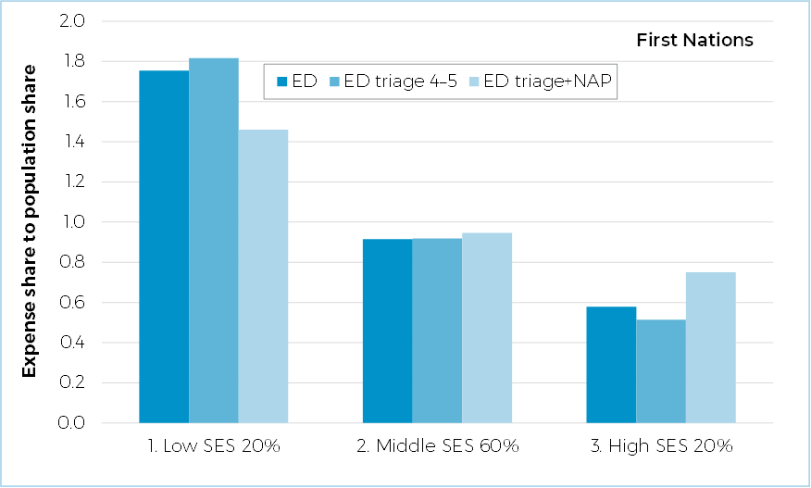

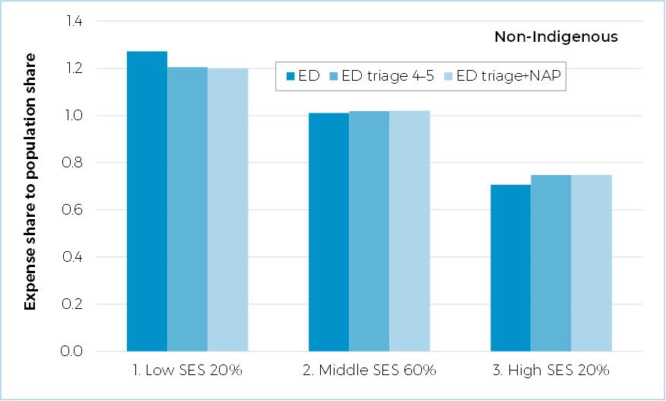

Source: Commission calculation using unpublished IHACPA data, ABS GFS expenses and ABS disaggregated population.

Figure C Current community health proxy vs ED and ED+NAP by age group, 2020–21

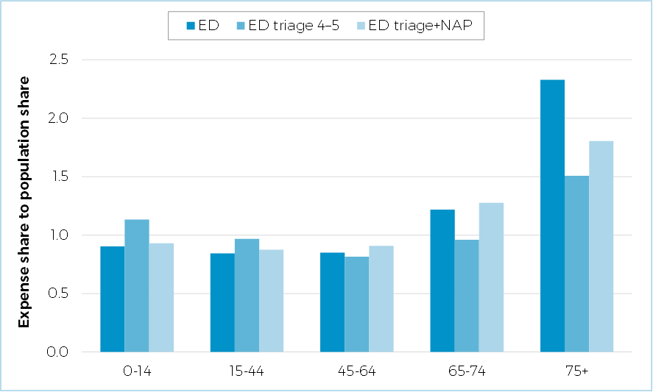

Source: Commission calculation using unpublished IHACPA data, ABS GFS expenses and ABS disaggregated population.

Attachment D: Draft data request: State data on non-hospital patient transport expenses

#### Background

Hospital and non‑hospital patient transport are assessed separately. Hospital transport (land ambulances) are included in the admitted patient component because the drivers of need are similar to hospital‑based services.

The non-hospital patient transport assessment is based on aero-medical and Patient Assisted Travel/Transport Scheme costs, as these costs are disproportionately attributable to people in remote and very remote regions.

Government Finance Statistics data cannot disaggregate patient transport expenses into land ambulance, Patient Assisted Travel/Transport Scheme and aero-medical expenses. Hence, state data are used to identify aero-medical and Patient Assisted Travel/Transport Scheme expenses. The data are also used to calculate a remoteness cost weight.

For the 2025 Review, the Commission is not proposing to change the assessment method for non‑hospital patient transport expenses. This data request seeks data from each state to update the assessment. The ratio of hospital to non‑hospital patient transport expense will be maintained for the period of the 2025 Review.

#### Scope

Non-hospital patient transport services other than land ambulance, largely aero-medical services.

Expenses related to the Patient Assistance Travel/Transport Scheme (PATS), a subsidy program by state governments that provides financial help for travel and accommodation expenses for patients who need to travel a long distance to access approved medical specialist services that are not available locally. The actual name of the scheme varies in each state.

#### Details of information required

The Commission is seeking patient transport expenses data for aero‑medical services and PATS for each year by remoteness region from 2022–23 to 2023–24. Expenses should be allocated to regions based upon the usual residence of the patient receiving the services. However, if you are unable to allocate expenses to different regions, please provide totals on the regions you can, such as individual health districts or country regions. Also, include services that are provided to interstate residents, in particular, services provided by the ACT to New South Wales residents (if possible, net of any revenue raised).

In regard to aero-medical expenses, these only include State expenses (not the total operating budget of service providers like the Royal Flying Doctor Service).

Please note that costs associated with land ambulance services will not be required as part of this data request.

#### Data request table

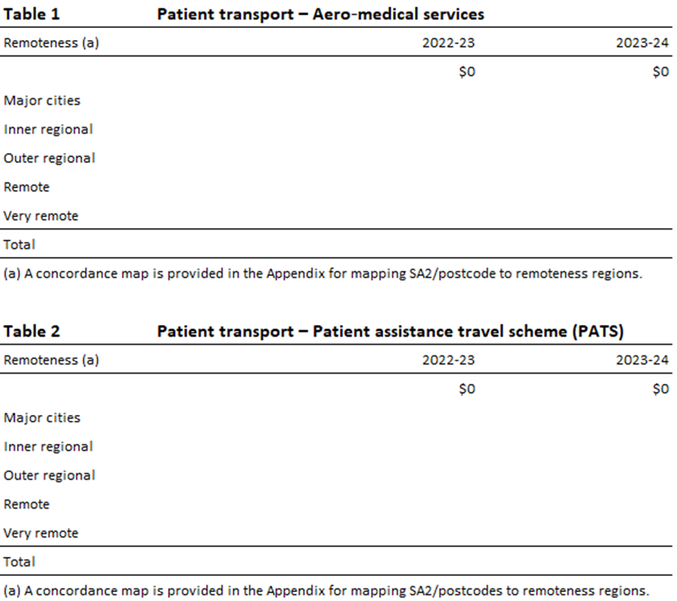

1. The regional cost adjustments could be based on remoteness adjustments applied by the Independent Health and Aged Care Pricing Authority to emergency departments activity data. The service delivery scale adjustments would be the same adjustments applied by the Commission to the current emergency department proxy.
2. See [Data tables: Expenditure on mental health-related services 2019-20.](https://www.aihw.gov.au/mental-health/resources/data-tables)
3. At the time of the 2020 Review, the national weighted activity unit data on non‑admitted patient services were not considered sufficiently reliable. Admitted patient separations data were used as a proxy for activity on non‑admitted patient services. The lack of a direct measure of activity for non‑admitted patient services meant it could not be used as a proxy for community and public health services.

   Based on advice from the then Independent Hospital Pricing Authority, at the time of the 2020 Review the Commission anticipated that non-admitted patient activity data for the next year (2018–19) would be sufficiently reliable. However, that data would only be available in January 2020, which did not give sufficient time to assess the quality of the data and to consult with states.

   In the 2021 Update the Commission consulted with states and decided to move to a direct measure of activity for non‑admitted patients, as the data were reasonably comprehensive and robust.
4. See 2020 Review Report, Volume 2, Part B, p172 [(cgc.gov.au)](https://www.cgc.gov.au/sites/default/files/2021-11/r2020_report_-_volume_2_-_part_b_ch5-18.pdf).
5. The updated proportions of bulk billed benefits would be 35% for procedure clinics and 24% for medical consultation clinics, based on data on the proportion of bulk billed benefits, for 2018–19 and 2019–20 by broad type of service, for specialists and operations.