**2025 Methodology Review**

Post-secondary education consultation paper

June 2023

|  |  |
| --- | --- |
| Paper issued | 20 June 2023 |
| Commission contact officer | Jacob Savage, 02 6218 5729, Jacob.Savage@cgc.gov.au |
| Submissions sought by | 13 October 2023  Submissions should be placed in your private state or territory channel in CGC Engagement Teams, with a post notifying Katrina Baldock.  Submissions should be in Word format and posted in the relevant state channel of the CGC engagement Team. Submissions more than 10 pages in length should include a summary section. |
| Confidential material | It is the Commission’s normal practice to make state submissions available on its website under the CC BY licence, allowing free use of content by third parties.  Creative Commons - CC BY Attribution  Further information on the CC BY licence can be found on the Creative Commons website (http://creativecommons.org).  Confidential material contained in submissions must be clearly identified or included in separate attachment/s, and details provided in the covering email. Identified confidential material will not be published on the Commission’s website. |

Contents

Overview of category 4

Current assessment method – 2020 Review 4

Data used in the assessment 6

Category and component expenses 6

GST distribution in the 2023 Update 7

What has changed since the 2020 Review? 7

The Australian labour market is evolving 7

Policies are changing and relative spending has been declining 8

New data have become available 9

Implications for assessment 9

Do the social, economic or policy changes challenge the appropriateness of the current assessment? 9

Do new data mean that a course mix driver should be assessed? 10

Does the socio-demographic composition driver need to be adjusted? 11

Proposed assessment 13

Differences from the 2020 Review approach 13

Proposed assessment structure 14

New data requirements 14

Consultation 15

## Overview of category

Post-secondary education covers state expenses on vocational education and training and other higher education. Most state spending on post-secondary education is for vocational education and training, including apprenticeships and traineeships (93%), with around 7% of spending for universities.[1]

State vocational education and training expenses mainly comprise spending on subsidised courses provided by public technical and further education institutes and private registered training organisations.

Vocational education and training courses span foundation skills, certificate I to IV programs (including apprenticeships and traineeships), diplomas, advanced diplomas and bachelors’ degrees. The campuses used for service delivery are widely dispersed in all states, and states with dispersed, small communities provide services in many of those communities. All state vocational education and training funding models, except the ACT’s, include regional loadings to recognise the higher cost of service delivery in regional and remote areas. Many states fund specific programs to support First Nations students, socio‑economically disadvantaged students, students with a disability and culturally and linguistically diverse populations.

## Current assessment method – 2020 Review

In 2020, the Commission determined that the main non-policy related drivers of difference in the cost of post-secondary education between states were:

* the difference in the socio-demographic profile of the states’ populations
* the higher cost of providing services to certain groups or in certain areas
* the extent to which students commute across state borders for post‑secondary education
* the difference in wage levels that staff receive in different states (see Figure 1).

#### Socio-demographic composition

Table 1 outlines the socio-demographic composition drivers for the assessment. Only enrolments of people aged 15‑64 are assessed. Different rates of use are assessed for Indigenous status, remoteness and socio-economic status. A higher cost per hour enrolled is assessed for First Nations people and people living in more remote areas.

For assessing differences in use rates, the population is divided between those in major cities and regional areas (non-remote) and those in remote or very remote areas (remote). For assessing differences in cost per contact hour, all 5 categories are used. Non-remote areas are divided by socio-economic status, using the Indigenous Relative Socio-Economic Outcomes index for the First Nations population and the Non-Indigenous Socio-Economic Index for Areas for the non-Indigenous population.

Table Socio-demographic composition, post-secondary education



Source: Commission decision.

#### Cross border use

People can enrol in vocational education and training courses in states other than where they live. Most such flows are small, but the effect of New South Wales residents enrolled in ACT courses is significant. National Centre for Vocational Education and Research data on state of residence by state of enrolment are used to reflect the net effect of cross border enrolments between these two states.

#### Wage costs

The Commission applies its general method for measuring the influence of wage costs. The Commission’s approach to measuring wage costs is described in the wage costs assessment consultation paper.

Figure Drivers of post-secondary education expenses, 2020 Review

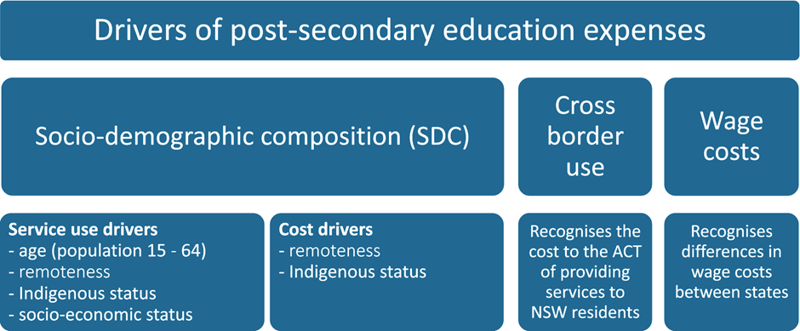

Source: Commission decision.

### Data used in the assessment

The National Centre for Vocational Education Research is the national professional body responsible for collecting, managing, analysing and communicating [research](https://www.ncver.edu.au/about/about-ncver/about-our-research) and [statistics](https://www.ncver.edu.au/about/about-ncver/about-our-data) on the Australian vocational education and training sector. It is an independent, not-for-profit Australian company owned by the Commonwealth, and state and territory ministers responsible for vocational education and training.[2]

Most of the data for the socio-demographic composition and cross‑border assessments are sourced from the National Centre for Vocational Education Research. It provides calendar year data on government-funded contact hours for persons aged 15-64 years, classified by Indigenous status, remoteness and socio‑economic status. The Commission combines state-provided data on the additional costs per contact hour of First Nations students and regional loadings from state vocational education and training funding models with National Centre for Vocational Education Research data to calculate First Nations and remoteness cost drivers.

State data on the cost per enrolled hour for First Nations students and students in more remote areas were collected in the 2020 Review. All other data are updated annually.

### Category and component expenses

The total expense for post-secondary education varied annually between 2018-19 to 2021-22, without any substantial growth over this period. There was a small fall in this component as a proportion of total operating expenses.

Table Post-secondary education expenses, 2018–19 to 2021–22

|  |  |  |  |  |
| --- | --- | --- | --- | --- |
|  | 2018-19 | 2019-20 | 2020-21 | 2021-22 |
| Total expenditure ($m) | 6,002 | 6,369 | 6,590 | 6,129 |
| Proportion of total expenditure (%) | 2.5 | 2.8 | 2.6 | 2.1 |

Note: Expenses are net of user charges.

Source: Commission calculation, 2023 Update.

Table 3 shows the category’s assessment structure and drivers.

Table Structure of the post-secondary education assessment, 2021–22

|  |  |  |  |  |
| --- | --- | --- | --- | --- |
| Component | Component expense |  | Driver | Influence measured by driver |
|  | $m |  |  |  |
| Post-secondary education | 6,129 |  | SDC | Recognises that for the working age population certain characteristics affect the use and cost of services, namely: Indigenous status, remoteness, and socio-economic status. |
|  |  | Cross border | Recognises the cost to the ACT of providing services to residents of New South Wales. |
|  |  |  | Wage costs | Recognises differences in wage costs between states. |

Note: Regional costs are captured through the socio-demographic composition driver.

Source: Commission calculation.

### GST distribution in the 2023 Update

Table 4 shows the GST impact of the assessment in the 2023 Update. The post‑secondary education assessment distributed $136 million ($5 per capita) away from an equal per capita distribution.

Table GST impact of the post-secondary education assessment, 2023–24

|  |  |  |  |  |  |  |  |  |  |
| --- | --- | --- | --- | --- | --- | --- | --- | --- | --- |
|  | NSW | Vic | Qld | WA | SA | Tas | ACT | NT | Total effect |
|  | $m | $m | $m | $m | $m | $m | $m | $m | $m |
| Total | -43 | -88 | 44 | 21 | -4 | 21 | -1 | 49 | 136 |
| Total ($pc) | -5 | -13 | 8 | 7 | -2 | 36 | -2 | 190 | 5 |

Source: Commission calculation, 2023 Update.

Further detail on service provision arrangements, the range of services included within this category and the underlying conceptual cases for the assessment methods are explained in Volume 2 *Chapter 14 – Post-secondary education* of the [Report on GST Revenue Sharing Relativities, 2020 Review.](https://www.cgc.gov.au/reports-for-government/2020-review)

## What has changed since the 2020 Review?

### The Australian labour market is evolving

Since 2020, unemployment rates have fallen and the occupational mix of those employed has changed, largely in line with longer term trends.

Between November 2019 and November 2022, 63% of all employment growth was in skill level 1 occupations (where university qualifications are the primary pathway), with 40% in skill level 2-4 (where vocational education and training qualifications are the primary pathway). There has been a 3% decline in employment in skill level 5 jobs (where jobs do not typically require a post—school qualification).

### Policies are changing and relative spending has been declining

Since the initial move to demand-driven vocational education and training funding by Victoria and South Australia more than a decade ago, there has been a gradual tightening of student entitlements. This ensures government subsidies are more aligned with current and emerging industry needs. Recently, the Commonwealth and states have introduced programs to jointly fund low and no-fee courses, with the aim of increasing vocational education and training participation, particularly in areas where there are skill shortages.

In addition to the tightening of student entitlements and introducing low or no-fee vocational education and training courses, all governments have committed to increasing real investment in the vocational education and training system. All states have agreed to work together to adopt a new funding model that improves national consistency for students, integrates subsidies and loans, and is linked with efficient pricing and skills needs. This work is likely to be completed towards the end of this review and may tie in with the next 5‑yearly National Skills Agreement, which is due to commence in 2024. There is also a push for greater standardisation of courses across jurisdictions.

These initiatives are likely to result in an increase in vocational education and training participation and related state expenses, and may result in changes to use rates among different socio-demographic groups. State spending on post-secondary education has been falling relative to other state spending, with relatively slow growth in nominal expenditure. The reforms described above may lead to a reversal, or at least a slowing, of this decline.

Figure Post-secondary education as proportion of total state expenses

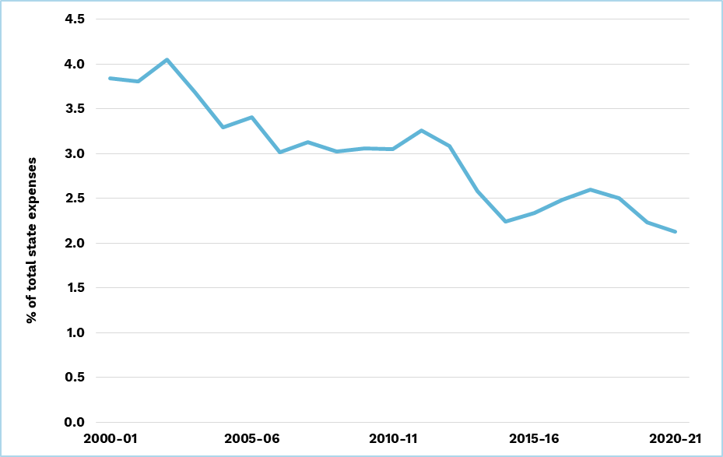

Note: Numbers in this figure compare to total expenses, excluding investment, and differ from estimates in Table 2 which compare to total expenditure including investment.

Source: Commission calculation

### New data have become available

The Commission has recently identified that the National Centre for Vocational Education Research produces data that measure the effect of states providing different mixes of courses, and that different courses have different costs of provision.

## Implications for assessment

The Commission has identified several issues for consideration:

* Do the social, economic or policy changes challenge the appropriateness of the current assessment?
* Do new data mean that a course mix driver should be assessed?
* Does the socio-demographic composition driver need to be adjusted?
* Do the cost weights need to be adjusted?

### Do the social, economic or policy changes challenge the appropriateness of the current assessment?

The Commission is not aware of any changes that would mean that socio‑demographic composition factors are no longer the primary driver of need. While changes to the labour market or vocational education and training sector may change the use rates and costs for different socio-demographic groups, the current assessment methods should appropriately capture these changes as they occur. This is because the assessment uses contemporaneous annual data and so will reflect changes in service use by different socio-demographic groups.

### Do new data mean that a course mix driver should be assessed?

In previous reviews, states have argued that the post-secondary education assessment should recognise additional drivers of state spending, including course mix. Differences in the industry structure of states may lead to students enrolling in different courses in different states. Some courses are more expensive to provide than others.

In the 2020 Review, the Commission accepted the conceptual case for including a course mix driver, noting the influence of state industry profiles on course mix and costs. However, no data were found to incorporate a course mix driver.

The Commission has recently identified a National Centre for Vocational Education Research measure of the average course mix cost weights of the states.[3] The weights incorporate the differences in enrolment patterns between states and the costs of 12 fields of study. For most states, the mix of courses means the average cost is close to the national average. However, students in the Northern Territory study courses that are 4% more costly than average (Table 5). Based on the 2023 Update, the Northern Territory would need to spend $492 per capita to deliver the national average standard of post-secondary education. If this were 4% higher, to account for the course mix of Northern Territory students, the Northern Territory would require an additional $21 per capita in GST. This is not material for any state.

As state labour markets and needs for skills continue to evolve in light of social, economic and industry policy changes, these course mix cost differentials may change.

Table Materiality of a course mix driver, 2023–24



Source: Commission calculation using National Centre for Vocational Education Research course mix weights for 2020.

The Commission’s preliminary view is that a course mix adjustment should not be introduced as it is not material.

#### Consultation question

1. Do states agree that a course mix driver should not be introduced?

### Does the socio-demographic composition driver need to be adjusted?

The 2020 Review method recognises that spending by each state on post‑secondary education services is affected by the size of its working age (15-64 years) population and the presence of those population groups that use services more intensively. These include:

* First Nations people
* people living in less remote areas
* socio-economically disadvantaged people living in non-remote areas.

Annual data capture any change in the socio-demographic groups that use post‑secondary education. However, it is normal practice in a review for the Commission to re-examine service use patterns using the latest available data to determine if the socio-demographic composition breakdown adopted in the previous review remains appropriate.

The use of vocational education and training services is higher among 15‑24 year‑olds than among older working age groups. However, given that state shares are similar for the groups within the 15-64 year age group, there appears to be little value in the added complexity of disaggregating age groups further. Less than 1% of enrolled hours are for people aged 65 and over.

Figure 3 shows that vocational education and training contact hours vary significantly between First Nations and non‑Indigenous students. National Centre for Vocational Education Research data have consistently shown that First Nations service use rates are approximately twice those of non-Indigenous students.

Figure Government funded contact hours per person by Indigenous status, 2016–2020

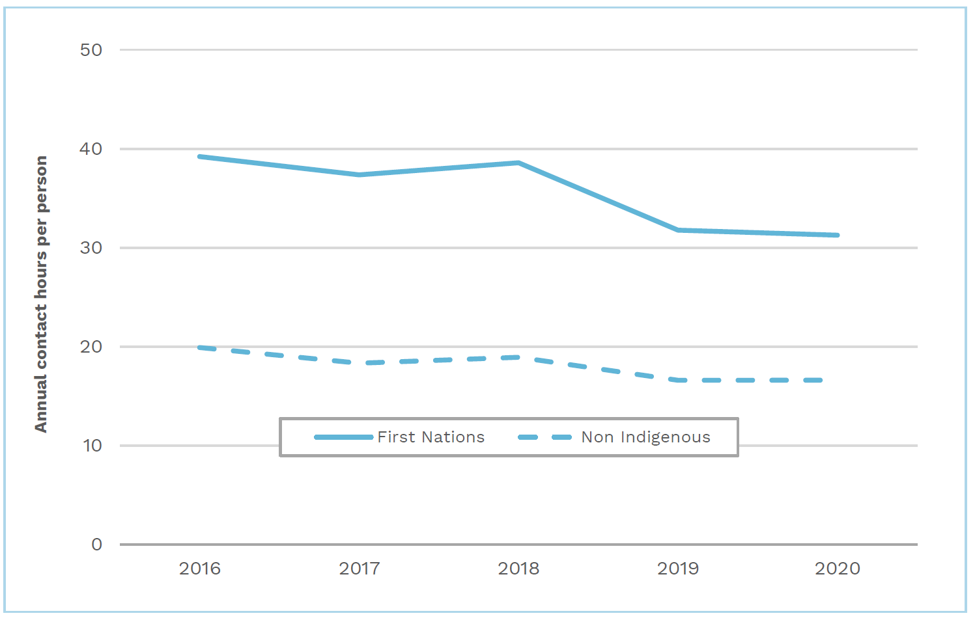

Source: Commission calculation using National Centre for Vocational Education Research data.

Non-remote vocational education and training use rates exceed remote use rates, however the cost of service delivery is higher for remote vocational education and training use. For the First Nations population, spending per capita is higher in non‑remote areas; for the non-Indigenous population it is higher in remote areas. Since differences in remote and non-remote spend rates exist, and remoteness is material across all assessments, the Commission proposes to continue to recognise the differential use and cost of vocational education and training services in different remoteness regions.

Consistent with the pattern seen in the 2020 Review, the latest National Centre for Vocational Education Research data show that people living in low socio-economic status areas have higher use of post-secondary education than people living in higher socio-economic status areas (Figure 4). For the non-Indigenous population living in non-remote areas, this evidence is strong and consistent. For First Nations people in non-remote areas, there was significant noise in the data, and in remote areas there was little evidence of a relationship between socio-economic status and enrolling in post-secondary education enrolment. Based on comparable data up to 2018, in the 2020 Review the Commission decided to group the socio-economic status quintiles for the non-remote population (top 20%, middle 60% and bottom 20%), and not disaggregate the remote population by socio-economic status. More recent data shown in Figure 4 suggests this approach remains appropriate. While service use varies among socio-economic status quintiles in remote areas, those patterns, particularly for First Nations students, do not have a strong conceptual basis to justify a disaggregation of socio-economic status in remote areas.

Socio-economic status is being considered separately. The Commission may reconsider the socio-economic status groupings that are currently used to ensure that they remain appropriate in light of any updated methods determined for measuring socio-economic status.

Figure Hours of post-secondary education per capita by socio-demographic attributes, 2020–21

Source: Commission calculation.

The Commission’s preliminary view is that the variables currently used in the socio‑demographic assessment of needs be retained.

#### Consultation question

1. Do states agree that the variables used in the socio-demographic assessment of needs be retained?

## Proposed assessment

### Differences from the 2020 Review approach

Subject to state views, the Commission proposes no substantive method changes for this assessment.

### Proposed assessment structure

Table 6 shows the same proposed assessment structure as the current structure, which is shown in Table 3.

Table Proposed assessment structure for post-secondary education

|  |  |  |  |  |  |
| --- | --- | --- | --- | --- | --- |
| Component | Component expense |  | Driver | Influence measured by driver | Change since 2020 Review |
|  | $m |  |  |  |  |
| Post-secondary education | 6,129 |  | SDC | Recognises that for the working age population certain characteristics affect the use and cost of services, namely: Indigenous status, remoteness, and socio-economic status. | Refresh |
|  |  |  | Cross-border | Recognises the cost to the ACT of providing services to residents of New South Wales. | No |
|  |  |  | Wage costs | Recognises differences in wage costs between states. | No |

Source: Commission calculation.

### New data requirements

#### Cost weights to be updated

The current assessment recognises the additional costs of providing services to First Nations students and students living in remote areas. For this review, the Commission intends to collect data from states to re-calculate Australian average First Nations and remoteness cost weights for the post-secondary education assessment.

The First Nations cost weight for the post-secondary education assessment is derived from state spending data on First Nations-specific vocational education and training programs and National Centre for Vocational Education Research contact hours data. The burden on states in supplying the spending data means they are only collected once during a review cycle and the weight remains fixed for the duration of the review. Information on the timing of these data requests will be provided in July 2023.

The remoteness cost weights for the assessment are based on regional loadings in state vocational education and training funding models and National Centre for Vocational Education Research contact hours data. Given the stability of the regional loadings in state vocational education and training funding models, there does not appear to be a case for updating them between reviews. Information on the timing of these data requests will be provided in July 2023.

## Consultation

The Commission welcomes state views on the consultation questions identified in this paper (outlined below) and the proposed assessment. State submissions should accord with the 2025 Review framework. States are welcome to raise other relevant issues with the Commission.

1. Do states agree that a course mix driver should not be introduced?
2. Do states agree that the variables used in the socio-demographic assessment of needs be retained?

1. The Commonwealth provides most of the funding for universities in Australia. Commonwealth higher education expenses are not included in the post-secondary assessment as they do not affect states' assessed fiscal capacities.
2. ‘About us’, *NCVER*, Canberra, 2022, <https://www.ncver.edu.au/about-ncver/about-us>, (accessed 1 June 2023).
3. ‘Revising course mix weight methodology for the 'Annual national report'’, *NCVER*, Canberra, 2011, <https://www.ncver.edu.au/research-and-statistics/publications/all-publications/revising-course-mix-weight-methodology-for-the-annual-national-report>, (accessed 31 October 2023).