# Schools

## Overview

The schools assessment covers state and territory (state) expenses on government pre-schools, primary, secondary and combined schools, and non‑government schools. It has the following components:

* state funded government schools
* state funded non-government schools
* Commonwealth funded government schools.

The assessment recognises that schools expense needs are influenced by the following.

* School student shares — states with a higher proportion of school students have higher spending needs.
* Government school student shares — states with a higher proportion of students in government schools (which cost states more per student than students in non-government schools) have higher spending needs.
* Secondary student shares — states with a higher proportion of secondary students have higher spending needs.
* Remoteness — states with a higher proportion of students in more remote areas have higher spending needs.
* Service delivery scale — states which provide schools in smaller population centres have higher spending needs.
* Socio-educational status of students — states with more students from a low socio-educational background have higher spending needs.
* Indigenous status of students — states with more First Nations students have higher spending needs.
* Wage costs — states facing greater wage cost pressures have higher spending needs.

## Actual state expenses

The first step in calculating assessed expenses is identifying actual state expenses on schooling services.[1] States collectively spent 17.5% of their total recurrent expenses on school education in 2022–23. Table 1 shows expenses broken down by component and Table 2 outlines actual expenses by state in 2022‑23.[2]

Table 1 Schools expenses by component, 2022–23

|  |  |  |
| --- | --- | --- |
|  | 2022-23 | |
|  | $pc | $m |
| State funded government schools | 1,418 | 37,304 |
| Commonwealth funded government schools | 391 | 10,294 |
| State funded non-government schools | 245 | 6,433 |
| Total | 2,054 | 54,031 |
| Proportion of total expenses (%) |  | 17.5 |

Table 2 Schools expenses by state, 2022–23

|  |  |  |  |  |  |  |  |  |  |
| --- | --- | --- | --- | --- | --- | --- | --- | --- | --- |
|  | NSW | Vic | Qld | WA | SA | Tas | ACT | NT | Total |
| Schools ($m) | 18,069 | 11,448 | 11,592 | 6,312 | 3,597 | 1,248 | 1,063 | 704 | 54,031 |
| Schools ($pc) | 2,191 | 1,704 | 2,152 | 2,226 | 1,959 | 2,179 | 2,304 | 2,800 | 2,054 |
| Proportion of total expenses (%) | 18.3 | 14.5 | 19.7 | 18.6 | 19.2 | 17.5 | 16.7 | 11.6 | 17.5 |

Total actual expenses do not include spending of Commonwealth funding on non‑government schools.[3] This is considered a Commonwealth own‑purpose expense, because states do not have a choice in how these funds are spent.

## Structure of assessment

Table 3 outlines the drivers that influence expenses in each component.

Table 3 Structure of the schools assessment

|  |  |  |
| --- | --- | --- |
| Component | Driver | Influence measured by driver |
| State funded government schools | Socio-demographic composition | Student numbers, Indigenous status, socio-educational status and remoteness influence the use and cost of services. |
| Service delivery scale | More remote areas have smaller schools, leading to higher costs per student (due to fixed costs of running a school). |
| Wage costs | Differences in wage costs between states affect costs. |
| State funded non‑government schools | Socio-demographic composition | Student numbers, Indigenous status and socio-educational status affect the use and cost of services. |
| Service delivery scale | More remote areas have smaller schools, leading to higher costs per student (due to fixed costs of running a school). |
| Wage costs | Differences in wage costs between states affect costs. |
| Commonwealth funded government schools | Schooling Resource Standard | Consistent with the terms of reference for the 2015 Review, this reflects the Department of Education’s needs-based funding formula. This includes a base amount adjusted for capacity of the school community to contribute additional funding for students with disability, First Nations students, socio‑educationally disadvantaged students, students with low English proficiency, students attending more remote schools and students attending smaller schools.[4] |
| Wage costs | Differences in wage costs between states affect costs. |

## Data

The data used in the assessment are outlined in Table 4.

Table 4 Data used in the schools assessment

|  |  |  |  |
| --- | --- | --- | --- |
| Source | Data | Updated | Component |
| Australian Curriculum Assessment and Reporting Authority | School profile, enrolment and finance data | Annually | State funded government schools |
| State funded non-government schools |
| ABS | Student counts data | Annually | State funded government schools |
| State funded non-government schools |
| Commonwealth funded government schools |
| Department of Education | Schooling Resource Standard | Annually | Commonwealth funded government schools |

Note: Data for the wage costs adjustment are also included in this assessment.

The adjusted budget data sources are outlined in the adjusted budget chapter of the *Commission’s Assessment Methodology*.

## Assessment method

The schools assessment has 3 components. The state funded government schools and the state funded non-government schools components use very similar regression‑based approaches. The Commonwealth funded government schools component reflects the Commonwealth’s needs‑based funding formula. In all components, a wage cost adjustment is made to reflect the different wage costs across states.

This process estimates the expenses that each state would incur if it provided the national average standard of education at average efficiency, given the profile of its students. This allows the assessed spending needs of each state to be calculated.

### State funded government schools component

The assessment method for the state funded government schools component uses a regression model to calculate:

* the base cost of providing education to students
* the additional cost of providing education to student populations that are more expensive to service (due to costs related to socio-demographic composition and service delivery scale).

These costs are applied to each state’s student population to find the assessed spending needed to educate its students. The national total spending in the state funded government schools component is allocated to states in proportion to these assessed needs. An adjustment is then made for the differences in wage costs between states. See Figure 1 for an outline of the process.

Figure 1 State funded government schools assessment method

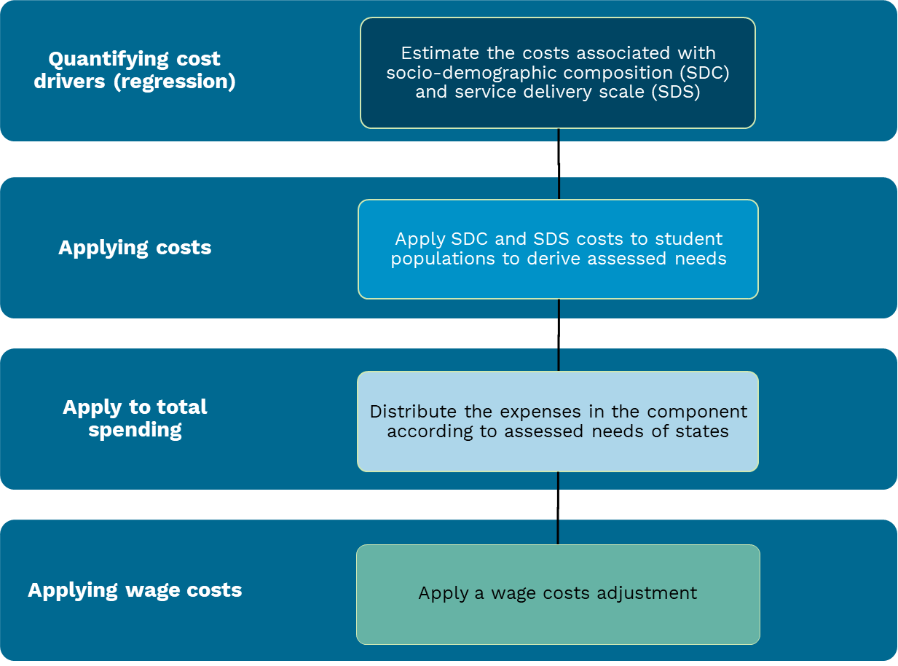

#### Quantifying cost drivers using a regression

The regression model allows the Commission to estimate the base cost of educating a student, and the additional costs of educating students from specific groups including secondary students and students who attend more remote schools.

The regression model uses data from the Australian Curriculum Assessment and Reporting Authority to model costs per student. This represents the total recurrent costs to states in providing a school, divided by the number of full-time equivalent students enrolled at that school.[5] The explanatory variables used in the model are outlined below and relate to the drivers of socio-demographic composition and service delivery scale. This allows the Commission to estimate the additional costs associated with these drivers.

##### Socio-demographic composition

Socio‑demographic composition accounts for student numbers, secondary student numbers, remoteness, socio‑educational status and Indigenous status using the variables listed below.

* Base student costs — the standard annual cost in providing education to a student.
* Secondary students — the additional cost of secondary students, defined as the proportion of students who are in year 7 or above, regardless of the institution they attend.
* Outer regional school students— the additional costs of providing education to students in outer regional areas.
* Remote school students — the additional costs of providing education to students in remote or very remote areas.
* Socio-educationally disadvantaged students — the additional costs of providing education to students from a low socio-educational background, represented by the proportion of students in the lowest quartile of educational advantage.[6]
* First Nations students — the additional cost of providing education to First Nations students, represented by the proportion of students who are First Nations students.

##### Service delivery scale

Service delivery scale accounts for the higher cost per student in more remote schools using the variables listed below.

* Fixed cost of a school — the fixed annual cost of running a school, represented by the inverse of the total number of students in a school.[7]
* Fixed cost of a secondary school — the fixed annual cost of running a secondary school, represented by the inverse of the number of students in a secondary school.

The regression produces dollar value estimates of the base cost of educating a student, as well as the additional costs associated with higher-cost students, and the fixed cost of schools. For example, Table 5 shows that in 2022–23, a student who attended an outer regional school was estimated to cost an additional $212.

Table 5 State funded government schools regression results, 2022–23

|  |  |
| --- | --- |
|  | Value |
| Socio-demographic composition | $ per student |
| Base student cost | 9,234 |
| Additional cost for |  |
| Secondary student | 834 |
| Outer regional school student | 212 |
| Remote or very remote school student | 2,715 |
| Socio-educationally disadvantaged student | 4,955 |
| First Nations student | 6,041 |
| Service delivery scale | $ per school |
| Fixed cost of a school | 357,504 |
| Fixed cost of a secondary school | 1,436,619 |

The values that are derived in the regression are additive. For example, in 2022–23, a First Nations student who attended a remote primary school was estimated to cost $17,990 ($9,234 + $6,041 + $2,715), plus their share of the fixed costs of that school.

The regression is recalculated each year to reflect evolving state funding formulas.

#### Applying socio-demographic composition costs

ABS data are available on the number of school students, First Nations students and secondary students in each state. Data from the Australian Curriculum Assessment and Reporting Authority on other socio‑demographic groups are scaled to be consistent with the ABS estimates. The costs per student group calculated in the regression are applied to these student counts. This derives the estimated socio-demographic composition costs of government students for each state.

Table 6 illustrates how costs associated with socio‑demographic composition are applied to state student populations to calculate assessed expense needs. The spending needs of each state, related to each element of socio‑demographic composition, can be found by multiplying the costs associated with the student group by the number of students in that group. For example, in 2022–23, Tasmania had around 24,000 students that were socio‑educationally disadvantaged. Therefore, the assessed cost that Tasmania faced in relation to socio‑educationally disadvantaged students was around $118,920,000 (24,000 * $4,955). The total assessed socio-demographic composition costs for a state are calculated by summing the cost per student group multiplied by the number of students in each group and summing them.

Table 6 Assessed socio-demographic composition costs by state, 2022–23

|  |  |  |  |  |  |  |  |  |  |  |  |
| --- | --- | --- | --- | --- | --- | --- | --- | --- | --- | --- | --- |
|  | Cost per student | NSW | Vic | Qld | WA | SA | Tas | ACT | NT | Total students | Total assessed costs |
|  | $ | '000 | '000 | '000 | '000 | '000 | '000 | '000 | '000 | '000 | $m |
| Students | 9,234 | 791 | 645 | 570 | 293 | 172 | 55 | 46 | 29 | 2,601 | 24,019 |
| Secondary students | 834 | 312 | 257 | 238 | 113 | 75 | 23 | 19 | 11 | 1,048 | 874 |
| Outer regional students | 212 | 37 | 26 | 83 | 21 | 23 | 20 | 0 | 17 | 227 | 48 |
| Remote or very remote students | 2,715 | 4 | 0 | 15 | 21 | 7 | 1 | 0 | 12 | 60 | 162 |
| Socio-educationally disadvantaged students | 4,955 | 251 | 180 | 189 | 88 | 57 | 24 | 6 | 14 | 810 | 4,012 |
| First Nations students | 6,041 | 71 | 17 | 63 | 26 | 12 | 7 | 2 | 13 | 210 | 1,270 |
| Total assessed SDC costs ($m) |  | 9,250 | 7,167 | 6,843 | 3,449 | 2,034 | 694 | 485 | 463 |  | 30,384 |

#### Applying service delivery scale costs

There are fixed costs associated with running a school, regardless of the size of that school. This means that small schools have a higher cost per student than larger schools. In 2022–23, the regression estimated the fixed cost of running a school was $357,504, with an additional $1.4 million for secondary schools (Table 5).

States have significant policy control over the size of their schools. Therefore, the Commission uses the average school size in each remoteness area across all states in the calculation of service delivery scale costs.

For example, in 2022–23, there were 1,876,334 government students attending the 3,455 schools in major cities nationally, or 543 students per school (Table 7). Given the regression estimated that each school had a fixed cost of $357,504, this represents a cost of $658 per student in major city schools. This fixed cost per student increases in more remote areas as average school size decreases.

Table 7 Fixed cost per student by remoteness area, 2022‑23

|  |  |  |  |  |  |
| --- | --- | --- | --- | --- | --- |
|  | Number of students | Number of schools | Average school size | Fixed cost per school ($) | Fixed cost per student ($) |
| Major city students | 1,876,334 | 3,455 | 543 | 357,504 | 658 |
| Inner regional students | 453,492 | 1,701 | 267 | 357,504 | 1,341 |
| Outer regional students | 229,040 | 1,121 | 204 | 357,504 | 1,750 |
| Remote students | 34,697 | 250 | 139 | 357,504 | 2,576 |
| Very remote students | 25,957 | 248 | 105 | 357504 | 3,416 |

The fixed cost per student for each remoteness area is applied to state student populations to calculate the assessed service delivery scale spending needs for each state (Table 8). The spending needs related to a state’s student population in each remoteness area is calculated by multiplying the fixed, per student cost in that remoteness area by the number of students in that remoteness area within the state.

Table 8 Assessed base service delivery scale costs by state, 2022–23

|  |  |  |  |  |  |  |  |  |  |  |  |
| --- | --- | --- | --- | --- | --- | --- | --- | --- | --- | --- | --- |
|  | Cost per student | NSW | Vic | Qld | WA | SA | Tas | ACT | NT | Total students | Total assessed costs |
|  | $ | '000 | '000 | '000 | '000 | '000 | '000 | '000 | '000 | '000 | $m |
| Major city | 658 | 600 | 501 | 365 | 226 | 126 | 0 | 46 | 0 | 1,864 | 1,227 |
| Inner regional | 1,341 | 151 | 117 | 107 | 25 | 17 | 34 | 0 | 0 | 451 | 604 |
| Outer regional | 1,750 | 37 | 26 | 83 | 21 | 23 | 20 | 0 | 17 | 227 | 397 |
| Remote | 2,576 | 3 | 0 | 8 | 13 | 5 | 1 | 0 | 5 | 34 | 88 |
| Very remote | 3,416 | 1 | 0 | 7 | 8 | 2 | 0 | 0 | 7 | 26 | 87 |
| Total assessed base SDS costs ($m) |  | 671 | 534 | 574 | 279 | 165 | 83 | 30 | 67 |  | 2,403 |

Secondary schools have higher fixed costs than primary or combined schools. The regression showed them to have fixed costs of $1,436,619 in addition to the $357,504 fixed costs faced by all schools.

Service delivery scale for secondary schools is calculated in the same way as for all schools with one exception. The number of schools is based on secondary schools, while the number of students includes all students in year 7 or above, regardless of whether they attend secondary schools, combined schools or (until 2022) South Australian primary schools.[8]

#### Rescaling spending needs to total spending

The regression model estimates state-only costs per student using finance data from the Australian Curriculum Assessment and Reporting Authority. The total state spending implicit in these data is different to the ABS Government Finance Statistics (GFS) estimate of total state spending. Therefore, once the assessed needs of each state are calculated, they must be rescaled such that the total state spending is consistent with GFS data.

The Australian Curriculum Assessment and Reporting Authority data indicate total spending on state funded government schools in 2022–23 was $34.0 billion. The equivalent GFS estimate was $37.3 billion. Thus, each state’s estimated need was increased by 10% to produce assessed expenses consistent with the adjusted budget.

#### Applying wage costs

Wages costs are a significant share of the total cost of providing schooling services. Differences in wage costs between states have a differential effect on the cost of providing schooling services. The schools assessment uses the Commission’s general method for measuring the influence of wage costs. Details on how this is calculated are in the wage costs chapter of the *Commission’s Assessment Methodology*.

#### Flexibility within the method

There is a conceptual case for assessing schools with different groups of First Nations students differently. This could be done by allowing for higher costs for schools with a high proportion of First Nations students, or higher costs for First Nations students who are disadvantaged or attending more remote schools. This conceptual case is not currently supported by the data. Each year, the Commission will retest variables reflecting the heterogeneity of the First Nations student population. If the latest data support it, the Commission may adjust its model after consulting with states.

### State funded non-government schools component

The assessment of state funded non-government schools is the same as the state funded government schools component but it uses a different group of explanatory variables. The model indicates that more remote schools do not attract a higher cost, so outer regional and remote schools are not separately identified in the regression model. While socio-educational disadvantage in the government schools regression uses the measure of the most disadvantaged 25%, the non‑government schools model uses the most disadvantaged 50%. This difference reflects that in non‑government schools the income dimension of socio-educational disadvantage impacts base funding through the capacity-to-pay concept which states use in their non-government funding.

Table 9 outlines the dollar values produced by the state funded non-government schools regression.

Table 9 State funded non-government schools regression results, 2022–23

|  |  |
| --- | --- |
|  | Value |
| Socio-demographic composition | $ per student |
| Base student cost | 1,351 |
| Additional cost for |  |
| Secondary student | 402 |
| Socio-educationally disadvantaged student | 3,024 |
| First Nations student | 272 |
| Service delivery scale | $ per school |
| Fixed cost of a school | 74,554 |
| Fixed cost of a secondary school | 39,422 |

The costs calculated in the regression are applied to student populations in the same way as in the state funded government schools component to derive total assessed needs for each state. These totals are rescaled such that the total state funding is equivalent to the GFS data. Finally, the wage cost factor is applied to the rescaled assessed expenses.

The First Nations variables which are currently not significant, will be retested annually in the same way as the state funded government schools component.

### Commonwealth funded government schools component

Commonwealth funding makes up around 22% of total recurrent funding for government schools.

The Commonwealth developed the Schooling Resource Standard to calculate the funding needs of each school. Based on this, an average cost per government student can be found for each state. These costs are applied to states’ student populations to derive the total level of funding needed in each state. An adjustment for differences in wage costs is then applied.

The state distribution of funding need is used to assess the spending associated with the Quality Schools Commonwealth payment. The actual distribution of the Quality Schools payment differs from the assessed payment for 2 reasons:

* different states negotiated for the Commonwealth to pay different proportions of their need
* the Schooling Resource Standard does not recognise that wage costs differ between states.

As part of the Better and Fairer Schools Agreement (2025‑2034), states have bilateral agreements with the Commonwealth, which outline new funding share levels.[9] The Commonwealth has committed to funding a different proportion of the Schooling Resource Standard in each state.

The 2015 Review Terms of Reference, which still apply to this aspect of the assessment, ask the Commission to “not have the effect of unwinding the recognition of educational disadvantage embedded in the National Education Reform Agreement funding arrangements”. As it has done since the 2015 Review, the Commission’s assessment incorporates the measures of educational disadvantage used by the Commonwealth.

Figure 2 Commonwealth funded government schools assessment method

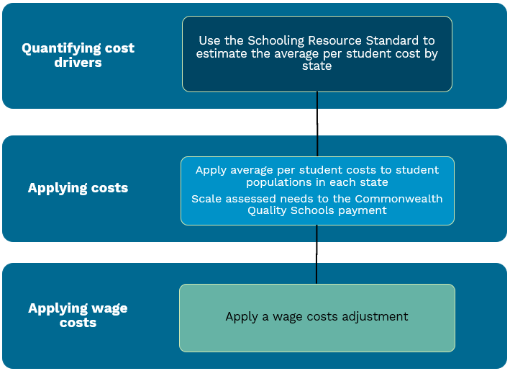

#### Quantifying cost drivers

The Schooling Resource Standard derives an estimate of the total public funding a school requires to support its students and is updated annually.[10] This estimate reflects a base cost with additional loadings for:

* students with disability
* First Nations students
* socio-educationally disadvantaged students
* students with low English proficiency
* school size
* school location.

The base cost and additional cost loadings outlined in the Schooling Resource Standard are used to calculate an average funding per student amount for each state which describes the average cost of a student in the state.

#### Applying costs

The average per student Schooling Resource Standard for each state is multiplied by state student population numbers to obtain a total spending need.

The total funding by state is then scaled to reflect the total Commonwealth Quality Schools payment. In 2022–23, the Commonwealth Quality Schools payment represented 19% of the total funding required. This differs from the 22% noted in paragraph 34 because some government schools have sources of income other than the Commonwealth and state governments and because schools are not yet funded at 100% of the Schooling Resource Standard.

#### Applying wage costs

The wage cost factor is applied in the same way as it is in the state funded government schools component.

## GST distribution in the 2025 Review

Table 10 shows the GST impact of the assessment in the 2025 Review.

Table 10 GST impact of the schools assessment, 2025–26

|  |  |  |  |  |  |  |  |  |  |
| --- | --- | --- | --- | --- | --- | --- | --- | --- | --- |
|  | NSW | Vic | Qld | WA | SA | Tas | ACT | NT | Total effect |
|  | $m | $m | $m | $m | $m | $m | $m | $m | $m |
| State funded government schools | -423 | -854 | 842 | 317 | -179 | 60 | -50 | 286 | 1,505 |
| State funded non-government schools | -27 | -15 | 42 | -8 | 20 | -12 | 2 | -3 | 65 |
| Commonwealth funded government schools | -126 | -169 | 207 | 27 | -32 | 3 | -22 | 113 | 349 |
| Total ($m) | -576 | -1,038 | 1,091 | 336 | -191 | 51 | -69 | 396 | 1,874 |
| Total ($pc) | -66 | -145 | 190 | 110 | -101 | 88 | -143 | 1,540 | 67 |

Note: Magnitude and direction of GST impact can change from year to year.

1. Adjusted budget calculations use ABS Government Financial Statistics data to determine actual state expenses. For further detail see the adjusted budget chapter of the *Commission’s Assessment Methodology*.
2. Tables in this chapter, unless otherwise stated, use 2022–23 data.
3. For constitutional reasons this spending is passed through state governments.
4. Department of Education, [*Schooling Resource Standard*](https://www.education.gov.au/recurrent-funding-schools/schooling-resource-standard), Department of Education website, 2024, accessed 20 June 2024.
5. Cost per student excludes school funding provided by the Commonwealth as this funding is assessed in the Commonwealth funded government schools component.
6. Educational advantage is calculated using Socio-Educational Advantage which ranks students from least to most educationally advantaged based on a range of attributes of the student’s parents.
7. In a regression model predicting cost per school, the fixed cost of a school would be the intercept, and the socio-demographic attributes measured would reflect the number of students in each group in each school. To convert this to a per student cost model, both the cost per school and all independent variables needs to be divided by the number of students (and the regression needs to be weighted by the number of students in each school). Thus, the fixed cost of a school is reflected by the inverse school size in the per student cost model.
8. Until 2022, South Australia educated year 7 students in primary schools rather than in high schools.
9. Department of Education, [*The Better and Fa**irer Schools Agreement (2025-2034)*](https://www.education.gov.au/recurrent-funding-schools/national-school-reform-agreement/better-and-fairer-schools-agreement-20252034), Department of Education website, 2024, accessed 20 June 2024
10. Department of Education, [*Schooling Resource Standard*](https://www.education.gov.au/recurrent-funding-schools/schooling-resource-standard).