# Welfare

## Overview

The welfare assessment covers state and territory (state) recurrent spending on social protection, including services for families and children, low-income households, disability services and other programs to mitigate social exclusion. It has the following components:

* child protection and family services
* National Disability Insurance Scheme
* concessions
* homelessness services
* other welfare.

The assessment recognises that welfare expense needs are influenced by the following.

* First Nations people— states with above-average shares of First Nations people have higher spending needs.
* Age — states with above-average shares of children have higher spending needs.
* Remoteness — states with above-average shares of people living in remote areas have higher spending needs.
* Socio-economic status — states with above-average shares of people from low socio-economic backgrounds have higher spending needs.
* Number of concession card holders — states with above-average shares of concession card holders have higher spending needs.
* Population shares —for some services each states’ expense needs are the same per person.
* Service delivery scale — states which provide services to small population centres have higher spending needs.
* Wage costs — states facing greater wage cost pressures have higher spending needs.

## Actual state expenses

The first step in calculating assessed expenses is identifying actual state expenses on welfare services.[1] States collectively spent 8.5% of their total recurrent expenses on welfare services in 2022–23. Table 1 shows expenses broken down by component and Table 2 outlines actual expenses by state in 2022–23.[2]

Table 1 Welfare expenses by component, 2022–23

|  |  |  |
| --- | --- | --- |
|  | 2022-23 | |
|  | $pc | $m |
| Child protection and family services | 335 | 8,816 |
| NDIS | 407 | 10,701 |
| Concessions | 95 | 2,486 |
| Other welfare | 114 | 2,990 |
| Homelessness services | 52 | 1,380 |
| Total | 1,002 | 26,374 |
| Proportion of total expenses (%) |  | 8.5 |

Table 2 Welfare expenses by state, 2022–23

|  |  |  |  |  |  |  |  |  |  |
| --- | --- | --- | --- | --- | --- | --- | --- | --- | --- |
|  | NSW | Vic | Qld | WA | SA | Tas | ACT | NT | Total |
| Welfare ($m) | 7,645 | 6,352 | 5,622 | 3,040 | 2,223 | 668 | 379 | 445 | 26,374 |
| Welfare ($pc) | 927 | 946 | 1,044 | 1,072 | 1,211 | 1,167 | 821 | 1,772 | 1,002 |
| Proportion of total expenses (%) | 7.7 | 8.1 | 9.6 | 8.9 | 11.9 | 9.4 | 5.9 | 7.3 | 8.5 |

## Structure of assessment

Table 3 outlines the drivers that influence expenses in each component.

Table 3 Structure of the welfare assessment

|  |  |  |
| --- | --- | --- |
| Component | Driver | Influence measured by driver |
| Child protection and family services | Socio-demographic composition | Age, Indigenous status, remoteness and socio-economic status influence the use and cost of services. |
| Regional costs | The cost of providing services increases as the level of remoteness increases. |
| Service delivery scale | The lack of economies of scale when providing services to small populations affects costs. |
| Wage costs | Differences in wage costs between states affect costs. |
| NDIS | Census state population | This driver reflects the method used to determine state contributions to the National Disability Insurance Agency to provide services through the NDIS. |
| Concessions | Socio-demographic composition | The number of Pension Concession Card, Health Care Card and Veterans’ Benefit holders in each state affects costs. |
| Homelessness services | Socio-demographic composition | Age, Indigenous status, remoteness and socio-economic status influence the use and cost of services. |
| Regional costs | The cost of providing services increases as the level of remoteness increases. |
| Wage costs | Differences in wage costs between states affect costs. |
| Cross-border costs | The ACT incurs additional costs in providing services to NSW residents. |
| Other welfare | Non-deliberative equal per capita | These expenses are not differentially assessed. |
| Regional costs | The cost of providing services increases as the level of remoteness increases. |
| Wage costs | Differences in wage costs between states affect costs. |

## Data

The data used in the assessment are outlined in Table 4.

Table 4 Data used in the welfare assessment

|  |  |  |  |
| --- | --- | --- | --- |
| Source | Data | Updated | Component |
| Australian Institute of Health and Welfare (AIHW) | Number and characteristics of child protection substantiations | Annually | Child protection and family services |
| Number and characteristics of users of specialist homelessness services | Annually | Homelessness services |
| ABS | Census population by state | 5-yearly | NDIS |
| Estimated resident population by state | Annually | Child protection and family services |
| Other welfare |
| Homelessness services |
| States | State spending on concessions | Annually | Concessions |
| Department of Social Services | Total state and in-kind contributions to the National Disability Insurance Scheme | Annually | NDIS |
| Number of low-income and pensioner concession cardholders | Annually | Concessions |
| Department of Veterans’ Affairs | Number of veterans concession cardholders | Annually | Concessions |

Note: Data for the regional, service delivery scale and wage cost adjustments are also included in this assessment.

The adjusted budget data sources are outlined in the adjusted budget chapter of the *Commission’s Assessment Methodology*.

## Assessment method

This section outlines the assessment method for each component.

### Child protection and family services

The child protection and family services component has 2 sub-components:

* child protection
* out of home care.

The key steps in the calculation of assessed expenses for each sub-component are as follows:

* derive sub-component expenses for child protection and out of home care services
* assess each sub-component using the same socio-demographic composition assessment
* aggregate assessed expenses for the 2 sub-components
* apply regional and service delivery scale costs
* apply wage costs.

Figure 1 shows each step of the child protection and family services assessment.

Figure 1 Child protection and family services assessment method

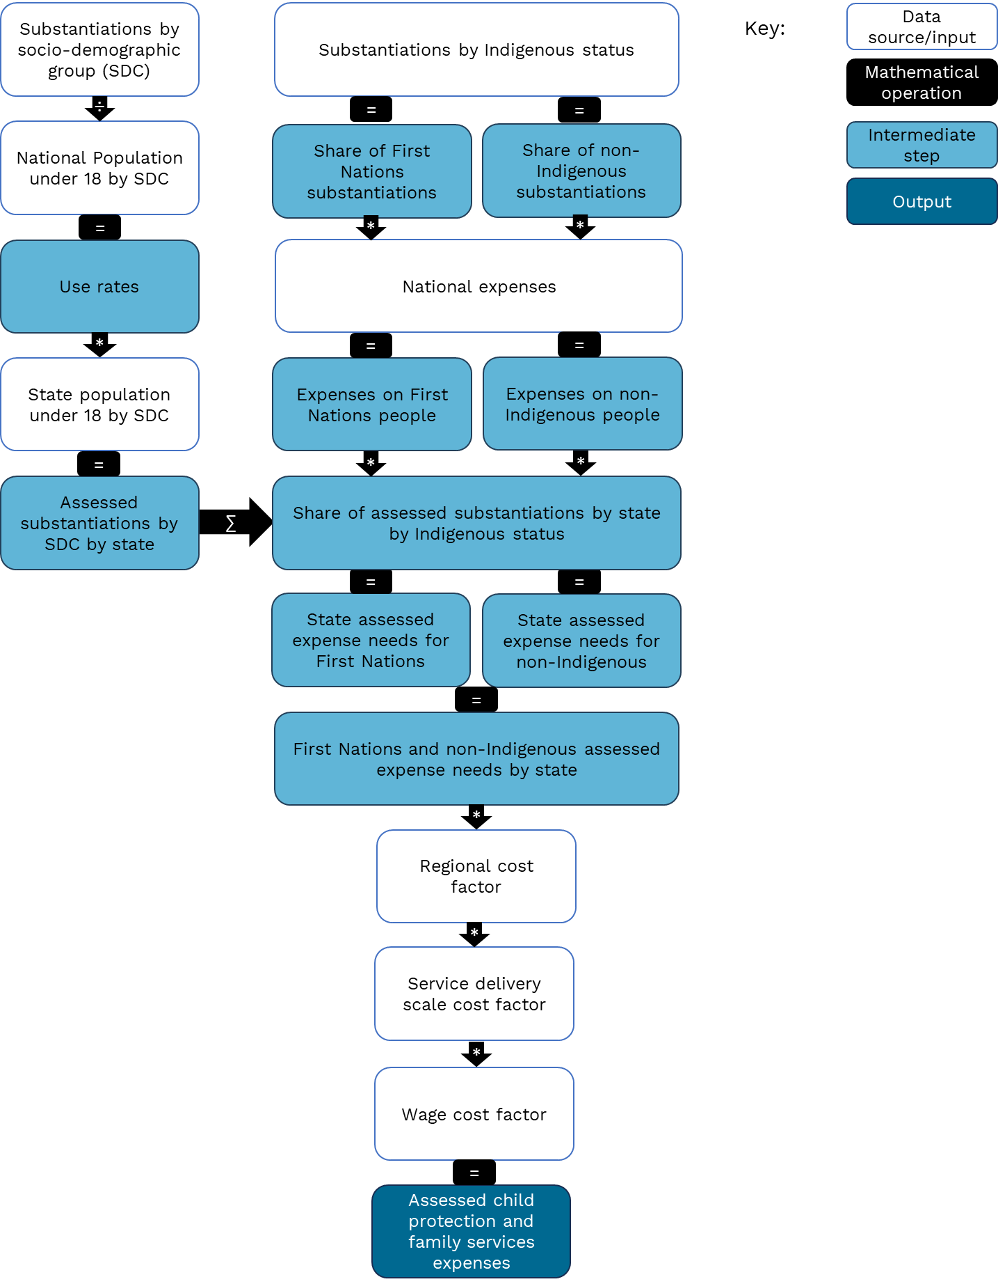

#### Sub-component expenses

The first step is to disaggregate total state child protection and family services expenses into spending on child protection and out of home care using data from the *Report on Government Services* because First Nations use of Out of Home Care services is materially different.[3],[4]

State spending for child protection services and out of home care are further disaggregated by Indigenous status. This split is based on the share of total clients who identify as First Nations or non-Indigenous from data collected by the Australian Institute of Health and Welfare. Non-identifying clients are allocated according to the ratio of First Nations to non-Indigenous identifying clients.

Separate assessments are undertaken for spending on First Nations and non‍-‍Indigenous clients in each sub‑component because the use of each type of service by First Nations people is materially different.

#### Child protection and out of home care socio-demographic assessment

The socio-demographic assessments for child protection and out of home care services recognise that the socio-demographic composition of the population with respect to Indigenous status, socio-economic status and remoteness affect the use and cost of services in each state.

The assessed socio-demographic groups reflect population groups who enter the child protection system more frequently than other population groups. Children who identify as First Nations, live in remote areas or are from lower socio‍-‍economic status areas are more likely to enter the protection system compared to non‍-‍Indigenous children from major cities from higher socio‍-‍economic status areas (Figure 2).

Figure 2 Child (0–17) protection substantiations (per 10,000) by Indigenous status, socio-economic status and remoteness, 2022–23

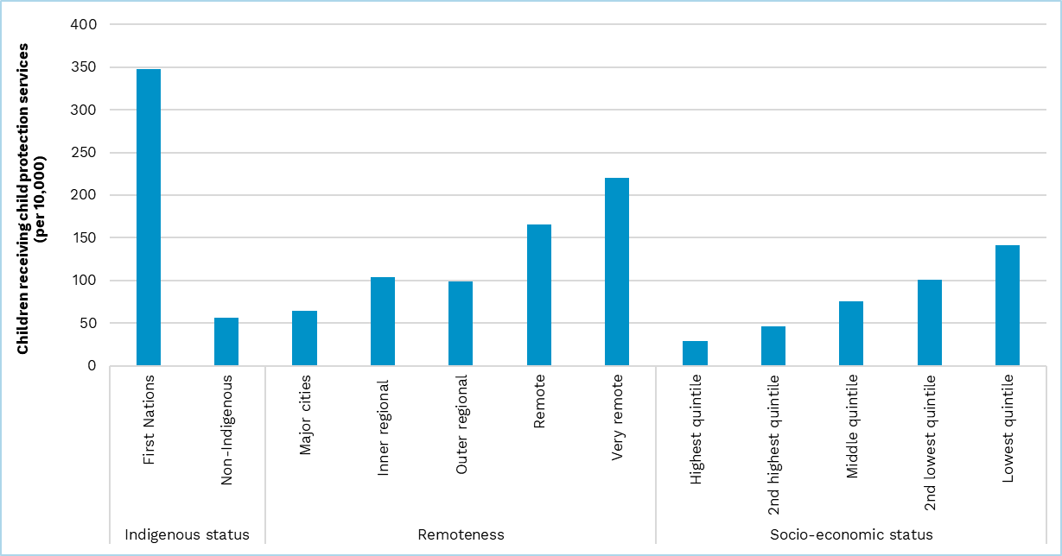

Source: Commission calculation based on AIHW (Australian Institute of Health and Welfare), [*Data Tables: Child protection Australia 2022–23*](https://www.aihw.gov.au/reports/child-protection/child-protection-australia-insights/data) [data set], AIHW, 2023, accessed 22 August 2024.

The child protection and out of home care socio-demographic assessments have the following steps:

* estimate the national average rate of substantiations by socio‑demographic group
* estimate assessed substantiations for each state
* apportion national spending to states using the share of assessed substantiations in each state.

##### Estimate the national average rate of substantiations by socio-demographic group

To differentially assess states using their socio-demographic composition, the Commission estimates the national average substantiation rate for each population sub-group. The national average substantiation rate is used to reduce the influence of state policy choices by representing an average of state policies.

The substantiation rate calculation uses Australian Institute of Health and Welfare data on child protection substantiations for clients aged 0–17 years and the estimated resident population aged 0–17 years, cross-classified by the identified socio-demographic characteristics.

##### Estimate assessed substantiations by socio-demographic group by state

Assessed substantiations are calculated by multiplying the national average substantiation rate for each socio-demographic group by the corresponding population in each state.

##### Apportion state spending using assessed substantiations by state

Each state’s share of total state child protection or out of home care expenses is equal to its share of assessed child protection substantiations by Indigenous status.

The assessed expenses for each state for child protection and out of home care services are subsequently aggregated for a component total before applying the regional cost, service delivery scale and wage cost adjustments.[5]

#### Applying the regional costs adjustment

The regional costs adjustment accounts for the additional costs states face in providing services in remote locations. The child protection component uses the general regional cost gradient because of a lack of suitable data to estimate a component-specific measure of these costs. Further details on the general cost gradient are in the geography chapter of the *Commission’s Assessment Methodology*.

#### Applying the service delivery scale costs adjustment

The child protection and family services component also includes a service delivery scale adjustment. Service delivery scale estimates the additional costs to states from a lack of economies of scale when providing services in remote and very remote Australia. It reflects that the average cost per client increases when providing services to small populations. For example, the cost of group homes per child is likely to be higher when there are fewer children requiring assistance. Further details on service delivery scale costs are in the geography chapter of the *Commission’s Assessment Methodology*.

#### Applying the wage costs adjustment

Wage costs are a significant share of the total cost of providing child protection and family services. Differences in wage costs between states have a differential effect on the cost of providing welfare services. The child protection and family services assessment uses the Commission’s general method for measuring the influence of wage costs. Further details on the wage costs adjustment are in the wage costs chapter of the *Commission’s Assessment Methodology*.

### National Disability Insurance Scheme (NDIS)

States provide funding to the National Disability Insurance Agency (NDIA) to facilitate the National Disability Insurance Scheme (NDIS).

State NDIS contributions are agreed in advance and set out in Commonwealth-state intergovernmental agreements.[6] The contribution of a state to the NDIS is based on each state’s share of the national population at the most recent census, currently the 2021 Census. The assessment uses these shares to assess state NDIS spending. Each state’s share of total state NDIS contributions is fixed between censuses.

### Concessions

State concessions for pensioners and low-income households include concessions for:

* electricity and other energy
* water and wastewater
* council rates.

Total state spending on concessions is assessed using each state’s share of eligible concession card holders (low-income health card, pension cards, and veterans’ benefits). Each card type is treated identically.

Data on the number of concession card holders is collected from the relevant Commonwealth agency. Low-income health and pension cards are collected from Services Australia and veterans’ benefit cards are collected from the Department of Veterans’ Affairs.

### Homelessness services

The homelessness services assessment has the following steps:

* estimate state homelessness services spending
* assess state spending using a socio-demographic composition assessment
* apply regional costs
* apply wage costs.

Figure 3 shows each step of the homelessness services assessment.

Figure 3 Homelessness services assessment method

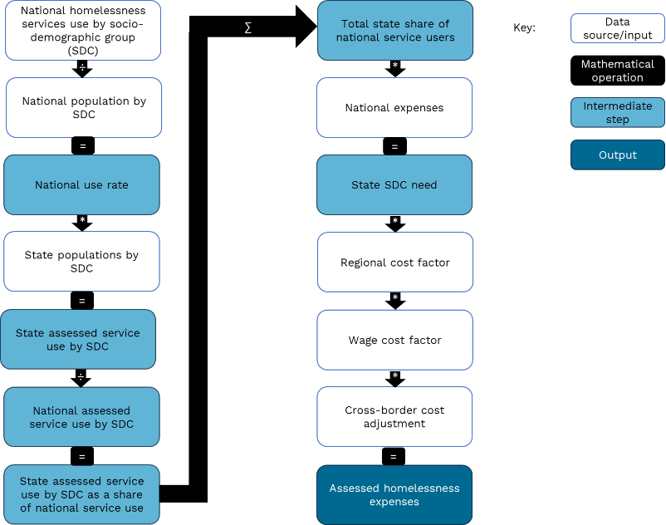

#### Estimating state homelessness services spending

State spending on homelessness services is not identified in the ABS Government Finance Statistics and therefore this information is collected from the states. States report homelessness services expenses to the Commission cross-classified by the classification of the functions of government – Australia (COFOG-A) as defined in the ABS Government Finance Statistics framework.

Where states report spending in a category other than welfare, such as housing, the Commission reclassifies the relevant expenses into the welfare category. If a state is unable to provide homelessness services expenses by COFOG-A, the Commission uses annual homelessness spending from the *Report on Government Services* and uses a weighted average of state reported spending by category to make an adjustment.[7] For example, a 6-state average may indicate that 10% of state homelessness services spending is in the housing category. For states which do not provide COFOG-A classified data, it is assumed that 10% of reported homelessness services spending from the *Report on Government Services* is classified in housing.

#### Homelessness services socio-demographic assessment

The socio-demographic assessment for homelessness services recognises that the socio-demographic composition of the population with respect to age, Indigenous status, socio-economic status and remoteness affect the use and cost of services in each state.

The drivers of service use were informed by the target population groups from the National Housing and Homelessness agreement. In the agreement, First Nations people, welfare recipients, young adults and the elderly were considered priority groups. In the subsequent National Social Housing and Homelessness agreement, which began on 1 July 2024, First Nations people are the sole priority group.[8] Figure 4 shows homelessness services clients per 10,000 people for each socio‍-‍demographic group.

Figure 4 Specialist Homelessness Services clients per 10,000 population by socio‑demographic group, 2022–23

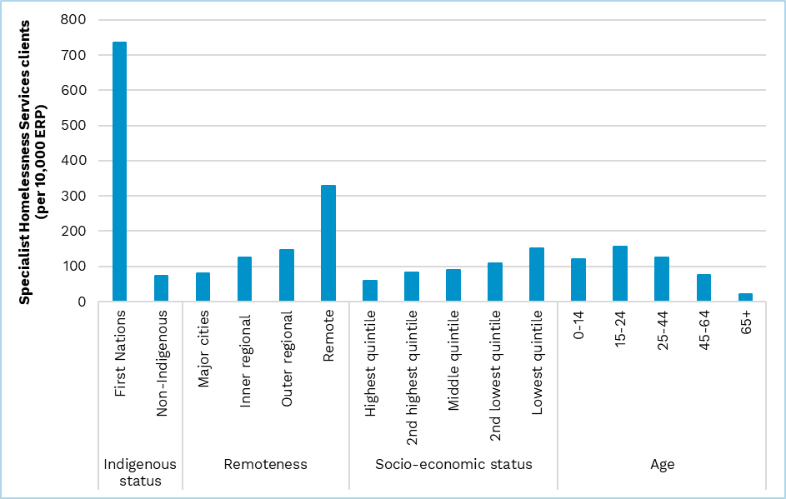

Note: Remote and very remote Australia have been aggregated into a single remote category to reduce the impact of lower service provision in very remote Australia on the assessment.

Source: Commission calculation based on AIHW (Australian Institute of Health and Welfare), [*Specialist Homelessness Services Collection data cubes 2011–12 to 2022–23*](https://www.aihw.gov.au/reports/homelessness-services/shsc-data-cubes/contents/data-cubes) [data set], AIHW, 2023, accessed 22 August 2024.

Subsequently, regional costs, wage costs, and cross-border cost adjustments are applied to capture the cost of providing services in regional and remote Australia, the impact of differences in state wage levels, and the provision of homelessness services by the ACT to residents of New South Wales.

##### Estimating the national average rate of service use by different population groups

Data on the use of homelessness services cross-classified by population groups is sourced from the Australian Institute of Health and Welfare. Instances of service use are compared against the size of the corresponding cross-classified estimated residential populations to estimate the use rate for homelessness services for each socio‍-‍demographic group.

##### Estimate assessed users of homelessness services by socio-demographic group by state

The national average rate of homelessness services use is used to estimate the number of clients by state under average state policy.

National average use rates are multiplied by state estimated resident populations cross‍-‍classified by the same socio-demographic characteristics to estimate assessed clients under average policy.

##### Apportion state spending using share of assessed service clients by state

Each state’s assessed need for spending on homelessness services is equal to its share of assessed clients.

#### Applying the regional costs adjustment

The regional costs adjustment is applied as outlined in paragraph 21.

#### Applying the wage costs adjustment

The wage costs adjustment is applied as outlined in paragraph 23.

#### Applying the cross-border costs adjustment

The homelessness services assessment also recognises the cost to the ACT of providing homelessness services to New South Wales residents. It is estimated using the national average cost per homelessness service client and the number of New South Wales residents accessing services in the ACT, net of ACT residents accessing services in New South Wales.

### Other welfare

The assessment of other welfare is undertaken in 3 steps:

* assess total other welfare spending equal per capita
* apply regional costs
* apply wage costs.

Other welfare is assessed as a non-deliberative equal per capita assessment because the Commission could not identify a suitable driver of need. As a result, each state’s spending need is their population share of national other welfare spending.

The expenses in this component include but are not limited to:

* non-NDIS disability services
* state-provided aged care services
* national redress scheme for institutional child sexual abuse
* support for refugees.

#### Applying the regional costs adjustment

The regional costs adjustment is applied as outlined in paragraph 21.

#### Applying the wage costs adjustment

The wage costs adjustment is applied as outlined in paragraph 23.

## GST distribution in the 2025 Review

Table 5 shows the GST impact of the assessment in the 2025 Review.

Table 5 GST impact of the welfare assessment, 2025–26

|  |  |  |  |  |  |  |  |  |  |
| --- | --- | --- | --- | --- | --- | --- | --- | --- | --- |
|  | NSW | Vic | Qld | WA | SA | Tas | ACT | NT | Total effect |
|  | $m | $m | $m | $m | $m | $m | $m | $m | $m |
| Child protection and family services | 111 | -797 | 392 | 67 | -70 | 50 | -68 | 315 | 935 |
| NDIS | 11 | -7 | -6 | -8 | 5 | 4 | 1 | 1 | 22 |
| Concessions | -15 | -28 | 37 | -39 | 44 | 22 | -22 | 1 | 104 |
| Other welfare | 0 | -4 | -4 | 8 | -5 | -1 | 2 | 5 | 14 |
| Homelessness services | -10 | -73 | 49 | 6 | -8 | 6 | -8 | 37 | 99 |
| Total ($m) | 97 | -910 | 469 | 34 | -34 | 80 | -95 | 360 | 1,039 |
| Total ($pc) | 11 | -127 | 82 | 11 | -18 | 139 | -197 | 1,398 | 37 |

Note: Magnitude and direction of GST impact can change from year to year.

1. The adjusted budget calculations use ABS Government Finance Statistics data to determine actual state expenses. For further detail see the adjusted budget chapter of the *Commission’s Assessment Methodology*.
2. Tables in this chapter, unless otherwise stated, use 2022–23 data.
3. SCRGSP (Steering Committee for the Review of Government Service Provision), [*Report on Government Services 2024,* Part F, Section 16: Child protection services](https://www.pc.gov.au/ongoing/report-on-government-services/2024/community-services/child-protection), Productivity Commission, 2024, accessed 26 August 2024.
4. In 2022–23, 34% of child protection substantiations were for First Nations children, while 44% of children in out of home care identified as First Nations despite comprising 7% of Australian children aged 0-17.
5. Out of home care is assessed using child protection substantiations, because of confidentiality concerns with disaggregating the number of children in out of home care.
6. Commonwealth-State NDIS intergovernmental agreements are published at: National Disability Insurance Agency (NDIA), [*Intergovernmental agreements*](https://www.ndis.gov.au/about-us/governance/intergovernmental-agreements), NDIA website, 2022, accessed 26 August 2024.
7. SCRGSP, [*Report on Government Services* *2024*](https://www.pc.gov.au/ongoing/report-on-government-services/2024), Part G, Section 19: Homelessness services, Productivity Commission, 2024, accessed 26 August 2024.
8. DSS (Department of Social Services), [*National Agreement on Social Housing and Homelessness*](https://www.dss.gov.au/housing-and-homelessness-strategy/national-agreement-social-housing-and-homelessness), DSS , 2024, accessed 26 August 2024.