# 2025 Methodology Review: justice draft position paper

## Overview

During the 2025 Methodology Review, finalisation of the justice assessment method was delayed until the 2026 Update. This was to enable substantive consultation on some potential method changes and to allow for the use of recent data, which are less likely to reflect temporary changes in service delivery made in response to the COVID-19 pandemic. Attachment A provides a timetable for state and territory (state) consultation on the justice assessment in the lead up to the 2026 Update. Attachment B provides a list of positions finalised during the 2025 Review.

The draft positions presented in this paper are based on analysis from only 2022–23 data. The Commission will use both 2022–23 and 2023–24 data in the revised justice assessment method for the 2026 Update. Draft positions are therefore subject to further change as they may be influenced by the inclusion of 2023–24 data.[1]

A paper on changes since the draft position paper and indicative GST impacts will be provided to states in October 2025.

The Commission invites states to comment on the draft positions presented in this paper by 8 August 2025.

## Assessment issues

### Justice model and data issues

In the justice chapter of *Review Outcomes* for the 2025 Review, the Commission decided to:

* broadly retain the 2020 Review model if supported by updated state data
* not apply discounts or equal per capita assessments in response to policy neutrality concerns
* not request data from states on an ongoing annual basis
* update the assessment using 2022–23 and 2023–24 data
* consider how cultural and linguistic diversity may affect state justice service costs as part of its forward work program.

Are 2022–23 data fit for purpose?

#### State views

All states agreed that data from 2019–20 to 2021–22 did not reflect typical justice services and costs. Other than South Australia, all states supported using 2022–23 data in the assessment. South Australia proposed 2022–23 data be analysed for potential COVID-19 influence prior to use.

The Northern Territory raised the possibility of using annual data to update the assessment. It considered that annual data would better capture short-term and medium-term trends in justice service use, particularly in remote areas.

Western Australia said it would be prudent to include 2023–24 and 2024–25 data, particularly if 2022–23 data were COVID-19 affected, but thought an annual data request could be burdensome. Queensland did not support requesting data from states on an ongoing annual basis.

Victoria expressed broad concerns regarding the data used to inform the assessment. It said the assessment is unable to adequately capture the drivers of justice expense needs because of data comparability issues. Victoria recommended the Commission discount, or assess components equal per capita, until a nationally consistent dataset is available. Victoria’s consultant also said data limitations warranted discounting the assessment. Queensland supported not applying any new equal per capita assessments or discounts due to data concerns and supported the data used in the assessment.

#### Commission response

In *Review Outcomes* for the 2025 Review, the Commission considered that data used in the justice assessment are the best currently available and fit for purpose. The Commission’s analysis of ABS data for 2022–23 indicated that these data had not been unduly affected by COVID-19. Figure 1 indicates that there has been a return to pre-COVID-19 levels of miscellaneous offences in Australia in 2022–23 and 2023–24, following the significant easing of COVID-19 restrictions in 2022 and the cessation of state lockdowns.[2]

**Figure 1 ABS miscellaneous offences in Australia, 2015–16 to 2023–24**

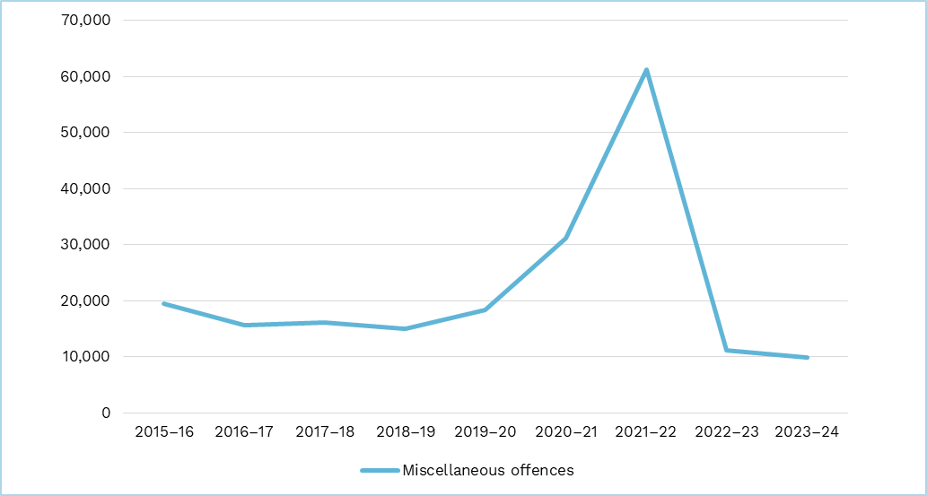

Source: Commission calculation based on ABS data from the 2023–24 release of ‘Recorded Crime – Offenders’.

Note: The ABS notes in its 2021–22 release of ‘Recorded Crime – Offenders’ that ‘miscellaneous offences increased by 30,020 offenders in 2021–22, a 96% increase from the previous year (from 31,209 to 61,229 offenders). This was largely due to fines being issued for COVID-19 related offences in New South Wales’.

The Commission has tested 2022–23 state data and considers that the data reflect normal justice services and that similar patterns are reflected broadly across states and in the national average. The Commission has found that the 2020 Review drivers in the justice assessment (with some exceptions discussed elsewhere in this paper) remain conceptually sound and that these relationships are evident in the data collected.

The Commission has collected data for 2023–24. Data are currently being processed for use in the assessment. The Commission will present states with the proposed final assessment for justice, incorporating 2023–24 data in October 2025.

##### Police

State-provided data show that on a national level, First Nations people are 11 times more likely to be charged as an offender (per 1,000 persons) than non-Indigenous people.[3] First Nations people have a higher proportion of offenders per capita than non–‍Indigenous people in every state.

Figure 2 Offence rates by Indigenous status per 1,000 persons, 2022–23

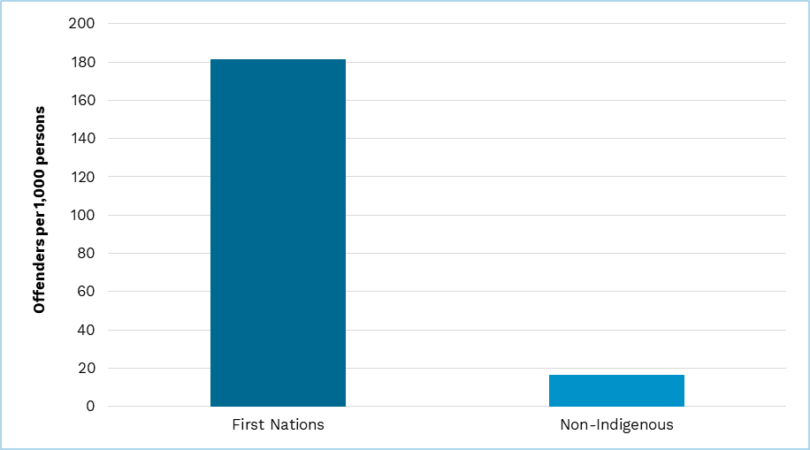

Note: Commission calculation based on 2022–23 state-provided data.

National offence rates remain higher amongst younger people, with the 15–24 and 25–44 age groups the highest across the average of all states. Commission analysis indicated that this relationship is significant for both First Nations and non‑Indigenous people.

Figure 3 Offence rates by Indigenous status and age per 1,000 offenders, 2022–23

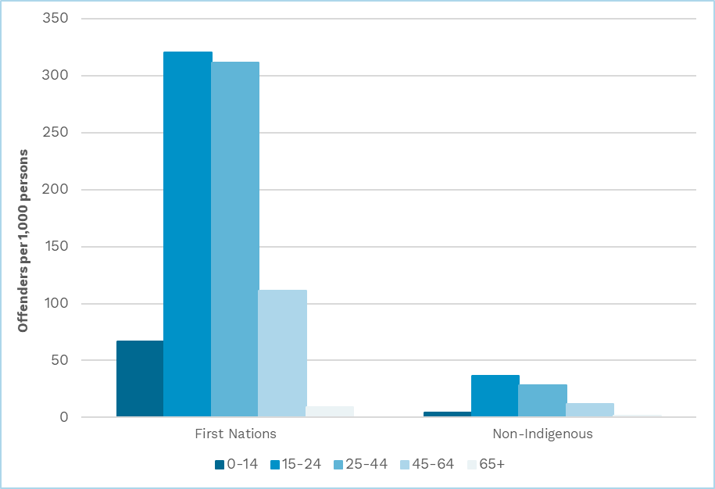

Note: Commission calculation based on 2022–23 state-provided data.

The Commission found that a national pattern continues to exist between offence rates and socio-economic status. The Commission discusses this issue in further detail, including a proposal to change First Nations socio-economic status to a 5-tier system, in the police assessment section.

The Commission examined the relationship between offenders and remoteness using 2022–23 data. It found that there was no clear relationship between offence rates and remoteness. This is consistent with the Commission’s finding in the 2020 Review.

##### Criminal courts

First Nations defendants appear before court around 9 times more than non‑Indigenous defendants per 1,000 persons. There is a higher proportion of First Nations defendants per 1,000 persons than non-Indigenous defendants in every state.

Figure 4 Defendants by Indigenous status per 1,000 persons, 2022–23

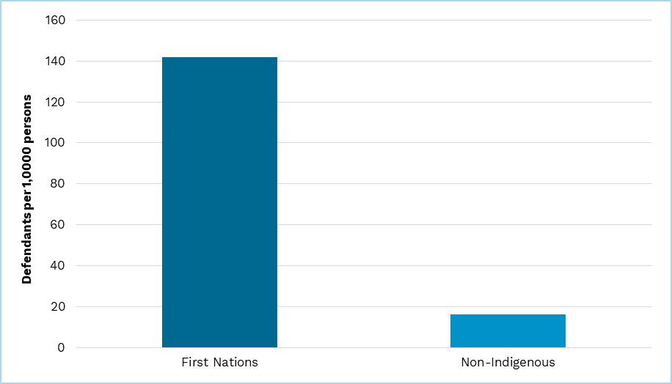

Note: Commission calculation based on 2022–23 state-provided data.

Younger people, that is people in the 15–24 and 25–44 age groups, have the highest proportions of defendants per 1,000 people of any age group. This is broadly reflected across states.

Figure 5 Defendants by Indigenous status and age per 1,000 persons, 2022–23

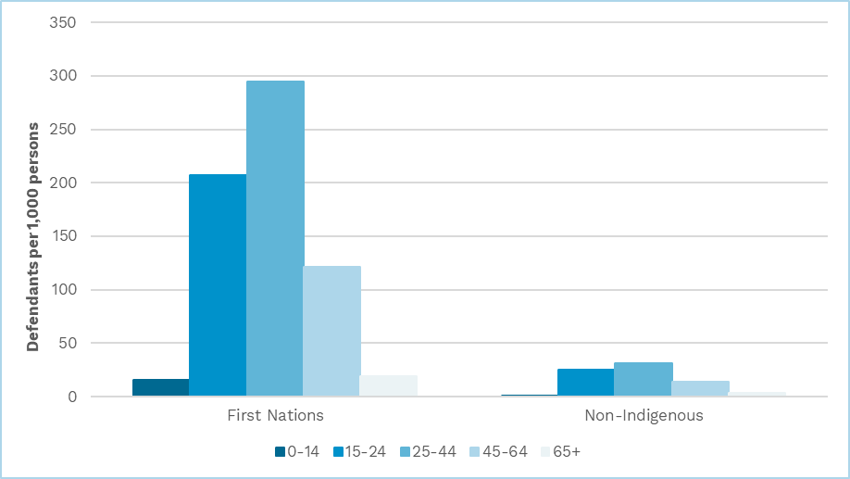

Note: Commission calculation based on 2022–23 state-provided data.

Commission analysis of 2022–23 data shows a clear, 5-tier relationship on the national level between defendant rates and socio-economic status.[4]

**Figure 6 Defendants by Indigenous status and socio-economic status per 1,000 persons, 2022–23**

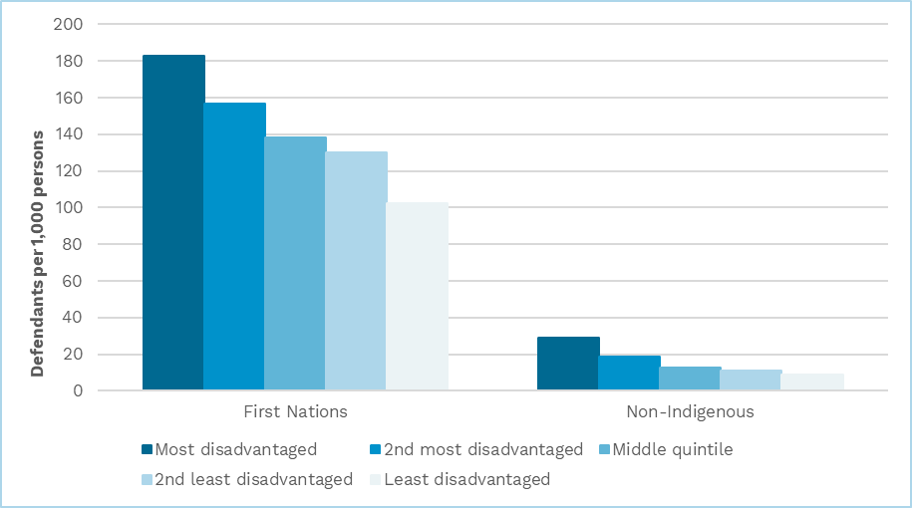

Note: Commission calculation based on 2022–23 state-provided data.

The Commission has retested the relationship between defendant rates and remoteness and still could not identify evidence of a clear relationship.

##### Prisons

The prisons assessment uses data from the ABS ‘Prisoners in Australia’ data series and the Australian Institute of Health and Welfare ‘Youth justice in Australia’ data series. These data are updated each year.

The Commission considers the ABS and Australian Institute of Health and Welfare data to be reliable and fit for purpose because they are audited for consistency of coding and quality across all states. The Commission considers that 2022–23 and 2023–24 ABS and Australian Institute of Health and Welfare data broadly reflect normal prison services.

**Figure 7 Prisoners by Indigenous status per 1,000 persons, average of 2022–23 and 2023–‍24**

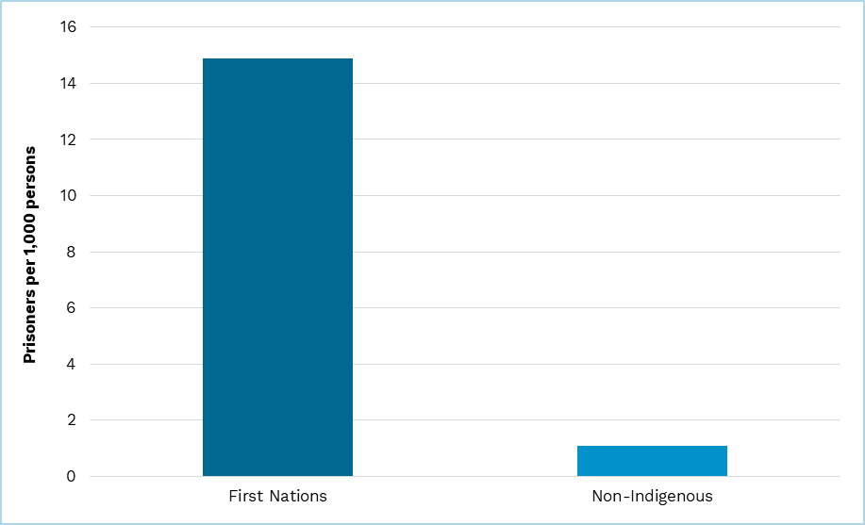

Note: Commission calculation based on the average of 2022–23 and 2023–24 combined ABS and Australian Institute of Health and Welfare data. ABS data are sourced from ‘Prisoners in Australia’. Australian Institute of Health and Welfare data are sourced from ‘Youth justice in Australia’.

**Figure 8 Prisoners by Indigenous status and age per 1,000 persons, average of   
2022–23 and 2023–24**

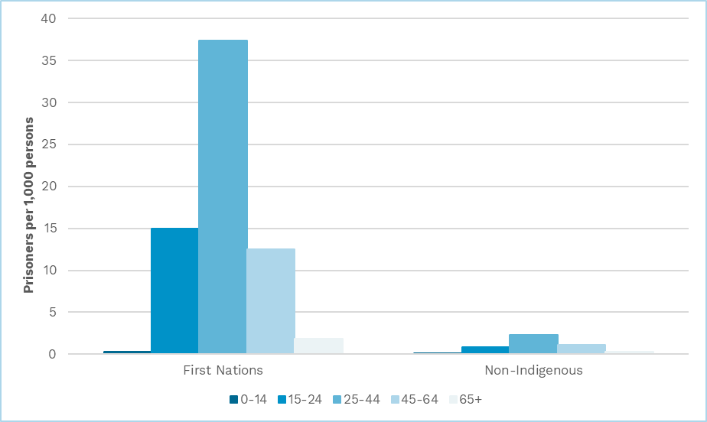

Note: Commission calculation based on the average of 2022–23 and 2023–24 combined ABS and Australian Institute of Health and Welfare data. ABS data are sourced from ‘Prisoners in Australia’. Australian Institute of Health and Welfare data are sourced from ‘Youth justice in Australia’.

#### Commission draft position

The Commission considers 2022–23 data from states are fit for use in developing the justice assessment because:

* justice service use and provision in 2022–23 have likely reverted to pre-COVID‑19 trends
* state data for police and courts show consistent patterns regarding socio‑demographic and socio-economic drivers of justice services.

The Commission considers 2022–23 and 2023–24 ABS and Australian Institute of Health and Welfare data to be the best available and fit for purpose for use in the prisons assessment.

### The impact of updating estimated residential population and 2021 First Nations proportions

In the 2024 Update, the Commission noted that there had been a substantial growth in First Nations populations due to non-demographic changes between the 2016 Census and the 2021 Census. The Commission decided to continue to use 2016 Census-based projections of First Nations estimated residential population until new use data could be incorporated into the justice assessment.

The revised justice assessment, to be published in the 2026 Update, will include new use data for 2022–23 and 2023–24. The Commission will therefore use 2021 Census‑based estimated residential populations in the revised justice assessment method.

The Commission will separate the effect of this change when calculating the effect of proposed method changes in the justice assessment.

### Police assessment

In the justice chapter of *Review Outcomes* for the 2025 Review, the Commission decided to:

* retain the 2020 Review regression model, in part because there was insufficient evidence to make changes based on potential barriers to policy reform
* continue to use proceedings counts for its measure of assessed offenders
* exclude traffic and breach of bail offence data from the assessment.

The Commission decided to undertake further analysis and consultation on:

* how central costs should be allocated to regions
* whether an additional variable for remote offenders should be added to the regression
* whether there is a case for a global cities driver
* the appropriate socio-economic group structure for First Nations people.

In addition, the Commission has updated the police regression with state data for 2022–23.

How should central costs be allocated to regions?

In response to state comments, the Commission considered whether the method used to allocate central costs to police districts prior to running the police regression was appropriate. The 2020 Review method allocated costs according to the proportion of total expenses in each police district.

#### State views

New South Wales said allocating all central policing costs across all police districts/regions in a state overestimates the cost of remoteness. It originally said that central costs should be allocated to police districts on an equal per capita basis, and an additional 25% discount should be applied to the regional cost gradient. New South Wales provided analyses to suggest that costs in metropolitan areas are greater than an equal per capita share would indicate.

Similarly, Victoria said the 2020 Review method overestimated remoteness cost weights and socio-demographic use weights. Victoria said it is more likely that central costs are driven by state population size rather than number of offences or remoteness of the population. It considered that central costs should be excluded from the regression and assessed separately on an equal per capita basis.

The Victorian consultant also raised concerns with central costs being allocated across states’ policing districts. Based on its analysis of Victoria’s expenses, it recommended allocating most police support services costs according to the number of full-time equivalent police officers (64%), some central costs on an equal per capita basis (32%) and a small proportion by offence statistics (4%).

Queensland did not support New South Wales’ and Victoria’s proposals to split central costs. It said that splitting these costs would breach 3 of the Commission’s 4 supporting principles (what states do, policy neutrality and practicality) and would be difficult to implement. Queensland noted that regional and remote police services rely more heavily on central services because they lack access to the same level of resources which are available to metropolitan police stations. It also said that central policing costs are driven by actual policing need and are not detached from other police spending.

#### Commission response

Commission analysis of state data found high levels of variation in the proportion of central cost expenses in each state. Between 43% and 77% of each state’s total expenses included in the police regression were attributable to central costs within that state.

The intention of the regression is to measure the police expenses per capita by remoteness area and expenses per offender. Given that the size of central cost expenses is a significant proportion of total costs, it is necessary for them to be allocated in some way.

In data returns, some states commented on the difficulty of allocating central costs to police districts because it is not in line with the budgetary practices of state police. The Commission encountered several other issues when seeking to identify an appropriate method to allocate central costs including:

* 2 states were unable to provide disaggregated data on central cost expenses
* a lack of comparability in the aggregation of central costs functions between states
* ambiguity on the functions or tasks completed by some state-identified central costs
* some central cost expenses being plausibly affected by more than one driver.

Given these challenges, judgement is required when determining an appropriate method for allocating central costs. The data available to the Commission allowed it to explore the possibility of allocating central costs according to proportions of police district full-time equivalent staff, offenders, population, expenses or a combination of these.

All states that recommended a method of allocating central costs suggested using full-time equivalent staff for at least some central cost expense line items. The Commission found that a significant proportion of central costs were incurred by police support services, such as human resources and training and development.

Central cost expenses that could be driven by offender numbers in each police district included expenses incurred by specialist response units such as forensics and canine squads.

The Commission also identified some central costs that are likely to be driven by population. These are mostly public-facing services and some police support services, such as media and communications, road policing, police call centres and major events units.

Police air and water services, emergency response centres and equipment procurement are all likely to have their expenses driven by the remote and challenging environments in which police operate.

Based on this analysis, the Commission considers that the central police services can be broadly grouped into police support services and specialist units. While some police support services expenses could be driven by population size, Commission analysis suggests full-time equivalent staff is the main driver for most police support service expenses as they are predominantly services used by, or in support of, police staff. For this reason and for simplicity, the Commission considers full‑time equivalent staff to be the driver of police support services expenses. It also considers the number of police staff employed in each police district in part reflects the size of its population.

As the use of specialist units is dependent on the occurrence of certain offences, the use of these services is driven by the number of offenders. However, given the increased expenses, such as travel costs, that the units incur when operating in remote areas, the Commission considers it appropriate to recognise that the cost of this aspect of policing increases with remoteness (Figure 9). The costs that special units incur will reflect the costs of policing in that location. The Commission, therefore, considers police district expenses to be the driver of specialist response units.

Figure 9 Police district expenses per capita (excluding central costs), 2022–23

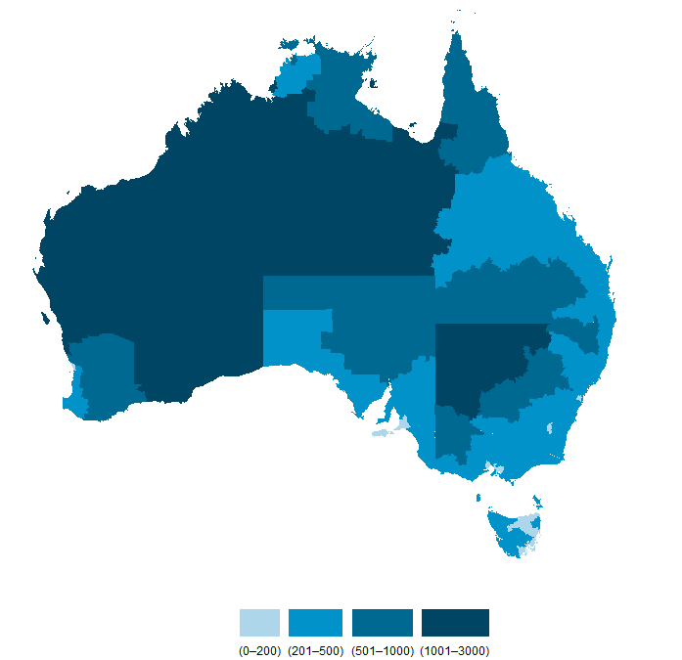

Note: Some differences in police district expenses may reflect differences in how states structure district and central budgets.

Commission analysis of the available data would suggest allocating 75% of central costs by the proportion of full-time equivalent staff in each police district and 25% by police district expenses. However, the Commission notes the states that were unable to provided disaggregated central cost data have large remote areas. States with larger remote areas tended to have a higher proportion of costs associated with specialist units. The Commission is therefore concerned that the available data underestimate the proportion of these costs. For this reason, it proposes to allocate central costs using a 50:50 split of police district proportions of full-time equivalent staff and police district expenses.

#### Commission draft position

The Commission proposes to allocate central costs using a 50:50 blend of proportion of police district full-time equivalent staff and police district expenses.

What is the effect of 2022–23 data on the regression model?

The Commission has analysed 2022–23 data and their effect on the police regression model.

#### Commission analysis

State-provided data continue to show that there is a strong relationship between police costs and remoteness. However, while there is a strong conceptual case that very remote areas should cost more to service than remote areas, this relationship could not be identified in the available data.

Data for 2022–23 show that the per capita costs of policing remote areas has increased faster than very remote areas since 2016–17. Remote police district costs grew significantly faster than very remote police district costs in the Northern Territory and slightly faster in Queensland. These states have 2 of the 3 largest state shares of remote and very remote populations and a larger impact on the national average in these areas.

Commission analysis indicates that the stronger relative growth of expenses in remote areas is likely due to a redistribution of policing resources within the Northern Territory, particularly in the reassignment of additional police staff to Alice Springs. Stronger relative growth in the per capita costs of policing remote areas does not necessarily reflect stronger growth in justice spending overall. It is more likely due to a redistribution of police resources.

The Commission notes that the police regression is held constant for the duration of the review period and is cautious about potentially embedding changes that potentially reflect temporary factors to police services in the regression. The Commission proposes to combine the cost weight applied to remote and very remote populations in the police regression, if 2023–24 data show similar trends to 2022–23 data.

The Commission re-ran the police regression with 2022–23 data and changes to the method of allocating central costs. A comparison of the cost weights produced by the 2020 Review method and the new method is presented in Table 1. The cost weights calculated in the 2020 Review were based on an average of 2015–16 and 2016–17 data.

Table 1 Police regression cost weights produced from 2022–23 and 2020 Review data

|  |  |  |
| --- | --- | --- |
| Cost weight | 2022–23 data | 2020 Review |
|  |  |  |
| Per person in major cities area | 1.00 | 1.00 |
| Per person in inner regional area | 1.53 | 1.50 |
| Per person in outer regional area | 1.85 | 1.72 |
| Per person in remote area (a) | 5.21 | 5.42 |
| Per person in very remote area (a) | 5.21 | 6.90 |
| Per offender | 17.37 | 19.95 |

1. Subject to 2023–24 data, the Commission is proposing to combine the cost weights for remote and very remote areas in the police regression for the 2026 Update (2022–23 column in the table above). This cost weight is repeated in the table above for an easier comparison with the 2020 Review cost weights.

The new method and data produced a model with an adjusted R‑squared of 0.65. This means that 65% of the police expenses are explained by the variables included in the model, once adjusted for number of variables. All variables are highly significant at 0.001% confidence, apart from the inner regional variable which is significant at 0.01% confidence.

The Commission tested whether other variables should be added to the model, including a remote offender variable which is discussed below. Other variable testing and further technical details about the model are provided in Attachment C.

#### Commission draft position

The Commission proposes to combine the remote and very remote variables in the police regression, if supported with the inclusion of 2023–24 data.

Should an additional variable for remote offenders be added to the regression?

In response to state comments, the Commission considered whether an additional cost weight should be added for remote offenders. The 2020 Review police regression estimated a national average policing cost weight per offender that was applied to offenders across all regions.

#### State views

During the 2025 Review state visit, Queensland presented evidence that policing offenders in remote regions is considerably more costly than in other regions. It supported an additional cost weight for remote offenders, while preferring a wholesale review of the policing model.

South Australia said the 2020 Review police assessment was an appropriate method for determining states’ policing costs. It said if evidence supported the inclusion of an additional cost weight for offenders in remote areas, it should be applied to offenders in both remote and very remote regions, rather than very remote regions only.

#### Commission response

When incorporated in the regression, an additional remote offender variable was not significant. The Commission could not find evidence that remote offenders cost more than non-remote offenders. For this reason, it does not support including an additional cost weight for remote offenders.

#### Commission draft position

The Commission proposes to not include an additional cost weight for remote offenders.

Is there a case for a global cities driver in the police assessment?

In response to states’ comments in the 2025 Review, the Commission explored the possibility of a global city assessment. The Commission requested data from states on policing expenses including those related to counterterrorism and complex crime. The Commission analysed these data and undertook further research to determine whether a reliable and material assessment could be developed.

#### State views

New South Wales said densely populated and highly globalised cities face costs and pressures that other areas do not. These include terrorism, complex crime, disproportionate rates of federal prisoners, and culturally and linguistically diverse prisoners. It recommended these effects should be assessed jointly to determine materiality. Alternatively, police service use rates could be estimated by remoteness area, which may allocate higher shares of costs related to complex crime to metropolitan areas.

Queensland and South Australia did not view complex crimes to be unique to major cities and said that Commonwealth agencies often investigate these crimes. They said there was a lack of evidence that the operation of justice services in major cities incurs greater expenses than anywhere else.

#### Commission response

The issue of culturally and linguistically diverse populations will be considered as part of the forward work program. The issue of federal prisoners was considered as part of the [Draft Report](https://www.cgc.gov.au/reports-for-government/2025-methodology-review/consultation/draft-report/part-2-review-methodology) for the 2025 Review. The Commission found that the per capita costs of detaining federal prisoners was distributed across states (including those with no major city) and, by itself, did not have a material effect on GST distribution. The issues of counterterrorism and complex crimes are considered here.

Research suggests that counterterrorism activities occur across all regions not only ‘globalised’ or major cities. In a submission to a parliamentary joint committee inquiry, the Australian Federal Police noted that terrorism was ‘geographically diverse and not restricted to major Australian cities’.[5] It cited examples of counterterrorism operations in Bundaberg and Albury.

On the issue of complex crime, the Australian Criminal Intelligence Commission found that drug use, and by extension illicit drug trafficking, was often higher per 1,000 people in regional areas than in state capitals.[6] The Australian Border Force also undertakes operations targeting drug trafficking in regional ports in cooperation with state police.[7] Therefore, defining which crimes, or prisoners, would be influenced by a global city driver is challenging.

As was noted in some states’ submissions following the 2025 Review Draft Report, the Australian Federal Police and other Commonwealth agencies support state police in combating terrorism and complex crimes. This Commonwealth assistance may reduce expenses on these types of offences in one state more than another if it receives more assistance. However, the Commission is not able to separately assess the costs of specific offence types because of data limitations. The Commission is, therefore, unable to determine how Commonwealth assistance affects the per offender expense in major cities compared with regional and remote areas, if at all.

New South Wales provided some data on this issue, but the Commission would require a similar level of disaggregation for offences across all states. The availability of these data could be considered by the data working group as part of the forward work program.

Given the difficulty in defining the scope of a global cities driver and estimating offence-specific costs due to data limitations, the Commission is unable at this time to introduce a global cities driver into the police assessment.

#### Commission draft position

The Commission proposes not to include a global cities driver in the assessment of police expenses.

What is the appropriate socio-economic group structure for First Nations people?

After receiving new state data, the Commission investigated the appropriate number of First Nations socio-economic groups to use in the assessment. In the 2020 Review, the standard 5-tier structure of socio-economic groups was simplified to 3.

#### State views

The Victorian consultant said the non-linear relationship between socio-economic status and offences did not warrant merging the standard 5-tier socio-economic groups into 3.

#### Commission response

In the 2020 Review, the Commission aggregated the tiers used for the socio‑economic status of First Nations offenders into 3 groups. This was because analysis of available data in a 5-tier structure did not show a uniform relationship between decreased offence rates and First Nations people living in less disadvantaged areas.

Commission analysis of 2022–23 state-provided data indicates that a 5-tier structure can be applied. When aggregated on a national level, these data have a uniform relationship between decreased offence rates and First Nations people living in less disadvantaged areas. Figure 10 below compares First Nations and non‑Indigenous offenders per 1,000 persons using a 5-tier socio-economic status structure.

Figure 10 First Nations offenders by socio-economic status, 2022–23

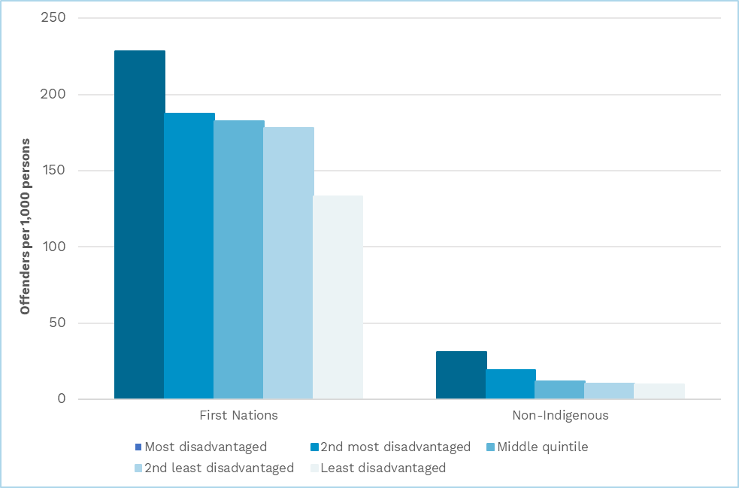

Note: The inclusion of 2023–24 data into the police assessment may alter these relationships.

#### Commission draft position

Subject to 2023–24 data, the Commission proposes to use a 5-tier structure to measure the socio-economic status of First Nations offenders.

### Criminal courts assessment

In the justice chapter of *Review Outcomes* for the 2025 Review, the Commission decided to:

* attribute Indigenous status to not-stated finalised defendants by the proportion of the stated defendant responses
* continue to use data provided by states for the 2025 Review to split other legal services expenses from criminal courts expenses.

The Commission decided to undertake further analysis and consultation on whether criminal courts should be assessed equal per capita.

In addition, the Commission has analysed state data to determine if they support an assessment of regional costs for criminal and civil courts.

Should criminal courts be assessed equal per capita?

In response to state comments, the Commission investigated the validity of using population as a driver of criminal courts’ spending needs. In the 2020 Review, finalised defendants were the measure of use in criminal courts.

#### State views

In its submission following the Draft Report, Victoria proposed assessing the criminal courts component on an equal per capita basis. It said that population was a better predictor of actual court expenses than finalisations using *Report on Government Services* data.[8] It also noted that an assessment method based on population would be simpler and allow criminal courts to be combined with other legal services.

#### Commission response

The Commission considers that removing the socio-demographic composition driver from the assessment would negatively affect its rigour. Based on clear evidence, the Commission’s police assessment recognises that certain characteristics affect the likelihood of someone becoming an offender. It would be consistent to recognise that this is also true of defendants in criminal courts.

Assessing criminal courts on an equal per capita basis would require a conceptual case and evidence that all individuals are equally likely to use criminal court services.[9]

#### Commission draft position

The Commission proposes not to assess the criminal courts component on an equal per capita basis.

Do data support an assessment of regional costs for criminal and civil courts?

The Commission analysed 2022–23 data to determine whether it is still appropriate to apply a regional cost gradient in criminal and civil courts.

#### Commission analysis

While the Commission received data from all states for calculating the socio‑demographic use rates of defendants and regional costs, only data from 5 states could be used in the analysis of regional costs in criminal and civil courts.[10] Data from Victoria, Queensland and South Australia were not fit for purpose because they did not allow the Commission to separately measure the cost per finalised defendant in different remoteness areas. These data either attributed court costs based on the proportion of finalised defendants in each court or had centralised expenses recorded under a limited number of courts.

Similar to the 2020 Review, the Commission’s analysis focused on expenses in magistrates’ courts. Useable data for remote higher courts were extremely limited, which affected the robustness of calculations of the relative cost per defendant in these courts.

Analysis of the available data did not show a clear relationship between remoteness and magistrates’ court expenses (Figure 11). While based on analysis of data from 5 states, the Commission considers that this analysis is representative of the average experience of all states because data were from states of varying size and remoteness profiles. Therefore, the Commission proposes to no longer assess regional costs as part of the criminal courts component.

Figure 11 Cost per defendant in magistrates’ courts by remoteness area

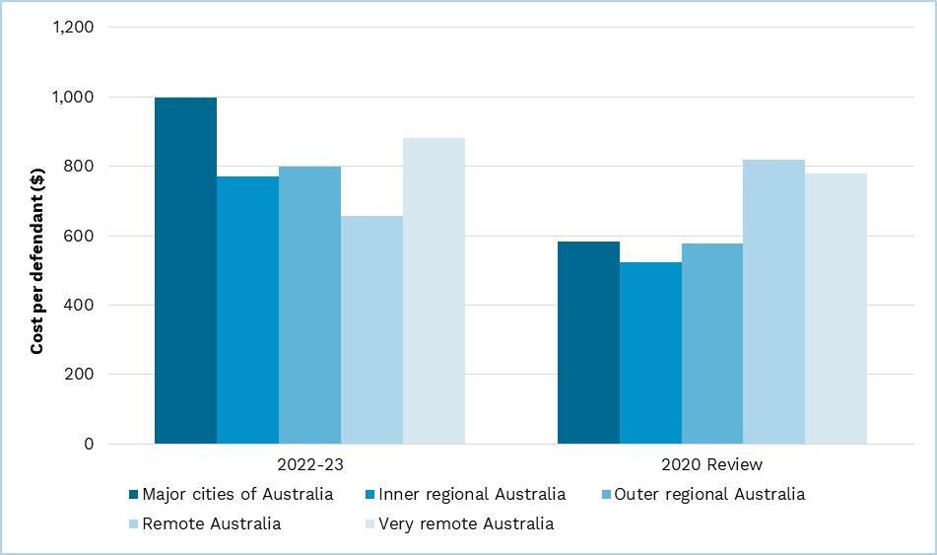

The reduction of costs for regional and remote courts is not linked to a reduction in caseloads. Commission analysis of state data suggests that the proportion of criminal cases finalised in remote and very remote magistrates’ courts has only decreased slightly.

State-provided data also show that Western Australia has closed more than two‑thirds of its remote and very remote magistrates’ courts since 2016–17. This likely explains the significant drop in its relative cost per defendant in remote areas compared with non-remote areas.

Table 2 Cost per defendant in remote courts as a proportion of non-remote

|  |  |  |  |
| --- | --- | --- | --- |
|  | NSW | WA | NT |
| 2016–17 | 109% | 143% | 55% |
| 2022–23 | 84% | 52% | 54% |

Note: The Commission only has data for New South Wales, Western Australia and the Northern Territory for both these years.

The Commission considers the relationship between remoteness and criminal court costs has changed following the increasing uptake of audiovisual technology. This has reduced the need for magistrates, court officials, witnesses and defendants to be present at remote courts. This would considerably reduce travel costs, as is noted in Western Australia’s Department of Justice’s annual report.[11] The Commission also understands that other locations, such as prisons and police stations, provide services that allow defendants to attend court virtually.

Audiovisual technology has been used by state courts for several decades and has significantly increased since the last review. A study undertaken by the Australian Institute of Criminology found that states began significant programs to upgrade their audiovisual capacity prior to the COVID-19 pandemic.[12] For example, in 2014–15, the Northern Territory began establishing audiovisual links to court services in 40 regional and remote police stations with the aim of reducing the cost of transporting defendants and witnesses to courts from remote areas. The Commission considers the increased use of audiovisual technology in courts to be a structural change within the court system. This conclusion is consistent with the opinions of many judges and legal practitioners.[13]

State data show that the relationship between remoteness and expenses has changed in the civil court system. Accordingly, the Commission proposes to no longer assess regional costs for civil courts within the other legal services component.

#### Commission draft position

Subject to 2023–24 data, the Commission proposes to discontinue assessing regional costs for criminal and civil courts.

### Prisons assessment

In the justice chapter of *Review Outcomes* for the 2025 Review, the Commission decided to:

* include an assessment of community correction orders in the prisons assessment if it is material
* apply a juvenile detainee cost weight to the prisons assessment if material – this includes altering age groups across the assessment from 0–14 and 15–24 to 0–17 and 18–24
* not alter the prisons assessment in response to changes in the minimum age of criminal responsibility.

The Commission decided to undertake further analysis and consultation on regional costs and service delivery scale in the prisons assessment.

Are separate assessments of community corrections and juvenile detainees material?

The Commission decided to include a cost weight for juvenile detainees and an assessment of community correction orders if they had a material impact on GST distribution.

#### Commission analysis

The Commission calculated the materiality of a community corrections assessment by creating a separate socio-demographic characteristics assessment using ABS data and splitting off the community corrections proportion of Government Finance Statistics expenses using data from the Productivity Commission.[14] The inclusion of a community corrections assessment was found not to be material, moving $29 per capita for one state. If the inclusion of 2023–24 data does not move $40 per capita or more for at least one state, the Commission will not include a separate assessment for community corrections.

The Commission tested the materiality of a juvenile detainee cost weight by applying it to the 0–17 years assessed prisoner population. The juvenile detainee cost weight was calculated with data from the Productivity Commission and the ABS.[15] The inclusion of a juvenile detainee cost weight, based on 2022–23 data, was close to being material for one state, moving $38 per capita. If the inclusion of 2023–24 data does not move $40 per capita or more for at least one state, the Commission will not include a separate assessment for juvenile detainees.

#### Commission draft position

The Commission proposes to retest the materiality of a juvenile detainee cost weight and an assessment of community corrections when 2023–24 data are available.

Do data support an assessment of regional costs for prisons?

In response to state comments and having received new state data, the Commission investigated whether these data supported an assessment of regional costs for prisons.

#### State views

New South Wales and Victoria held concerns on the robustness of the regression model. New South Wales said its state-level modelling suggests the operating costs of metropolitan prisons in New South Wales were higher (per prisoner) than for remote prisons. New South Wales proposed the Commission replace the remoteness dummy variable in the prisons regression with a major cities dummy variable. Alternatively, it said a discount to remoteness and service delivery scale effects may be appropriate to recognise standard errors and uncertainty.

New South Wales said the prisons assessment lacked evidence to support inclusion of the service delivery scale factor in calculating a regional cost gradient. While it agreed small prisons are more expensive than large prisons, it did not consider the effect was reliably driven by remoteness.

Victoria noted the results of the 2020 Review prisons regression were not statistically significant, with high standard errors. It suggested the results were not sufficiently robust to meet the Commission’s principles or the review terms of reference.

Queensland said that remoteness is a key cost driver within the prisons model and adds considerable explanatory power.

Western Australia said the conceptual case for costs being higher for prisons in remote areas was very strong. However, the prisons regression that calculates regional cost factors has a relatively low explanatory power. It also implied that the coefficients of those variables are not robust. It suggested that several other variables, such as prison age, could be added to the model.

#### Commission response

Commission analysis of new prison data revealed that there were considerable differences between 2016–17 data used in the 2020 Review regression and 2022–23 data. While some change was expected, the Commission notes that there were fewer data points in remote and very remote areas,[16] and the number of prisoners classified as maximum security prisoners increased significantly in some states but decreased in others.[17]

Updating the 2020 Review regression with 2022–23 data produced a model with reduced explanatory power and insignificant variables for both maximum security prisoners and remote prisoners (see Table 3). These variables also had large standard errors such that the Commission could not determine with any confidence whether they increased or reduced the cost per prisoner. The variability of prisoner security classifications across states in particular seems to have affected the quality of data used in the regression.

Table 3 2020 Review regression method applied to 2022–23 data

|  |  |  |  |  |  |  |  |
| --- | --- | --- | --- | --- | --- | --- | --- |
|  | 2016–17 data | | |  | 2022–23 data | | |
|  | Estimate | Standard error | Significance |  | Estimate | Standard error | Significance |
| Intercept | 73,773 | 5,630 | *** |  | 106,290 | 10,236 | *** |
| Fixed cost | 1,409,314 | 734,016 | . |  | 4,227,168 | 1,546,392 | ** |
| Maximum security | 63,989 | 13,750 | *** |  | -9,618 | 13,989 |  |
| All remote | 31,340 | 24,853 |  |  | -6,261 | 30,340 |  |
|  |  |  |  |  |  |  |  |
| Adjusted R-squared | 0.19 |  |  |  | 0.06 |  |  |
| Sample size | 100 |  |  |  | 101 |  |  |

Note: ‘***’ represents statistically significant coefficients at a 0.001 confidence, ‘**’ at a 0.01 confidence, and ‘.’ at 0.1 confidence.

The Commission explored using other regression models but found the data did not support the use of a regression to assess regional and service delivery scale costs.

The Commission considers there is still a strong conceptual case for the continued assessment of service delivery scale costs, and analysis of state data supported this. Figure 12 shows that the cost per prisoner increases as the size of prisons decreases. It also shows that there is no consistent pattern to the cost of different sized prisons in each of the remoteness areas. The higher costs for major cities likely reflect the proportion of high-cost maximum security prisoners in major city prisons.[18] This was reflected in regression testing that found there was no strong evidence for regionality affecting prison expenses when composition of prisoner security was controlled for. For these reasons, the Commission proposes to assess service delivery scale but not regional costs in the prisons assessment.

Figure 12 Cost per prisoner by remoteness area and prison size, 2022–23

Note: State data contained information for only 8 prisons in remote and very remote areas nationally. Aggregate statistics for these groups are based on small samples and may not be accurate.

The data limitations of the prisons-specific data mean the Commission is not able to isolate the effect that the different security services needed to manage prisoners of higher security classifications are having on the cost per prisoner. Therefore, the Commission proposes to use the service delivery scale cost gradient for prisons based on the general service delivery scale gradient.

Consistent with the use of the general gradient, a 25% discount will be applied to the general gradient to reflect the uncertainty around its value when it is applied to areas where a specific cost gradient cannot be measured.

The Commission considered the appropriateness of applying the general service delivery scale gradient calculated using health and education data to prisons. Figure 13 shows that the average size of a prison in non-remote areas is similar, ranging from 400 to 460 prisoners. Remote prisons are considerably smaller on average, ranging from 100 to 230 prisoners. It also shows that there is only a small sample of remote prisons (noting that Queensland and Western Australia do not provide data for some or all their remote prisons). The Commission acknowledges that several smaller prisons exist in major city areas, however, their size often relates to function, for example prerelease prisons, rather than the effects of population dispersion.

Figure 13 Average prison size by remoteness area, 2022–23

Given the average size of prisons across non-remote areas is similar, applying a gradient that increases incrementally may not be considered appropriate.

In addition, the gradient in the 2020 Review was adjusted to recognise that not all assessed remote prisoners are placed in remote prisons. Applying a similar adjustment to the general gradient is difficult because the Commission would have to make assumptions as to which region prisoners were placed.

The Commission could adjust the general gradient to combine non-remote regions. In addition, if the remote and very remote cost weight were combined, the Commission could make an adjustment to account for the placement of remote prisoners. However, the general gradient is an approximate measure that is already discounted by 25%.

The Commission considers that given the lack of reliable comparable data to inform a prison specific service delivery scale gradient, applying the general gradient is the simplest and most appropriate way to recognise the additional service delivery scale expenses faced by smaller prisons (see Table 4).

Table 4 2020 Review prisons gradient compared with the general service delivery scale cost gradient

|  |  |  |
| --- | --- | --- |
|  | 2020 Review prisons gradient | 2025 Review general gradient (2023–24) |
| Major cities of Australia | 1.00 | 1.00 |
| Inner regional Australia | 1.00 | 1.03 |
| Outer regional Australia | 1.00 | 1.06 |
| Remote Australia | 1.17 | 1.09 |
| Very remote Australia | 1.17 | 1.23 |

Note: The general gradient is updated annually for each assessment year and discounted by 25%.

#### Commission draft position

The Commission proposes to use the general service delivery scale cost gradient (discounted by 25%) to assess service delivery scale in prisons and not assess regional costs.

## Draft 2026 Update assessment method

Table 5 shows the proposed structure for the 2025 Review justice assessment.

Table 5 Proposed structure of the revised justice assessment

|  |  |  |  |  |  |  |  |
| --- | --- | --- | --- | --- | --- | --- | --- |
| Component |  | Driver | Influence measured by driver |  |  | Change since 2020 Review? |  |
|  |  |  |  |  |  |  |  |
| **Police (a)** |  | Regional costs | Recognises the cost of providing police services increases as the level of remoteness increases. |  |  | Yes – the Commission is proposing to combine the remote and very remote cost weights and to apportion central costs on the bases of 50% FTE and 50% district expenses. |  |
|  |  | Socio-demographic composition | Recognises that certain population characteristics (Indigenous status, age, and SES) affect the degree of police activity. |  |  | Yes – the Commission is proposing to use a 5-tier structure for First Nations socio-economic status. |  |
|  |  | Wage costs (c) | Recognises differences in wage costs between states. |  |  | No |  |
| **Criminal courts (b)** |  | Socio-demographic composition | Recognises that certain population characteristics (Indigenous status, age, and SES) affect the use of criminal court services. |  |  | Yes – not-stated Indigenous status responses will be attributed in proportion to stated responses. |  |
|  |  | Wage costs (c) | Recognises differences in wage costs between states. |  |  | No |  |
| **Other legal services (b)** |  | Non-deliberative equal per capita | These expenses are not differentially assessed. |  |  | No |  |
|  |  | Wage costs (c) | Recognises differences in wage costs between states. |  |  | No |  |
| **Prisons** |  | Service delivery scale (SDS) | Recognises the additional costs of small, dispersed prisons |  |  | Yes – the Commission is proposing to assess SDS using the general gradient and to not assess remoteness costs. |  |
|  |  | Juvenile detainee costs | Recognises the additional costs of providing corrective services to juvenile detainees |  |  | To be determined – if material |  |
|  |  | Socio-demographic composition | Recognises that certain population characteristics (Indigenous status, age and SES) affect the use of prisons*.* |  |  | No |  |
|  |  | Community corrections | Recognises that certain population characteristics (Indigenous status, age and SES) affect the use of community correction services*.* |  |  | To be determined – if material |  |
|  |  | Wage costs (c) | Recognises differences in wage costs between states. |  |  | No |  |

Notes:

1. The 2020 Review method included an assessment of national capital policing costs. The Commission suspended the national capital assessment for the police component following state consultation in the 2024 Update and discontinued the assessment in the 2025 Review. Please see the national capital chapter of *Review Outcomes* for the 2025 Review for more information.
2. The 2020 Review method included an assessment of regional costs in criminal and civil courts. The Commission has proposed to discontinue the regional costs assessment in the criminal courts and other legal services components.
3. The Commission separately consulted with states on the wages assessment as part of the 2025 Review. The Commission now applies the 2025 Review method to assess wage costs in the justice assessment.

## Indicative distribution impacts

The indicative impact on the GST distribution in 2025–26 from data updates and proposed method changes is shown in Table 6.

Table 6 Indicative impact on GST distribution recurrent and investment (difference from an equal per capita distribution), 2025–26

|  |  |  |  |  |  |  |  |  |  |  |
| --- | --- | --- | --- | --- | --- | --- | --- | --- | --- | --- |
|  | NSW | | Vic | Qld | WA | SA | Tas | ACT | NT | Total Effect |
|  | | $m | $m | $m | $m | $m | $m | $m | $m | $m |
| R2025 using R2020 methods | | -334 | -1,299 | 476 | 373 | -8 | 113 | -137 | 817 | 1,779 |
| R2025 using draft U2026 methods | | -172 | -1,351 | 475 | 310 | -32 | 166 | -141 | 744 | 1,695 |
| Effect of proposed changes | | 163 | -52 | -1 | -63 | -23 | 54 | -4 | -73 | 216 |
|  | | $pc | $pc | $pc | $pc | $pc | $pc | $pc | $pc | $pc |
| R2025 using R2020 methods | | -39 | -181 | 83 | 122 | -4 | 195 | -284 | 3,178 | 64 |
| R2025 using draft U2026 methods | | -20 | -188 | 83 | 101 | -17 | 288 | -292 | 2,895 | 61 |
| Effect of proposed changes | | 19 | -7 | 0 | -21 | -12 | 93 | -8 | -283 | 8 |

Note: Includes impact of changes to recurrent justice assessment and the subsequent impact on the investment assessment.

The GST pool and population estimates are equivalent to those used in the 2025 Review.

The data included in the table have not been subject to full quality assurance processes and, as such, should be treated as indicative only.

Indicative GST impacts are provided for illustrative purposes only and should not be used to predict impacts on GST distribution for 2026–27.

### Impact of data updates

The indicative impact of updates to data in the justice assessment on GST distribution in 2025–26 are shown in Table 7.

On a per capita basis, data updates would have the largest impact on distribution to Tasmania and the Northern Territory. The change is due to the inclusion of 2021 Census First Nations population data, and cost and/or use data relating to police, courts and prisons (from states and the ABS). The Commission has used projected 2016 Census data since the 2020 Review to ensure that GST distribution was not adversely affected by changes in Indigenous status proportions. Given that 2020 Review use rates were based on 2015–16 and 2016–17 state data, applying these use rates to a population with different Indigenous status proportions was considered inappropriate.

Table 7 Indicative impact on GST distribution of data updates (difference between the 2025 Review assessment, and an assessment using updated data), 2025–26

|  |  |  |  |  |  |  |  |  |  |
| --- | --- | --- | --- | --- | --- | --- | --- | --- | --- |
|  | NSW | Vic | Qld | WA | SA | Tas | ACT | NT | Total |
|  | $m | $m | $m | $m | $m | $m | $m | $m | $m |
| Police (a) | 3 | -26 | 15 | 0 | -13 | 21 | 2 | -2 | 42 |
| Criminal Courts (b) | 22 | -71 | 15 | 11 | -8 | 6 | -5 | 30 | 84 |
| Prisons (c) | 89 | 25 | -33 | -38 | 6 | 18 | -2 | -65 | 138 |
| **Total** | **113** | **-72** | **-3** | **-27** | **-15** | **45** | **-4** | **-37** | **158** |
|  | $pc | $pc | $pc | $pc | $pc | $pc | $pc | $pc | $pc |
| Police | 0 | -4 | 3 | 0 | -7 | 37 | 5 | -9 | 1 |
| Criminal Courts | 2 | -10 | 3 | 4 | -4 | 10 | -10 | 117 | 3 |
| Prisons | 10 | 3 | -6 | -13 | 3 | 31 | -4 | -251 | 5 |
| **Total** | **13** | **-10** | **0** | **-9** | **-8** | **78** | **-9** | **-143** | **6** |

(a) Updated ERP based on 2021 Census, state police district expense and offender data.

(b) Updated ERP based on 2021 Census, state criminal cost and other legal services expense data, and defendant data.

(c) Updated ERP based on 2021 Census and ABS prisoner data and state defendant SES data.

Note: Includes the impact of data changes on the recurrent justice assessment and subsequent impact on the investment assessment.

The GST pool and population estimates are equivalent to those used in the 2025 Review.

The data included in the table have not been subject to full quality assurance processes and, as such, should be treated as indicative only.

Indicative GST impacts are provided for illustrative purposes only and should not be used to predict impacts on GST distribution for 2026–27.

Most change from data updates can be explained by a combination of the following.

* The proportion of the population that identify as First Nations is greater in the 2021 Census compared with the 2016 Census. This would have the effect of reducing the relative use rate of offenders, defendants and prisoners that identify as First Nations. This would reduce the assessed GST needs of states with large First Nations populations, such as the Northern Territory.
* Updated use data suggest that First Nations people are coming into contact with the justice system at higher rates than was reported in 2016. This would increase the relative use rates of First Nations offenders and defendants and increase the assessed GST needs of states with large First Nations populations, such as the Northern Territory.
* Updated use data also indicate that the proportion of defendants and offenders that identify as First Nations in the less disadvantaged socio-economic groups has increased relative to offenders and defendants who identify as First Nations experiencing more socio-economic disadvantage. This would reduce the assessed GST needs of states with a greater proportion of the more socio-economically disadvantaged First Nations populations (such as the Northern Territory) and increase the needs for states with a greater proportion of First Nations population experiencing less socio-economic disadvantage (such as Tasmania).

For the Northern Territory, in the police and criminal courts assessment, the increase in First Nations populations (reducing assessed GST needs) would be more than offset by the increase in the First Nations offenders and defendants (increasing assessed GST needs). The changing socio‑economic profile of offenders and defendants would reduce the Northern Territory’s assessed GST needs. The net effect of these effects would be positive for criminal courts and slightly negative for police. In the prisons assessment, the Commission has been able to incorporate the increase in First Nations prisoners in each annual update, so the impact in Table 2 only reflects the increase in First Nations populations and changes in the profile of defendant socio-economic disadvantage, both of which would result in a reduction in the Northern Territory’s assessed GST needs.

For Tasmania, the most significant driver in all 3 components is the change in the socio-economic profile of offenders (police) and defendants (criminal courts and prisons). 44% of the First Nations population in Tasmania are in the 2nd least disadvantaged quintile. A growth in the number of offenders among this group would increase Tasmania’s assessed GST needs for police. Offenders among this First Nations group increased by 56% between 2015–‍16 and 2022–‍23, compared with a 12% increase among other groups of First Nations people, and a 24% decrease among non‑Indigenous people. Similar patterns were found among defendants. This would increase Tasmania’s assessed GST needs for criminal courts and prisons.

### Impact of method changes

The indicative GST impact of the proposed changes to the justice assessment in 2025­–26 is shown in Table 8. On a per capita basis, method changes would have the largest impact on the Northern Territory.

The change in the GST distribution compared with the 2025 Review are due largely to the proposals to:

* allocate police central costs to police districts on a 50% proportion of police district expenses and 50% proportion of full-time equivalent staff basis
* remove the regional gradient in criminal courts and replace the regional gradient in prisons with the general service delivery scale gradient
* allocate defendants with not-stated Indigenous status responses based on known defendant proportions.

Table 8 Indicative impact on GST distribution of method changes, (difference between the 2025 Review assessment, and an assessment with proposed method changes) 2025–26

|  |  |  |  |  |  |  |  |  |  |
| --- | --- | --- | --- | --- | --- | --- | --- | --- | --- |
|  | NSW | Vic | Qld | WA | SA | Tas | ACT | NT | Total |
|  | $m | $m | $m | $m | $m | $m | $m | $m | $m |
| **Police** | **22** | **17** | **-18** | **-10** | **-4** | **0** | **0** | **-7** | **39** |
| Allocation of central costs | 24 | 22 | -8 | -18 | -1 | -2 | 2 | -19 | 48 |
| Combining remote and very remote costs | -2 | 1 | 2 | 1 | -5 | 0 | 0 | 4 | 8 |
| Change SES split | 1 | -6 | -13 | 8 | 3 | 2 | -2 | 7 | 21 |
| **Criminal Courts** | **19** | **-2** | **6** | **-10** | **-2** | **2** | **0** | **-15** | **27** |
| Allocation of not-stated responses | 5 | -13 | 7 | -1 | -2 | 1 | -1 | 3 | 16 |
| Removing regional gradient | 14 | 11 | -1 | -9 | 0 | 1 | 1 | -17 | 26 |
| **Other legal services** | **1** | **1** | **0** | **-1** | **0** | **0** | **0** | **-1** | **2** |
| Removing regional gradient | 1 | 1 | 0 | -1 | 0 | 0 | 0 | -1 | 2 |
| **Prisons** | **8** | **4** | **14** | **-16** | **-4** | **7** | **0** | **-13** | **32** |
| Allocation of not-stated responses | 15 | 13 | 4 | -13 | -3 | 1 | 2 | -19 | 35 |
| Replacing regional costs with SDS gradient | -8 | -10 | 10 | -3 | -1 | 6 | -2 | 6 | 22 |
| **Total** | **49** | **20** | **1** | **-36** | **-9** | **9** | **0** | **-35** | **80** |
|  | $pc | $pc | $pc | $pc | $pc | $pc | $pc | $pc | $pc |
| **Police** | **3** | **2** | **-3** | **-3** | **-2** | **0** | **0** | **-29** | **1** |
| Allocation of central costs | 3 | 3 | -1 | -6 | -1 | -3 | 5 | -73 | 2 |
| Combining remote and very remote costs | 0 | 0 | 0 | 0 | -3 | -1 | 0 | 16 | 0 |
| Change SES split | 0 | -1 | -2 | 3 | 1 | 4 | -4 | 28 | 1 |
| **Criminal Courts** | **2** | **0** | **1** | **-3** | **-1** | **3** | **0** | **-57** | **1** |
| Allocation of not-stated responses | 1 | -2 | 1 | 0 | -1 | 2 | -1 | 10 | 1 |
| Removing regional gradient | 2 | 2 | 0 | -3 | 0 | 1 | 1 | -67 | 1 |
| **Other legal services** | **0** | **0** | **0** | **0** | **0** | **0** | **0** | **-3** | **0** |
| Removing regional gradient | 0 | 0 | 0 | 0 | 0 | 0 | 0 | -3 | 0 |
| **Prisons** | **1** | **1** | **2** | **-5** | **-2** | **12** | **0** | **-49** | **1** |
| Allocation of not-stated responses | 2 | 2 | 1 | -4 | -1 | 2 | 3 | -73 | 1 |
| Replacing regional costs with SDS gradient | -1 | -1 | 2 | -1 | 0 | 10 | -3 | 24 | 1 |
| **Total** | **6** | **3** | **0** | **-12** | **-4** | **15** | **1** | **-139** | **3** |

Note: Includes the impact of method changes on the recurrent justice assessment and subsequent impact on the investment assessment.

The data included in the table have not been subject to full quality assurance processes and, as such, should be treated as indicative only.

Indicative GST impacts are provided for illustrative purposes only and should not be used to predict impacts on GST distribution for 2026–27.

#### Police

The proposal to allocate police central costs on the basis of a 50% proportion of police district expenses and 50% proportion of full‑time equivalent staff would increase the relative expenses allocated to major cities and regional areas, and lower expenses allocated to remote areas. This would reduce the assessed GST needs of states with larger remote populations, such as Western Australia and the Northern Territory. It would increase the needs of states with larger non-remote populations, such as the ACT.

Compared with the new method of allocating central costs, combining remote and very remote costs would increase the assessed expense needs of very remote populations and decrease the needs of remote populations. This change would increase the assessed GST needs of the Northern Territory and decrease the needs of South Australia.

Increasing the socio-economic status structure of First Nations offenders from a 3‑tier system to a 5-tier system would increase the use weights applied to First Nations populations experiencing the highest level of socio-economic disadvantage and decrease the use weights applied to First Nations populations experiencing the lowest levels of socio-economic disadvantage. This change would increase the assessed GST need of states with a greater proportion of First Nations populations experiencing the highest levels of socio-economic disadvantage, such as the Northern Territory. It would reduce needs for states with a below-average proportion of this population, such as the ACT.

#### Criminal courts and other legal services

Under the proposed method of allocating not-stated Indigenous status responses by proportions of stated responses, states with a higher proportion of First Nations people would tend to have increased assessed GST needs (such as Queensland and the Northern Territory). However, whether not‑stated responses are allocated to First Nations defendants or non‑Indigenous defendants under the method would depend on the composition of their individual socio‑demographic sub‑group. The largest increases in numbers of defendants that identify as First Nations are in major cities and inner regional areas. There is a corresponding decrease in non‑Indigenous defendants in the same areas. In some states, such as New South Wales and Queensland, the combination of changes would increase assessed GST needs, but in others, such as Victoria, needs would be reduced.

Removing the regional gradient from the assessments of criminal courts and other legal services would decrease the assessed GST needs of states with larger remote populations, such as Western Australia and the Northern Territory, and increase needs for states with a smaller proportion of remote populations, such as New South Wales and Victoria.

#### Prisons

The proposed method of allocating not-stated Indigenous status of defendants in criminal courts assessment impacts the prisons assessment because defendant data are used to impute the socio-economic profile of prisoners. The change would reduce the share of prisoners who identify as First Nations who experience highest level of socio-economic disadvantage. This would reduce the assessed GST needs of states with a greater proportion of First Nations populations experiencing the highest level of socio‑economic disadvantage, particularly the Northern Territory. It would increase needs for states with a below-average proportion of this population, such as the ACT.

Replacing the regional cost gradient with the general service delivery scale gradient would increase the assessed cost per prisoner in regional areas and very remote areas and reduce the assessed cost per prisoner in remote areas. This would increase the assessed GST needs of states with greater shares of regional populations, such as Tasmania, and/or very remote populations, such as the Northern Territory.

## Attachment A: Timetable for consultation on the justice assessment

|  |  |
| --- | --- |
| Timing | Process |
| **2025** |  |
| 2 May | 2023–24 state justice data due. |
| 27 June | Draft position paper issued to states. |
| 8 August | State submissions on draft position paper due. |
| Mid-October | Overview of final justice assessment including changes since the draft position paper and indicative GST impacts. |
| Mid-November | State submissions due on overview of final justice assessment paper due. |
| **2026** |  |
| February | Final justice assessment applied in the 2026 Update. Revised *Review Outcomes* and *Commission’s Assessment Methodology* chapters released. |

## Attachment B: Issues that were finalised during the 2025 Review

|  |  |  |  |
| --- | --- | --- | --- |
| Issue raised | Who raised the issue | Commission position | Why the Commission reached that position |
| Justice model and data issues | | | |
| Whether to retain the 2020 Review justice model. | The Commission | Broadly retain the 2020 Review model if supported by updated state data. | The Commission noted broad support for the 2020 Review model, and considers the overall approach remains appropriate if supported by new state data. |
| Broad data quality and policy neutrality concerns across the justice assessment. | Victoria | Not apply discounts or equal per capita assessments in response to policy neutrality concerns. | Data used are best available and fit for purpose. |
| Updating state data in justice annually. | Northern Territory | Not request data from states on an ongoing annual basis. | Annual data requests would be a significant imposition on states and the Commission given the size, complexity and tight deadlines involved. |
| Including a second year of data in justice. | The Commission | Use 2022–23 and 2023–24 data in the final assessment. | Incorporating 2023–24 data better reflects current and future state justice needs. |
| Delaying method changes in justice until the 2026 Update. | The Commission | Maintain the 2020 Review method for recommendations for GST distribution in 2025–26 and implement any 2025 Review method changes in the 2026 Update with data from 2022–23 and 2023–‍24. | Delayed to the 2026 Update due to the time required to process states’ 2022–23 and 2023–24 justice data and consult with states on proposed method changes. |
| Police component | | | |
| Policy neutrality concerns stemming from how diversionary programs are captured. | Victoria | The Commission will not make changes to the police assessment in response to concerns regarding potential barriers to policy reform. | The justice assessment is based on national average policies. Changes in one state’s sub‑group offence rates are unlikely to materially affect the national average rates. The police assessment considers all policing costs, not only costs related to offender rates. If a state chooses to increase spending on diversionary programs to reduce offending, these costs will be captured and inform the national average per capita costs for policing in each region. |
| Weight offences by their seriousness. | Victorian consultant | The weighting of offences by seriousness is unfeasible given current data availability. | A conceptual case exists that the cost of investigating some crimes is significantly more expensive. However, the Commission is unaware of any national data that would allow it to determine this cost. |
| Does the police regression reflect what states do? | Victoria and Queensland | The regression approach, derived in the 2020 Review, is suitable for accounting for policy differences. | Assessing all police expenses by only using national average offender numbers or only using police district population characteristics would not adequately recognise all the drivers of police costs. |
| Different police district size and populations used in the police regression. | Victorian consultant | The police regression remains appropriate. | Population weighting in the police regression negates the bias resulting from states having different numbers and population sizes in police districts. |
| Cultural and linguistic diversity in large cities. | New South Wales | The Commission will consider whether cultural and linguistic diversity may affect state service costs, including justice services, as part of its forward work program. | The Commission accepts there is a conceptual case that culturally and linguistically diverse prisoners could drive higher costs in providing justice services. However, there are significant impediments to reliably identify and quantify how such groups affect costs in justice. |
| Exclude all central costs in the police regression and assess it equal per capita. | Victoria | Excluding all central costs from the regression would underestimate costs in the police assessment. | Some areas of central costs are likely to be used by police services across the whole state and not just major cities. |
| Use of offender counts rather than proceedings. | Victorian consultant | The Commission will continue using proceedings counts for its measure of assessed offenders. | Using the ABS’ offenders count would not recognise the costs associated with a second (or more) separate instance of offending and their impact on the cost of policing. |
| Include traffic and breach of bail offences. | Western Australia | The Commission will continue to exclude traffic and breach of bail offence data. | In the absence of evidence of improvements in the quality and comparability of the data, the Commission considers that these data are not fit for purpose. |
| Criminal courts component | | | |
| Specialist courts and diversions programs. | Victoria | Finalised defendants remains a suitable driver for court expenses. | While the number of assessed finalised defendants currently excludes finalised defendants in specialist courts and diversion programs, excluding these data produces a more nationally comparable cost per assessed defendant. Because these defendants are finalised in the court that first heard their case, including any additional finalisations would lead to double counting. |
| Regression for regional and service delivery costs. | Western Australia | The Commission decided to continue to apply a cost gradient when assessing regional and service delivery scale costs in the criminal courts assessment. The Commission noted however that analysis of the updated state data and consultation with states was required to determine if the cost gradient should be changed.  After analysing 2022–23 data in this paper, the Commission is proposing to discontinue an assessment of regional costs for criminal courts and other legal services in the revised justice method. | In the 2020 Review, the Commission decided to adopt a simple approach to calculating regional costs because of data limitations and offsetting cost factors. Using a regression may add unnecessary complexity to the model. |
| Using data from 5 states in the socio-demographic calculation and data from 4 states in the criminal courts regional cost gradient. | Victoria and the Victorian consultant | Use data from all states in the criminal courts component. If this is not possible, the Commission will determine the best approach consistent with the objective of horizontal fiscal equalisation in consultation with states. | The Commission used all fit-for-purpose data available. Given the importance of Indigenous status and regional costs, limiting modelling to where data are available for every state would be contrary to horizontal fiscal equalisation. Using data from a selection of states provides a reasonable estimate of the national average if these states form a representative cross-section of all states. |
| Treatment of not-stated Indigenous status. | Western Australia | Attribute Indigenous status to not-stated finalised defendants by the proportion of the stated defendant responses for inclusion in the 2026 Update. | Western Australia’s 2022–23 data show 24% of finalised defendants identified as First Nations. The Commission also noted that the proportion of not-stated defendant responses has fallen to 7% in the 2022–23 data down from 41% in the 2020 Review data. The Commission considers that attributing Indigenous status to not-stated finalised defendants by shares of stated defendant responses would not overestimate the number of First Nations finalised defendants. |
| Other legal services component | | | |
| Using the *Report on Government Services* data to split actual expenses in criminal courts and other legal services. | Victoria and the Victorian consultant | The Commission will continue to use data provided by states for the 2025 Review to split other legal services expenses from criminal courts expenses. | There are some legal services related to both criminal courts and other legal services that are excluded from the *Report on Government Services* data. The Commission considers splitting court expenses in this manner does not provide the best estimate of costs incurred by states’ criminal courts and other legal services. |
| Prisons component | | | |
| Altering age groups due to changes in the minimum age of criminal responsibility. | The Commission | The Commission does not consider changing the age group to be warranted to account for changes in the minimum age of responsibility. | All states that responded supported not changing the juvenile detainee age groups in response to changes to the minimum age of criminal responsibility across states. |

## Attachment C: Development of the police regression

* 1. When considering the use of a regression to assess police expenses, the Commission asked the following questions:
* What are the non-policy drivers of police spending that can be reliably measured with the data we have?
* What can a regression tell us about the relationship between costs and the drivers?
* Are the results consistent with our conceptual understanding of the drivers?
* What do the diagnostics tell us about how well the regression estimates costs?

#### Non-policy drivers of police expenses and data

##### Population

* 1. As with most state government services, the level of service provision must reflect the size of the service population.
  2. The Commission obtained the estimated resident population by police district through geographical data on police districts provided by states. Geographical data were either in the form of geospatial boundaries, or concordances matching police districts to other geography measures by which estimated resident populations could be obtained.

##### Offenders

The conceptual case for offenders is that criminal activity is one of the primary sources of work for any police force. Areas observed to have higher recorded offenders are expected to require more policing activity and therefore incur higher costs.

Offenders per capita is included in the regression as the total number of offenders recorded in a district divided by its population. The resulting coefficient can be interpreted as the additional cost per capita per offender. Applying the coefficient to total assessed offenders derives the total cost effect of offenders for a district.

States provided expenses and actual offender numbers by police district for the 2022–23 financial year. These measures informed the cost per capita and offenders per capita for the regression.

The Commission acknowledges that actual offender numbers are likely to be influenced by policy decisions regarding police funding and priorities. Hence, it uses actual offenders to determine costs in the regression model. However, the estimated cost per offender should be applied to a policy‑neutral measure of how many offenders would exist if the police force followed national average policy.

This creates an additional level of complexity but is required due to the principle of policy neutrality.

##### Remoteness

There is a strong conceptual case for the cost of operating a police district to be driven by the remoteness of its area. Physical isolation presents significant challenges, such as the need for increased transportation, specialised equipment, vehicles and communication systems. In addition to higher non-labour costs, staff are often incentivised to work in isolated areas through higher salaries. More police may be required for smaller populations when large areas need coverage, further increasing the cost of policing remote districts.

Geographical data from states show that a number of police districts overlap across more than one remoteness area. The Commission used estimated resident population data to obtain the proportion of population in each police district within each remoteness area.

##### Socio-economic disadvantage and Indigenous status

When considering other measures of socio-demographic drivers, it is important to note that the principal conceptual case for disadvantaged and First Nations populations driving policing costs is the correlation with offence rates. Having already controlled for offenders, the conceptual basis for a net effect on costs for these drivers is less compelling.

In theory, policing an area with a high share of disadvantaged populations could be expensive due to a higher need for police patrols regardless of actual offender numbers. First Nations or socio-economically disadvantaged communities may have lower levels of trust in law enforcement, requiring increased spending on community policing initiatives.

Socio-economically disadvantaged populations were defined as proportions of total population, as either non-Indigenous proportions below a certain non-Indigenous Socio-Economic Indexes for Areas decile, or First Nations proportions below a particular Indigenous Relative Socioeconomic Outcomes index decile. Different disadvantage thresholds ranging from exclusively the lowest decile to the lowest 3 deciles were tested.

##### Service delivery scale

There is a conceptual case that there is some fixed cost of operating each police district. This could result in higher costs per capita for police districts with small populations. The Commission included this driver of cost in the regression as the inverse of population, consistent with the per capita model specification.

##### Interactions

There is a conceptual case that the cost per offender could be higher in remote areas. Police officers are likely to travel further to respond to each crime, and to transport detainees. The Commission measured remote offenders for police districts as its remote population share, applied to offenders per capita.

#### Relationship between drivers and costs

The model was tested with many different specifications, starting from an exhaustive specification that included all drivers (see above for drivers not included, and relationships between drivers). Per capita costs were used as the dependent variable. This constrained the explanatory power to only measure the effects of drivers, not including population, on policing costs.

#### Initial model

Table C-1 Comprehensive regression model on police district expenses, 2022–23

|  |  |  |  |
| --- | --- | --- | --- |
|  | Estimate | Standard error | Significance |
| Intercept | 336 | 40 | *** |
| Inverse District Population | 6,295,149 | 2,356,996 | ** |
| Inner Regional | 215 | 65 | ** |
| Outer Regional | 359 | 93 | *** |
| Remote | 1,558 | 327 | *** |
| Very Remote | 2,105 | 669 | ** |
| Indigenous status | -1,350 | 829 |  |
| Non-Indigenous low SES | -28 | 122 |  |
| First Nations low SES | -1,081 | 1,128 |  |
| Offenders | 7,179 | 1,025 | *** |
|  |  |  |  |
| R-squared | 0.684 |  |  |
| Adjusted R-squared | 0.663 |  |  |
| Sample size | 152 |  |  |

Note: ‘***’ represents statistically significant coefficients at a 0.001 confidence and ‘**’ at a 0.01 confidence.

Non-Indigenous low SES and First Nations low SES are defined as proportions of population living in the 2 lowest Indigenous Relative Socioeconomic Outcomes index or non-Indigenous Socio-Economic Indexes for Areas deciles respectively.

##### Socio-economic disadvantage and Indigenous status

Including variables of socio-economic disadvantage in the model did not produce significant coefficients. This was likely due to the inclusion of offenders per capita, already capturing the associated cost. The Commission considered there is not sufficient evidence to support a net effect on cost due to socio-economic disadvantage.

After excluding First Nations low SES, Indigenous status produced a significant and negative coefficient. This was not consistent with the conceptual basis for assessing its cost and was also excluded from the model.

Due to its relationship with other predictors of policing costs, the removal of Indigenous status had significant effects on the regression model. The estimated impact of fixed costs, along with the cost of policing very remote areas fell sharply and became less significant.

Additionally, the coefficient for very remote decreased to approximately half the cost of remote. As this was inconsistent with the conceptual case, these variables were grouped to form the All Remote variable. Grouping remote areas resulted in a further decrease in the magnitude and significance of fixed costs (see Table C-2).

#### Intermediate models

Table C-2 Intermediate regression models testing the treatment of remoteness

|  |  |  |  |  |  |  |  |
| --- | --- | --- | --- | --- | --- | --- | --- |
|  | Before grouping remoteness | | |  | After grouping remoteness | | |
|  | Estimate | Standard error | Significance |  | Estimate | Standard error | Significance |
| Intercept | 344 | 35 | *** |  | 346 | 35 | * |
| Inverse District Population | 3,316,575 | 1,965,727 | . |  | 2,540,069 | 1,867,094 |  |
| Inner Regional | 177 | 58 | ** |  | 181 | 58 | ** |
| Outer Regional | 288 | 86 | ** |  | 292 | 86 | *** |
| Remote | 1,611 | 319 | *** |  |  |  |  |
| Very Remote | 861 | 456 | . |  |  |  |  |
| All Remote |  |  |  |  | 1,345 | 237 | *** |
| Offenders | 6,123 | 957 | *** |  | 6,139 | 958 | *** |
|  |  |  |  |  |  |  |  |
| R-squared | 0.667 |  |  |  | 0.664 |  |  |
| Adjusted R-squared | 0.653 |  |  |  | 0.652 |  |  |
| Sample size | 152 |  |  |  | 152 |  |  |

Note: ‘***’ represents statistically significant coefficients at a 0.001 confidence, ‘**’ at a 0.01 confidence, ‘*’ at a 0.05 confidence, and ‘.’ at a 0.1 confidence.

Removing fixed costs prior to grouping remote areas increased the magnitude of the very remote coefficient to $1,248, as well as its significance. Its impact was still substantially lower than the cost of policing remote areas, at $1,677. This suggests that while smaller police districts face higher per capita costs, these costs are mostly explained by remoteness, and that any net effect on costs was minimal or uncertain. The Commission chose to include variables for regional costs instead of service delivery scale as it better explained variation in funding. These results support the idea that police districts containing small populations may not require significant administrative resources and most of these can be centralised.

Grouping remote areas and excluding fixed costs resulted in a significant and plausible coefficient of $1,498 per resident living in remote or very remote areas.

Socio-economic disadvantage was retested through various measures after the removal of Indigenous status, fixed costs and the consolidation of remote areas but remained excluded due to its insignificance.

The model was further tested for differential costs per offender for remote areas but remained excluded as this complexity did not improve the overall fit of the model. Any such difference appears to be readily explained by simply using cost per capita by remoteness.

The Commission conducted further residual analysis and diagnostics which confirmed that:

* the impacts of included drivers were appropriately captured with respect to the chosen model specification
* there was no scope of reintroducing omitted drivers, including interactions, that had a conceptual case to impact costs
* predicted costs were reasonably accurate and without significant bias.

Detailed results of the above analysis cannot be shared due to data confidentiality.

#### Candidate model

Table C-3 Proposed police regression

|  |  |  |  |
| --- | --- | --- | --- |
|  | Final police regression fit statistics | | |
|  | Estimate | Standard error | Significance |
| Intercept | 355 | 34 | *** |
| Inner Regional | 189 | 58 | ** |
| Outer Regional | 300 | 86 | *** |
| All Remote | 1,498 | 209 | *** |
| Offenders | 6,173 | 961 | *** |
|  |  |  |  |
| R-squared | 0.660 |  |  |
| Adjusted R-squared | 0.650 |  |  |
| Sample size | 152 |  |  |

Note: ‘***’ represents statistically significant coefficients at a 0.001 confidence and ‘**’ at a 0.01 confidence.

Results are based off a method for allocating central costs that apportion 50% by shares of full-time staff and 50% by shares of expenses in police districts.

In the proposed police regression, all variables were significant to at least a 0.01 confidence level. The R-squared and adjusted R-squared were 0.66 and 0.65 respectively.

1. For instance, the socio-economic status structure used in the final police assessment will best reflect a linear relationship between socio‑economic status and offender numbers. 2022–23 data may indicate that a 5-tier socio‑economic status structure could be used, but a 3-tier structure may be more appropriate once 2023–24 data are included in the assessment.
2. The [AIHW](https://www.aihw.gov.au/reports/australias-health/covid-19) provides a timeline on the easing of COVID-19 related restrictions up until the Australian Government declared the end of the emergency response in October 2023. The [ABS](https://www.abs.gov.au/articles/effects-covid-19-strains-australian-economy) published a timeline related to the use of lockdowns by states in metropolitan areas in June 2022.
3. The Commission uses ABS proceedings as its offender count.
4. Defendant socio-economic status is used in both the criminal courts and prisons components.
5. Australian Federal Police (AFP), [Inquiry into extremist movements and radicalism in Australia](https://www.aph.gov.au/Parliamentary_Business/Committees/Joint/Intelligence_and_Security/ExtremistMovements/Submissions), submission to the Parliamentary Joint Committee on Intelligence and Security, AFP, 2021, p 3.
6. Australian Crime Intelligence Commission (ACIC), [National Wastewater Drug Monitoring Program - Report 20](https://www.acic.gov.au/sites/default/files/2023-11/wastewater_report_20_web.pdf), ACIC, Australian Government, 2023, pp 57–58. The Commission notes that the data does not control for Indigenous status or socio-economic status.
7. Australian Border Force (ABF), [ABF targets drug smuggling at regional ports](https://www.abf.gov.au/newsroom-subsite/Pages/abf-targets-drug-smuggling-at-regional-ports-23-03-2023.aspx) [media release], ABF, Australian Government, 23 March 2023, accessed 19 March 2025.
8. The Commission notes that it only used *Report on Government Services* finalisations and expense data in the 2020 Review criminal courts method when calculating regional cost weights. They were not used in calculating assessed expenses or defendants. The defendant definition and scope of expenses captured in the Commission’s assessment are broader than that used in the *Report on Government Services.*
9. Such a deliberative equal per capita assessment of expenses would differ from the assessment of other legal services expenses, which is a non‑deliberative equal per capita assessment. In this case of other legal services, the Commission was unable to identify any expense driver.
10. All states’ defendant data were fit for purpose and can be used to calculate use rates.
11. Department of Justice (DoJ), [Annual Report 2023/24](https://www.wa.gov.au/system/files/2024-10/department-of-justice-annual-report-2023-2024.pdf), DoJ, Western Australian Government, 2024, p 55.
12. RG Smith, R Savage and C Emami, ‘[Benchmarking the use of audiovisual link technologies in Australian criminal courts before the pandemic](https://www.aic.gov.au/publications/rr/rr23)’, *Research Report 23*, Australian Institute of Criminology, Australian Government, 2021, pp 10–16.
13. A Dale, ‘[Reset Part 2: Adapting to technology](https://lsj.com.au/articles/reset-part-2-adapting-to-technology/)’, *Law Society Journal online*, 19 July 2022, accessed 13 March 2025; T Liveris, [The Future of the Legal Profession: Sailing into Cyberspace](https://lawcouncil.au/publicassets/a9474d7b-b279-ec11-9447-005056be13b5/2022%2001%2013%20-%20SP%20-%20The%20Future%20of%20the%20Legal%20Profession%20Sailing%20into%20Cyberspace.pdf), Law Council of Australia, 2022, accessed 13 March 2025; M Legg and A Song, ‘[The Courts, the Remote Hearing and the Pandemic: From Action to Reflection](https://www.unswlawjournal.unsw.edu.au/article/the-courts-the-remote-hearing-and-the-pandemic-from-action-to-reflection)’, *UNSW Law Journal*, 2021, 44(1): 126–166; The Law Society of NSW, [A Fair Post-Covid Justice System: Canvassing Member Views](https://www.lawsociety.com.au/sites/default/files/2022-02/21051%20Post-COVID%20Justice%20System%20Summary%20Report%20FINAL%20220124.pdf), Heartward Strategic, 2022, pp 3–4.
14. Community corrections data were derived from ABS Corrective services data, Community-based corrections, Table 4 ‘Persons in community–based corrections, Indigenous status by age.’ Community corrections expenses were derived from the Productivity Commission’s *Report on Government Services 2025*, Table 8A.2 ‘Real net operating expenditure, 2023-24 dollars. The Community corrections expenses were split from total prisons Government Finance Statistics expenses (COFOG-A 341) and were applied to assessed community corrections figures. Concerning regional costs, the general gradient was applied instead of the gradient used in prisons because community corrections services differ from prison services.
15. The Commission uses Australian Institute of Health and Welfare data for its juvenile detainees. The Commission combines juvenile detainees with ABS adult prisoners to derive an actual prisoner dataset.
16. The Commission is aware that in 2 states some or all remote work camps have been recorded under their host prisons.
17. Some states have changed the way they classify the security level of prisoners resulting in less comparable data.
18. 60% of major city prisoners are maximum security compared with about 40% in regional areas and less than 4% of remote prisoners. Given the additional expenses associated with higher security prisoners, a simple average cost per prisoner would not disaggregate the effect of different security needs for prisoners.