

2026 Update

GST Relativities 2026–27

March 2026

Acknowledgement of Country
The Commonwealth Grants Commission acknowledges the Traditional Owners of Country throughout Australia, and their continuing connection to land, water and community. We pay our respects to them and their cultures and to Elders both past and present.

Copyright
ISBN: 978-1-7641044-1-8

© Commonwealth of Australia 2026

All material presented in this document is provided under a Creative Commons Attribution 4.0 International Licence, with the exception of the Commonwealth Coat of Arms, Commonwealth Grants Commission logo and all images.

Use of the Coat of Arms
Guidelines for using the Commonwealth Coat of Arms are published on the website of the Department of the Prime Minister and Cabinet: www.pmc.gov.au/honours-and-symbols/commonwealth-coat-arms

Attribution
The recommended attribution for this document is Commonwealth Grants Commission, 2026 Update GST Relativities 2026–27.

Contact us
Inquiries regarding the licence and any use of this document should be directed to:

Secretary
Commonwealth Grants Commission
73 Northbourne Avenue
CANBERRA ACT 2601
Telephone (02) 6218 5700
Email secretary@cgc.gov.au

Internet
A copy of this report can be obtained from the Commission’s website www.cgc.gov.au.

Contents
Contents 3
Letter of transmittal 4
Terms of reference 5
Acknowledgements 8
Notes 8
Acronyms 8
Glossary 8
Executive summary 9
Introduction 12
1. Recommended GST relativities 14
2. Drivers of GST distribution 20
3. State by state changes 36
Appendix A: The Commission’s approach 53
Appendix B: How GST relativities are calculated 2026-27 55
Appendix C: GST distribution since 2000–‍01 60
Appendix D: Quality assurance 64
Attachment A 65

Letter of transmittal
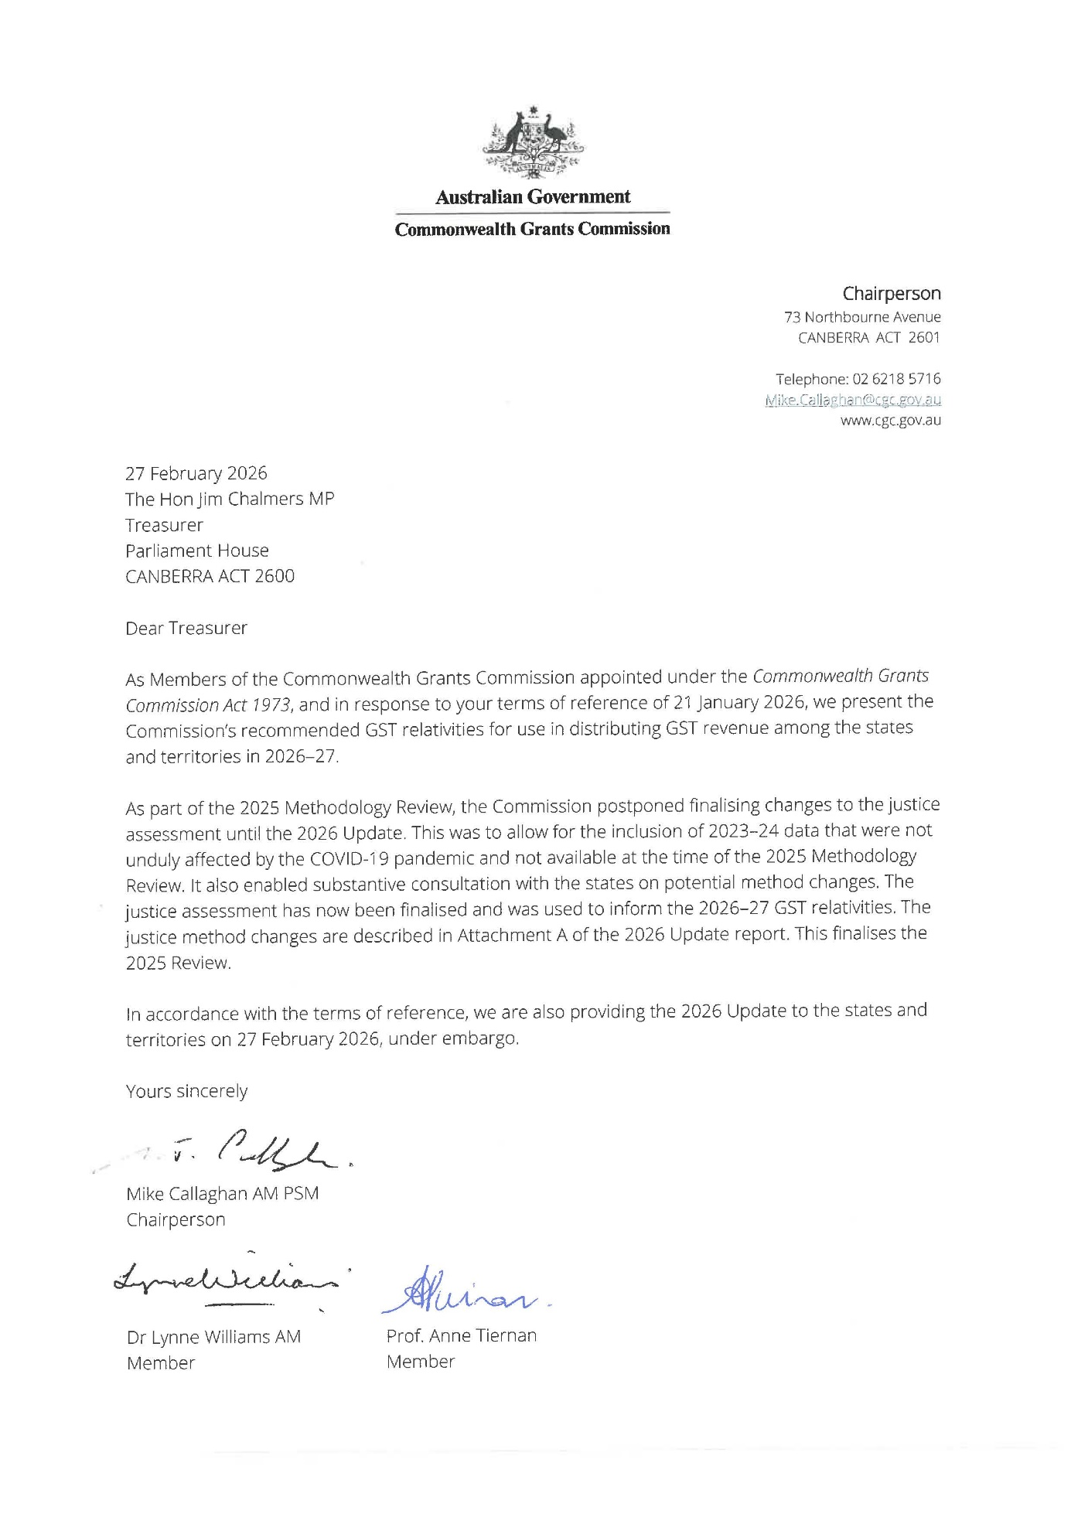

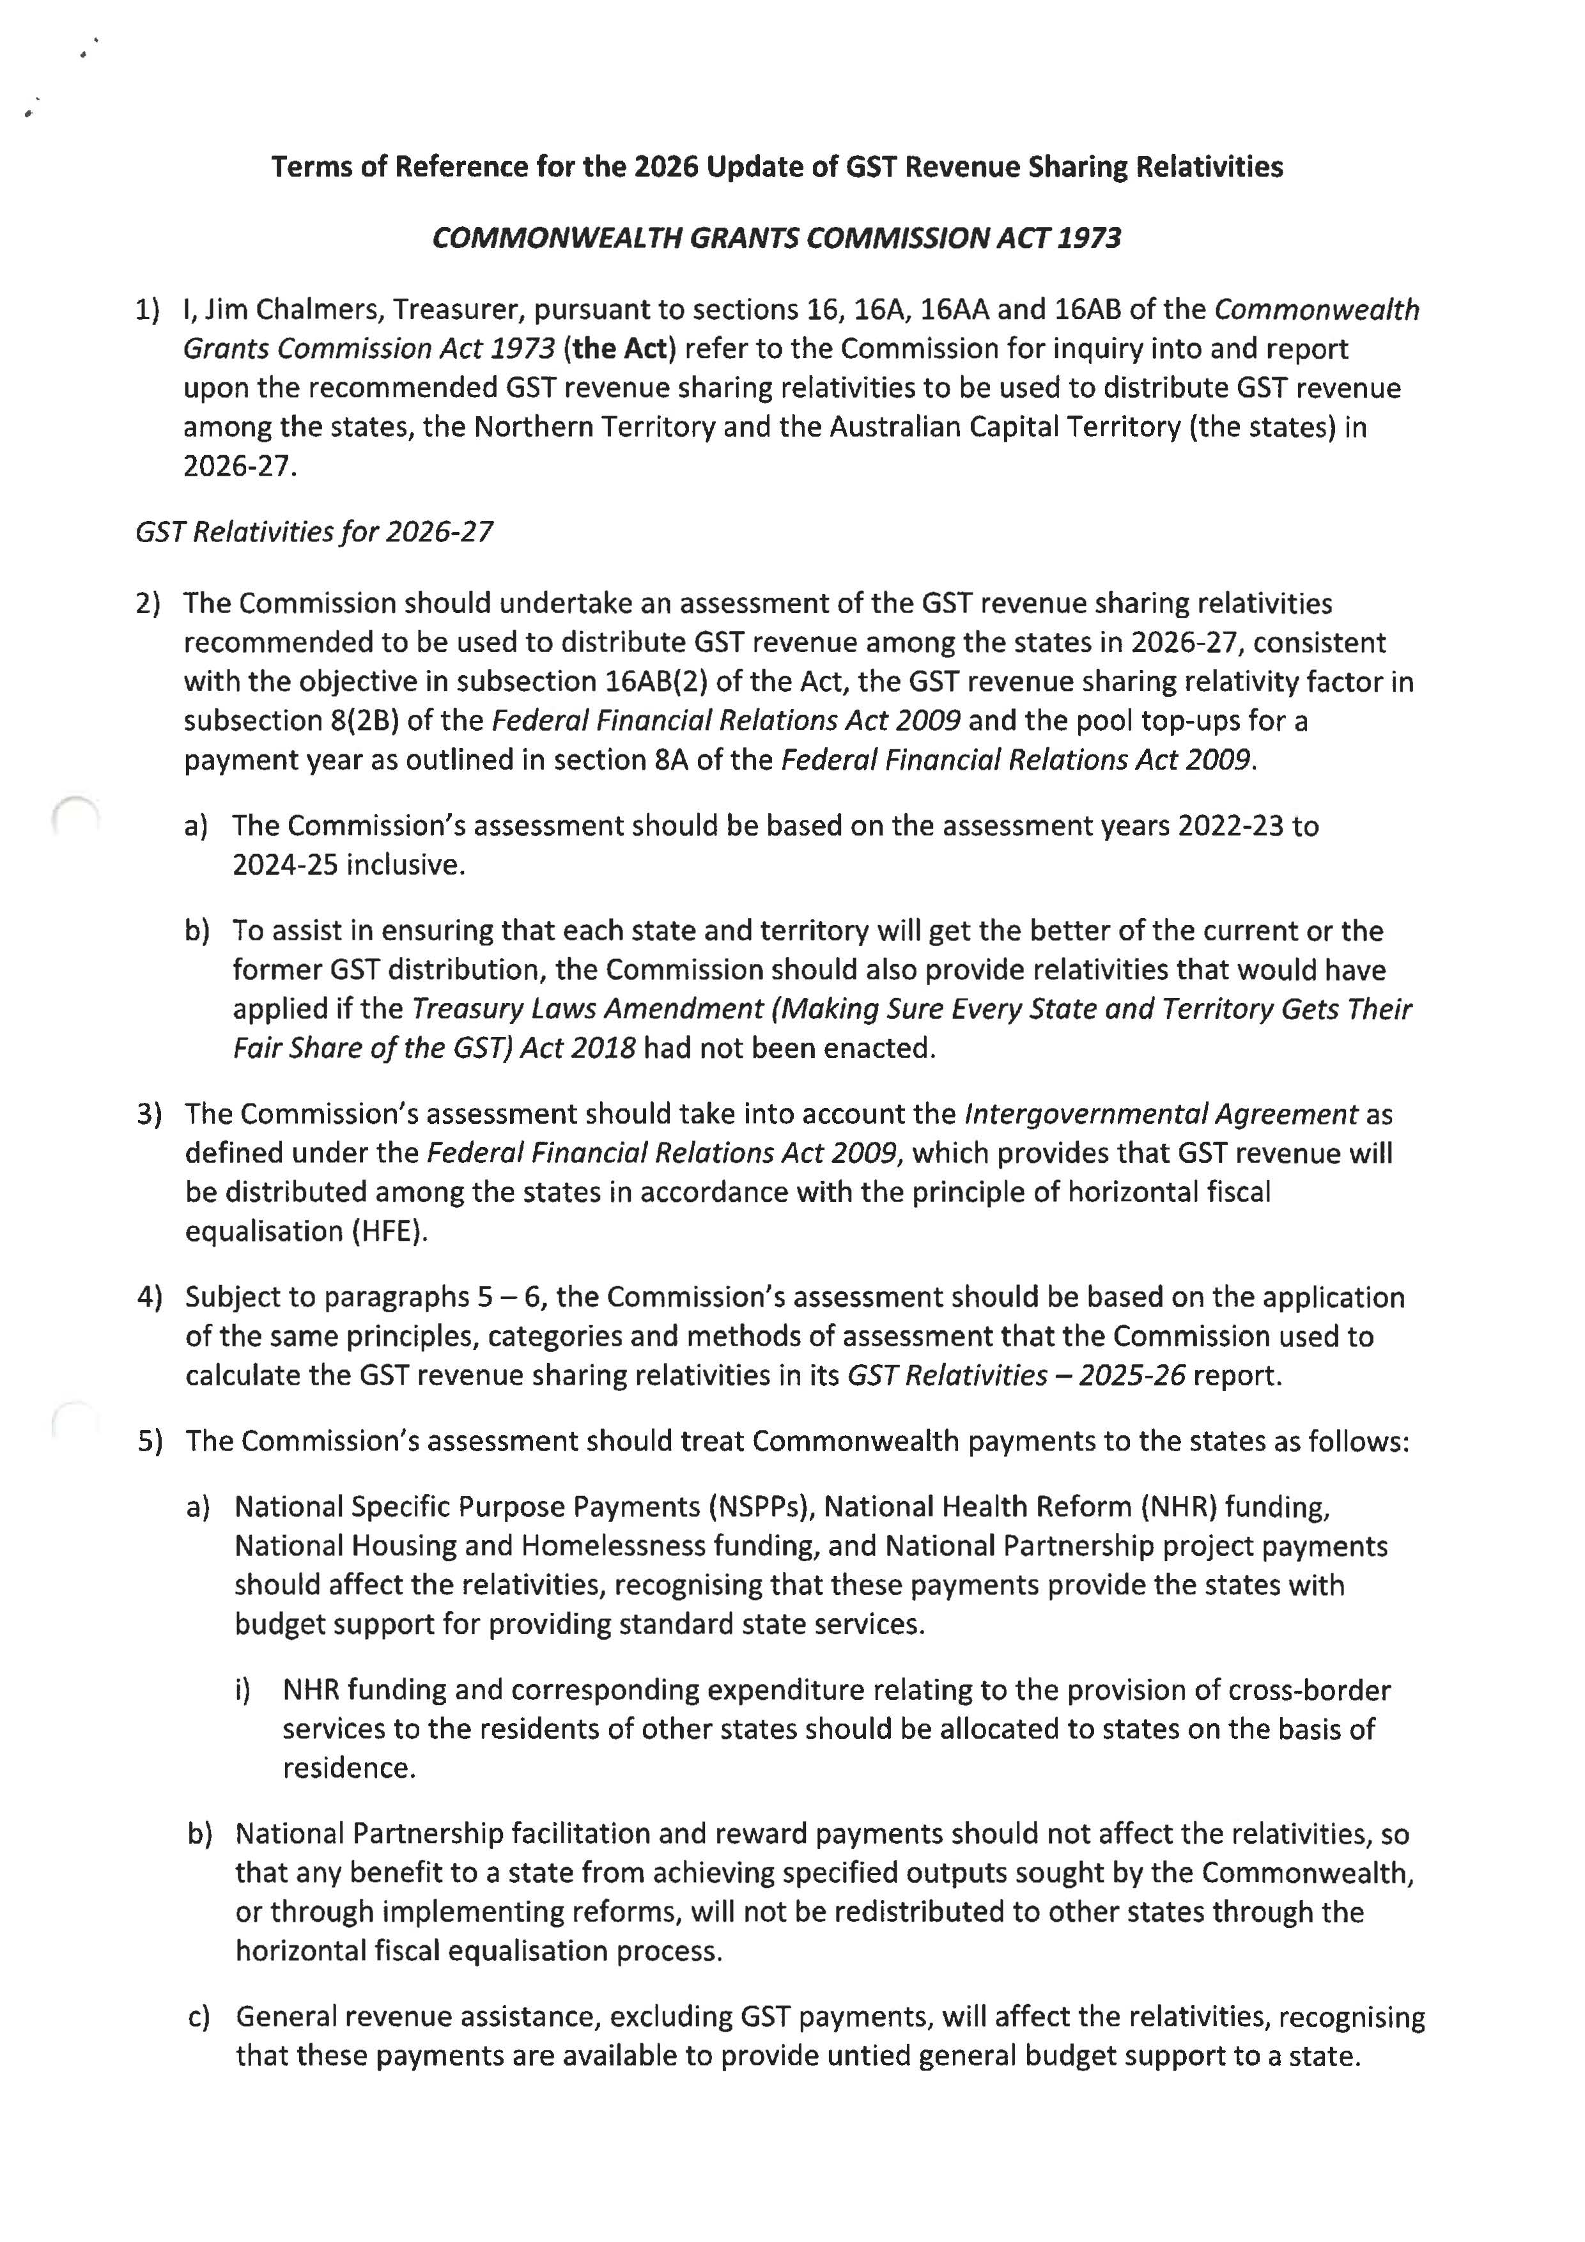
Terms of reference

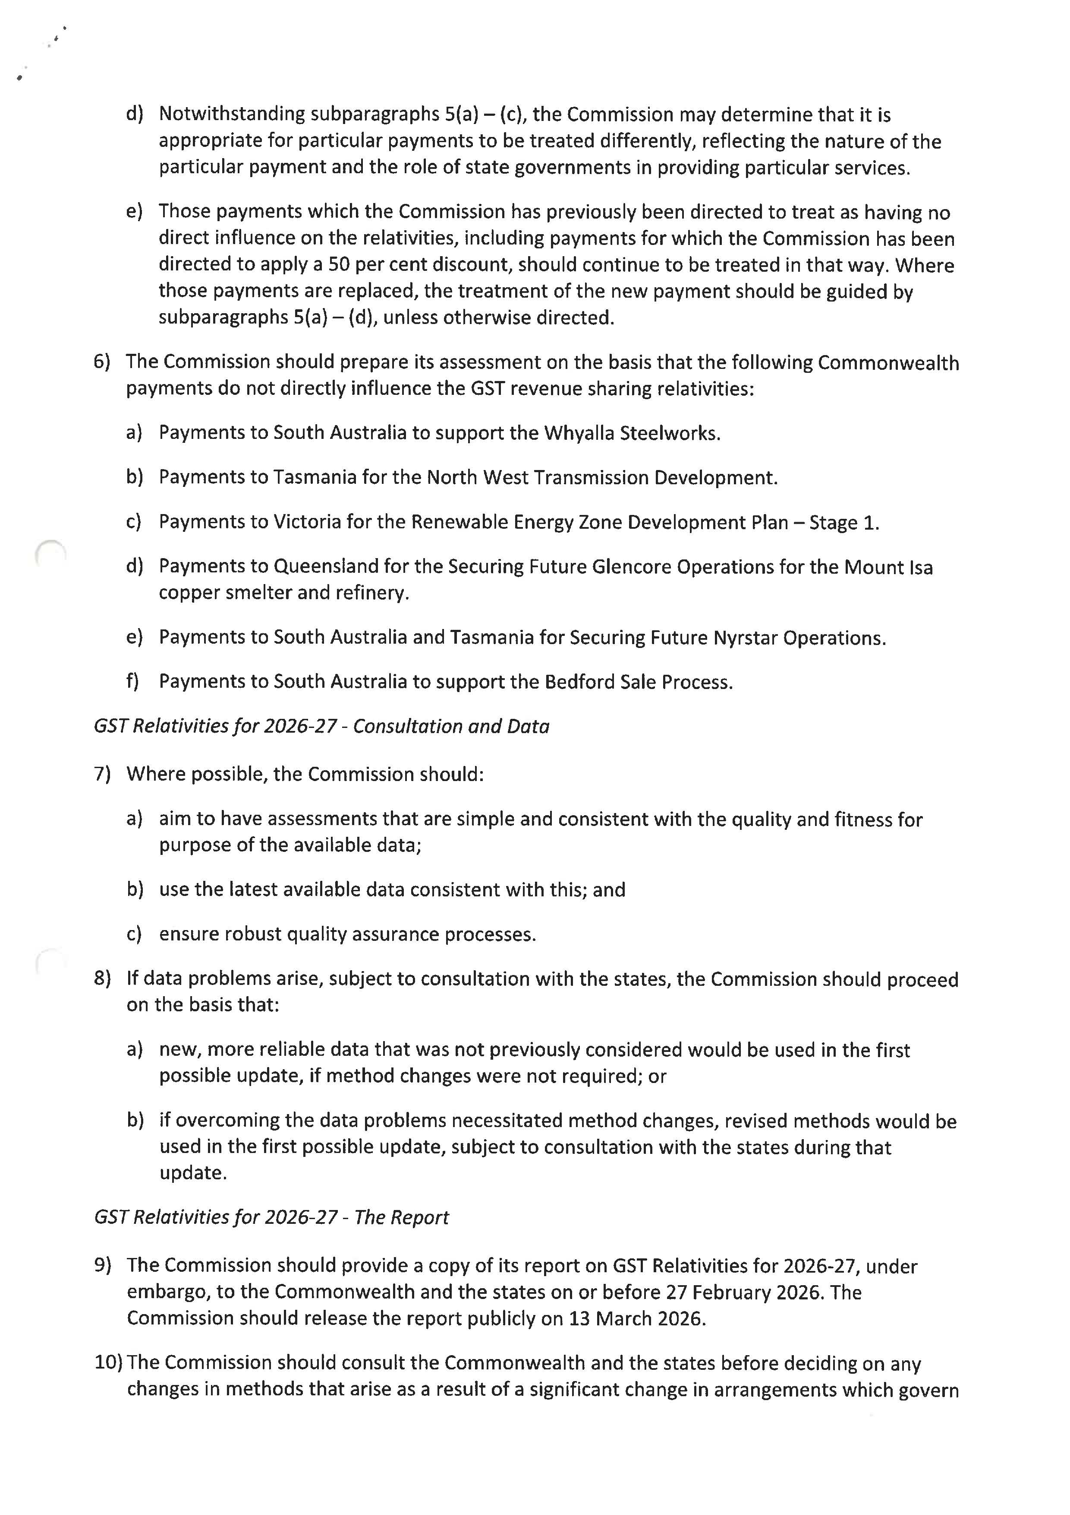
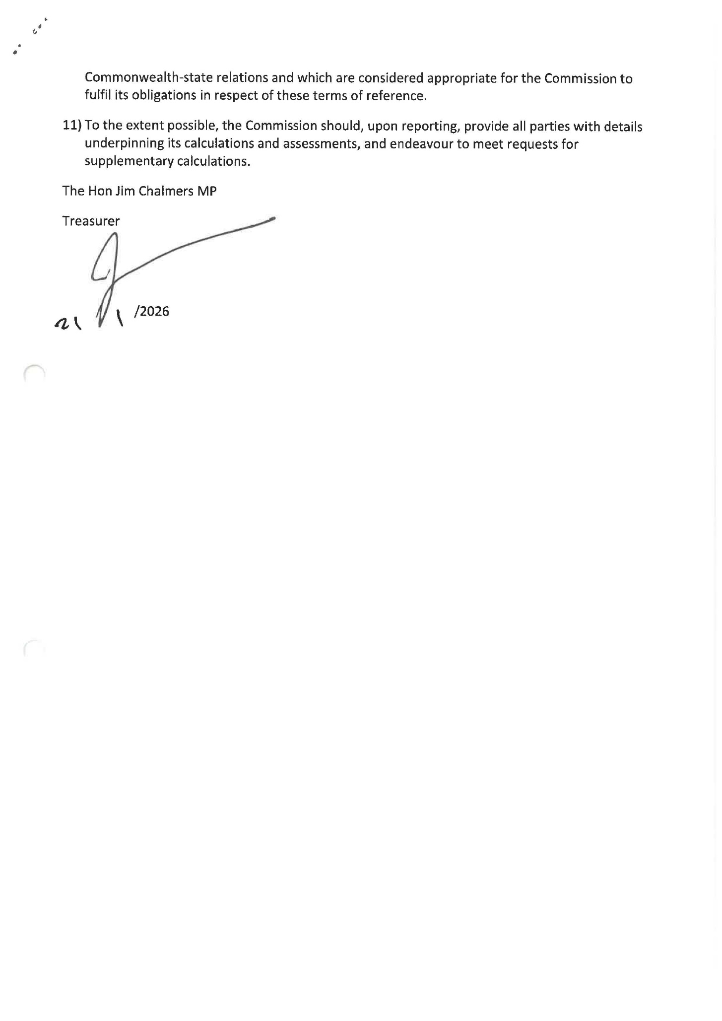

Acknowledgements
The Commission appreciates the cooperation of the Commonwealth and state treasuries, and other agencies during this update.

The Commission also acknowledges the work and commitment of its staff.

Notes
State(s): Unless the text indicates otherwise, the term ‘state(s)’ includes the ACT and the Northern Territory.

Figures in tables may not add due to rounding.

Acronyms
ABS | Australian Bureau of Statistics
ACT | Australian Capital Territory
CGC | Commonwealth Grants Commission
GST | Goods and Services Tax
m | Million
pc | Per capita
SDC | Socio-demographic composition

Glossary
A glossary is available on the Commission’s website: www.cgc.gov.au/publications/glossary.

Executive summary

Recommended GST relativities
In accordance with the Terms of Reference for the 2026 Update, the Commission’s recommended Goods and Services Tax (GST) relativities for 2026–27 are presented in the table below.
The table also includes each state and territory’s (state’s) estimated share of the GST pool and estimated GST distribution in 2026–27, as well as comparisons with 2025–26. The final amount of GST each state receives in 2026–27 will be based on state populations and the GST pool determined after the 2026–27 Final Budget Outcome.
GST relativities, estimated shares and estimated GST distribution, 2025–26 and 2026–27 (excludes no worse off payments)
 | NSW | Vic | Qld | WA | SA | Tas | ACT | NT | Total
GST relativities
2025-26 | 0.86034 | 1.06722 | 0.84571 | 0.75000 | 1.38876 | 1.84053 | 1.17223 | 5.15112 | 1.00000
2026-27 | 0.81964 | 1.05742 | 0.87237 | 0.81964 | 1.35920 | 1.88285 | 1.16179 | 5.24149 | 1.00000
GST shares (%)
2025-26 | 26.7 | 27.3 | 17.4 | 8.3 | 9.5 | 3.8 | 2.1 | 4.9 | 100
2026-27 | 25.5 | 27.2 | 18.0 | 9.1 | 9.3 | 3.9 | 2.0 | 5.0 | 100
GST distribution ($m)
2025-26 | 25,807 | 26,373 | 16,758 | 7,990 | 9,206 | 3,682 | 1,985 | 4,753 | 96,554
2026-27 | 26,123 | 27,867 | 18,438 | 9,337 | 9,548 | 3,968 | 2,095 | 5,142 | 102,518
Difference | 316 | 1,494 | 1,680 | 1,347 | 342 | 286 | 110 | 389 | 5,964
Difference ($pc) | 36 | 207 | 290 | 431 | 178 | 496 | 222 | 1,446 | 212
Note: Estimates subject to changes in the GST pool and populations.
Under the 2018 GST distribution legislation, 2026‍–‍27 completes a 6-year transition away from distributing the GST pool based solely on the Commission’s assessment of states’ relative fiscal capacities. From this update, the Commission’s assessment includes an adjustment so that no state will have a GST relativity less than the lower of New South Wales or Victoria (referred to as the ‘standard state’).
In 2026–27, New South Wales is the standard state in all 3 assessment years. Western Australia’s GST relativity is lifted to New South Wales’ relativity in all assessment years, while Queensland’s GST relativity is lifted in 2 assessment years (2022‍–‍23 and 2023‍–‍24).
A permanent feature of the 2018 GST distribution legislation is a GST relativity floor of 0.75. While the relativity floor was triggered during the transition period, it is not triggered in 2026‍–‍27. This is because all states’ relativities, after adjusting for the standard state, are above the floor.

Estimated total GST-related payments
All states are estimated to receive higher GST-related payments in 2026‍–‍27 compared with 2025‍–‍26.
Queensland is estimated to receive the largest increase in GST distribution of $1.7 billion. The Northern Territory is estimated to receive the largest increase in per capita terms of $1,446.
In addition to the GST distribution, a state will receive a no worse off payment from the Commonwealth if it is worse off compared with the arrangements prior to the 2018 GST distribution legislation. In 2026‍–‍27, Western Australia is estimated to receive $6.6 billion more in GST payments than under the previous arrangements. All other states are expected to receive a no worse off payment.
As a result of the 2018 GST distribution legislation, the total cost to the Commonwealth in 2026–27 is estimated to be $6.6 billion. This comprises $5.5 billion in no worse off payments and $1.1 billion in GST pool top-up payments.
Estimated total payments to the states from GST distribution and no worse off payments
 | NSW | Vic | Qld | WA | SA | Tas | ACT | NT | Total
 | $m | $m | $m | $m | $m | $m | $m | $m | $m
2025-26
Total GST distribution | 25,807 | 26,373 | 16,758 | 7,990 | 9,206 | 3,682 | 1,985 | 4,753 | 96,554
No worse off payments | 2,276 | 1,870 | 55 | 0 | 500 | 150 | 128 | 66 | 5,045
Total | 28,082 | 28,243 | 16,813 | 7,990 | 9,706 | 3,832 | 2,113 | 4,819 | 101,599
2026-27
Total GST distribution | 26,123 | 27,867 | 18,438 | 9,337 | 9,548 | 3,968 | 2,095 | 5,142 | 102,518
No worse off payments | 2,125 | 1,753 | 826 | 0 | 466 | 140 | 120 | 64 | 5,492
Total | 28,248 | 29,619 | 19,263 | 9,337 | 10,014 | 4,108 | 2,215 | 5,206 | 108,011
Difference
GST distribution | 316 | 1,494 | 1,680 | 1,347 | 342 | 286 | 110 | 389 | 5,964
No worse off payments | -151 | -117 | 770 | 0 | -34 | -10 | -8 | -3 | 447
Total ($m) | 166 | 1,377 | 2,450 | 1,347 | 308 | 276 | 102 | 386 | 6,412
Total ($pc) | 19 | 191 | 423 | 431 | 160 | 478 | 206 | 1,436 | 228
Note: Estimates subject to changes in the GST pool and populations.
Queensland is the only state estimated to have an increased no worse off payment in 2026‍–‍27 compared with 2025–26. This is because, in 2025–26, Queensland benefited from having its assessed relativity lifted to the standard state in all 3 assessment years. However, in 2026–27, Queensland’s assessed relativity is lifted to the standard state in only 2 of the assessment years. In effect, the 2018 legislated changes reduce Queensland’s GST relativity by more in 2026–27 than in 2025‍–‍26, thereby increasing its no worse off payment.

Drivers of changes to state GST distributions
Recommended GST relativities in 2026–27 reflect changes in state circumstances. These include spending on COVID-19 in 2021–22 dropping out of the assessment period, coal and iron ore royalty revenue falling between 2021–22 and 2024–25, and changes in the value of property being transferred. Downward revisions to some states’ natural disaster relief expenses and the 2018 legislated changes to determining relativities also impact the GST distribution.
The largest single factor affecting states’ GST distributions in 2026‍–‍27 compared with 2025–‍26 is growth in the GST pool. The GST pool (which does not include no worse off payments) is estimated to grow by almost $6 billion in 2026–27, to around $103 billion. Consequently, all states are expected to receive more GST in 2026‍–‍27, despite some states having a lower GST relativity.
New South Wales and Victoria both have a lower GST relativity in 2026‍–‍27 compared with 2025‍–‍26. Contributing to the reduction in their assessed GST needs is COVID-19 spending dropping out of the assessment period (both states had above-average COVID-19 expenses). Lower mining royalty revenue in Queensland and Western Australia in 2024–25 have increased their assessed GST needs and reduced the needs of other states, including New South Wales and Victoria (see Box 2-1). Revisions to natural disaster relief expenses (a large downward revision for New South Wales and an upward revision for Victoria) have reduced New South Wales’ assessed GST needs and increased Victoria’s.
Queensland has experienced an increase in assessed GST needs between 2025–26 and 2026–27. This is due to it having below-average COVID-19 expenses and a decrease in its capacity to raise revenue from mining royalties (particularly due to a fall in coal prices).
Western Australia continues to have the lowest assessed GST needs, driven by its strong capacity to raise revenue from iron ore royalties. However, compared with 2025–26, Western Australia’s assessed GST needs have increased as iron ore prices fell over the assessment period.
In addition to the impact from COVID-19 spending, mining royalty revenue and natural disaster relief expenses, the smaller states have been particularly impacted by changes to states’ shares of the value of property transferred, and changes in national spending on First Nations populations and Australians living in regional areas. Together, these decrease the assessed GST needs of South Australia and the ACT and increase them for Tasmania and the Northern Territory.
Alongside the major drivers of change mentioned above, estimated state populations for 2026–27 and method changes have also impacted states’ GST distributions. The impacts on GST distribution for all states from these major drivers of changes are included in the table below.
Major drivers of change in GST distribution, 2025–26 to 2026–27 (excludes no worse off payments)
 | NSW | Vic | Qld | WA | SA | Tas | ACT | NT | Total effect
 | $m | $m | $m | $m | $m | $m | $m | $m | $m
Changes in fiscal capacities
Changes in circumstances - mining production | -381 | -912 | 284 | 1,390 | -236 | -54 | -64 | -27 | 1,674
Changes in circumstances - COVID-19 | -674 | -853 | 829 | 365 | 267 | 60 | -11 | 17 | 1,538
Changes in circumstances - property sales | 666 | 429 | -379 | -538 | -192 | -33 | 46 | 2 | 1,143
Data revisions - natural disaster relief | -770 | 558 | 279 | -171 | 31 | 32 | 28 | 14 | 942
Other revisions | 279 | 87 | -221 | 30 | -56 | -144 | 23 | 3 | 421
Other changes in circumstances | -795 | 451 | 463 | -294 | -25 | 151 | -38 | 89 | 1,153
Method changes | 145 | -197 | 113 | -63 | -40 | 66 | -15 | -7 | 323
Total change in fiscal capacities | -1,530 | -440 | 1,370 | 717 | -253 | 77 | -31 | 89 | 2,253
2018 legislated changes to determining relativities | 298 | 249 | -763 | 97 | 68 | 21 | 17 | 12 | 763
Change in population | -44 | 52 | 36 | 37 | -40 | -37 | 1 | -5 | 127
Change in pool (a) | 1,591 | 1,632 | 1,037 | 496 | 566 | 225 | 123 | 293 | 5,964
Total change in GST | 316 | 1,494 | 1,680 | 1,347 | 342 | 286 | 110 | 389 | 5,964
- Total effect from change in pool represents the sum of the effect for each state from total growth in GST and pool top-up payments, rather than the distribution of GST between states (net effect) shown for other drivers of change.

Introduction
On 21 January 2026, the Commonwealth Treasurer issued terms of reference asking the Commonwealth Grants Commission (the Commission) to recommend GST sharing relativities to be used to distribute the Goods and Services Tax (GST) revenue pool among the states in 2026–27.

Commission’s role
The Commission provides independent advice to the Australian Government on how GST revenue should be distributed among the states. The distribution of GST revenue is governed by legislation and annual terms of reference issued by the Commonwealth Treasurer, which require the Commission’s advice to be based on the objective of horizontal fiscal equalisation. This objective has been a feature of Australia’s federal financial arrangements for many decades. It seeks to provide each state with the financial capacity to provide services at a comparable standard if each made the same effort to raise revenue. In this way, all Australians, regardless of the state in which they live, have the opportunity to receive a comparable standard of service.

2025 Methodology Review
During the 2025 Methodology Review, the Commission delayed finalising and implementing method changes to the justice assessment until the 2026 Update. This was to allow for the inclusion of data for 2023–24 that were not unduly affected by the COVID-19 pandemic and not available at the time of the 2025 Review. Changes made to the justice assessment had implications for the Commission’s geography assessment. The 2026 Update includes the effects of these method changes on GST distribution.
Further details on the changes to the justice assessment method are included in the justice – addendum chapter of the 2025 Methodology Review – Review Outcomes at Attachment A.

2018 GST distribution legislation
In 2018, the Commonwealth Parliament legislated a new way to distribute GST revenue to the states. The GST distribution legislation changed the GST distribution arrangements from a ‘full’ equalisation standard to a ‘reasonable’ equalisation standard. Under the legislation, 2026–‍27 completes a 6-year transition to the ‘reasonable’ equalisation benchmark. From 2026–27, no state will have a GST relativity less than the lower of New South Wales or Victoria (referred to as the ‘standard state’). For GST relativities in 2026–27, New South Wales is the standard state for all 3 assessment years (2022–23, 2023–‍24 and 2024–25). After a state’s relativity is raised to the relativity of the standard state, the relativities of all states are reduced on a population share basis to accommodate the increase (see Appendix B for further detail).
The 2018 GST distribution legislation also provides for a permanent GST relativity floor of 0.75. For 2026–27, the GST floor has not been triggered because all states’ relativities, after adjusting for the standard state, are above this floor.
The 2018 GST distribution legislation includes a guarantee that no state will be worse off under the new arrangements (GST pool top-up payments, a GST relativity floor and the standard state approach). The legislated no worse off guarantee operates from 2021–22 until 2026–27, with no worse off payments calculated and provided by the Commonwealth in accordance with the legislation. Under an agreement between the Commonwealth and the states, no worse off payments will continue until 2029–30.

Report structure
Chapter 1 sets out the Commission’s recommended GST relativities and the estimated GST revenue distribution for 2026–27. It also provides relativities for the Commonwealth Treasurer to use in calculating no worse off payments.
Chapter 2 explains the main changes in the Commission’s assessment of each state’s GST needs since the 2025 Review.
Chapter 3 provides a snapshot of the main factors impacting each state’s GST relativity and recommended GST distribution for 2026–27.
Appendix A outlines the Commission’s approach to implementing horizontal fiscal equalisation and estimating states’ relative fiscal capacities.
Appendix B provides additional detail on how the GST relativities are calculated.
Appendix C contains information on states’ GST shares since 2000–01.
Appendix D outlines the Commission’s quality assurance process.
Attachment A contains the justice – addendum chapter of the 2025 Methodology Review – Review Outcomes.
The Commission consulted with states on new issues arising in this update. State views and Commission responses are outlined in New Issues in the 2026 Update.

Recommended GST relativities

Key points
- All states are estimated to receive an increased GST distribution in 2026–27.
The GST pool is estimated to increase from around $97 billion in 2025–26 to around $103 billion in 2026–27.
- Based on the Commission’s 2026–27 recommended GST relativities, Queensland is estimated to receive the largest increase in GST distribution of $1.7 billion ($290 per capita). The Northern Territory is estimated to receive the largest increase in per capita terms of $1,446 per capita.
- Under the 2018 legislated changes to determining relativities, Western Australia’s GST relativity is lifted to the standard state, New South Wales, in all 3 assessment years. Queensland’s GST relativity is lifted in 2 assessment years (2022–23 and 2023–24).
- Western Australia is estimated to receive $6.6 billion more in 2026–27 than under the previous GST distribution arrangements. Before no worse off payments from the Commonwealth, all other states are estimated to receive less than under the previous GST distribution arrangements.
- As a result of the 2018 GST distribution legislation, the total cost to the Commonwealth in 2026–27 is estimated to be $6.6 billion. This comprises $5.5 billion in no worse off payments and $1.1 billion in GST pool top-up payments.
- Changes in the estimated GST distribution between 2025–26 and 2026–27 are driven by the combination of changes in GST relativities, changes in state population shares and growth in the GST pool.
- Changes in state circumstances have a significant impact on the 2026 Update, with 2021‍–‍22 dropping out of the assessment period and being replaced by 2024‍–‍25.

Recommended GST relativities
Consistent with the terms of reference, the Commission’s recommended GST relativities for 2026–27 are presented in Table 1-1. This table also includes the states’ shares of the GST pool and the estimated GST pool distribution, as well as comparisons with 2025‍‍–26. The estimated GST distribution for 2026‍–‍27 is calculated by applying 2026–27 GST relativities to forecast state populations for 2026‍–‍27 and the estimated GST pool for 2026–27. The actual GST distribution each state receives in 2026–27 will be based on state populations and the GST pool determined after the 2026‍–‍27 Final Budget Outcome. The table does not include no worse off payments.
Table 1-1 GST relativities, shares and estimated GST distribution, 2025‍–‍26 to 2026‍–‍27 (excludes no worse off payments)
 | NSW | Vic | Qld | WA | SA | Tas | ACT | NT | Total
GST relativities
2025-26 | 0.86034 | 1.06722 | 0.84571 | 0.75000 | 1.38876 | 1.84053 | 1.17223 | 5.15112 | 1.00000
2026-27 | 0.81964 | 1.05742 | 0.87237 | 0.81964 | 1.35920 | 1.88285 | 1.16179 | 5.24149 | 1.00000
GST shares (%)
2025-26 | 26.7 | 27.3 | 17.4 | 8.3 | 9.5 | 3.8 | 2.1 | 4.9 | 100
2026-27 | 25.5 | 27.2 | 18.0 | 9.1 | 9.3 | 3.9 | 2.0 | 5.0 | 100
GST distribution ($m)
2025-26 | 25,807 | 26,373 | 16,758 | 7,990 | 9,206 | 3,682 | 1,985 | 4,753 | 96,554
2026-27 | 26,123 | 27,867 | 18,438 | 9,337 | 9,548 | 3,968 | 2,095 | 5,142 | 102,518
Difference | 316 | 1,494 | 1,680 | 1,347 | 342 | 286 | 110 | 389 | 5,964
Difference ($pc) | 36 | 207 | 290 | 431 | 178 | 496 | 222 | 1,446 | 212
Note: Estimates subject to changes in the GST pool and populations.
Source: 2025–26 and 2026–27 GST pool estimates and 2025–26 population estimates were taken from the Mid-Year Economic and Fiscal Outlook 2025–26. 2026–27 population estimates were provided by the Commonwealth Treasury.
All states are estimated to receive an increase in GST distribution in 2026–27. Queensland will receive the largest increase in GST distribution of $1.7 billion ($290 per capita). The Northern Territory will receive the largest increase in per capita terms of $1,446.
Total payments to the states will also include no worse off payments, which ensure no state is worse off than it would have been under the GST arrangements that existed prior to the 2018 GST distribution legislation. All states, other than Western Australia, are estimated to receive a no worse off payment in 2026–27.
Appendix B provides further details on how GST relativities are calculated.

Movements in the GST distribution
Table 1-2 shows the estimated change in GST distribution from changes to population shares, the GST pool and GST relativities between 2025–26 and 2026–27.

Table 1-2 Change in GST distribution, 2025–26 to 2026–27 (excludes no worse off payments)
 | NSW | Vic | Qld | WA | SA | Tas | ACT | NT | Total
 | $m | $m | $m | $m | $m | $m | $m | $m | $m
Estimated 2025-26 distribution | 25,807 | 26,373 | 16,758 | 7,990 | 9,206 | 3,682 | 1,985 | 4,753 | 96,554
Estimated 2026-27 distribution | 26,123 | 27,867 | 18,438 | 9,337 | 9,548 | 3,968 | 2,095 | 5,142 | 102,518
Change caused by:
Population (a) | -44 | 52 | 36 | 37 | -40 | -37 | 1 | -5 | 0
Pool (b) | 1,591 | 1,632 | 1,037 | 496 | 566 | 225 | 123 | 293 | 5,964
GST relativities (c) | -1,231 | -191 | 606 | 814 | -184 | 99 | -14 | 101 | 0
Assessed relativities (d) | -1,530 | -440 | 1,370 | 717 | -253 | 77 | -31 | 89 | 0
2018 legislated changes to determining relativities (e) | 298 | 249 | -763 | 97 | 68 | 21 | 17 | 12 | 0
Change ($m) | 316 | 1,494 | 1,680 | 1,347 | 342 | 286 | 110 | 389 | 5,964
Change ($pc) | 36 | 207 | 290 | 431 | 178 | 496 | 222 | 1,446 | 212
- Effects on the distribution of the 2025–26 GST pool of using estimated state populations for 2026–27 instead of 2025–26, with 2025 relativities.
- Effects of applying the 2025 relativities to the estimated 2026–27 GST pool instead of the estimated 2025–26 GST pool.
- Effects on the distribution of the 2026–27 GST pool of using the 2026 GST relativities instead of the 2025 GST relativities.
- Effects on the distribution of the 2026–27 GST pool of using the 2026 assessed relativities instead of the 2025 assessed relativities.
- Effects on the distribution of the 2026–27 GST pool of using the 2026 standard state relativities instead of the 2025 blended relativities and GST relativity floor.
Source: 2025–26 and 2026–27 GST pool estimates and 2025–26 population estimates were taken from the Mid-Year Economic and Fiscal Outlook 2025–26. 2026–27 population estimates were provided by the Commonwealth Treasury.
Changes in estimated GST payments between 2025–26 and 2026–27 are driven by the following.
- Changes to state populations: the GST distribution is determined by applying GST relativities to state populations. The estimated 2026–27 GST distribution is based on Commonwealth estimates of state populations for 2026–27 at the time of the Mid-Year Economic and Fiscal Outlook 2025–26. Expected changes in state populations between 2025–26 and 2026–27 impact the estimated GST distribution.
- Slower forecast population growth between these years in New South Wales, South Australia, Tasmania and the Northern Territory reduces their estimated GST distribution. Higher forecast population growth in Victoria, Queensland, Western Australia and the ACT increases their estimated GST distribution.
- Changes to state populations also impact the Commission’s assessment of states’ GST needs. These impacts are separately captured in the changes to GST relativities (see below).
- Growth in the GST pool: in the Mid-Year Economic and Fiscal Outlook 2025–26, the Australian Government estimated an increase in the GST pool from around $97 billion in 2025–26 to around $103 billion in 2026–27. Growth in the pool is distributed among states using their population shares, weighted by their 2026–27 relativities.
- All states benefit from anticipated growth in the GST pool in 2026–27. States with a higher GST relativity, in particular the Northern Territory, but also Tasmania and South Australia, benefit more on a per capita basis than states with a lower GST relativity.

- Changes to the GST relativities: changes in GST relativities reflect changes in assessed relativities (influenced by method changes, data revisions and changes in state circumstances), as well as the application of the 2018 legislated changes to determining relativities.
- Compared with 2025–26, the recommended GST relativities for 2026–27 (excluding the impact of changes in populations and changes in the GST pool), increase the GST distribution to Queensland, Western Australia, Tasmania and the Northern Territory and decrease the GST distribution to New South Wales, Victoria, South Australia and the ACT.
- New South Wales has the largest decrease in GST distribution from changes to the GST relativities. New South Wales’ GST relativity is its lowest since the introduction of the GST in 2000–01.
- In 2025–26, Queensland’s relativity was lifted to the standard state in all 3 assessment years, whereas in 2026–27 it is only lifted in the first 2 assessment years. This means the 2018 legislated changes result in a bigger reduction in Queensland’s GST in 2026–27 than in 2025–26.
- Chapter 2 provides details on the main drivers of the changes to assessed GST needs.
Appendix C provides an analysis of how the GST distribution has changed since the introduction of the GST in 2000–01.

Impact of replacing 2021–22 data with 2024–25 data
The Commission’s aim, to the extent reliable data allow, is that the GST distribution provided to states in a year reflects state circumstances. Given robust data for the application year are not available until the application year has passed, the Commission bases its recommendations on historical data. The 3-year lagged, moving average of state fiscal capacities provides a balance between contemporaneity, predictability and smoothing the impacts of fiscal shocks.
Under this approach, each update is impacted by differences between the year being removed from the Commission’s calculations and the year replacing it. In the 2026 Update, 2021–22 data have been removed and 2024–25 data have been introduced. Some notable state experiences in these years are outlined below.
In 2021–22:
- states’ spending on the COVID-19 public health response and business support varied significantly, with some states spending much more than others
- the COVID-19 pandemic had large impacts on population movements, both into Australia and between states
- there were high commodity prices, particularly for coal
- there was a significant property boom across Australia, particularly impacting Sydney and Melbourne.
Comparably, in 2024–25:
- the majority of COVID-19 health and business support spending had finished
- population movements continued to return towards long-term trends following the COVID-19 pandemic effect
- commodity prices had fallen, particularly for coal and iron ore
- property prices were more stable in Sydney and Melbourne but there were property booms in other areas of Australia, particularly Perth, Brisbane and Adelaide
- the Commonwealth and states agreed to education funding reforms, requiring a different treatment of Commonwealth education payments by the Commission.
These changes had a significant impact on states’ relative circumstances. Replacing
2021–22 data with 2024–25 data in the 2026 Update increases the assessed GST needs of Queensland, Western Australia, Tasmania and the Northern Territory, and reduces the assessed GST needs of the other states.

Impact of the 2018 GST distribution legislation
Under the 2018 GST distribution legislation, 2026‍–‍27 completes the 6-year transition away from distributing the GST pool based solely on the Commission’s assessment of states’ relative fiscal capacities. From this update, no state will have a GST relativity less than the lower of New South Wales or Victoria (referred to as the ‘standard state’) or below the GST floor of 0.75. In 2026–27, New South Wales is the standard state in all assessment years (2022–23, 2023–24 and 2024–25) and the floor is not triggered.
Table 1-3 compares the estimated distribution from the GST pool (including pool top-ups but excluding no worse off payments) in 2026–27 with the Commission’s estimate of what each state would have received if the 2018 GST distribution legislation had not been enacted. It shows the total difference is $1.1 billion, which reflects the Commonwealth’s estimated top-up to the GST pool in 2026–27.
Table 1-3 Impact of 2018 GST distribution legislation on the distribution of the GST pool, 2026–27 (excludes no worse off payments)
 | NSW | Vic | Qld | WA | SA | Tas | ACT | NT | Total
 | $m | $m | $m | $m | $m | $m | $m | $m | $m
Estimated GST pool distribution | 26,123 | 27,867 | 18,438 | 9,337 | 9,548 | 3,968 | 2,095 | 5,142 | 102,518
Distribution under previous arrangements | 28,248 | 29,619 | 19,263 | 2,737 | 10,014 | 4,108 | 2,215 | 5,206 | 101,410
Difference | -2,125 | -1,753 | -826 | 6,601 | -466 | -140 | -120 | -64 | 1,108
Western Australia is estimated to receive around $6.6 billion more in GST payments in 2026–‍27 than under the previous GST distribution arrangements. This reflects Western Australia’s relativity being lifted to New South Wales’ relativity.
Before no worse off payments from the Commonwealth, all other states are estimated to receive less than under the previous GST distribution arrangements.

Relativities to determine no worse off payments
The Terms of Reference for the 2026 Update asks the Commission to provide the relativities that would have applied had the 2018 GST distribution legislation not been enacted. These relativities are used by the Commonwealth to determine whether to make a no worse off payment to a state. The estimated no worse off relativities for 2026–27 are shown in Table 1-4.
Table 1-4 No worse off relativities, 2026–27
 | NSW | Vic | Qld | WA | SA | Tas | ACT | NT | Total
Relativities | 0.89478 | 1.13465 | 0.92013 | 0.24251 | 1.43916 | 1.96772 | 1.24006 | 5.35688 | 1.00000
The 2026–27 no worse off relativities differ from assessed relativities because they include adjustments to remove the impact of the Commonwealth’s legislated top-ups to the GST pool.

Estimated total payments to the states in 2026–27
The Commission has calculated indicative estimates of total payments from the GST pool and no worse off payments (see Table 1-5).
All states are estimated to receive more in total GST and no worse off payments than they received in 2025–26. All states except Western Australia are estimated to receive a no worse off payment in 2026–27.
Queensland is the only state to have an increased estimated no worse off payment in 2026–27, compared with 2025–26. This is because, in 2025–26, Queensland benefited from having its relativity lifted to that of New South Wales under the standard state approach in all 3 assessment years. However, in 2026–27, Queensland’s relativity is lifted to the standard state in only 2 of the assessment years. In effect, the 2018 legislated changes reduce Queensland’s GST relativity by a greater amount in 2026–27 than in 2025–26, thereby increasing its no worse off payment.
As a result of the 2018 GST distribution legislation, the total cost to the Commonwealth in 2026–27 is estimated to be $6.6 billion. This comprises $5.5 billion in no worse off payments and $1.1 billion in GST pool top-up payments.
Table 1-5 Estimated total payments to states from GST distribution and no worse off payments
 | NSW | Vic | Qld | WA | SA | Tas | ACT | NT | Total
 | $m | $m | $m | $m | $m | $m | $m | $m | $m
2025-26
Total GST distribution | 25,807 | 26,373 | 16,758 | 7,990 | 9,206 | 3,682 | 1,985 | 4,753 | 96,554
No worse off payments | 2,276 | 1,870 | 55 | 0 | 500 | 150 | 128 | 66 | 5,045
Total | 28,082 | 28,243 | 16,813 | 7,990 | 9,706 | 3,832 | 2,113 | 4,819 | 101,599
2026-27
Total GST distribution | 26,123 | 27,867 | 18,438 | 9,337 | 9,548 | 3,968 | 2,095 | 5,142 | 102,518
No worse off payments | 2,125 | 1,753 | 826 | 0 | 466 | 140 | 120 | 64 | 5,492
Total | 28,248 | 29,619 | 19,263 | 9,337 | 10,014 | 4,108 | 2,215 | 5,206 | 108,011
Difference
GST distribution | 316 | 1,494 | 1,680 | 1,347 | 342 | 286 | 110 | 389 | 5,964
No worse off payments | -151 | -117 | 770 | 0 | -34 | -10 | -8 | -3 | 447
Total ($m) | 166 | 1,377 | 2,450 | 1,347 | 308 | 276 | 102 | 386 | 6,412
Total ($pc) | 19 | 191 | 423 | 431 | 160 | 478 | 206 | 1,436 | 228

2. Drivers of GST distribution

Key points
- Changes in state circumstances have a significant impact on the 2026 Update, with 2021‍–‍22 dropping out of the assessment period and being replaced by 2024‍–‍25.
- COVID-19 expenses were largest in 2021–22 and declined significantly in subsequent years. States with above-average COVID-19 expenses, notably New South Wales, Victoria and the ACT, now have lower assessed GST needs.
- Coal and iron ore prices fell between 2021–22 and 2024–25. This decreases Queensland’s and Western Australia’s revenue raising capacities and increases their assessed GST needs.
- New South Wales, Victoria, the ACT and the Northern Territory had a larger than average fall in the value of property transferred. This lowers their relative revenue raising capacities, which increases their assessed GST needs.
- Revisions by states to their natural disaster relief data have resulted in large changes to assessed GST needs. In particular, New South Wales made a significant downward revision to its 2022–23 expenses, which has decreased its assessed GST needs. Revisions have also been made to investment and health data for all states.
- The Commission made changes to the justice assessment as part of the 2025 Methodology Review. These involved changes to methods as well as updating 5-yearly data that inform the assessment. These changes increase the assessed GST needs of New South Wales, Queensland and Tasmania.

Why GST shares have changed
Chapter 1 outlined how changes in GST distribution since 2025–26 are driven by changes to GST relativities, population and the GST pool. In turn, changes in GST relativities are driven by the Commission’s assessment of states’ GST needs and the application of the 2018 legislated changes to determining relativities.
This chapter focuses on the main drivers of changes to assessed GST needs. Table 2-1 shows that, at the highest level, changes occurred for 3 reasons.
- Method changes – as part of the 2025 Review, the Commission delayed implementing changes to the justice assessment until the 2026 Update. The Commission also made a data-related method change to the urban transport assessment.
- Revisions – data providers released updated data for 2021–22 to 2023–24, which have been incorporated.
- Changes in state circumstances – states’ economic and socio-demographic circumstances change over time. The Commission uses a 3-year lagged, moving average of state fiscal capacities. For the 2026–27 GST relativities, states’ GST needs have been assessed using data from 2022–23 to 2024–25. There are significant differences in state circumstances between the year brought into the 3-year average (2024–25) and the year removed (2021–22). The difference in state circumstances between these 2 years has the largest total impact on estimated GST distribution.
Table 2-1 Change in assessed GST needs by source of change, 2025–‍26 to 2026–‍27
 | NSW | Vic | Qld | WA | SA | Tas | ACT | NT | Total effect
 | $m | $m | $m | $m | $m | $m | $m | $m | $m
Method changes | 145 | -197 | 113 | -63 | -40 | 66 | -15 | -7 | 323
Data revisions (a) | -492 | 645 | 59 | -141 | -25 | -112 | 51 | 16 | 770
Changes in circumstances (b) | -1,182 | -888 | 1,198 | 921 | -188 | 124 | -67 | 80 | 2,324
Total change | -1,530 | -440 | 1,370 | 717 | -253 | 77 | -31 | 89 | 2,253
- Includes revisions in relative state circumstances and revisions in how much states collectively spend or raise.
- Includes changes in relative state circumstances and changes in how much states collectively spend or raise.

Composition of total change
The Commission measures the sources of change to GST distribution within each of its assessments. These can be grouped by type of assessment, such as revenues or expenses. In estimating the total change in GST distribution, the Commission also measures the impact of the 2018 legislated changes to determining relativities. Changes in states’ expense needs have the largest impacts on GST distribution in 2026–27 (see Table 2-2).
Table 2-2 Composition of estimated changes in GST distribution, 2025–26 to 2026–‍27
 | NSW | Vic | Qld | WA | SA | Tas | ACT | NT | Total effect
 | $m | $m | $m | $m | $m | $m | $m | $m | $m
Expense needs | -1,489 | -778 | 1,715 | 118 | 269 | 187 | -41 | 20 | 2,308
Investment needs | -304 | 491 | -126 | 111 | -110 | -81 | -59 | 78 | 681
Net borrowing | 57 | -116 | 70 | -57 | 22 | 33 | 6 | -14 | 187
Revenue raising capacity | 87 | -182 | -341 | 848 | -403 | -68 | 40 | 19 | 994
Commonwealth payments (a) | 118 | 147 | 50 | -302 | -30 | 8 | 24 | -15 | 347
Total change | -1,530 | -440 | 1,370 | 717 | -253 | 77 | -31 | 89 | 2,253
2018 legislated changes to determining relativities | 298 | 249 | -763 | 97 | 68 | 21 | 17 | 12 | 763
Change in GST relativities | -1,231 | -191 | 606 | 814 | -184 | 99 | -14 | 101 | 1,620
- The effects of changing Commonwealth payments for COVID-19 and the Better and Fairer Schools Agreement are included in the changes to expense needs.

Method changes
The Commission has implemented method changes in the justice and transport assessments. Changes to the justice assessment complete the Commission’s work undertaken as part of the 2025 Methodology Review. Changes to the urban transport assessment were made as part of the New Issues process for the 2026 Update.
Table 2-3 Change to assessed GST needs due to method changes, 2025–‍26 to 2026–‍27
 | NSW | Vic | Qld | WA | SA | Tas | ACT | NT | Total effect
 | $m | $m | $m | $m | $m | $m | $m | $m | $m
Changes to justice assessment
Recurrent justice expenses | 218 | -232 | 97 | -68 | -40 | 55 | -15 | -15 | 370
Investment in justice | 32 | -19 | 3 | -15 | -2 | 6 | -1 | -4 | 41
General gradient changes to other assessments | -8 | -6 | 2 | 3 | 0 | 1 | -1 | 8 | 14
Total | 242 | -257 | 102 | -81 | -43 | 62 | -17 | -10 | 407
Changes to blending in urban transport
Recurrent urban transport expenses | -84 | -29 | 49 | 22 | 19 | 9 | 9 | 5 | 113
Investment in urban transport | -14 | 88 | -38 | -4 | -16 | -6 | -8 | -2 | 88
Total | -97 | 59 | 11 | 18 | 3 | 3 | 1 | 3 | 97
Total method changes | 145 | -197 | 113 | -63 | -40 | 66 | -15 | -7 | 323
Note: Numbers for the changes to the justice assessment differ from those presented in the Overview of the final draft justice assessment because they incorporate the growth of the GST pool for 2026–27 compared with the 2025 Review.

Justice
As part of the 2025 Methodology Review, the Commission delayed method changes in the justice assessment until the 2026 Update. This was to allow for the use of data that were not unduly affected by the COVID-19 pandemic and appropriate consultation with the states.
The Commission has implemented several method changes in the justice assessment. These include changes to how police central costs are allocated and the addition of a juvenile detainee cost weight. However, most of the change in GST distribution in the justice assessment is due to updating 5-yearly data. New data have been used in calculating justice services use rates and the police regression. In combination, these changes increase the assessed GST needs of New South Wales, Queensland and Tasmania and reduce the GST needs of other states (Table 2-3).
Changes made in the justice assessment also impact the justice component of the investment assessment and the calculation of the general gradient used to assess regional costs. These impacts are small compared with changes to the justice assessment. Further information on Commission decisions and data updates in the justice assessment is in Attachment A.

Urban transport blending
As part of New Issues in the 2026 Update, the Commission has retained the 2025 Review regression’s coefficients based on a single year of data (2022–‍23). The Commission has also increased the urban population blending ratio by 5 percentage points in the recurrent urban transport assessment and the investment assessment.
In the 2025 Methodology Review, the Commission decided to re-estimate the transport regression in the 2026 Update with 2 years of state net expense data (2022–23 and 2023–‍24) to enhance the reliability and contemporaneity of the model. This was supported by most states.
The Commission found significant comparability problems with the second year of data. In line with the terms of reference, the Commission decided not to use the 2023–‍‍24 data. In response, some states recommended that the regression be given less prominence by increasing the blending ratio or applying discounts.
The Commission considers that the regression model is less reliable than anticipated in the 2025 Review because of the data problems. Consistent with the terms of reference, to address the identified data problems and state concerns, the Commission has increased the blending ratio in favour of urban populations to reduce the impact of the regression on the assessment.
The Commission will also continue to work with the states through the Data Working Group to try and resolve the identified data problems.

Data revisions
Since the 2025 Review, data providers have released updated data for 2021–22 to 2023–‍‍24. The Commission has revised its assessments using the latest available data. These revisions affect the GST distribution as presented in Table 2-4.
Table 2-4 Changes to assessed GST needs due to data revisions, 2025–‍26 to 2026–27
 | NSW | Vic | Qld | WA | SA | Tas | ACT | NT | Total effect
 | $m | $m | $m | $m | $m | $m | $m | $m | $m
Natural disaster relief | -770 | 558 | 279 | -171 | 31 | 32 | 28 | 14 | 942
Investment | 231 | -145 | -169 | 82 | -31 | -55 | 8 | 80 | 401
Net Borrowing | -120 | 159 | 79 | 22 | -52 | -27 | -30 | -32 | 260
Health | 113 | 48 | -89 | 12 | 14 | -80 | 30 | -47 | 216
Mining revenue | -14 | 8 | 48 | -85 | 13 | 10 | 0 | 20 | 99
Other revisions | 68 | 17 | -90 | -1 | 0 | 9 | 15 | -18 | 109
Total | -492 | 645 | 59 | -141 | -25 | -112 | 51 | 16 | 770

Revisions to natural disaster relief data
Revisions by states to their natural disaster relief data result in large changes to assessed GST needs. In particular, New South Wales made a significant downward revision to its 2022–‍‍23 expenses.
Data on natural disaster relief expenses are subject to revision, partly because the Disaster Recovery Funding Arrangements require multiple levels of auditing, often resulting in the data for the assessment years being incomplete at the time of reporting. As per usual practice, the Commission incorporates the revised data into its calculations when available. Given natural disaster relief expenses are assessed on an actual per capita basis, where material, the Commission also makes an adjustment to correct for the use of unrevised data in previous updates. This ensures correct actual expenses are assessed over time. There were material data revisions to natural disaster relief for New South Wales, Victoria, Western Australia and South Australia that triggered adjustments to GST distribution.

Revisions to investment data
Upward revisions were made to investment data, particularly for urban transport and rural roads. This increases the assessed GST needs of states with a greater share of the user populations.
Revisions were also made to user population data. User population revisions in schools have increased the Northern Territory’s assessed GST needs.
Total investment revisions increase the assessed GST needs of New South Wales, Western Australia, the ACT and the Northern Territory and reduce the assessed GST needs of the other states.

Revisions to net borrowing data
The ABS revised its estimates of state populations. States whose shares of population were revised downwards, particularly Victoria and Queensland, have higher assessed GST needs in order to maintain the average level of debt per person.

Revisions to health data
The Commission’s health assessment uses hospital activity data. There is a one-year lag in receiving the latest year’s data. Therefore, the most recent assessment year in each update uses the data from the previous assessment year. For the 2025 Review, 2022–‍‍23 data were used for both the 2022–23 and 2023–24 assessment years. For this update, 2023–‍‍24 data are available and have been used.
GST distribution was also impacted by a revision to the Independent Health and Aged Care Pricing Authority’s (IHACPA) National Weighted Activity Unit data for 2021–22 and 2022–‍23. IHACPA identified that some data for major cities were misclassified to other remoteness categories. Correct classification has increased hospital activity in major cities.
Combined, these revisions to the health data increase the assessed GST needs of New South Wales, Victoria, Western Australia, South Australia and the ACT and reduce the assessed GST needs of the other states.

Revisions to mining data
A separate assessment of nickel is not material in this update. Therefore, nickel royalites have been assessed in the other minerals component.
Western Australia, the major nickel-producing state, is assessed to have a higher revenue capacity (and lower assessed GST needs) because the average royalty rate of other minerals is higher than the average nickel royalty rate.
See Box 2-1 for more information on aggregating nickel into other minerals.

Changes in state circumstances
The Commission uses a 3-year lagged, moving average of state fiscal capacities. For this update, 2024‍–‍25 data replace 2021‍–‍22 data in the 3-year assessment period. Differences in states’ relative circumstances in 2024‍–‍25 compared with 2021‍–‍22 are significant, contributing to large changes in GST distribution (see Table 2-5 and Table 2-6). This section outlines several large changes in state circumstances.
Table 2-5 Composition of changes in state circumstances, 2025–‍26 to 2026–‍27
 | NSW | Vic | Qld | WA | SA | Tas | ACT | NT | Total effect
 | $m | $m | $m | $m | $m | $m | $m | $m | $m
Expense needs | -901 | -1,214 | 1,323 | 345 | 256 | 158 | -69 | 102 | 2,184
Investment needs | -517 | 517 | 43 | 61 | -52 | -25 | -49 | 22 | 643
Net borrowing | 141 | -230 | 22 | -89 | 65 | 58 | 25 | 9 | 320
Revenue raising capacity | 7 | -149 | -277 | 917 | -419 | -74 | 12 | -19 | 937
Commonwealth payments (a) | 85 | 190 | 85 | -311 | -37 | 7 | 14 | -33 | 382
Total | -1,182 | -888 | 1,198 | 921 | -188 | 124 | -67 | 80 | 2,324
- The effects of changing Commonwealth payments for COVID-19 and the Better and Fairer Schools Agreement are included in the changes to expense needs.
Table 2-6 Change to assessed GST needs due to changes in state circumstances, 2025–‍26 to 2026–‍27
 | NSW | Vic | Qld | WA | SA | Tas | ACT | NT | Total effect
 | $m | $m | $m | $m | $m | $m | $m | $m | $m
Mining production | -381 | -912 | 284 | 1,390 | -236 | -54 | -64 | -27 | 1,674
COVID-19 (a) | -674 | -853 | 829 | 365 | 267 | 60 | -11 | 17 | 1,538
Property sales | 666 | 429 | -379 | -538 | -192 | -33 | 46 | 2 | 1,143
Taxable land values | -473 | 211 | 82 | 160 | -18 | 10 | 22 | 6 | 490
Population growth | 12 | 387 | -255 | -79 | -29 | -21 | -37 | 22 | 421
Capital improvements | -236 | -159 | 164 | 56 | 76 | 49 | 18 | 33 | 395
Commonwealth payments | 85 | 190 | 85 | -311 | -37 | 7 | 14 | -33 | 382
Taxable payrolls | 114 | 191 | -240 | -91 | 40 | -7 | -2 | -4 | 345
Cost of construction | -152 | 59 | 156 | -5 | -34 | 5 | -6 | -24 | 220
Natural disaster relief | 56 | -151 | 153 | -7 | -39 | -5 | -11 | 3 | 213
Other changes in circumstances | -202 | -277 | 318 | -16 | 15 | 113 | -36 | 86 | 532
Total | -1,182 | -888 | 1,198 | 921 | -188 | 124 | -67 | 80 | 2,324
(a) Includes the net effect of the fall in expenditure on COVID-19 and the fall in associated Commonwealth payments.

Mining production
Total mining revenues were significantly lower in 2024–25 than in 2021–22. Table 2-7 outlines the estimated aggregate effect of changes in mining royalties and the value of mining production on the distribution of GST in 2026–27. The GST effects of each component of the assessment vary across states.
Table 2-7 Change to assessed GST needs due to changes in value of mineral production, 2025–26 to 2026–27
 | NSW | Vic | Qld | WA | SA | Tas | ACT | NT | Total effect
 | $m | $m | $m | $m | $m | $m | $m | $m | $m
Iron ore | -477 | -395 | -317 | 1,344 | -90 | -22 | -27 | -16 | 1,344
Coal | 180 | -471 | 714 | -208 | -127 | -38 | -32 | -18 | 894
Grants in lieu of royalties | -74 | -61 | -49 | 212 | -16 | -5 | -4 | -1 | 212
Gold | 24 | 39 | 19 | -81 | 0 | 2 | 2 | -5 | 87
Lithium | -15 | -12 | -10 | 42 | -3 | -1 | -1 | 0 | 42
Copper | -8 | -8 | 11 | 17 | -10 | -1 | -1 | 0 | 28
Other minerals (a) | -11 | -5 | -84 | 65 | 10 | 12 | -1 | 14 | 101
Total | -381 | -912 | 284 | 1,390 | -236 | -54 | -64 | -27 | 1,674
- For confidentiality reasons, the Commission does not publish data on its bauxite and onshore oil and gas assessments. This assessment is an aggregation of the bauxite, onshore oil and gas and other minerals assessments.
Iron ore royalty revenue was 14% lower in 2024–25 than in 2021–22. This large decline in Western Australia’s assessed iron ore revenue capacity increases its assessed GST needs, which results in a large reduction in the assessed GST needs of the other states.
Coal royalty revenue was 22% lower in 2024–25 than in 2021–22. This reduces the assessed revenue capacities of New South Wales and Queensland. The impact of the decline in coal royalty revenue is larger for Queensland due to it having a larger share of the production value of coal.
Overall, changes in states’ mining royalty revenue increase the assessed GST needs of Queensland and Western Australia and decrease those of the other states.

Box 2-1 The effect of royalty revenue on GST distribution
Mining royalty revenue can be highly volatile, driven by both commodity prices and changes in production. Changes to production occur over years but prices and subsequently royalty revenue (levied as a percentage of the transaction value) can change quickly. For many years, changes in mining royalty revenue have been the single largest driver of changes in state GST distributions.
Only 3 states collect significant royalty revenue from iron ore and coal
Mineral endowments are unevenly distributed in Australia, with iron ore concentrated in Western Australia and coal in Queensland and New South Wales. Over the past decade, iron ore royalty revenue increased due to high prices and growth in production. In contrast, the increase in coal royalty revenue from 2020–21 was driven by temporary factors (see Figure 2-1).
Figure 2-1 Iron ore and coal royalty revenue and production, 2015–16 to 2024–25
Source: State-provided data and Department of Industry, Science and Resources.
The unequal distribution of minerals across states, combined with large changes in royalty revenue, can result in large GST effects when commodity prices change.
From 2015–16 to 2020–21, the growth in iron ore production and prices significantly increased Western Australia’s fiscal capacity relative to other states as iron ore royalty revenues increased from $3.6 billion to $11.3 billion. From 2020–21, lower iron ore prices more than offset rising production and total royalty revenue declined to $8.5 billion in 2024–‍25. This has reduced the fiscal capacity of Western Australia relative to other states.
Mining royalty revenues also strengthened Queensland’s fiscal capacity in recent years. Coal royalty revenue spiked in 2022–23, driven by significantly higher international coal prices and an increase in royalty rates. However, coal prices quickly fell as international market conditions normalised, reducing the relative fiscal capacity of Queensland in this update.
A separate assessment of nickel is not material
A significant increase in global nickel production, primarily in Indonesia, resulted in large and sustained falls in global nickel prices. This led to a scaling back of production in Western Australia and a 64% fall in nickel royalties between 2021–22 and 2024–‍25 to $43 million. As a result, it is no longer material to separately assess nickel. Nickel royalties have been combined and assessed with other mining royalties in this update.

COVID-19
The large COVID-19-related health and business support expenses incurred by some states in 2021–22 are no longer in the assessment period. This change significantly reduces the assessed GST needs of New South Wales and Victoria.

Box 2-2 Effects of the COVID-19 pandemic on GST distribution
The COVID-19 pandemic significantly affected state circumstances in 2021–22, the year that has dropped out of the Commission’s 3-year assessment period in the 2026 Update.
The Commission was unable to change its assessment methods in response to COVID-19’s effect on state circumstances during the pandemic. Changes were only permitted under the Commission’s terms of reference as part of the 2025 Methodology Review. Consequently, the Commission first differentially assessed COVID-19 expenses in the 2025 Review.
In the 2025 Review, the Commission assessed state expenses under the National Partnership on COVID-19 Response (health) and COVID-19 Business Support national partnerships on an actual per capita basis. This meant that states’ expense needs were assessed as equal to their actual expenses. The Commonwealth and the states agreed to jointly fund these services on a 50:50 basis and the Commission assessed the associated Commonwealth payments as impacting the GST distribution.
COVID-19 expenses under the national partnerships were largest in 2021–22 and declined significantly in subsequent years. The last Commonwealth payments for health under the COVID-19 national partnership agreements were in 2022–23 and the last payments for business support were in 2023–24.
Table 2-8 shows the impact on the GST distribution of the expenses in 2021–22 dropping out of the assessment period. The expense effects are partly offset by the Commonwealth payment also dropping out of the assessment period.
- For health expenses, New South Wales, Victoria, Tasmania and the Northern Territory had above-average needs in 2021–22. Replacing 2021–‍22 with 2024–25 has reduced their assessed GST needs.
- For business support expenses, New South Wales, Victoria and the ACT had above-average needs in 2021–22. Replacing 2021–22 with 2024–25 has reduced their assessed GST needs.
In combination, the effects of the COVID-19 expenses (and associated Commonwealth payments) in 2021–22 dropping out of the assessment period reduces the assessed GST needs of New South Wales, Victoria and the ACT, and increases the needs of other states.
Table 2-8 Change in assessed GST needs due to changes in COVID-19 health and business support expenses, 2025–26 to 2026–27
 | NSW | Vic | Qld | WA | SA | Tas | ACT | NT | Total effect
 | $m | $m | $m | $m | $m | $m | $m | $m | $m
Health
Effect of ending Commonwealth payment | 121 | 217 | -264 | -20 | -60 | 4 | -9 | 11 | 353
Effect of ending state spending | -242 | -434 | 527 | 40 | 120 | -7 | 19 | -23 | 707
Net effect | -121 | -217 | 264 | 20 | 60 | -4 | 9 | -11 | 353
Business support
Effect of ending Commonwealth payment | 553 | 636 | -565 | -345 | -206 | -64 | 20 | -29 | 1,209
Effect of ending state spending | -1,105 | -1,272 | 1,130 | 689 | 413 | 128 | -41 | 58 | 2,418
Net effect | -553 | -636 | 565 | 345 | 206 | 64 | -20 | 29 | 1,209
Total net effect | -674 | -853 | 829 | 365 | 267 | 60 | -11 | 17 | 1,538
‍

Property sales
Stamp duties from the transfer of property are volatile. Property market cycles can lead to large changes across years and states. This can have large effects on states’ relative revenue raising capacities.‍‍‍‍‍‍‍‍‍‍
In 2024–25, the national per capita value of property transferred was 6% lower than in 2021–22. However, Queensland, Western Australia and South Australia experienced growth over the period (see Figure 2-2), which reduces these states’ assessed GST needs. Tasmania’s assessed GST needs also reduced because its fall in the per capita value of property transferred over the period was below average.
Figure 2-2 Value of property transferred per capita, 2021–22 to 2024–25

Source: State-provided data.

Taxable land values
Cycles in property markets change land values and, as a result, states’ capacities to raise land tax.
Total land tax revenue was 64% higher in 2024–25 than in 2021–22. This reduces the assessed GST needs of states with an above-average capacity to raise land tax (New South Wales and Victoria) and increases the assessed GST needs of the other states.
In addition, per capita taxable land values increased by 20% nationally. New South Wales, Queensland, South Australia, Tasmania and the Northern Territory experienced above-average growth over the period (see Figure 2-3), reducing their assessed GST needs.
The combined effect of higher total land tax revenue and changing growth patterns in per capita taxable land values between states has reduced the assessed GST needs of New South Wales and South Australia. In turn, this has increased the assessed GST needs of the other states.
Figure 2-3 Value of taxable land holdings per capita, 2021–22 to 2024–25
Note: The Commission estimates the Northern Territory’s land values.
Source: State-provided data.

Population growth
Changes in states’ population growth impact GST distribution. States with faster growing populations generally have a greater need to invest in infrastructure, increasing their assessed GST needs. This is partially offset by a decrease in their net borrowing needs as debt per person is reduced.
States’ population growth rates are presented in Figure 2-4. Victoria experienced a fall in population during 2021–22 but has grown in each subsequent year. Removing 2021–22 from the calculation increases its assessed GST needs.
New South Wales and the Northern Territory experienced a below-average increase in population growth in 2024–25 compared with 2021–22. This increases the assessed GST needs of both states for net borrowing and decreases New South Wales’ needs for investment. Despite a below-average increase in population growth, the Northern Territory had an increased share of the user population for investment in schools and health. This increases its assessed GST needs.
Figure 2-4 Population growth rate, 2021–22 to 2024–25
Source: ABS data.

Capital improvements
Urban transport investment was 19% lower in 2024–25 than in 2021–22, reflecting the completion of several major rail projects in 2023–24. This reduces the assessed GST needs of New South Wales and Victoria.

Commonwealth payments
The Commonwealth makes payments to states for specific purposes. If a payment is for a state-type service for which the Commission assesses expense needs, then this revenue is included in the Commission’s assessment. To the extent that a state receives above-average per capita amounts of Commonwealth payments, it requires less GST per capita. The total value of assessed Commonwealth payments was lower in 2024–25 than in 2021–‍‍‍‍22.
New and ceased payments in 2024–‍25 impact GST distribution. Payments for infrastructure investment in rail and roads have the largest impact on changes to states’ shares of Commonwealth payments (see Table 2-9).
In response to the Supplementary Terms of Reference for the 2025 Review, the Better and Fairer Schools Agreement payments do not impact GST distribution for the assessment year coming in, 2024–‍25. Compared with 2021–‍22, which included Quality Schools payments, this change has both a revenue and expense impact on assessed GST needs, which largely offset each other.
Table 2-9 Changes in the assessed GST needs due to changes in Commonwealth payments, 2025–26 to 2026–27 (a)
 | NSW | Vic | Qld | WA | SA | Tas | ACT | NT | Total effect
 | $m | $m | $m | $m | $m | $m | $m | $m | $m
Infrastructure investment - rail investment | 153 | 97 | 9 | -366 | 67 | 18 | 16 | 6 | 366
Infrastructure investment - road investment | -63 | 287 | 0 | -102 | -99 | -20 | -3 | 0 | 287
National Health Reform funding (Hospitals) | 55 | -182 | 51 | 63 | 5 | -16 | 7 | 17 | 198
Infrastructure investment - Roads of strategic importance | -43 | -36 | 9 | 20 | 12 | 37 | -3 | 5 | 82
National Water Grid Fund | 27 | 24 | -14 | 14 | 5 | -11 | 2 | -47 | 72
Infrastructure investment - Urban Congestion Funds | -36 | -17 | -3 | 51 | 14 | -3 | -3 | -2 | 64
Skilling Australians Fund | 14 | -15 | -12 | 8 | 3 | 1 | 1 | 1 | 27
JobTrainer Fund | -13 | 14 | -5 | -3 | 8 | -1 | 0 | 0 | 22
Community Health Hospitals and Infrastructure projects | -19 | 2 | 13 | 2 | -2 | 3 | 1 | 0 | 21
Expansion of the Flinders Medical Centre | 7 | 6 | 5 | 2 | -21 | 0 | 0 | 0 | 21
Other | 2 | 11 | 32 | 0 | -28 | -1 | -4 | -13 | 46
Total | 85 | 190 | 85 | -311 | -37 | 7 | 14 | -33 | 382
- Commonwealth payments for COVID-19 and the Better and Fairer Schools Agreement are excluded from this table as their effect has been included in the changes to expense needs.

Taxable payrolls
There was strong growth in revenue collected from payroll tax, as well as changes to states’ relative capacities to raise revenue from payroll tax between 2021–22 and 2024–25.
Total revenue from payroll tax grew by 47% over this period. This reduces the assessed GST needs of states with above-average capacity to raise payroll tax, particularly Western Australia.
Queensland, Tasmania, the ACT and the Northern Territory experienced above-average growth in the per capita value of taxable payrolls over the period (see Figure 2-5). This reduces the assessed GST needs of those states.
Figure 2-5 Value of taxable payrolls per capita, 2021–22 to 2024–25
Source: Custom ABS data.

Cost of construction
Since 2021–‍22, construction costs have grown more in Victoria, Queensland and Tasmania, increasing their assessed GST needs.

Natural disaster relief
National expenses under the Disaster Recovery Funding Arrangements were significantly higher in 2024–25 than in 2021–22. New South Wales, Queensland and the Northern Territory experienced an above-average increase in expenses. This has increased the assessed GST needs of these states and reduced the needs of the other states.

Why GST shares differ between states
The previous sections in this chapter focus on differences between the 2026–27 and 2025–‍26 GST relativities. This section focuses on the reasons why a state has an above-average or below-average fiscal capacity, including the effects of the 2018 legislated changes to determining relativities.
A state with above-average assessed GST needs receives more than an equal per capita allocation (see Table 2-10). Over the 3-year assessment period used to estimate the 2026–‍27 GST relativities, Victoria, South Australia, Tasmania, the ACT and the Northern Territory have been assessed to have above-average GST needs, with an average assessed relativity above one. New South Wales, Queensland and Western Australia have below-average needs, with an assessed relativity below one.
New South Wales, Queensland and Western Australia have above-average capacities to raise revenue. For New South Wales, this reflects its strength in property sales, land values and payroll. For Queensland and Western Australia, mining production is the key driver, and Western Australia also has a strong payroll tax base.
Queensland, Western Australia, Tasmania and the Northern Territory have above-average expense needs. Population dispersion is a key reason as it generally costs more to provide services in more remote regions. On average, it costs more to provide services to First Nations people because of greater complexity of needs and higher use of services. This, along with socio-economic status, has driven above-‍average expense needs for these states.
South Australia’s comparatively low socio-economic status and older age profile increase its expense needs, but low wage costs and urban centre characteristics more than offset this, giving it below-average expense needs overall. While the ACT has high expense needs from administrative scale, low non-state sector provision of health services and high wage costs, these are more than offset by its more concentrated and less disadvantaged population.
Victoria, Western Australia and the Northern Territory have above-average investment needs. This is due to Victoria and Western Australia having higher population growth over the period 2021–22 to 2024–25, Victoria and the Northern Territory having above-average investment needs due to capital improvements, and Western Australia and the Northern Territory having above-average construction costs.
The application of the 2018 legislated changes to determining relativities in this update reduces GST revenue for all states except Western Australia. While Queensland benefits from its relativity being lifted to the standard state for 2 assessment years, this is outweighed by its contribution to lifting Western Australia’s relativity to that of the standard state.

Table 2-10 Drivers of difference from an equal per capita distribution of GST, 2026–27
 | NSW | Vic | Qld | WA | SA | Tas | ACT | NT | Total effect
 | $m | $m | $m | $m | $m | $m | $m | $m | $m
Revenue raising capacity
Mining production | 4,382 | 8,942 | -5,771 | -10,726 | 1,874 | 600 | 627 | 72 | 16,497
Taxable land values | -3,632 | -482 | 1,892 | 1,004 | 643 | 248 | 218 | 109 | 4,114
Property sales | -2,288 | 177 | 333 | 517 | 749 | 307 | 19 | 186 | 2,288
Taxable payrolls | -460 | 395 | 642 | -1,721 | 797 | 279 | 70 | -2 | 2,184
Other revenue effects | 317 | 122 | -234 | -191 | -167 | 4 | 116 | 32 | 591
Total revenue | -1,681 | 9,154 | -3,138 | -11,117 | 3,895 | 1,439 | 1,050 | 398 | 15,936
Commonwealth payments | 641 | 1,983 | -1,201 | -870 | 45 | -186 | 163 | -575 | 2,831
Expense needs
Socio-demographic composition (SDC)
Population dispersion | -2,405 | -1,939 | 1,318 | 635 | 107 | 876 | -356 | 1,764 | 4,700
Indigenous status | 573 | -3,772 | 1,633 | 312 | -340 | 241 | -172 | 1,524 | 4,283
Non-Indigenous disadvantage | -199 | -299 | 534 | -166 | 530 | 161 | -394 | -167 | 1,225
Age | 319 | -230 | -185 | -64 | 347 | -39 | -45 | -102 | 665
Other SDC | -139 | -156 | 142 | 31 | 26 | -25 | -30 | 151 | 350
Total SDC | -1,852 | -6,395 | 3,442 | 747 | 670 | 1,215 | -997 | 3,170 | 9,244
Administrative scale | -741 | -520 | -316 | 70 | 223 | 403 | 416 | 465 | 1,577
Wage costs | 480 | 139 | -514 | 430 | -567 | -227 | 197 | 63 | 1,308
Population weighted density | 853 | 320 | -533 | -244 | -192 | -127 | -25 | -52 | 1,173
Non-state sector | -912 | -96 | 212 | 599 | 7 | -39 | 192 | 37 | 1,048
Natural disaster relief | 260 | -345 | 621 | -282 | -183 | -33 | -39 | 1 | 882
Other expenses | -366 | -579 | 30 | 930 | 17 | 3 | -181 | 145 | 1,125
Total expenses | -2,278 | -7,476 | 2,942 | 2,250 | -24 | 1,194 | -437 | 3,829 | 10,215
Investment
Population growth | -1,494 | 773 | 452 | 948 | -396 | -233 | -83 | 34 | 2,207
Capital improvements | 952 | 183 | -540 | -12 | -440 | -247 | -310 | 414 | 1,549
Cost of construction | 275 | -864 | 17 | 547 | -106 | -38 | 38 | 132 | 1,009
Total investment | -267 | 92 | -71 | 1,483 | -943 | -519 | -355 | 579 | 2,154
Net borrowing | 348 | -153 | -153 | -278 | 109 | 101 | 13 | 12 | 584
Total effect of assessed relativities (a) | -3,238 | 3,597 | -1,618 | -8,531 | 3,082 | 2,030 | 435 | 4,244 | 13,387
2018 legislated changes to determining relativities | -2,463 | -2,045 | -1,048 | 6,493 | -548 | -166 | -140 | -82 | 6,493
Total | -5,702 | 1,552 | -2,667 | -2,038 | 2,534 | 1,864 | 294 | 4,162 | 10,406
Note: This table shows the drivers for each state receiving more or less than an equal per capita share of GST in 2026–‍27.
- Assessed relativities reflect the GST each state needs to have the same capacity to provide services as the other states. Legislation specifies how these are adjusted to derive GST relativities, which determine GST distribution.

3. State by state changes

Key points
- This chapter provides state outcomes and identifies the 7 largest drivers of change in assessed GST needs of each state compared with the 2025 Review.
- All states are estimated to receive an increase in GST distribution in 2026–27.
- New South Wales: $316 million ($36 per capita)
- Victoria: $1,494 million ($207 per capita)
- Queensland: $1,680 million ($290 per capita)
- Western Australia: $1,347 million ($431 per capita)
- South Australia: $342 million ($178 per capita)
- Tasmania: $286 million ($496 per capita)
- the ACT: $110 million ($222 per capita)
- the Northern Territory: $389 million ($1,446 per capita)
- The main factors affecting state outcomes are the estimated increase in the GST pool and changes in state circumstances between the year dropping out of the assessment period (2021–22) and the year coming in (2024–25).

Introduction
This chapter sets out the main factors influencing the changes in each state’s 2026‍–‍27 GST distribution compared with 2025‍–‍26. These include method changes, data revisions and changes in state circumstances between 2021–22 and 2024–25. In addition, states’ estimated GST distributions are affected by:
- changes in estimated state populations in the GST distribution year
- changes in the estimated size of the GST pool
- the 2018 legislated changes to determining relativities.

New South Wales
In 2026–27, New South Wales’ GST distribution is estimated to increase by $316 million ($36 per capita). Its assessed GST needs have decreased by $1,530 million ($175 per capita) in 2026–27, however, this is more than offset by growth in the GST pool.
- New South Wales’ assessed GST needs have decreased largely due to:
- a significant downward revision to its natural disaster relief expenses in 2022‍–‍23
- lower COVID-19 expenses, noting New South Wales’ above-average COVID-19 expenses
- above-average growth in taxable land values
- lower iron ore prices, which increase Western Australia’s assessed GST needs and decrease assessed GST needs of the other states.
- This is partially offset by a larger than average fall in the value of property transferred in New South Wales, which decreases its relative capacity to raise revenue from stamp duties and increases its assessed GST needs.
- Expected growth in the GST pool more than offsets New South Wales’ reduced GST relativity and increases its GST distribution.
- Compared with 2025‍–‍26, the 2018 legislated changes to determining relativities increase New South Wales’ GST distribution by $298 million.
Table 3-1 Change in estimated GST distribution from 2025–26 to 2026–27, New South Wales (excludes no worse off payments)
 | $m | $pc
Change in population | -44 | -5
Growth in GST pool | 1,591 | 182
Changes in assessed GST needs
Method changes | 145 | 17
Data revisions | -492 | -56
State circumstances | -1,182 | -135
Total | -1,530 | -175
2018 legislated changes to determining relativities | 298 | 34
Total change | 316 | 36

Figure 3-1 New South Wales: main changes in assessed GST needs, 2026–27 relativities
Method changes
Driver | Change |  | Explanation
 | $m | $pc
Justice method changes | 242 | 28 | The Commission updated the police regression with the latest available data. These data show an increase in the cost of policing offenders and higher relative costs in non-remote areas, which increases New South Wales’ assessed GST needs. State prisoner data have also been updated and show a growing proportion of First Nations defendants who have lower (rather than higher) levels of disadvantage. This increases New South Wales’ assessed GST needs.
Revisions
Driver | Change |  | Explanation
 | $m | $pc
Natural disaster relief | -770 | -88 | A significant downward revision by New South Wales to its natural disaster relief expenses in 2022–23 decreases its assessed GST needs. Also, the Commission makes an adjustment to correct for the use of unrevised data in previous updates and this further decreases New South Wales’ assessed GST needs.
Changes in circumstances
Driver | Change |  | Explanation
 | $m | $pc
COVID-19 | -674 | -77 | COVID-19 expenses were largest in 2021–22 and declined significantly in subsequent years. States with above-average COVID-19 expenses, including New South Wales, now have lower expenses, decreasing assessed GST needs.
Property sales | 666 | 76 | A larger than average fall in the value of property transferred in 2024–25 (from 2021–22) reduces New South Wales’ relative revenue raising capacity and increases its assessed GST needs.
Taxable land values | -473 | -54 | Growth in total land tax revenue increases capacity for states with above-average revenue raising capacity. Above-average growth in taxable land values in 2024–25 compared with 2021–22 further increases New South Wales’ relative revenue raising capacity. These both reduce its assessed GST needs.
Mining production | -381 | -44 | Iron ore prices fell between 2021–22 and 2024–25. This decreases Western Australia’s revenue raising capacity and increases its assessed GST needs. Consequently, this decreases assessed GST needs of the other states. For New South Wales, this is partly offset by a decrease in coal prices, which reduces its revenue raising capacity and increases its assessed GST needs.
Capital improvements in urban transport | -223 | -26 | Investment in urban transport was around 19% lower in 2024–25 than in 2021–22. This decreases assessed GST needs of states with above-average urban transport investment needs, including New South Wales.

Victoria
In 2026–27, Victoria’s GST distribution is estimated to increase by $1,494 million ($207 per capita). Its assessed GST needs have decreased by $440 million ($61 per capita) in 2026–27, however, this is more than offset by growth in the GST pool.
- Victoria’s assessed GST needs have decreased largely due to:
- lower coal and iron ore prices, which increase Queensland’s and Western Australia’s assessed GST needs and decrease assessed GST needs of the other states
- lower COVID-19 expenses, noting Victoria’s above-average COVID-19 expenses.
- This is partially offset by an upward revision to Victoria’s natural disaster relief expenses and a downward revision to New South Wales’ natural disaster relief expenses. Victoria also had a larger than average fall in the value of property transferred. Combined, these increase Victoria’s assessed GST needs.
- Expected growth in the GST pool more than offsets Victoria’s reduced GST relativity and increases its GST distribution.
- Compared with 2025–26, the 2018 legislated changes to determining relativities increase Victoria’s GST distribution by $249 million.
Table 3-2 Change in estimated GST distribution from 2025–26 to 2026–27, Victoria (excludes no worse off payments)
 | $m | $pc
Change in population | 52 | 7
Growth in GST pool | 1,632 | 226
Changes in assessed GST needs
Method changes | -197 | -27
Data revisions | 645 | 89
State circumstances | -888 | -123
Total | -440 | -61
2018 legislated changes to determining relativities | 249 | 35
Total change | 1,494 | 207

Figure 3-2 Victoria: main changes in assessed GST needs, 2026–27 relativities
Method changes
Driver | Change |  | Explanation
 | $m | $pc
Justice method changes | -257 | -36 | The Commission updated the police regression with the latest available data. These data show an increase in the cost of policing offenders, which decreases Victoria’s assessed GST needs. Court defendant data have also been updated and show an increase in the share of First Nations defendants. This increases assessed GST needs of states with higher proportions of First Nations populations and decreases assessed GST needs of the other states, including Victoria.
Revisions
Driver | Change |  | Explanation
 | $m | $pc
Natural disaster relief | 558 | 77 | A significant downward revision by New South Wales to its natural disaster relief expenses in 2022–23 decreases its assessed GST needs and increases assessed GST needs of the other states, including Victoria. Also increasing Victoria’s assessed GST needs is an upward revision to its 2023–24 expenses and an adjustment the Commission makes to correct for the use of unrevised data in previous updates.
Changes in circumstances
Driver | Change |  | Explanation
 | $m | $pc
Mining production | -912 | -126 | Coal and iron ore prices fell between 2021–22 and 2024–25. This decreases Queensland’s and Western Australia’s revenue raising capacities and increases their assessed GST needs. Consequently, this decreases assessed GST needs of the other states, including Victoria.
COVID-19 | -853 | -118 | COVID-19 expenses were largest in 2021–22 and declined significantly in subsequent years. States with above-average COVID-19 expenses, including Victoria, now have lower expenses, decreasing assessed GST needs.
Property sales | 429 | 59 | A larger than average fall in the value of property transferred in 2024–25 (from 2021–22) reduces Victoria’s relative revenue raising capacity and increases its assessed GST needs.
Relative growth of investment needs for urban transport | 241 | 33 | Melbourne had strong population growth in 2024–25, compared with a declining population in 2021–22. This increases Victoria’s need for urban transport investment, which increases its assessed GST needs.
Net borrowing | -230 | -32 | Victoria had strong population growth in 2024–25 compared with a declining population in 2021–22. This increases its ability to service assessed liabilities and decreases its assessed GST needs.

Queensland
In 2026‍–‍27, Queensland’s GST distribution is estimated to increase by $1,680 million ($290 per capita). Its assessed GST needs have increased by $1,370 million ($236 per capita) in 2026–27.
- Queensland’s assessed GST needs have increased largely due to:
- lower COVID-19 expenses, noting Queensland’s below-average COVID-19 expenses
- a significant downward revision by New South Wales to its natural disaster relief expenses, which increases assessed GST needs of the other states
- lower coal prices, which decrease its capacity to raise revenue from coal royalties.
- This is partially offset by above-average growth in the value of property transferred in Queensland. This increases its relative capacity to raise revenue from stamp duties and decreases its assessed GST needs.
- Expected growth in the GST pool contributes to an increase in Queensland’s GST distribution.
- Compared with 2025‍–‍26, the 2018 legislated changes to determining relativities decrease Queensland’s GST distribution by $763 million. This is because in 2025‍–‍26, Queensland’s relativity was lifted to the standard state for all 3 assessment years. In 2026–27, its relativity is lifted to the standard state for 2 assessment years.
Table 3-3 Change in estimated GST distribution from 2025–26 to 2026–27, Queensland (excludes no worse off payments)
 | $m | $pc
Change in population | 36 | 6
Growth in GST pool | 1,037 | 179
Changes in assessed GST needs
Method changes | 113 | 19
Data revisions | 59 | 10
State circumstances | 1,198 | 207
Total | 1,370 | 236
2018 legislated changes to determining relativities | -763 | -132
Total change | 1,680 | 290

Figure 3-3 Queensland: main changes in assessed GST needs, 2026–27 relativities
Revisions
Driver | Change |  | Explanation
 | $m | $pc
Natural disaster relief | 279 | 48 | A significant downward revision by New South Wales to its natural disaster relief expenses in 2022–23 decreases its assessed GST needs and increases assessed GST needs of the other states, including Queensland. Also, the Commission makes an adjustment to correct for the use of unrevised data in previous updates and this further increases Queensland’s assessed GST needs.
Changes in circumstances
Driver | Change |  | Explanation
 | $m | $pc
COVID-19 | 829 | 143 | COVID-19 expenses were largest in 2021–22 and declined significantly in subsequent years. States with above-average COVID-19 expenses, notably New South Wales, Victoria and the ACT, now have lower expenses, decreasing their assessed GST needs and increasing the assessed GST needs of the other states, including Queensland.
Property sales | -379 | -65 | Above-average growth in the value of property transferred between 2021–22 and 2024–25 increases Queensland’s relative revenue raising capacity and decreases its assessed GST needs.
Mining production | 284 | 49 | Coal prices fell between 2021–22 and 2024–25. This decreases Queensland’s revenue raising capacity and increases its assessed GST needs. This is partly offset by a decrease in iron ore prices, which increases Western Australia’s assessed GST needs and decreases assessed GST needs of the other states, including Queensland.
Taxable payrolls | -240 | -42 | Queensland’s value of taxable payroll was much higher in 2024–25 than in 2021–22, which increases its capacity to raise payroll tax revenue. This decreases Queensland’s assessed GST needs.
Wage costs | 182 | 31 | Wages in Queensland have been increasing faster than the national average in recent years, increasing its assessed GST needs.
Capital improvements in urban transport | 168 | 29 | Investment in urban transport was around 19% lower in 2024–25 than in 2021–22. This increases assessed GST needs of states with below-average urban transport investment needs, including Queensland.

Western Australia
In 2026‍–‍27, Western Australia’s GST distribution is estimated to increase by $1,347 million ($431 per capita). Its assessed GST needs have increased by $717 million ($230 per capita) in 2026–27.
- Western Australia’s assessed GST needs have increased largely due to:
- lower iron ore prices, which decrease its capacity to raise revenue from iron ore royalties
- lower COVID-19 expenses, noting Western Australia’s below-average COVID-19 expenses.
- This is partially offset by above-average growth in the value of property transferred in Western Australia. This increases its relative capacity to raise revenue from stamp duties. Western Australia also received a greater share of Commonwealth payments in 2024‍–‍25 than in 2021‍–‍22. Combined, these decrease its assessed GST needs.
- Expected growth in the GST pool contributes to an increase in Western Australia’s GST distribution.
- In 2025–‍26, Western Australia’s relativity was lifted to the floor (0.75). In 2026‍–‍27, it is lifted to the standard state (New South Wales, 0.82). The net impact of moving from 0.75 to 0.82 is $97 million.
Table 3-4 Change in estimated GST distribution from 2025‍–‍26 to 2026‍–‍27, Western Australia (excludes no worse off payments)
 | $m | $pc
Change in population | 37 | 12
Growth in GST pool | 496 | 159
Changes in assessed GST needs
Method changes | -63 | -20
Data revisions | -141 | -45
State circumstances | 921 | 295
Total | 717 | 230
2018 legislated changes to determining relativities | 97 | 31
Total change | 1,347 | 431

Figure 3-4 Western Australia: main changes in assessed GST needs, 2026–27 relativities
Revisions
Driver | Change |  | Explanation
 | $m | $pc
Natural disaster relief | -171 | -55 | A downward revision by Western Australia to its natural disaster relief expenses in 2022–23 decreases its assessed GST needs. Also, the Commission makes an adjustment to correct for the use of unrevised data in previous updates and this further decreases Western Australia’s assessed GST needs.
Changes in circumstances
Driver | Change |  | Explanation
 | $m | $pc
Mining production | 1,390 | 445 | Iron ore prices fell between 2021–22 and 2024–25. This decreases Western Australia’s revenue raising capacity and increases its assessed GST needs.
Property sales | -538 | -172 | Above-average growth in the value of property transferred between 2021–22 and 2024–25 increases Western Australia’s relative revenue raising capacity and decreases its assessed GST needs.
COVID-19 | 365 | 117 | COVID-19 expenses were largest in 2021–22 and declined significantly in subsequent years. States with above-average COVID-19 expenses, notably New South Wales, Victoria and the ACT, now have lower expenses, decreasing their assessed GST needs and increasing the assessed GST needs of the other states, including Western Australia.
Commonwealth payments | -311 | -100 | Western Australia received a greater share of assessed Commonwealth payments in 2024–25 than in 2021–22, mainly driven by payments for investment in rail. This decreases its assessed GST needs.
Taxable land values | 160 | 51 | Below-average growth in taxable land values between 2021–22 and 2024–25 decreases Western Australia’s relative revenue raising capacity and increases its assessed GST needs.
Taxable payrolls | -91 | -29 | Payroll tax revenue increased by around 47% between 2021–22 and 2024–25. This decreases assessed GST needs of states with above-average capacity to raise payroll tax revenue, including Western Australia.

South Australia
In 2026‍–‍27, South Australia’s GST distribution is estimated to increase by $342 million ($178 per capita). Its assessed GST needs have decreased by $253 million ($131 per capita) in 2026–27, however, this is more than offset by growth in the GST pool.
- South Australia’s assessed GST needs have decreased largely due to:
- lower coal and iron ore prices, which increase Queensland’s and Western Australia’s assessed GST needs and decrease assessed GST needs of the other states
- above-average growth in the value of property transferred, which increases its relative capacity to raise revenue from stamp duties.
- This is partially offset by lower COVID-19 expenses, noting South Australia’s below-average COVID-19 expenses, which increase its assessed GST needs.
- Expected growth in the GST pool more than offsets South Australia’s reduced GST relativity and increases its GST distribution.
- Compared with 2025‍–‍26, the 2018 legislated changes to determining relativities increase South Australia’s GST distribution by $68 million.
Table 3-5 Change in estimated GST distribution from 2025‍–‍26 to 2026‍–‍27, South Australia (excludes no worse off payments)
 | $m | $pc
Change in population | -40 | -21
Growth in GST pool | 566 | 294
Changes in assessed GST needs
Method changes | -40 | -21
Data revisions | -25 | -13
State circumstances | -188 | -97
Total | -253 | -131
2018 legislated changes to determining relativities | 68 | 35
Total change | 342 | 178

Figure 3-5 South Australia: main changes in assessed GST needs, 2026–27 relativities
Revisions
Driver | Change |  | Explanation
 | $m | $pc
Net borrowing | -52 | -27 | A downward revision to the size of states’ net financial liabilities has reduced assessed liabilities per person. South Australia’s population growth rate has been revised up towards the national average, further reducing assessed liabilities per person. These both reduce South Australia’s assessed GST needs.
Changes in circumstances
Driver | Change |  | Explanation
 | $m | $pc
COVID-19 | 267 | 138 | COVID-19 expenses were largest in 2021–22 and declined significantly in subsequent years. States with above-average COVID-19 expenses, notably New South Wales, Victoria and the ACT, now have lower expenses, decreasing their assessed GST needs and increasing the assessed GST needs of the other states, including South Australia.
Mining production | -236 | -122 | Coal and iron ore prices fell between 2021–22 and 2024–25. This decreases Queensland’s and Western Australia’s revenue raising capacities and increases their assessed GST needs. Consequently, this decreases assessed GST needs of the other states, including South Australia.
Property sales | -192 | -100 | Above-average growth in the value of property transferred between 2021–22 and 2024–25 increases South Australia’s relative revenue raising capacity and decreases its assessed GST needs.
Relative growth of investment needs for schools | 69 | 36 | South Australia had below-average growth in government school students in 2021–22, which changed to above-average growth in 2024–25. This increases South Australia’s need for investment in schools and increases its assessed GST needs.
Net borrowing | 65 | 34 | South Australia had a smaller share of population growth in  2024–25 than in 2021–22. This decreases its ability to service assessed liabilities and increases its assessed GST needs.
Capital improvements in urban transport | 60 | 31 | Investment in urban transport was around 19% lower in 2024–25 than in 2021–22. This decreases assessed GST needs of states with above-average urban transport investment needs and increases assessed GST needs of the other states, including South Australia.

Tasmania
In 2026‍–‍27, Tasmania’s GST distribution is estimated to increase by $286 million ($496 per capita). Its assessed GST needs have increased by $77 million ($134 per capita) in 2026–27.
- Tasmania’s assessed GST needs have increased largely due to:
- increases in costs of admitted patients in regional areas
- increases in relative costs of policing in regional areas
- lower COVID-19 expenses, noting Tasmania’s below-average COVID-19 expenses
- a smaller share of population growth in 2024‍–‍25 than in 2021‍–‍22, which increases assessed GST needs for net borrowing.
- This is partially offset by data revisions due to the misclassification of some major city hospital activity to other remoteness areas, which reduces Tasmania’s assessed GST needs.
- Expected growth in the GST pool contributes to an increase in Tasmania’s GST distribution.
- Compared with 2025‍–‍26, the 2018 legislated changes to determining relativities increase Tasmania’s GST distribution by $21 million.
Table 3-6 Change in estimated GST distribution from 2025‍–‍26 to 2026‍–‍27, Tasmania (excludes no worse off payments)
 | $m | $pc
Change in population | -37 | -65
Growth in GST pool | 225 | 390
Changes in assessed GST needs
Method changes | 66 | 114
Data revisions | -112 | -195
State circumstances | 124 | 215
Total | 77 | 134
2018 legislated changes to determining relativities | 21 | 36
Total change | 286 | 496

Figure 3-6 Tasmania: main changes in assessed GST needs, 2026–27 relativities
Method changes
Driver | Change |  | Explanation
 | $m | $pc
Justice method changes | 62 | 108 | The Commission updated the police regression with the latest available data. These data show an increase in the cost of policing offenders and higher relative costs in non-remote areas, which increases Tasmania’s assessed GST needs. State prisoner data have also been updated and show a growing proportion of First Nations defendants who have lower (rather than higher) levels of disadvantage. This increases Tasmania’s assessed GST needs.
Revisions
Driver | Change |  | Explanation
 | $m | $pc
Population dispersion | -76 | -131 | Previous data had misclassified some major city hospital activity to other remoteness areas. This revision increases the costs of providing health services in major cities and decreases costs for other areas. This reduces assessed GST needs of states with more regional and remote areas, including Tasmania.
Changes in circumstances
Driver | Change |  | Explanation
 | $m | $pc
Population dispersion | 64 | 111 | Above-average increases in costs of admitted patients in regional areas between 2021–22 and 2024–25 increase assessed GST needs of states with large shares of people in regional areas, including Tasmania. Further, health spending increased between 2021–22 and 2024–25 and population dispersion is an important driver of health spending. This increases assessed GST needs of states with more regional areas, including Tasmania.
COVID-19 | 60 | 104 | COVID-19 expenses were largest in 2021–22 and declined significantly in subsequent years. States with above-average COVID-19 expenses, notably New South Wales, Victoria and the ACT, now have lower expenses, decreasing their assessed GST needs and increasing the assessed GST needs of the other states, including Tasmania.
Net borrowing | 58 | 101 | Tasmania had a smaller share of population growth in 2024–25 than in 2021–22. This decreases its ability to service assessed liabilities and increases its assessed GST needs.
Mining production | -54 | -93 | Coal and iron ore prices fell between 2021–22 and 2024–25. This decreases Queensland’s and Western Australia’s revenue raising capacities and increases their assessed GST needs. Consequently, this decreases assessed GST needs of the other states, including Tasmania.
Relative growth of investment needs for urban transport | -39 | -67 | In 2021–22, Tasmania introduced a ferry service in Hobart. This resulted in a significant increase in assessed investment needs for that year. As 2021–22 is no longer in the assessment period, Tasmania’s assessed GST needs have decreased.

Australian Capital Territory
In 2026‍–‍27, the ACT’s GST distribution is estimated to increase by $110 million ($222 per capita). Its assessed GST needs have decreased by $31 million ($63 per capita) in 2026–27, however, this is more than offset by growth in the GST pool.
- The ACT’s assessed GST needs have decreased largely due to:
- lower coal and iron ore prices, which increase Queensland’s and Western Australia’s assessed GST needs and decrease assessed GST needs of the other states
- an upwards revision to population growth rates, which decreases its assessed GST needs in net borrowing.
- This is partially offset by a larger than average fall in the value of property transferred in the ACT, which decreases its relative capacity to raise revenue from stamp duties and increases its assessed GST needs.
- Expected growth in the GST pool more than offsets the ACT’s reduced GST relativity and increases its GST distribution.
- Compared with 2025‍–‍26, the 2018 legislated changes to determining relativities increase the ACT’s GST distribution by $17 million.
Table 3-7 Change in estimated GST distribution from 2025‍–‍26 to 2026‍–‍27, ACT (excludes no worse off payments)
 | $m | $pc
Change in population | 1 | 2
Growth in GST pool | 123 | 248
Changes in assessed GST needs
Method changes | -15 | -31
Data revisions | 51 | 103
State circumstances | -67 | -135
Total | -31 | -63
2018 legislated changes to determining relativities | 17 | 35
Total change | 110 | 222

Figure 3-7 ACT: main changes in assessed GST needs, 2026–27 relativities
Revisions
Driver | Change |  | Explanation
 | $m | $pc
Net borrowing | -30 | -60 | A downward revision to the size of states’ net financial liabilities has reduced assessed liabilities per person. The ACT’s population growth rate has been revised up towards the national average, further reducing assessed liabilities per person. These both reduce the ACT’s assessed GST needs.
Natural disaster relief | 28 | 57 | A significant downward revision by New South Wales to its natural disaster relief expenses in 2022–23 decreases its assessed GST needs and increases assessed GST needs of the other states, including the ACT. Also, the Commission makes an adjustment to correct for the use of unrevised data in previous updates and this further increases the ACT’s assessed GST needs.
Population dispersion | 28 | 57 | Previous data had misclassified some major city hospital activity to other remoteness areas. This revision increases the costs of providing health services in major cities and decreases costs for other areas. This increases assessed GST needs of states with less remote areas, including the ACT.
Changes in circumstances
Driver | Change |  | Explanation
 | $m | $pc
Mining production | -64 | -129 | Coal and iron ore prices fell between 2021–22 and 2024–25. This decreases Queensland’s and Western Australia’s revenue raising capacities and increases their assessed GST needs. Consequently, this decreases assessed GST needs of the other states, including the ACT.
Property sales | 46 | 93 | A larger than average fall in the value of property transferred in 2024–25 (from 2021–22) reduces the ACT’s relative revenue raising capacity and increases its assessed GST needs.
Net borrowing | 25 | 50 | The ACT had a smaller share of population growth in 2024–25 than in 2021–22. This decreases its ability to service assessed liabilities and increases its assessed GST needs.
Taxable land values | 22 | 44 | Below-average growth in taxable land values between 2021–22 and 2024–25 decreases the ACT’s relative revenue raising capacity and increases its assessed GST needs.

Northern Territory
In 2026‍–‍27, the Northern Territory’s GST distribution is estimated to increase by $389 million ($1,446 per capita). Its assessed GST needs have increased by $89 million ($330 per capita) in 2026–27.
- The Northern Territory’s assessed GST needs have increased largely due to:
- increases in costs of servicing First Nations populations in 2024‍–‍25 compared with 2021‍–‍22
- revised data in the schools assessment, which show an increase in investment needs due to an increase in the cost of educating First Nations students
- increases in health spending, where population dispersion is a big driver.
- This is partially offset by data revisions due to the misclassification of some major city hospital activity to other remoteness areas. The Northern Territory also received a greater share of Commonwealth payments in 2024‍–‍25 than in 2021‍–‍22. Combined, these decrease its assessed GST needs.
- Expected growth in the GST pool contributes to an increase in the Northern Territory’s GST distribution.
- Compared with 2025‍–‍26, the 2018 legislated changes to determining relativities increase the Northern Territory’s GST distribution by $12 million.
Table 3-8 Change in estimated GST distribution from 2025‍–‍26 to 2026‍–‍27, Northern Territory (excludes no worse off payments)
 | $m | $pc
Change in population | -5 | -19
Growth in GST pool | 293 | 1,091
Changes in assessed GST needs
Method changes | -7 | -28
Data revisions | 16 | 58
State circumstances | 80 | 299
Total | 89 | 330
2018 legislated changes to determining relativities | 12 | 45
Total change | 389 | 1,446

Figure 3-8 Northern Territory: main changes in assessed GST needs, 2026–27 relativities
Revisions
Driver | Change |  | Explanation
 | $m | $pc
Population dispersion | -66 | -245 | Previous data had misclassified some major city hospital activity to other remoteness areas. This revision increases the costs of providing health services in major cities and decreases costs for other areas. This reduces assessed GST needs of states with more regional and remote areas, including the Northern Territory.
Relative growth of investment needs for schools | 42 | 157 | Updated data show an increase in the cost of educating First Nations students, which increases the Northern Territory’s assessed GST needs.
Net borrowing | -32 | -118 | A downward revision to the size of states’ net financial liabilities has reduced assessed liabilities per person. The Northern Territory’s population growth rate has been revised up towards the national average, further reducing assessed liabilities per person. These both reduce the Northern Territory’s assessed GST needs.
Changes in circumstances
Driver | Change |  | Explanation
 | $m | $pc
Indigenous status | 63 | 234 | The increase in costs between 2021–22 and 2024–25 of servicing First Nations populations in health and schools increases the influence of Indigenous status on the GST distribution. This increases the Northern Territory’s assessed GST needs.
Commonwealth payments | -33 | -124 | The Northern Territory received a greater relative share of assessed Commonwealth payments in 2024–25 compared with 2021–22, mainly driven by the National Water Grid Fund, reducing its assessed GST needs.
Population dispersion | 32 | 121 | Population dispersion is an important cost driver in the health assessment and health spending increased between 2021–22 and 2024–25. This increases assessed GST needs of states with more remote areas, including the Northern Territory. Above-average increases in the cost of admitted patients in outer regional areas further increase the Northern Territory’s assessed GST needs.
Mining production | -27 | -102 | Coal and iron ore prices fell between 2021–22 and 2024–25. This decreases Queensland’s and Western Australia’s revenue raising capacities and increases their assessed GST needs. Consequently, this decreases assessed GST needs of the other states, including the Northern Territory.

Appendix A: The Commission’s approach

Horizontal fiscal equalisation
Pursuing horizontal fiscal equalisation is not an exact science. It depends on the availability of appropriate data and requires the Commission to apply estimates, trade-offs and judgements.
The Commission depends heavily on reliable and fit-for-purpose data. Around every 5 years, the Commonwealth Treasurer asks the Commission to undertake a methodology review. The review tests all methods and data to allow changes, where necessary, to support a continuing fit-for-purpose approach. Between reviews, the Commission generally retains the same assessment methods, providing an annual update incorporating the most recent state financial and other data.
The Commission assesses each state’s revenue raising capacity in comparison to the average revenue collected by all states. The Commission also accounts for circumstances outside the control of each state that affect its cost of providing services, relative to other states. In each revenue and expense assessment, the Commission considers a range of economic, demographic and geographic characteristics (for example, value of property transferred, age, socio-economic status and levels of remoteness).
The Commission’s recommendation for the distribution of GST is based on a 3-year lagged, moving average of state fiscal capacities. This balances the need for contemporaneity, predictability and smoothing the impacts of fiscal shocks. States have supported this approach through recent methodology reviews, including the 2025 Methodology Review.
The Commission’s approach to calculating GST relativities is guided by the policy neutrality supporting principle. This means that a state’s policy choices (in relation to the revenue it raises or the services it provides) should not directly influence its GST share. Similarly, the Commission’s assessments should not create incentives or disincentives for states to choose a particular policy approach. For example, a state that runs a larger budget deficit than other states through its policy choices will not be rewarded with an increase in its GST share.
The Commission recognises that in some instances its assessment methods are complex. Complexity is often a result of pursuing methods that are ‘policy neutral’ to the extent possible. Complexity can also arise from adopting methods that seek to best reflect a wide range of state expenditures and revenues. The Commission adopts a materiality threshold as a guardrail against undue complexity. States have generally supported this approach.
The Commission values collaboration and consultation with states to ensure the most reliable methods are put in place. All the Commission’s calculations are made available to the states, except where states or other data custodians impose confidentiality restrictions on underlying data. Staff from the Commission and state treasuries work together to support a common understanding of the Commission’s approach through training and ongoing dialogue. The Commission is always open to assisting stakeholders to improve their understanding of its assessments and the implications for the distribution of GST revenue.
The Commission seeks to make its work as consistent, transparent and understandable as possible. To support public understanding, the Commission has introduced an Occasional and Research Paper series. These papers (available on the CGC website) explain in non-technical terms how the Commission assesses states’ relative fiscal capacities and describe various features of the Commission’s approach.

Estimating states’ relative fiscal capacities
The Commission takes account of states’ different abilities to raise revenue and different costs of providing services. It is normal for each state’s GST relativity to change from year to year (see Figure A-1). For example, a state could experience an increased share of property transfers, a decline in its share of Commonwealth payments or an increased share of national population growth (‘changes in state circumstances’). There could be ‘data revisions’, such as updated data on natural disaster relief expenses for a year that has already been in the Commission’s calculations. Each state’s GST relativity is also affected by other states’ circumstances or data revisions. The amount of GST each state receives also depends on the size of the GST pool and its share of the national population, as well as the 2018 legislated changes to determining relativities.
The Commission only recommends GST distribution for the upcoming financial year. Forecasts of a state’s GST share beyond one year would be highly uncertain as they would depend on expectations about revenue and expenses, non-contemporaneous data and assumptions about the future movements of all these factors across all 8 states.
Figure A-1 GST relativities, 2000–01 to 2026–27

Appendix B: How GST relativities are calculated 2026-27
This appendix provides details on how GST relativities are calculated. Box B-1 explains key terms used in the appendix.

Box B-1 Key relativity terms explained
The Commission’s recommendations on GST relativities are consistent with the Commonwealth Grants Commission Act 1973, the Federal Financial Relations Act 2009, the Treasury Laws Amendment (Making Sure Every State and Territory Gets Their Fair Share of GST) Act 2018 and the terms of reference issued by the Commonwealth Treasurer. The Commission undertakes several steps to produce GST relativities.

Assessed relativities
Assessed relativities are calculated for each assessment year by comparing each state’s relative capacity to raise revenue with its relative cost of providing services.
Drivers of differences in revenue capacity include mineral endowments, land values, property transactions, and taxable payrolls. States also receive different levels of funding through Commonwealth payments.
Service costs can vary by state for a range of reasons, including socio-demographic characteristics of the population, wage pressures, population dispersion, population density and rates of population growth.
Assessed relativities match a state’s assessed expenditure with its assessed revenue including GST. Without the 2018 GST distribution legislation, GST relativities would equal assessed relativities.

Standard state relativities
Standard state relativities are calculated for each assessment year by adjusting assessed relativities so that no state has a relativity less than the lower of New South Wales or Victoria (referred to as the ‘standard state’). Therefore, any state that is fiscally stronger (and therefore has a lower assessed relativity) than the standard state, will have its relativity increased to the assessed relativity of the standard state. Given the GST is distributed from a fixed funding pool, relativities for all states are adjusted down on a population share basis to accommodate this increase.

GST relativity floor
The GST relativity floor sets a minimum relativity (0.75), below which any state’s per capita share of the GST pool cannot fall. If a standard state’s relativity is below the floor, its GST relativity is adjusted up to the floor, along with any other states that may also have a GST relativity below this floor after being lifted to the standard state. To accommodate this, the relativities of the remaining states are adjusted down on a population share basis. In 2026–27, the standard state relativities are above 0.75, so no adjustments related to the GST relativity floor have been required.

GST relativities
The final numbers are called GST relativities. The Commission recommends these to the Commonwealth Treasurer for the distribution of the GST pool.

Assessed, standard state and GST relativities
Table B-1 shows the assessed and GST relativities for 2026–27.
Table B-1 Assessed relativities to GST relativities, 2026-27
 | NSW | Vic | Qld | WA | SA | Tas | ACT | NT
Assessed relativities
2022–23 | 0.88759 | 1.17122 | 0.82115 | 0.25891 | 1.58677 | 1.97862 | 1.25690 | 5.25840
2023–24 | 0.90987 | 1.17386 | 0.89310 | 0.23528 | 1.37845 | 1.85759 | 1.19553 | 5.27162
2024–25 | 0.88972 | 1.05547 | 1.04793 | 0.25379 | 1.34066 | 2.04060 | 1.26122 | 5.42273
Average | 0.89573 | 1.13351 | 0.92073 | 0.24933 | 1.43529 | 1.95894 | 1.23788 | 5.31758
Standard state relativities (a)
2022–23 | 0.80618 | 1.08981 | 0.80618 | 0.80618 | 1.50536 | 1.89721 | 1.17549 | 5.17698
2023–24 | 0.83291 | 1.09690 | 0.83291 | 0.83291 | 1.30149 | 1.78063 | 1.11857 | 5.19467
2024–25 | 0.81982 | 0.98557 | 0.97804 | 0.81982 | 1.27076 | 1.97070 | 1.19132 | 5.35283
GST relativities | 0.81964 | 1.05742 | 0.87237 | 0.81964 | 1.35920 | 1.88285 | 1.16179 | 5.24149
- New South Wales is the standard state for all 3 assessment years.

Assessed relativities
Assessed relativities have changed since 2025–26.
- The Commission uses a 3-year lagged, moving average of state fiscal capacities. Accordingly, 2021–22 drops out of the assessment period and is replaced by
2024–25.
- Alongside the changing period, the Commission incorporates revisions to data from earlier years, so relativities are based on the most current information.
- The Commission has changed the justice assessment method in the 2026 Update as part of finalising the 2025 Review and has made a change to the urban transport assessment in response to data problems.
Further information on the main reasons for changes in assessed relativities in 2026–27 is in Chapter 2.

Standard state relativities
The 2018 GST distribution legislation established a 6-year transition to an equalisation benchmark linked to a standard state, with full transition occurring in 2026–27.
In 2026–27, New South Wales is the standard state for all assessment years (2022–23, 2023–24 and 2024–25) because its assessed relativity is lower than Victoria’s in each year.
For the 2026 Update, Queensland’s assessed relativity is below the standard state in
2022–23 and 2023–24 and Western Australia’s assessed relativity is below for all 3 years. Accordingly, Queensland and Western Australia’s relativities are lifted to match New South Wales in the relevant years and the relativities of all states are reduced on a population share basis to accommodate these increases.

GST relativities
A state’s GST relativity is the average of its 3 standard state relativities.

Box B-2 Calculating Western Australia’s GST relativity
Western Australia’s assessed relativity is lifted to the standard state (New South Wales) in each assessment year for the 2026 Update. To accommodate the increase for Western Australia and Queensland, the relativities of all states are reduced on a population share basis, producing a standard state relativity. The resulting number is the GST relativity.
The following diagram illustrates these steps.

Box B-3 Calculating Queensland’s GST relativity
Queensland’s assessed relativity is lifted to the standard state (New South Wales) in the first 2 assessment years for the 2026 Update. Its assessed relativity in the third year has not changed as it is above the standard state. To accommodate the increase for Western Australia and Queensland, the relativities of all states are reduced on a population share basis, producing a standard state relativity. The resulting number is the GST relativity.

Assessed state budgets
Assessed relativities reflect differences in states’ GST requirements. They are calculated by comparing each state’s relative capacity to raise revenue and its share of Commonwealth payments with its relative cost of delivering services and infrastructure. A state’s GST need is higher when this gap is larger.
Figure B-1 illustrates the estimated assessed state budgets for 2026–27. The blue bar on the left shows the state’s relative cost of delivering services and infrastructure. The bar on the right shows its relative capacity to raise revenue, its assessed net borrowing, its Commonwealth payments and its revenue from the GST pool.
Figure B-1 Assessed state budgets per capita 2026–27 (excludes no worse off payments)
- Includes expenses and investment.
Under the previous GST distribution arrangements, each state’s GST entitlement was set so that its assessed revenue (including its recommended GST distribution) equalled its assessed expenditure.
Following the application of the 2018 GST distribution legislation, Western Australia’s GST allocation, combined with its assessed revenues, is estimated to exceed its assessed expenditure. For other states, no worse off payments largely offset the gap between their assessed expenditure and the combined total of their GST distribution and assessed revenues.

Appendix C: GST distribution since 2000–‍01
This appendix provides an overview of how states’ GST shares compare over time. A state’s GST share is primarily driven by its relative fiscal capacity, with a lower relative fiscal capacity resulting in a greater (per capita) share of GST revenue. The 2018 GST distribution legislation also affects GST shares. The aim of the GST distribution arrangements is to provide all states with the fiscal capacity to provide a broadly comparable standard of services to their residents.
Figure C-1 and Figure C-2 show how each state’s proportion of GST pool compares to its population share over time.
- Figure C-1 shows when a state receives a larger proportion of the GST pool than if funds were distributed according to population share. This occurs when a state is assessed as having a relatively low fiscal capacity and therefore receives more than an equal per capita distribution, i.e. a GST relativity above one.
- Figure C-2 shows when a state receives a smaller proportion of the GST pool relative to its population share. This occurs when a state is assessed as having a relatively high fiscal capacity, and therefore receives less than an equal per capita distribution, i.e. a GST relativity below one.
For example, in 2000–01, the Northern Territory’s share of the GST pool exceeded its population share by around 4 percentage points and Victoria’s GST share was around 4 percentage points less than its population share.
Figure C-1 Proportion of the GST pool in excess of a state’s population share,
2000–01 to 2026-27 (excludes no worse off payments)
Note: This refers to GST distribution, which has been different from assessed relativities since the 2018 GST distribution legislation came into effect. It does not include no worse off payments.

Figure C-2 Proportion of the GST pool less than a state’s population share,
2000–01 to 2026–27 (excludes no worse off payments)
Note: This refers to GST distribution, which has been different from assessed relativities since the 2018 GST distribution legislation came into effect. It does not include no worse off payments.

States with above-average assessed GST needs
In 2026–27, 5 states will receive more than their population share of GST (a GST relativity above one): Victoria, South Australia, Tasmania, the ACT and the Northern Territory. In 2025–26, these states also had above-average GST needs (Figure C-1).
- Until 2025–26, Victoria’s GST relativity was below one, largely reflecting its compact size and the socio-demographic composition of its population. In
2025–26, Victoria’s GST relativity rose above one for the first time (1.06722). This increase mainly reflected Victoria’s above-average expenses for COVID-19 health and business support, the relative growth of investment needs for urban transport, and a relative decline in Victoria’s mining revenue raising capacity compared with states benefiting from increased capacity in coal royalties. While some of these influences remain, the phasing out of COVID-19 related expenses and reduced disadvantage in royalty-raising, when compared to states with typically high capacity in mining production, have contributed to Victoria’s GST relativity falling to 1.05742 in 2026–27.
- South Australia’s GST relativity has ranged from 1.19971 to 1.47727. This largely reflects its below-average revenue-raising capacity, particularly from mining and property sales, as well as higher spending needs associated with its socio-demographic profile.
- Tasmania’s GST relativity has ranged from 1.58088 to 1.96067. This largely reflects its below-average capacity to raise revenue, particularly from mining and property sales, as well as higher spending needs associated with a large share of the population living in regional areas.
- The ACT’s GST relativity has ranged from 1.09250 to 1.27051. This largely reflects its below-average revenue-raising capacity. It has no capacity to raise revenue from mining royalties or to impose land tax or payroll tax on the Australian Government.
- The Northern Territory’s GST relativity has ranged from 4.25816 to 5.66061. Its high assessed GST needs are largely driven by the high cost of delivering services to disadvantaged and remote communities, particularly First Nations populations. As a result, the Northern Territory consistently receives a much larger share of the GST pool relative to its population than other states.

States with below-average assessed GST needs
In 2026–27, 3 states will receive less than their population share of GST (a GST relativity below one): New South Wales, Queensland and Western Australia (Figure C-2).
- Since 2000–01, New South Wales’ GST relativity has ranged from 0.81964 to 0.97500. This largely reflects an above-average capacity to raise revenue from property sales, land tax and payroll tax. It also has below-average spending needs, particularly due to a relatively small share of the population living in regional or remote areas.
Queensland and Western Australia have each had GST relativities above one in some years and below one in others.
- Queensland’s GST relativity has ranged from 0.84571 to 1.18769. It has mostly remained above one due to the higher costs of delivering services to large First Nations and regional and remote populations. However, from 2008–09, Queensland’s GST relativity was below one for 5 years, and since 2024–25, its GST relativity has also been below one. This largely reflects an increase in the value of coal production and associated royalties.
- Western Australia’s GST relativity has ranged from 0.29999 to 1.03811 and has been below one since 2007–08. This has been driven largely by an above-average capacity to raise mining royalties, as well as the strength of its payroll tax base. In general, changes in Western Australia’s assessed GST needs closely follow changes in iron ore royalties, which can be volatile, but have generally increased over the past 2 decades. Western Australia also has ongoing high expenditure needs relating to its socio-demographic composition, including its dispersed population and above-average proportion of First Nations people. Following the application of the 2018 GST distribution legislation, Western Australia’s relativity each year has been lifted to the GST relativity floor, until 2026–27, where it has been lifted to the standard state, New South Wales.

GST relativities since 2000–01
Table C-1 shows state GST relativities since 2000–01. The relativities for the last 6 years reflect the application of the 2018 GST distribution legislation.
Table C-1 GST relativities, 2000–01 to 2026–2027
Financial Year | NSW | Vic | Qld | WA | SA | Tas | ACT | NT
2000-01 | 0.88914 | 0.84510 | 1.02507 | 0.98692 | 1.20433 | 1.61016 | 1.17050 | 4.79406
2001-02 | 0.90228 | 0.85168 | 1.00625 | 0.97571 | 1.19971 | 1.60490 | 1.21100 | 4.61547
2002-03 | 0.88419 | 0.84227 | 1.01673 | 0.97612 | 1.21719 | 1.68200 | 1.22552 | 4.91642
2003-04 | 0.86533 | 0.84243 | 1.02495 | 0.96455 | 1.23997 | 1.75292 | 1.23351 | 5.13490
2004-05 | 0.83468 | 0.83641 | 1.06994 | 1.03811 | 1.23041 | 1.71466 | 1.21407 | 5.00304
2005-06 | 0.83571 | 0.84900 | 1.05700 | 1.03303 | 1.22712 | 1.70370 | 1.22837 | 5.00537
2006-07 | 0.84193 | 0.87451 | 1.03271 | 1.00778 | 1.20839 | 1.69599 | 1.22918 | 5.06502
2007-08 | 0.86380 | 0.88206 | 1.01143 | 0.93616 | 1.23141 | 1.68662 | 1.24724 | 5.09597
2008-09 | 0.88743 | 0.91347 | 0.96196 | 0.85797 | 1.23192 | 1.66348 | 1.25603 | 5.25758
2009-10 | 0.93186 | 0.91875 | 0.91556 | 0.78485 | 1.24724 | 1.62040 | 1.27051 | 5.25073
2010-11 | 0.95205 | 0.93995 | 0.91322 | 0.68298 | 1.28497 | 1.62091 | 1.15295 | 5.07383
2011-12 | 0.95776 | 0.90476 | 0.92861 | 0.71729 | 1.27070 | 1.59942 | 1.11647 | 5.35708
2012-13 | 0.95312 | 0.92106 | 0.98477 | 0.55105 | 1.28472 | 1.58088 | 1.19757 | 5.52818
2013-14 | 0.96576 | 0.90398 | 1.05624 | 0.44581 | 1.26167 | 1.61454 | 1.22083 | 5.31414
2014-15 | 0.97500 | 0.88282 | 1.07876 | 0.37627 | 1.28803 | 1.63485 | 1.23600 | 5.66061
2015-16 | 0.94737 | 0.89254 | 1.12753 | 0.29999 | 1.35883 | 1.81906 | 1.10012 | 5.57053
2016-17 | 0.90464 | 0.90967 | 1.17109 | 0.30330 | 1.41695 | 1.77693 | 1.15648 | 5.28450
2017-18 | 0.87672 | 0.93239 | 1.18769 | 0.34434 | 1.43997 | 1.80477 | 1.19496 | 4.66024
2018-19 | 0.85517 | 0.98670 | 1.09584 | 0.47287 | 1.47727 | 1.76706 | 1.18070 | 4.25816
2019-20 | 0.87013 | 0.98273 | 1.05370 | 0.51842 | 1.46552 | 1.75576 | 1.23759 | 4.26735
2020-21 | 0.91808 | 0.95992 | 1.04907 | 0.44970 | 1.35765 | 1.89742 | 1.15112 | 4.76893
2021-22 | 0.95617 | 0.92335 | 1.05918 | 0.41967 | 1.34719 | 1.96067 | 1.16266 | 4.79985
2022-23 | 0.95065 | 0.85861 | 1.03377 | 0.70000 | 1.28411 | 1.85360 | 1.09250 | 4.86988
2023-24 | 0.92350 | 0.85169 | 1.03118 | 0.70000 | 1.39463 | 1.79080 | 1.19540 | 4.98725
2024-25 | 0.86736 | 0.96502 | 0.95232 | 0.75000 | 1.40312 | 1.82832 | 1.20419 | 5.06681
2025-26 | 0.86034 | 1.06722 | 0.84571 | 0.75000 | 1.38876 | 1.84053 | 1.17223 | 5.15112
2026-27 | 0.81964 | 1.05742 | 0.87237 | 0.81964 | 1.35920 | 1.88285 | 1.16179 | 5.24149
Note: Prior to 2009–10, the Commission was asked to provide relativities to distribute a pool of GST revenue and Health Care Grants. The relativities shown are those applicable for distributing a GST only pool.
A relativity floor of 0.70 in 2021–22 was funded from outside of the pool and is not reflected in the numbers in this table. Since 2022–23, the GST relativity floor has been funded from within the GST pool: a floor of 0.70 in 2022–23 and 2023–24 and 0.75 from 2024–25. The 2018 GST distribution legislation also introduced transitional arrangements under which standard state relativities were blended with assessed relativities from 2021–22. From 2026–27, this blending arrangement no longer applies and has been replaced by standard state relativities.

Appendix D: Quality assurance
This appendix reports on the quality assurance procedures applied in this update. These procedures aim to ensure:
- data used in the Commission’s assessments are fit for purpose and of the best possible quality
- analysis is accurate
- reporting of the Commission’s findings and reasoning is accurate and transparent.

Checking calculations
The Commission completed a rigorous internal review of all calculations. For each assessment, internal checks were performed and signed off by the assessment officer, another officer not involved in the original calculation, and the assessment director.
The Commission also engaged officers from the Commonwealth Treasury with the relevant technical expertise to check calculations. This was completed after internal checks.

Reporting of methods, decisions and results
Transparency and accuracy in reporting assessment methods, decisions and results are important in ensuring high quality outputs.
The Commission undertook a comprehensive program of proofreading and checking of tables and results to ensure they aligned with the original calculations.
The Commission has posted this update, consultation on new issues, and a range of supporting documents on the Commission website (www.cgc.gov.au).

Quality Assurance Framework
The Commission’s Quality Assurance Framework is available on the Commission’s website: Quality Assurance Framework.

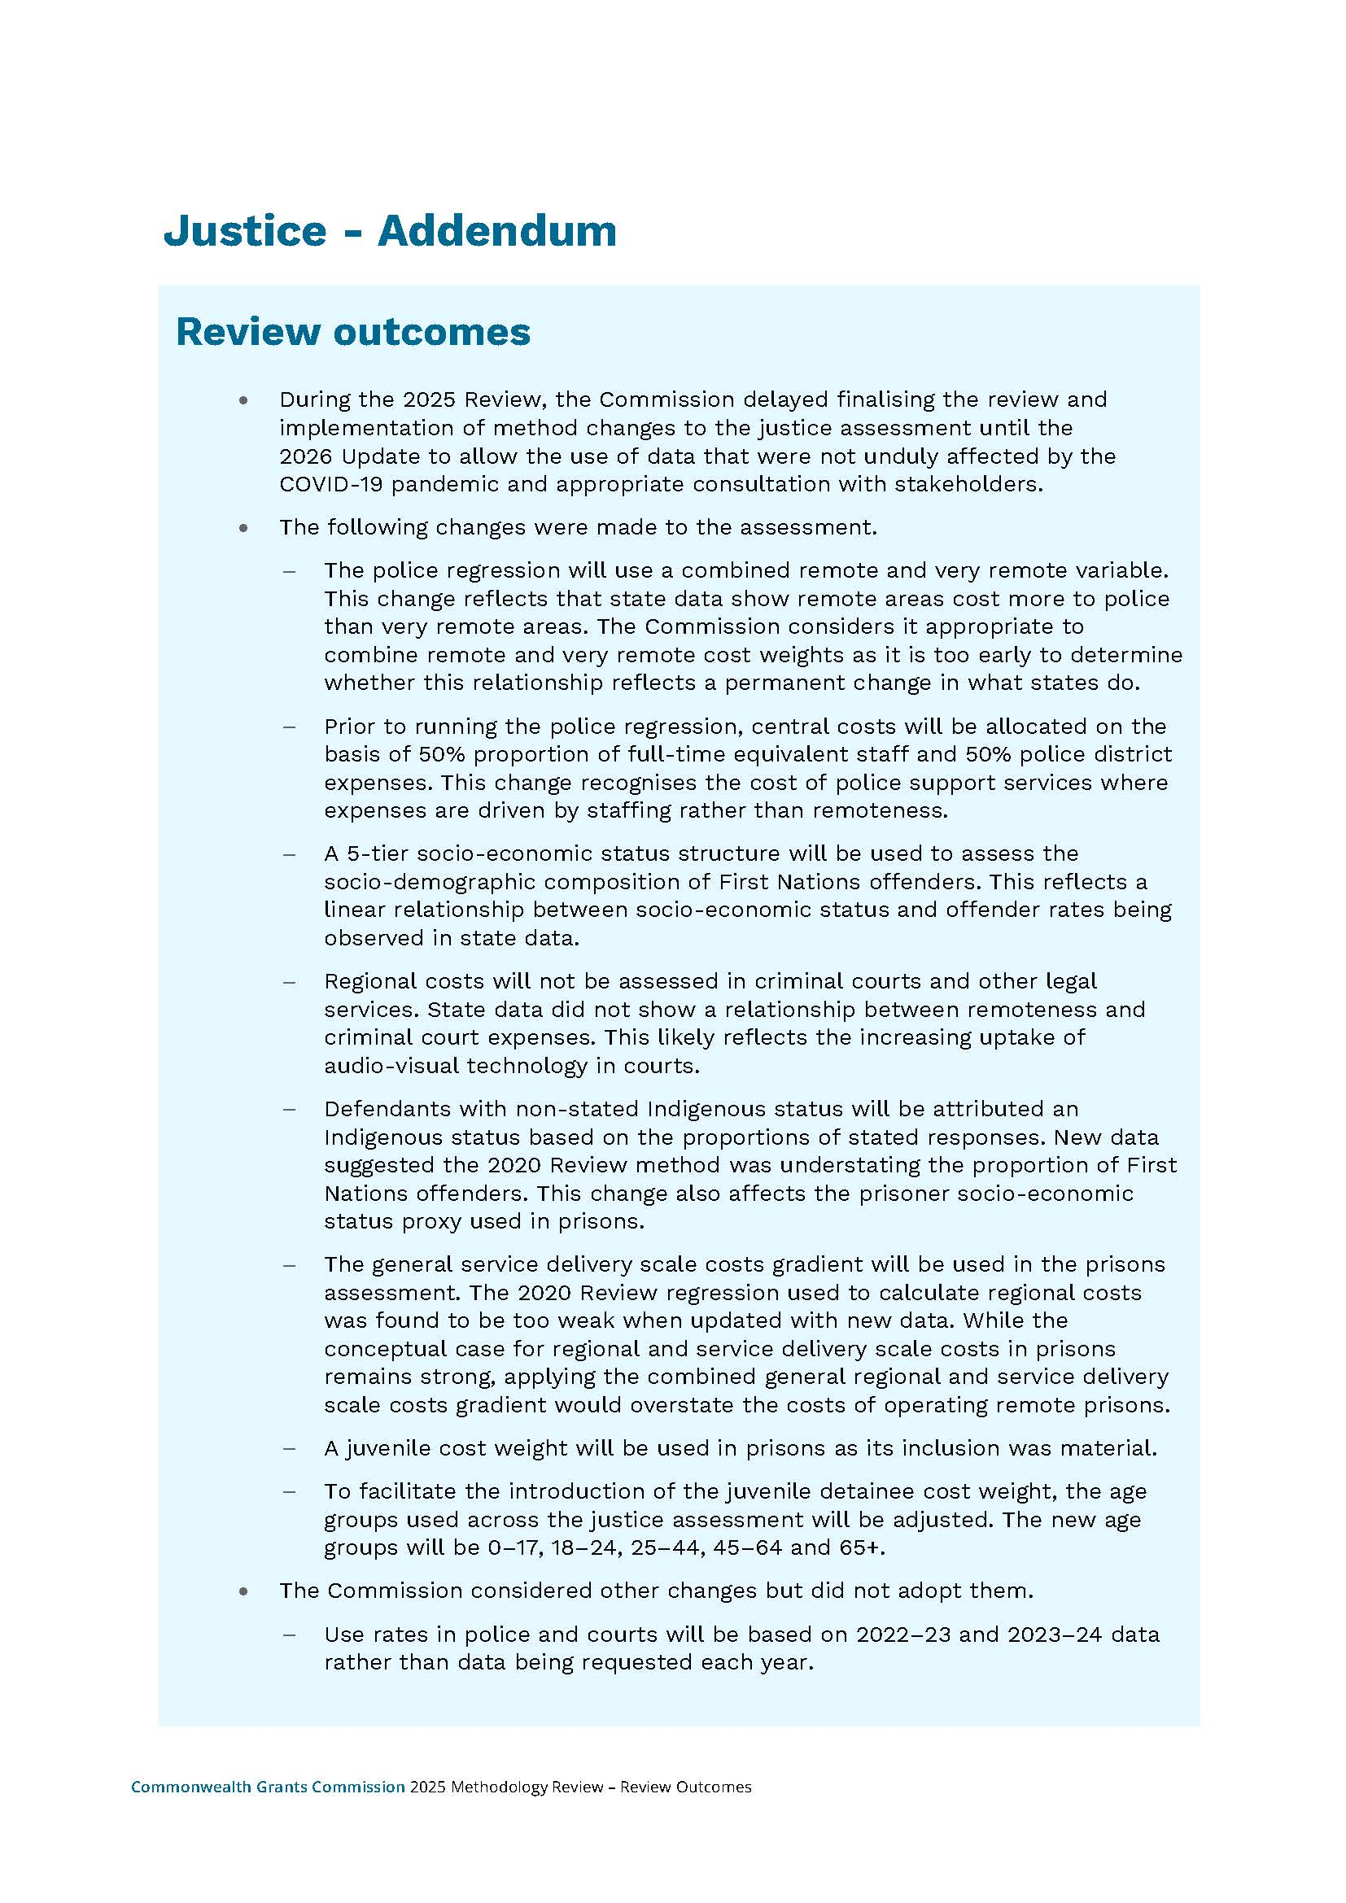
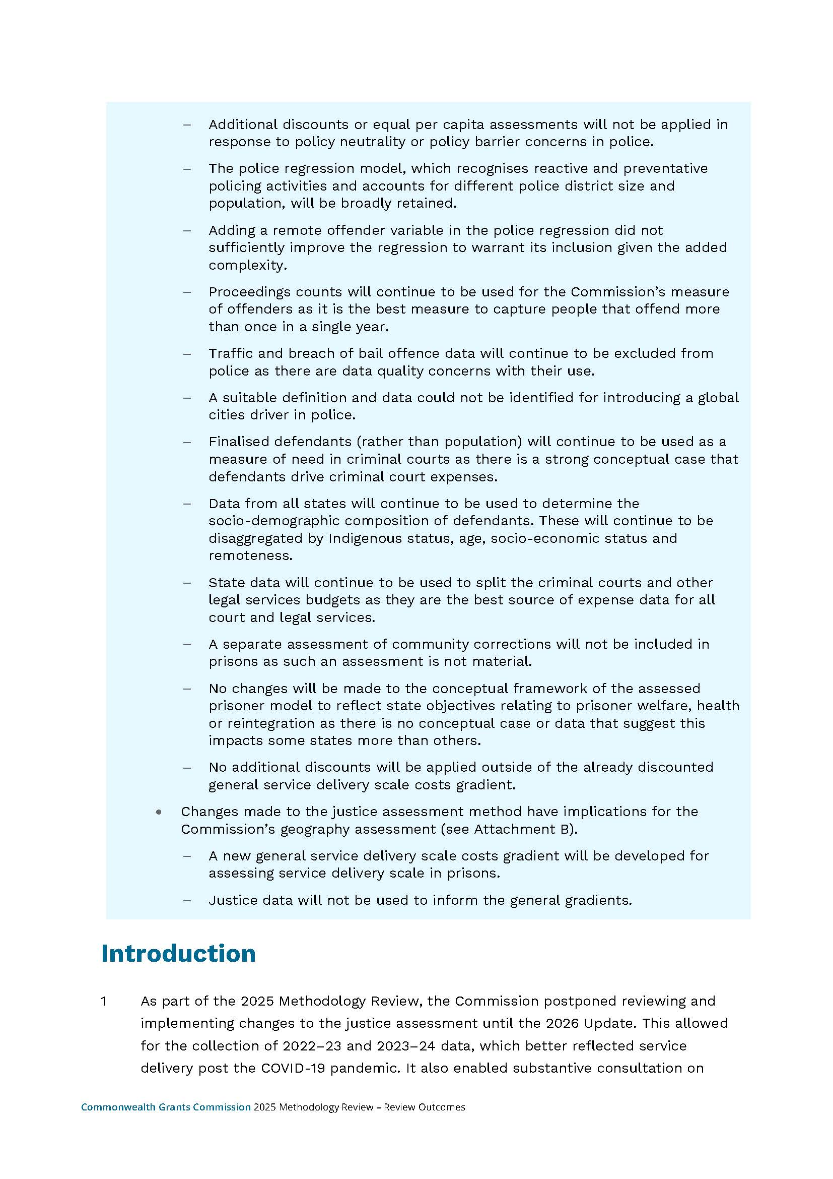
Attachment A
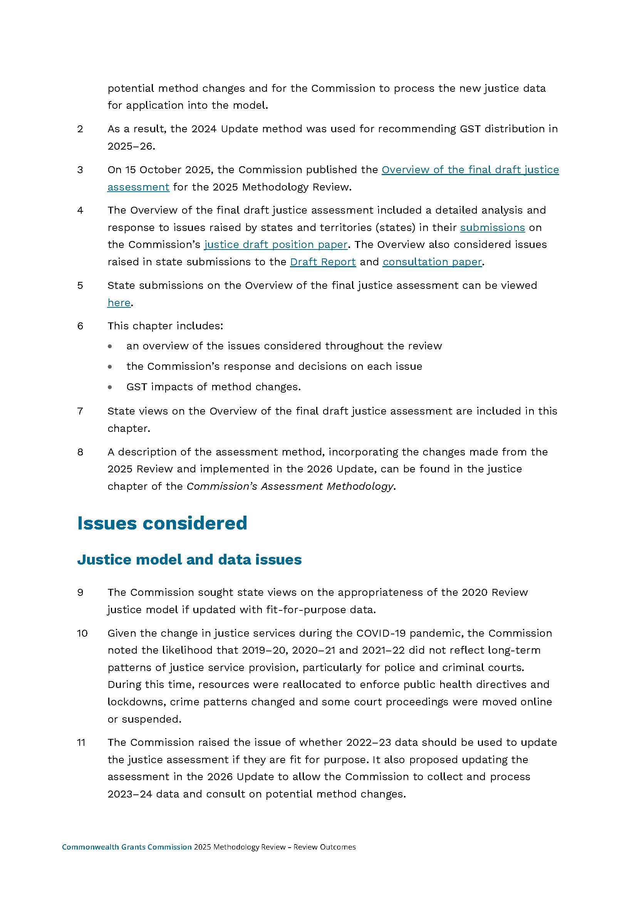
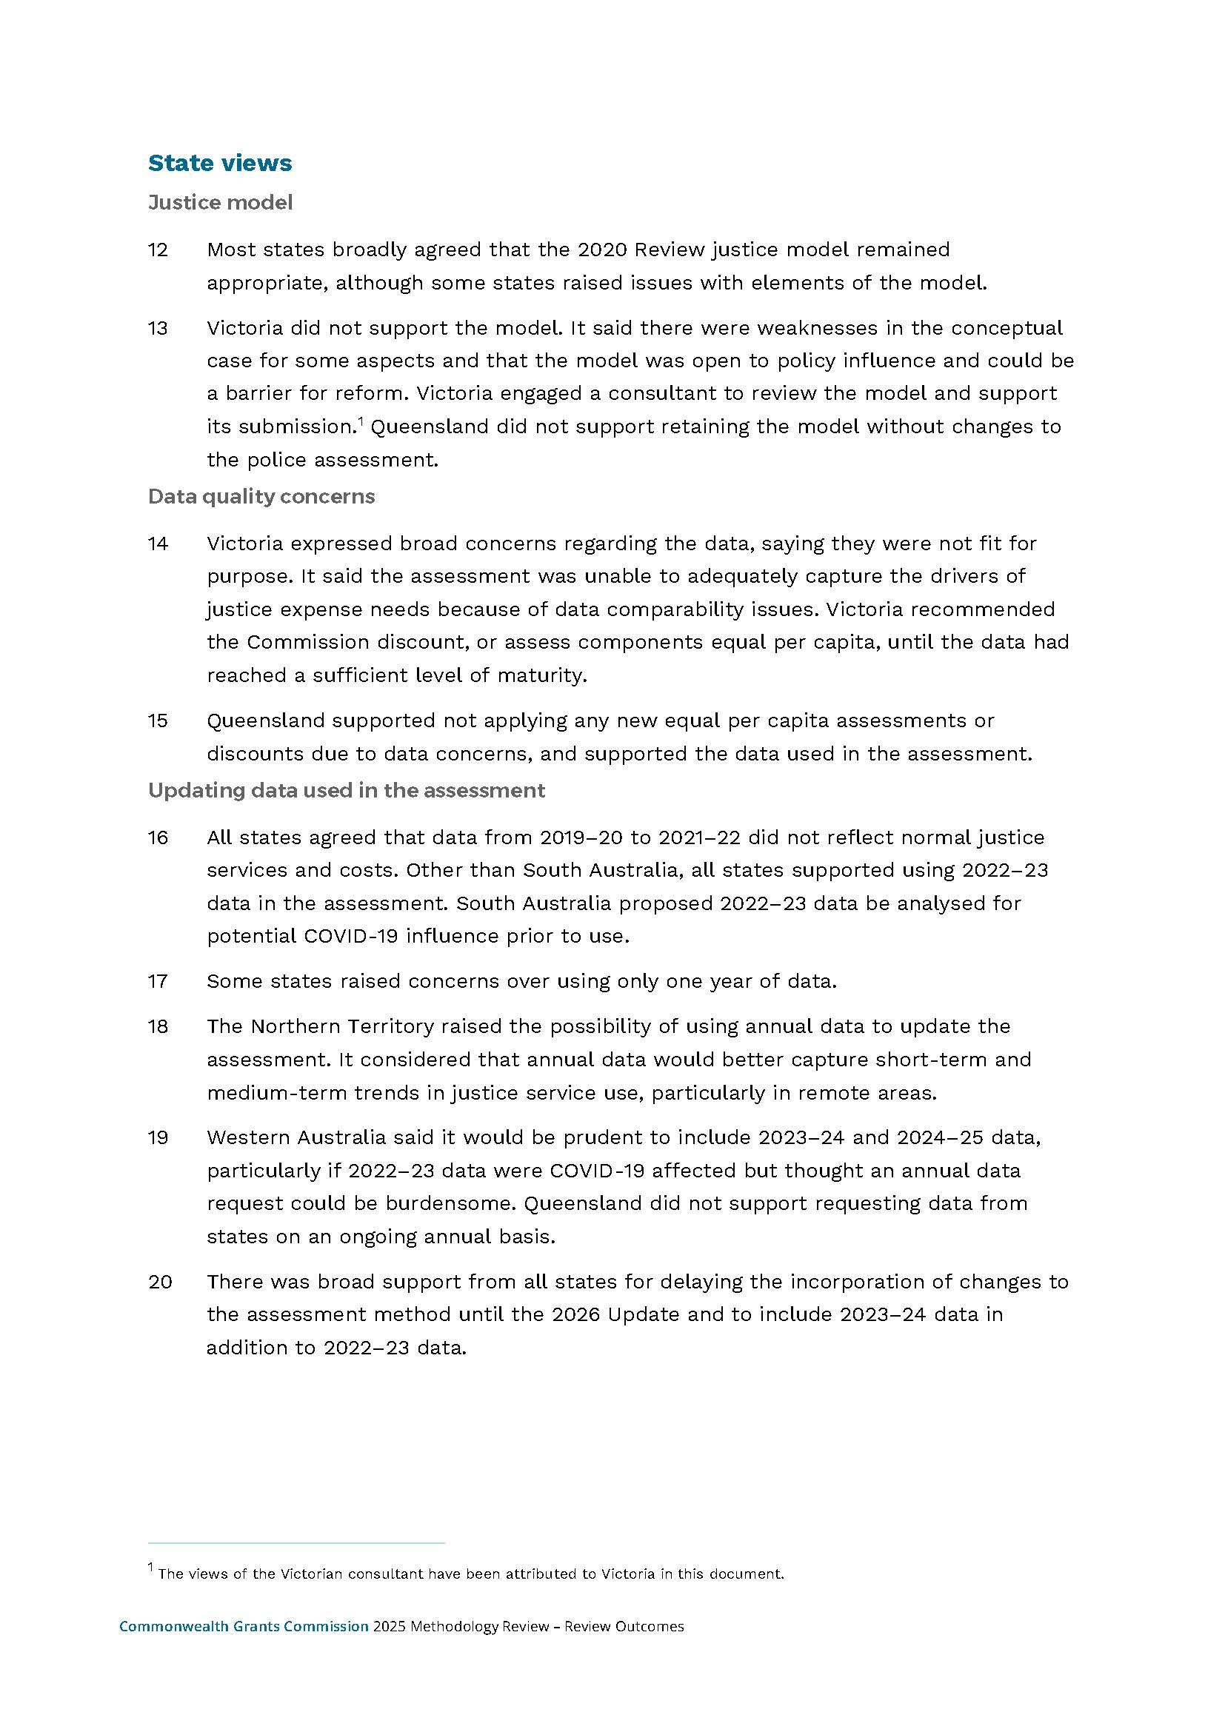
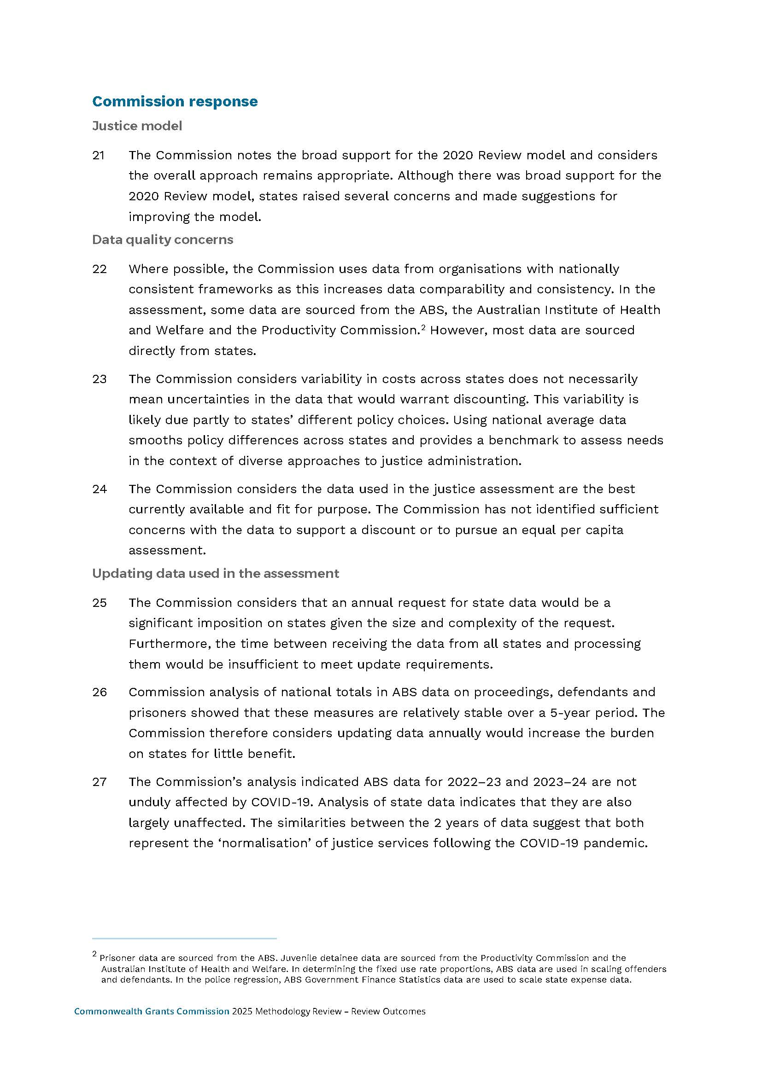
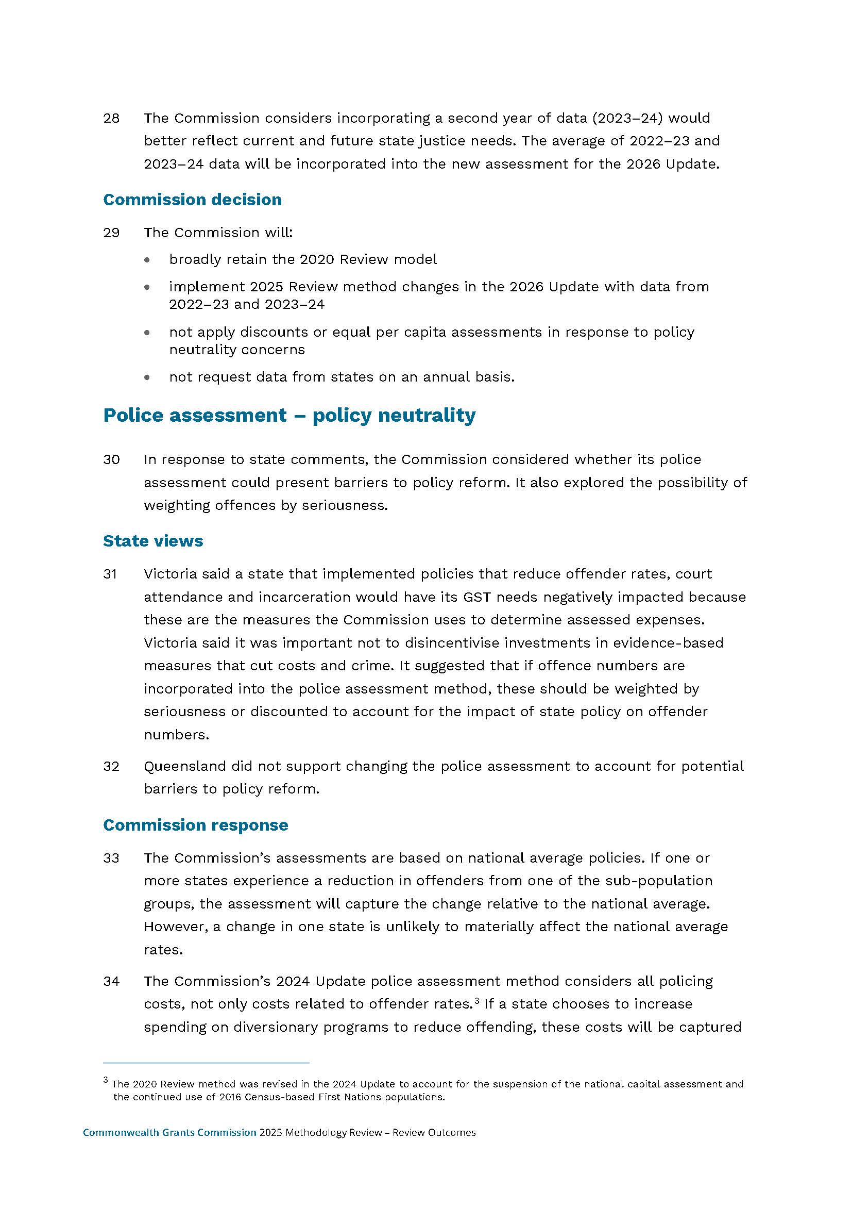
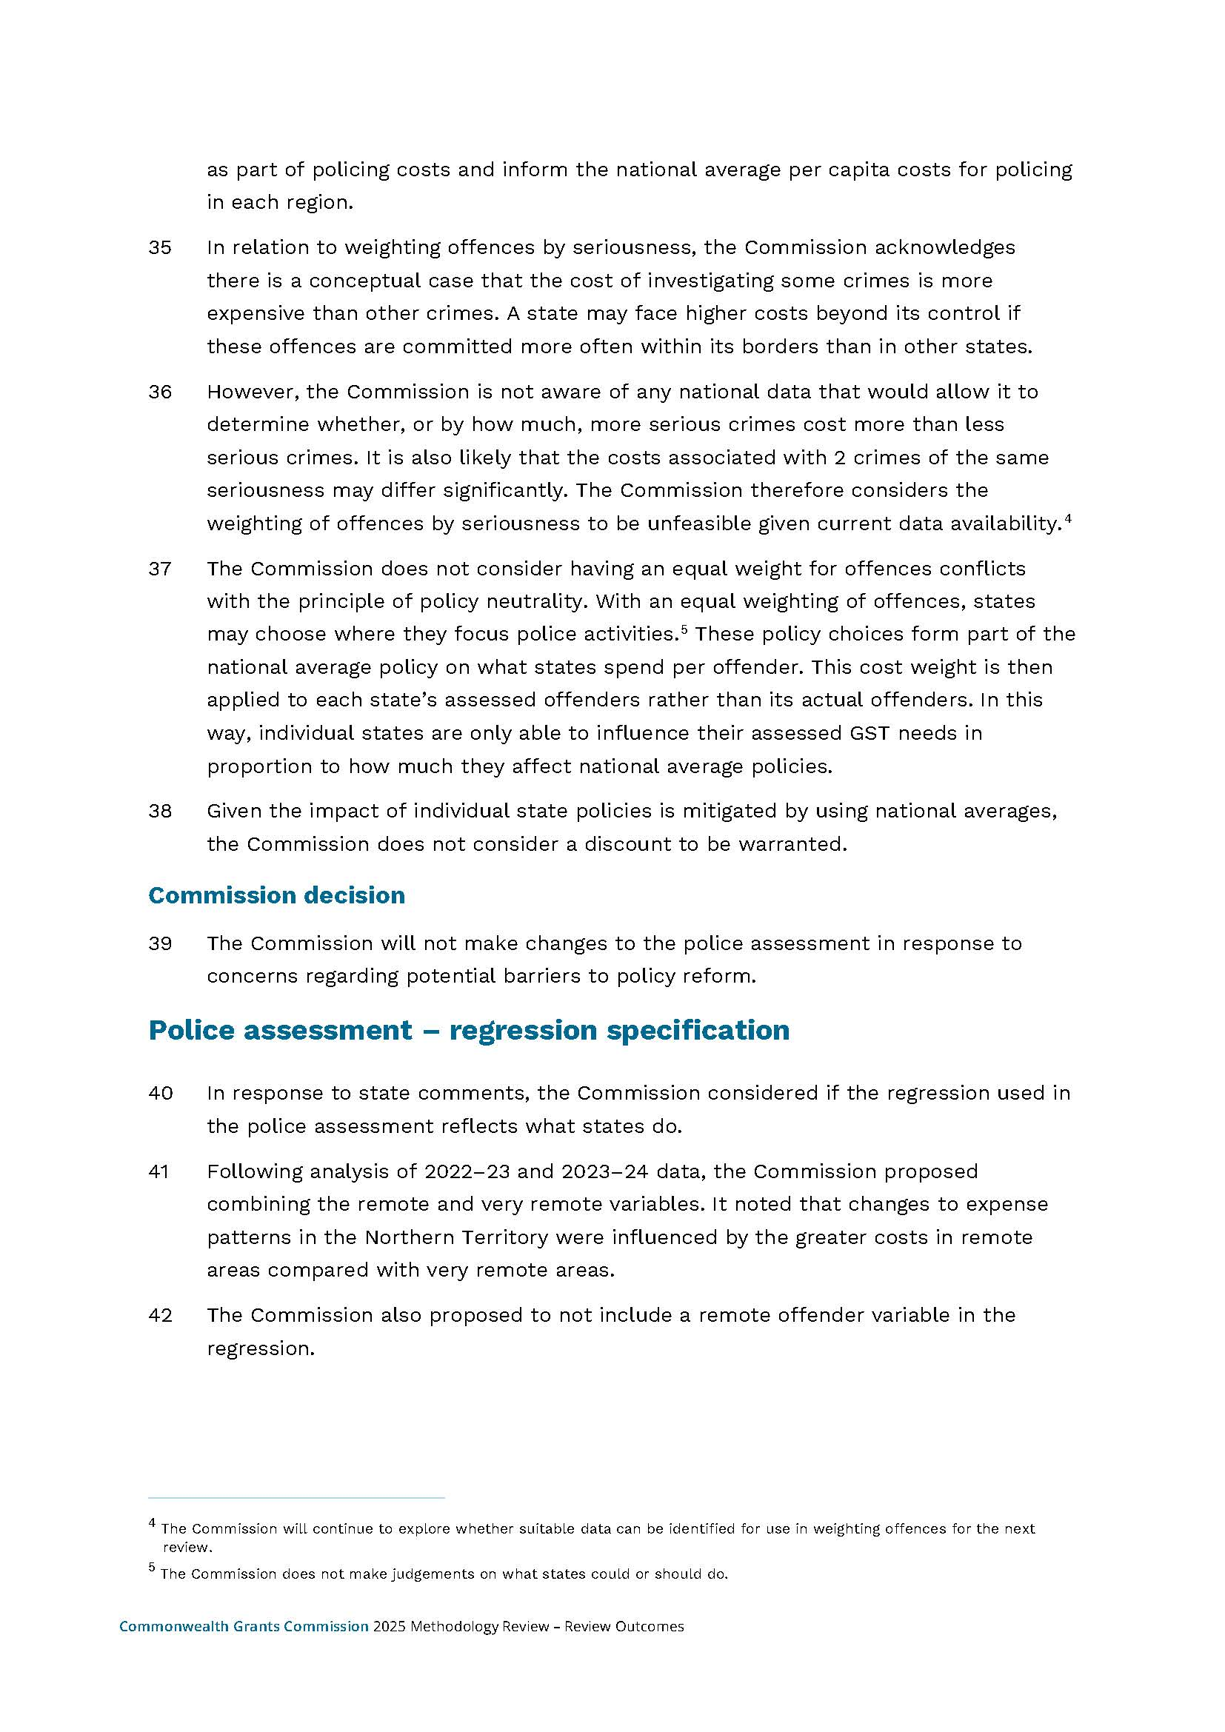
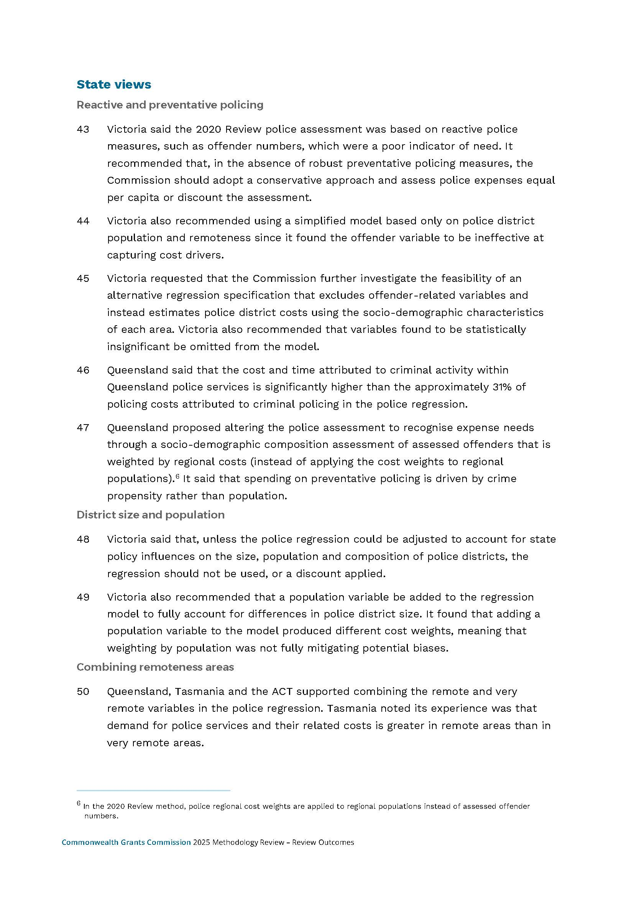
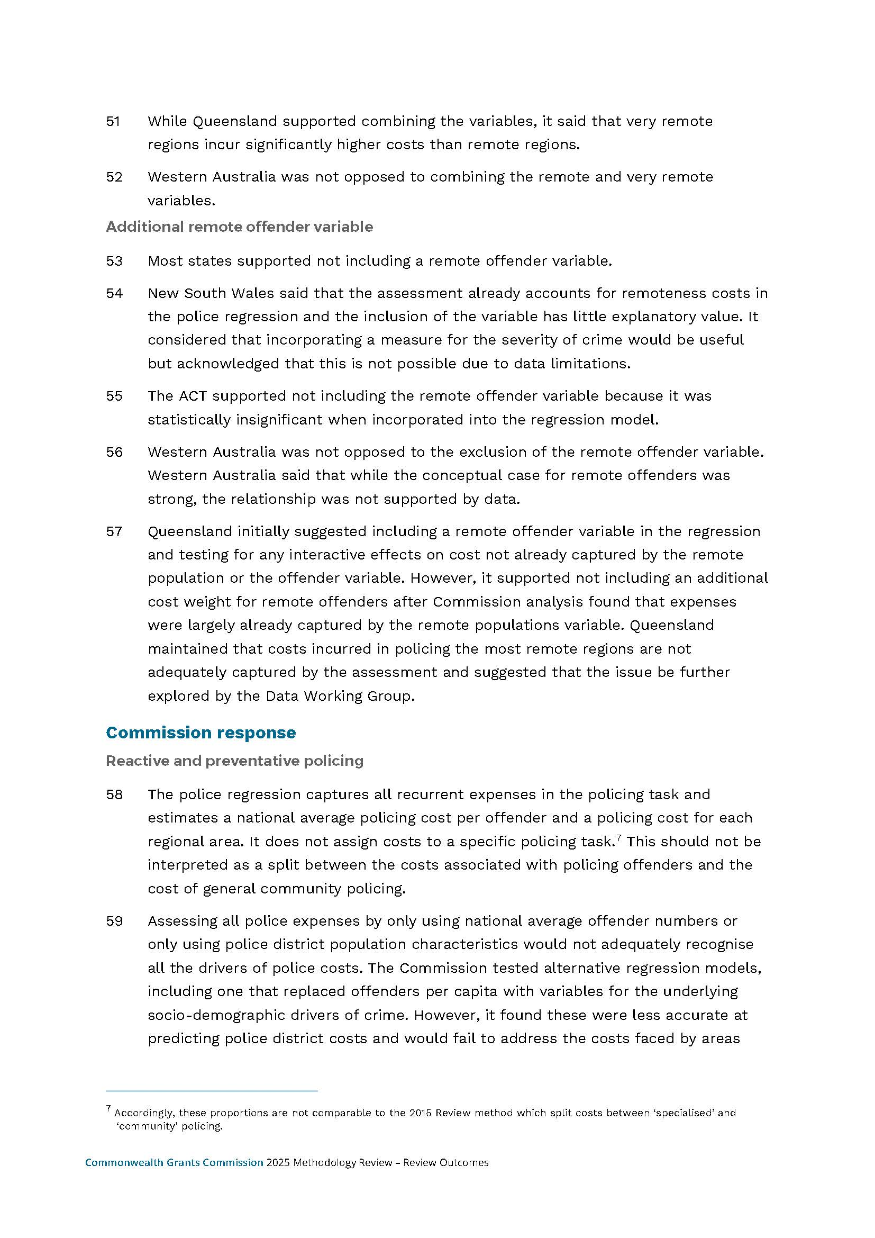
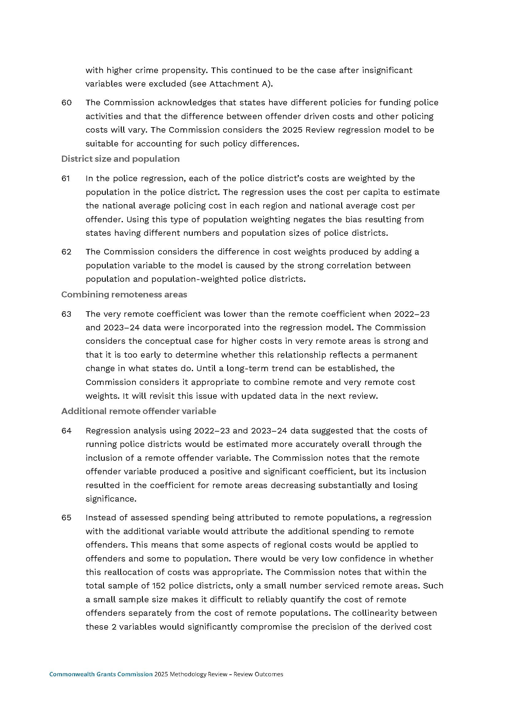
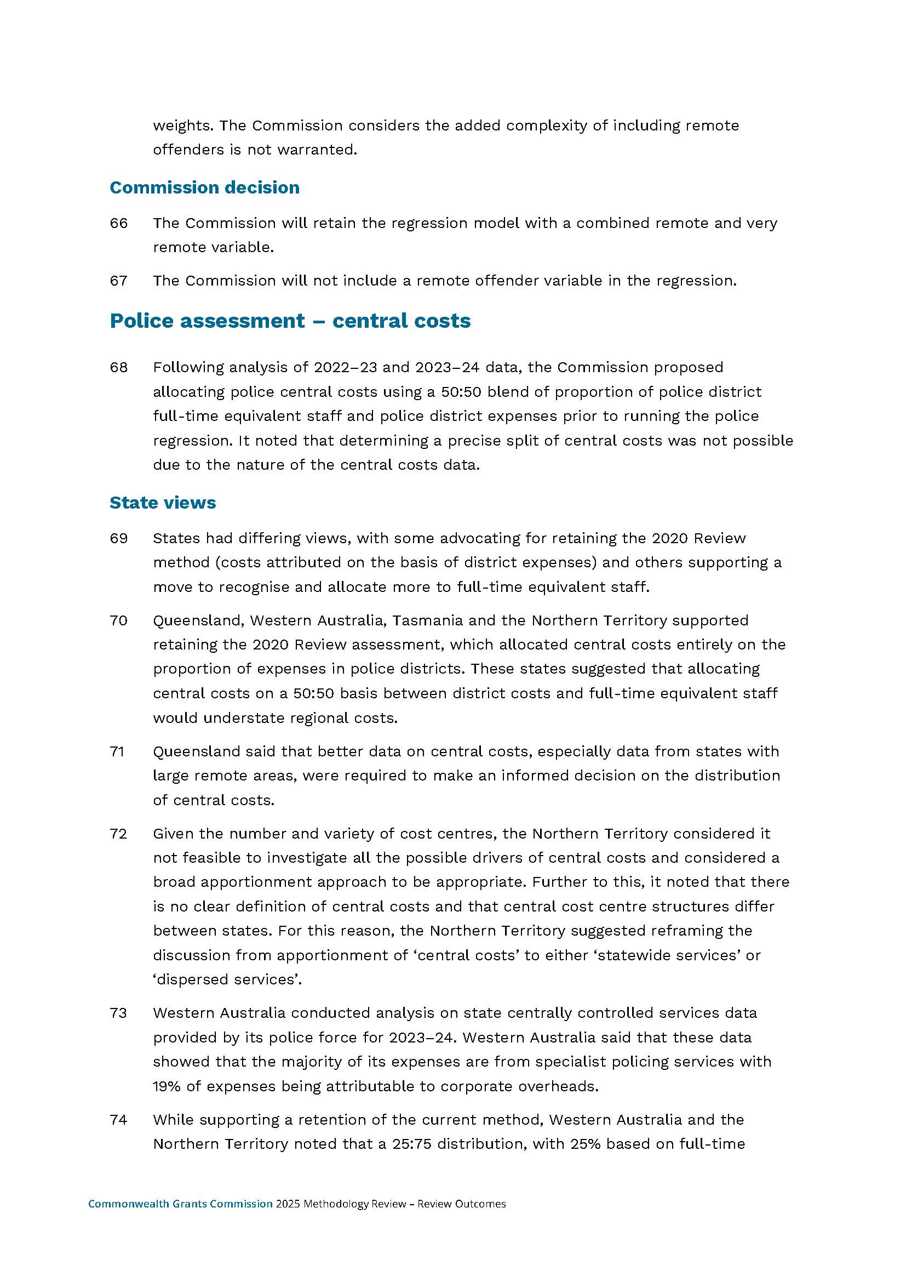
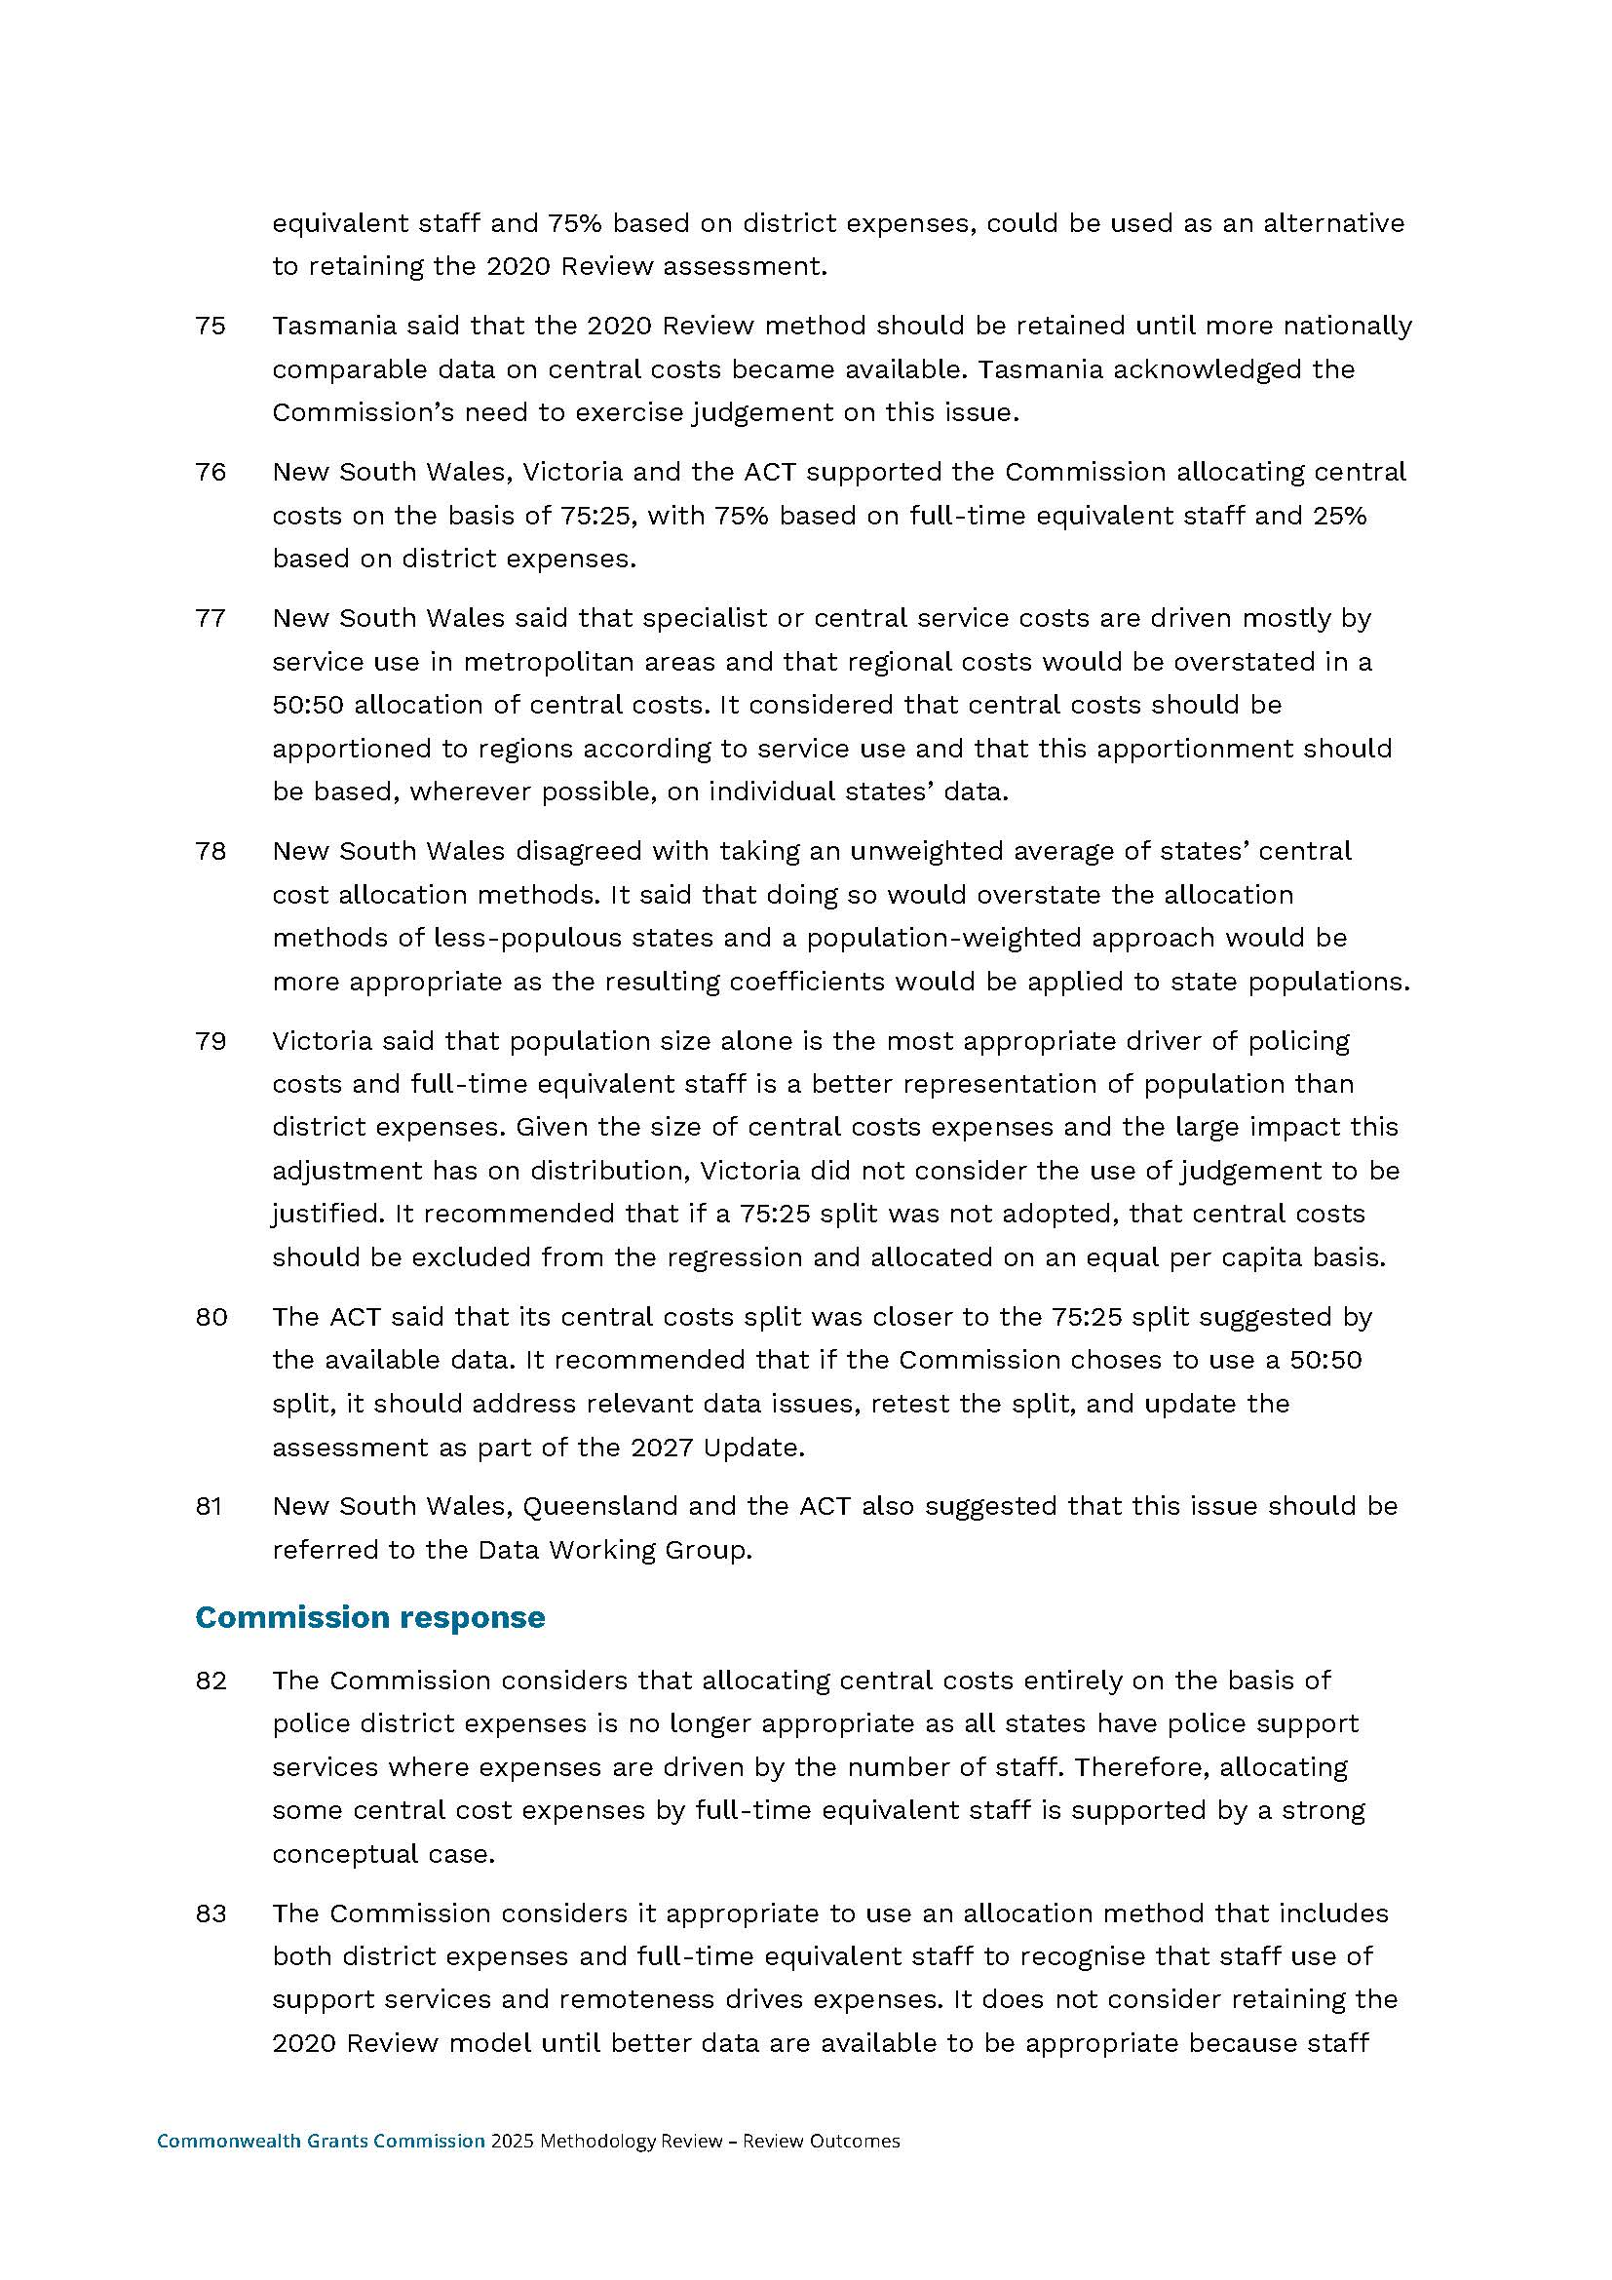
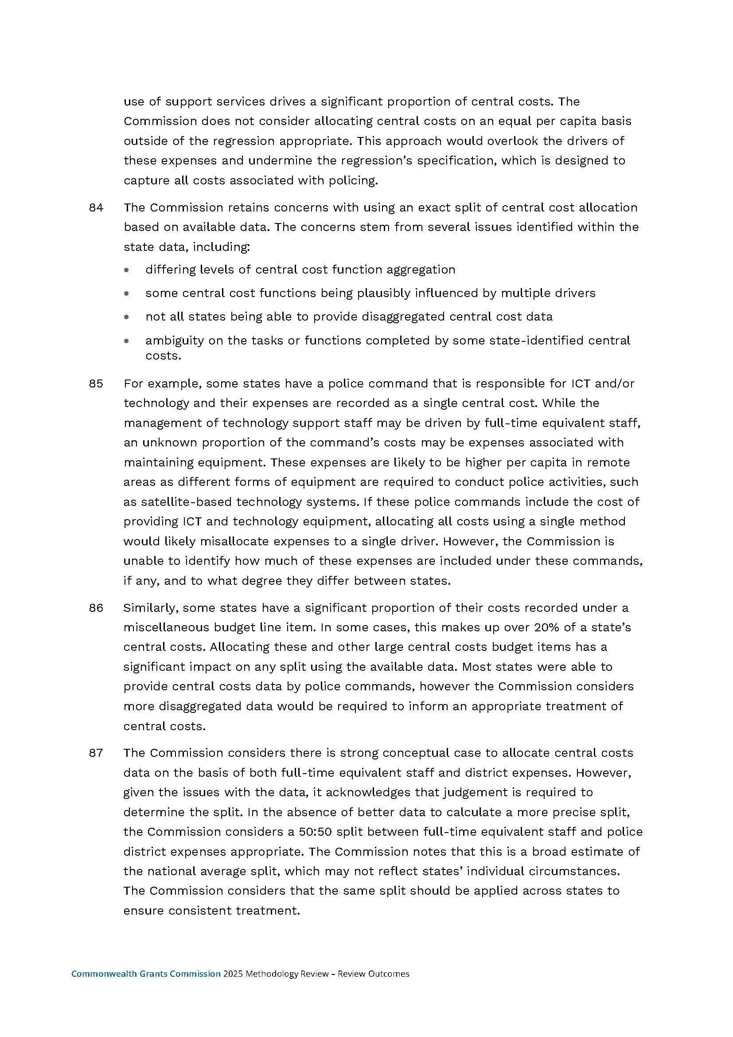
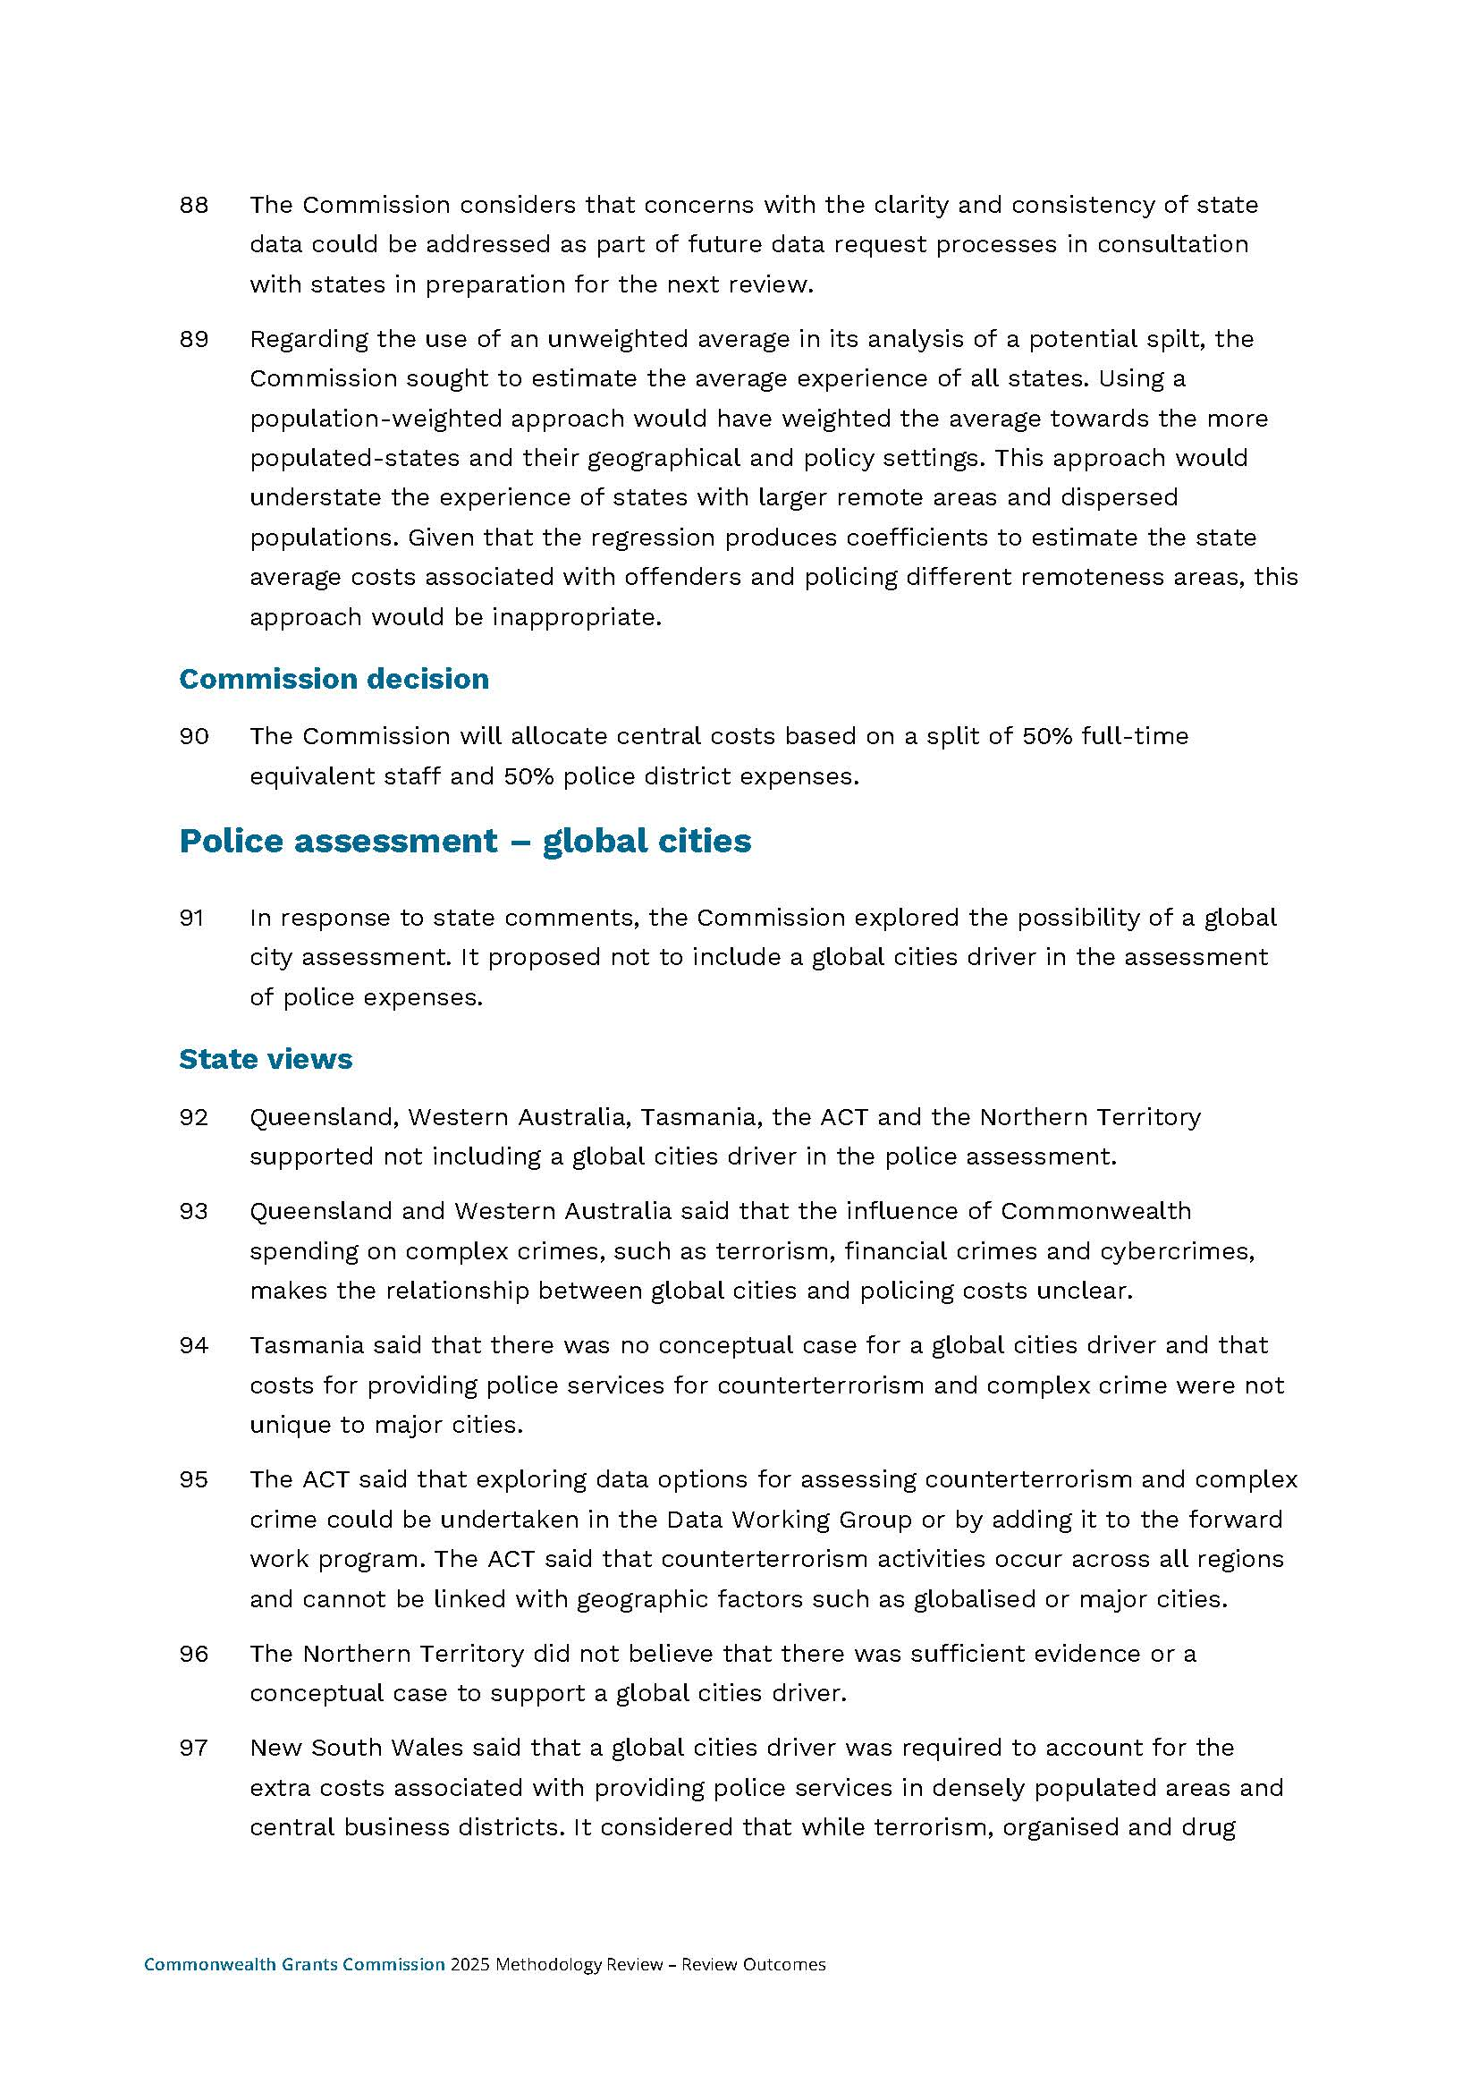
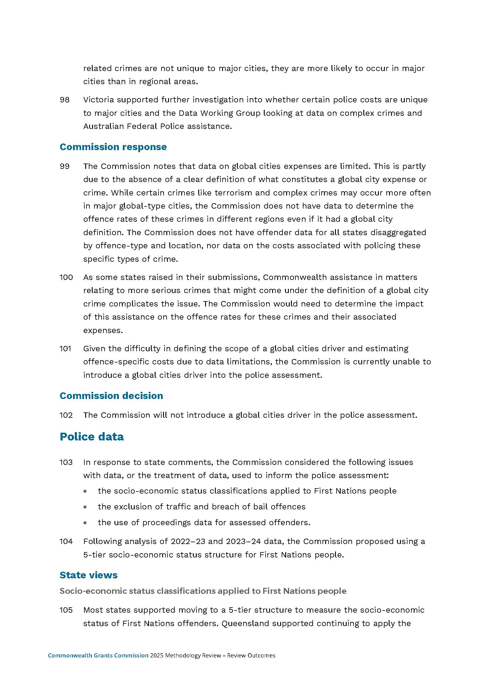
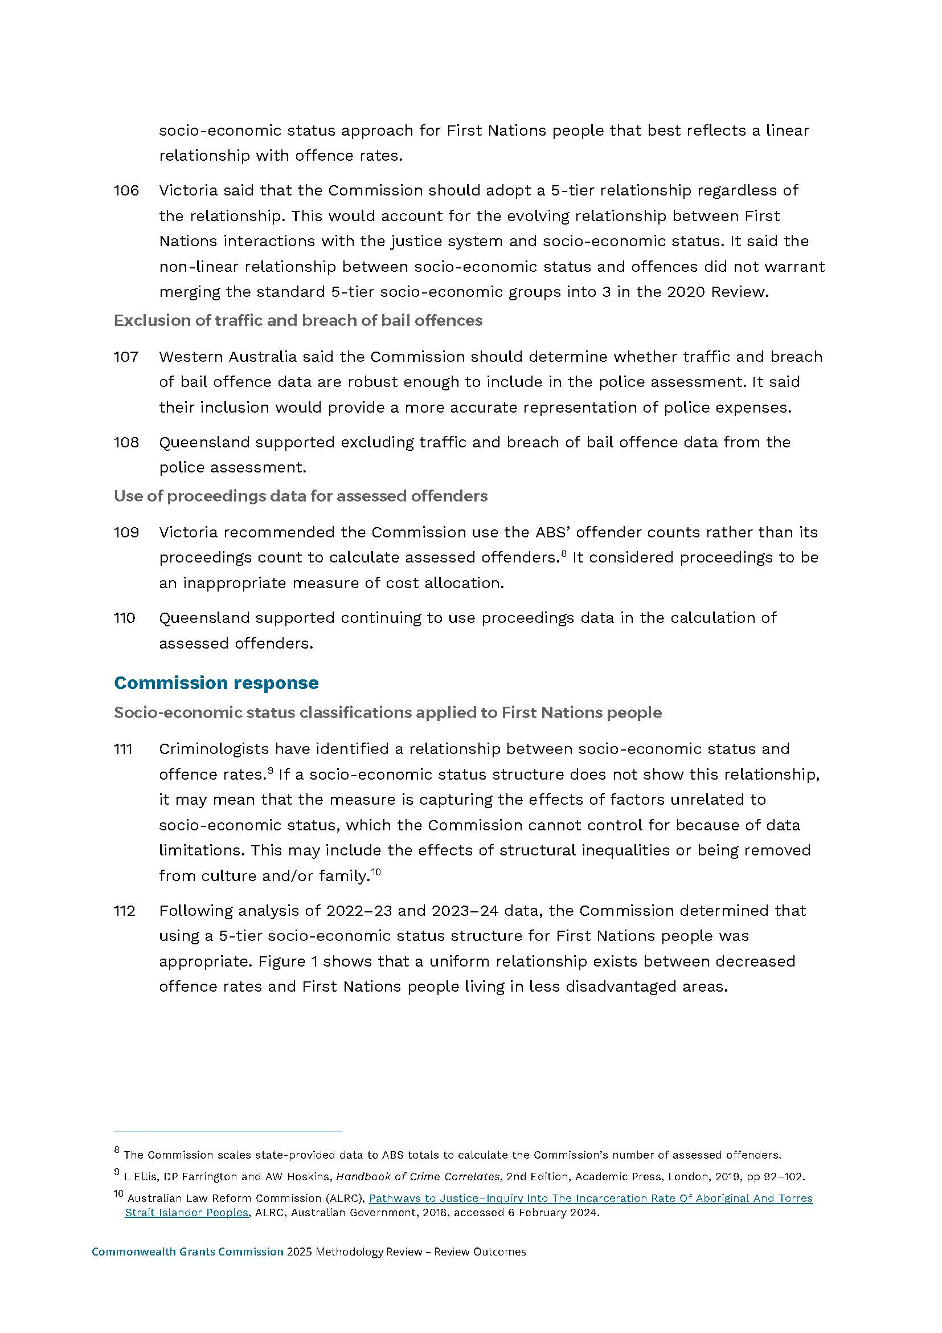
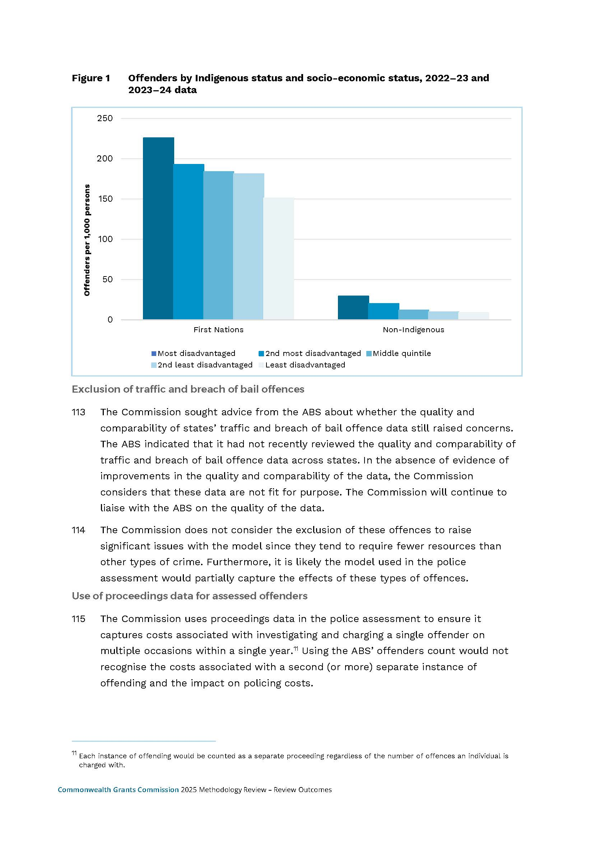
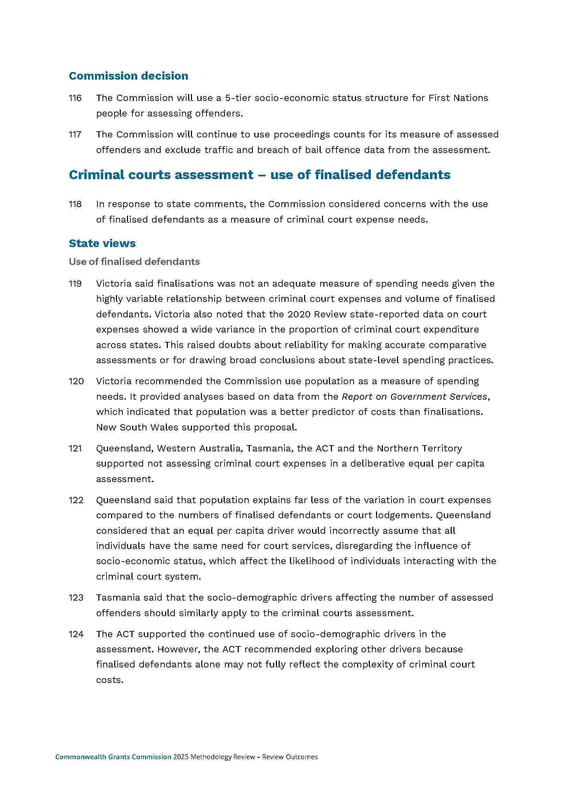
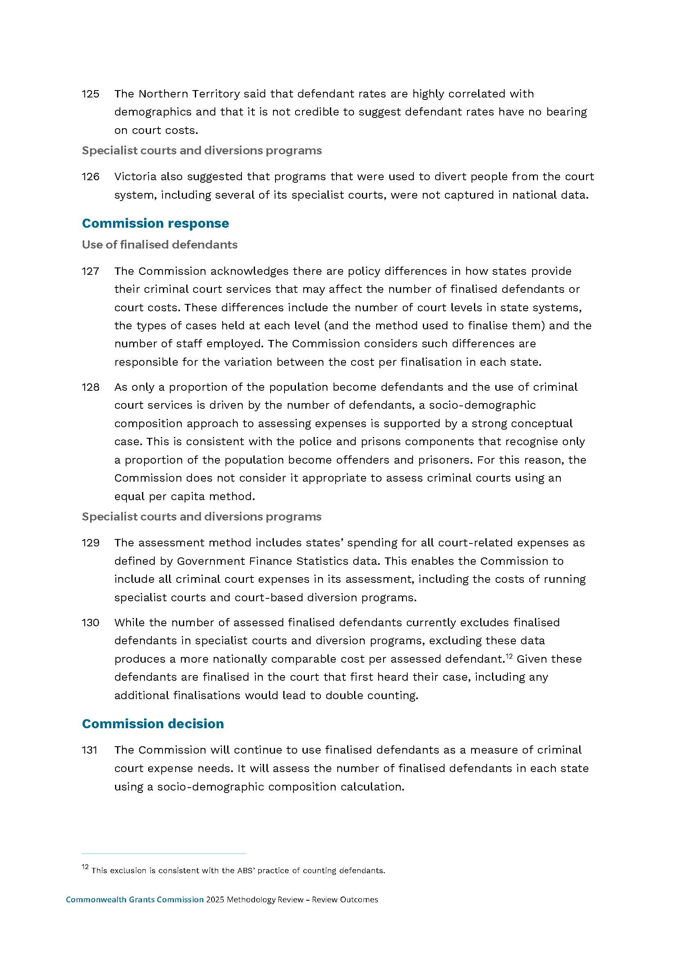
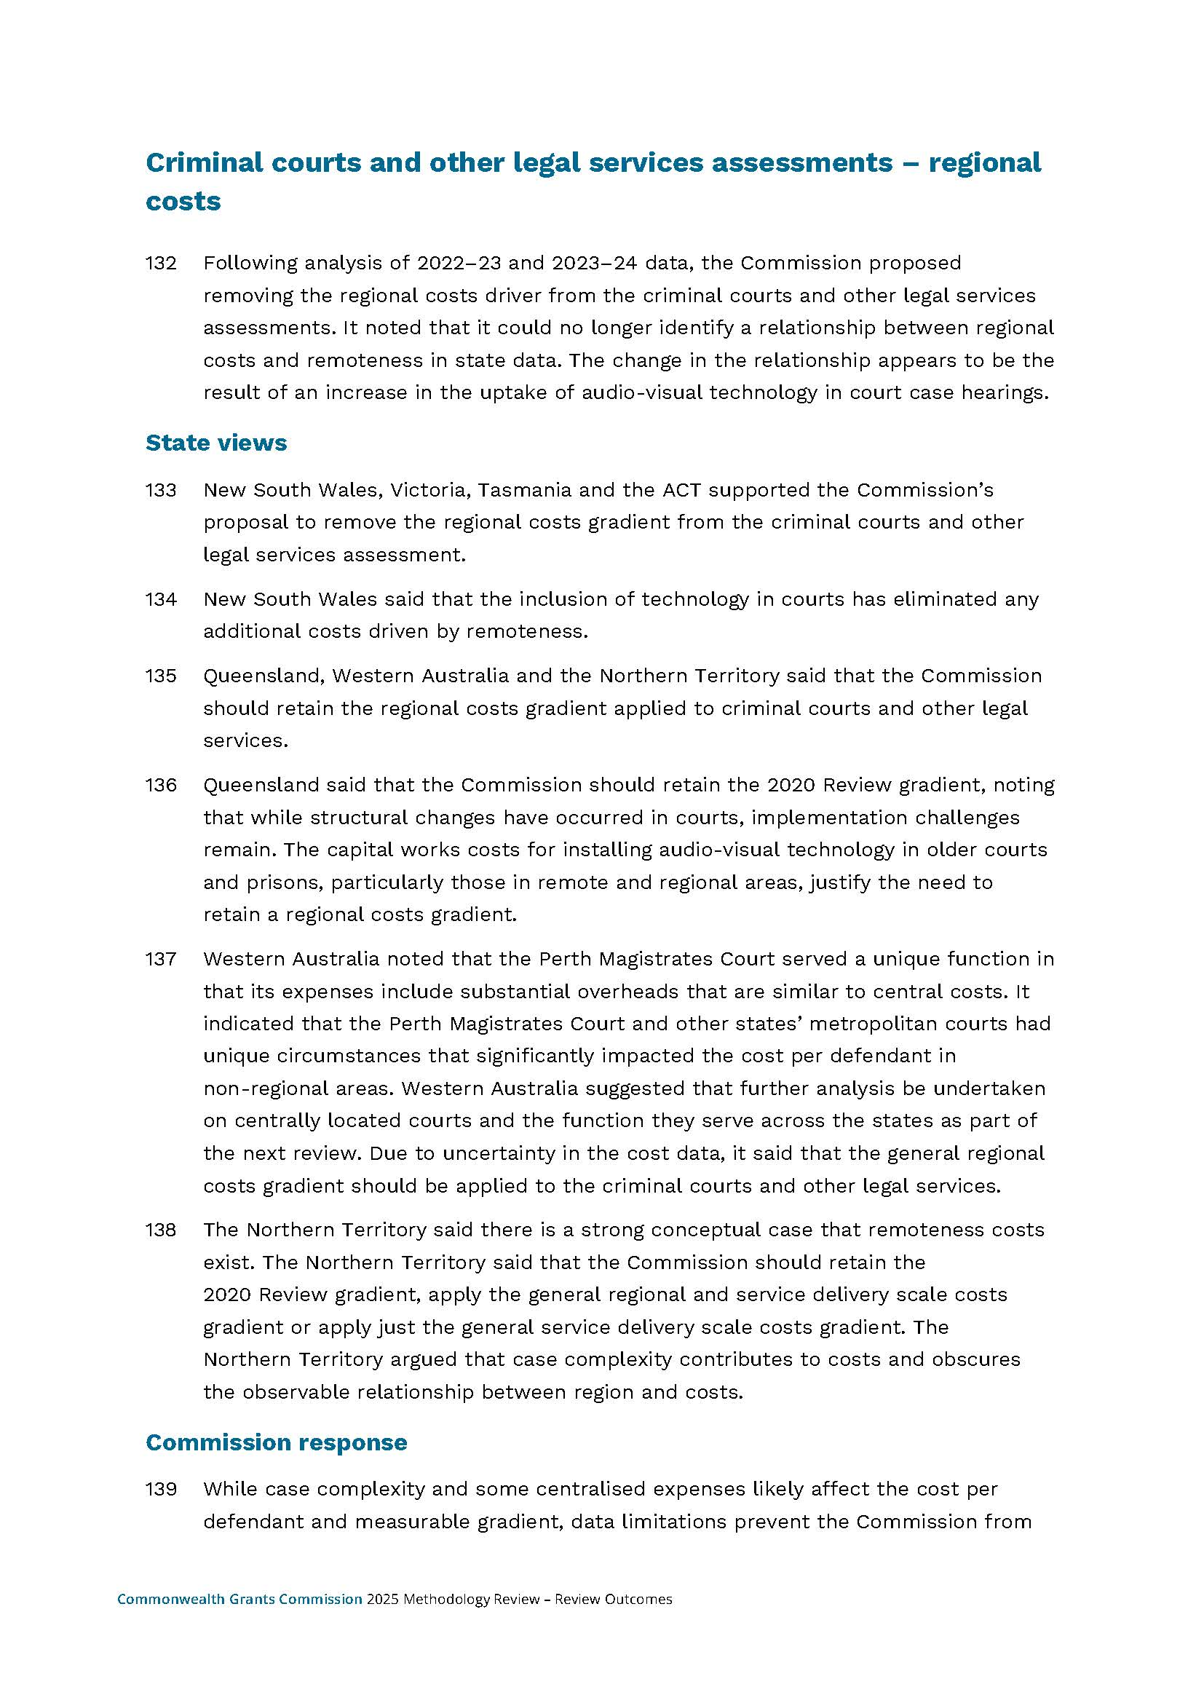
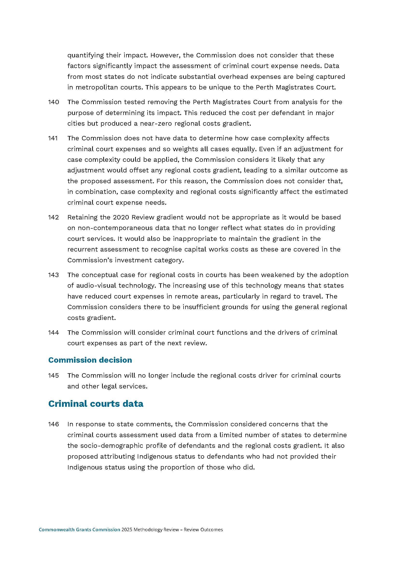
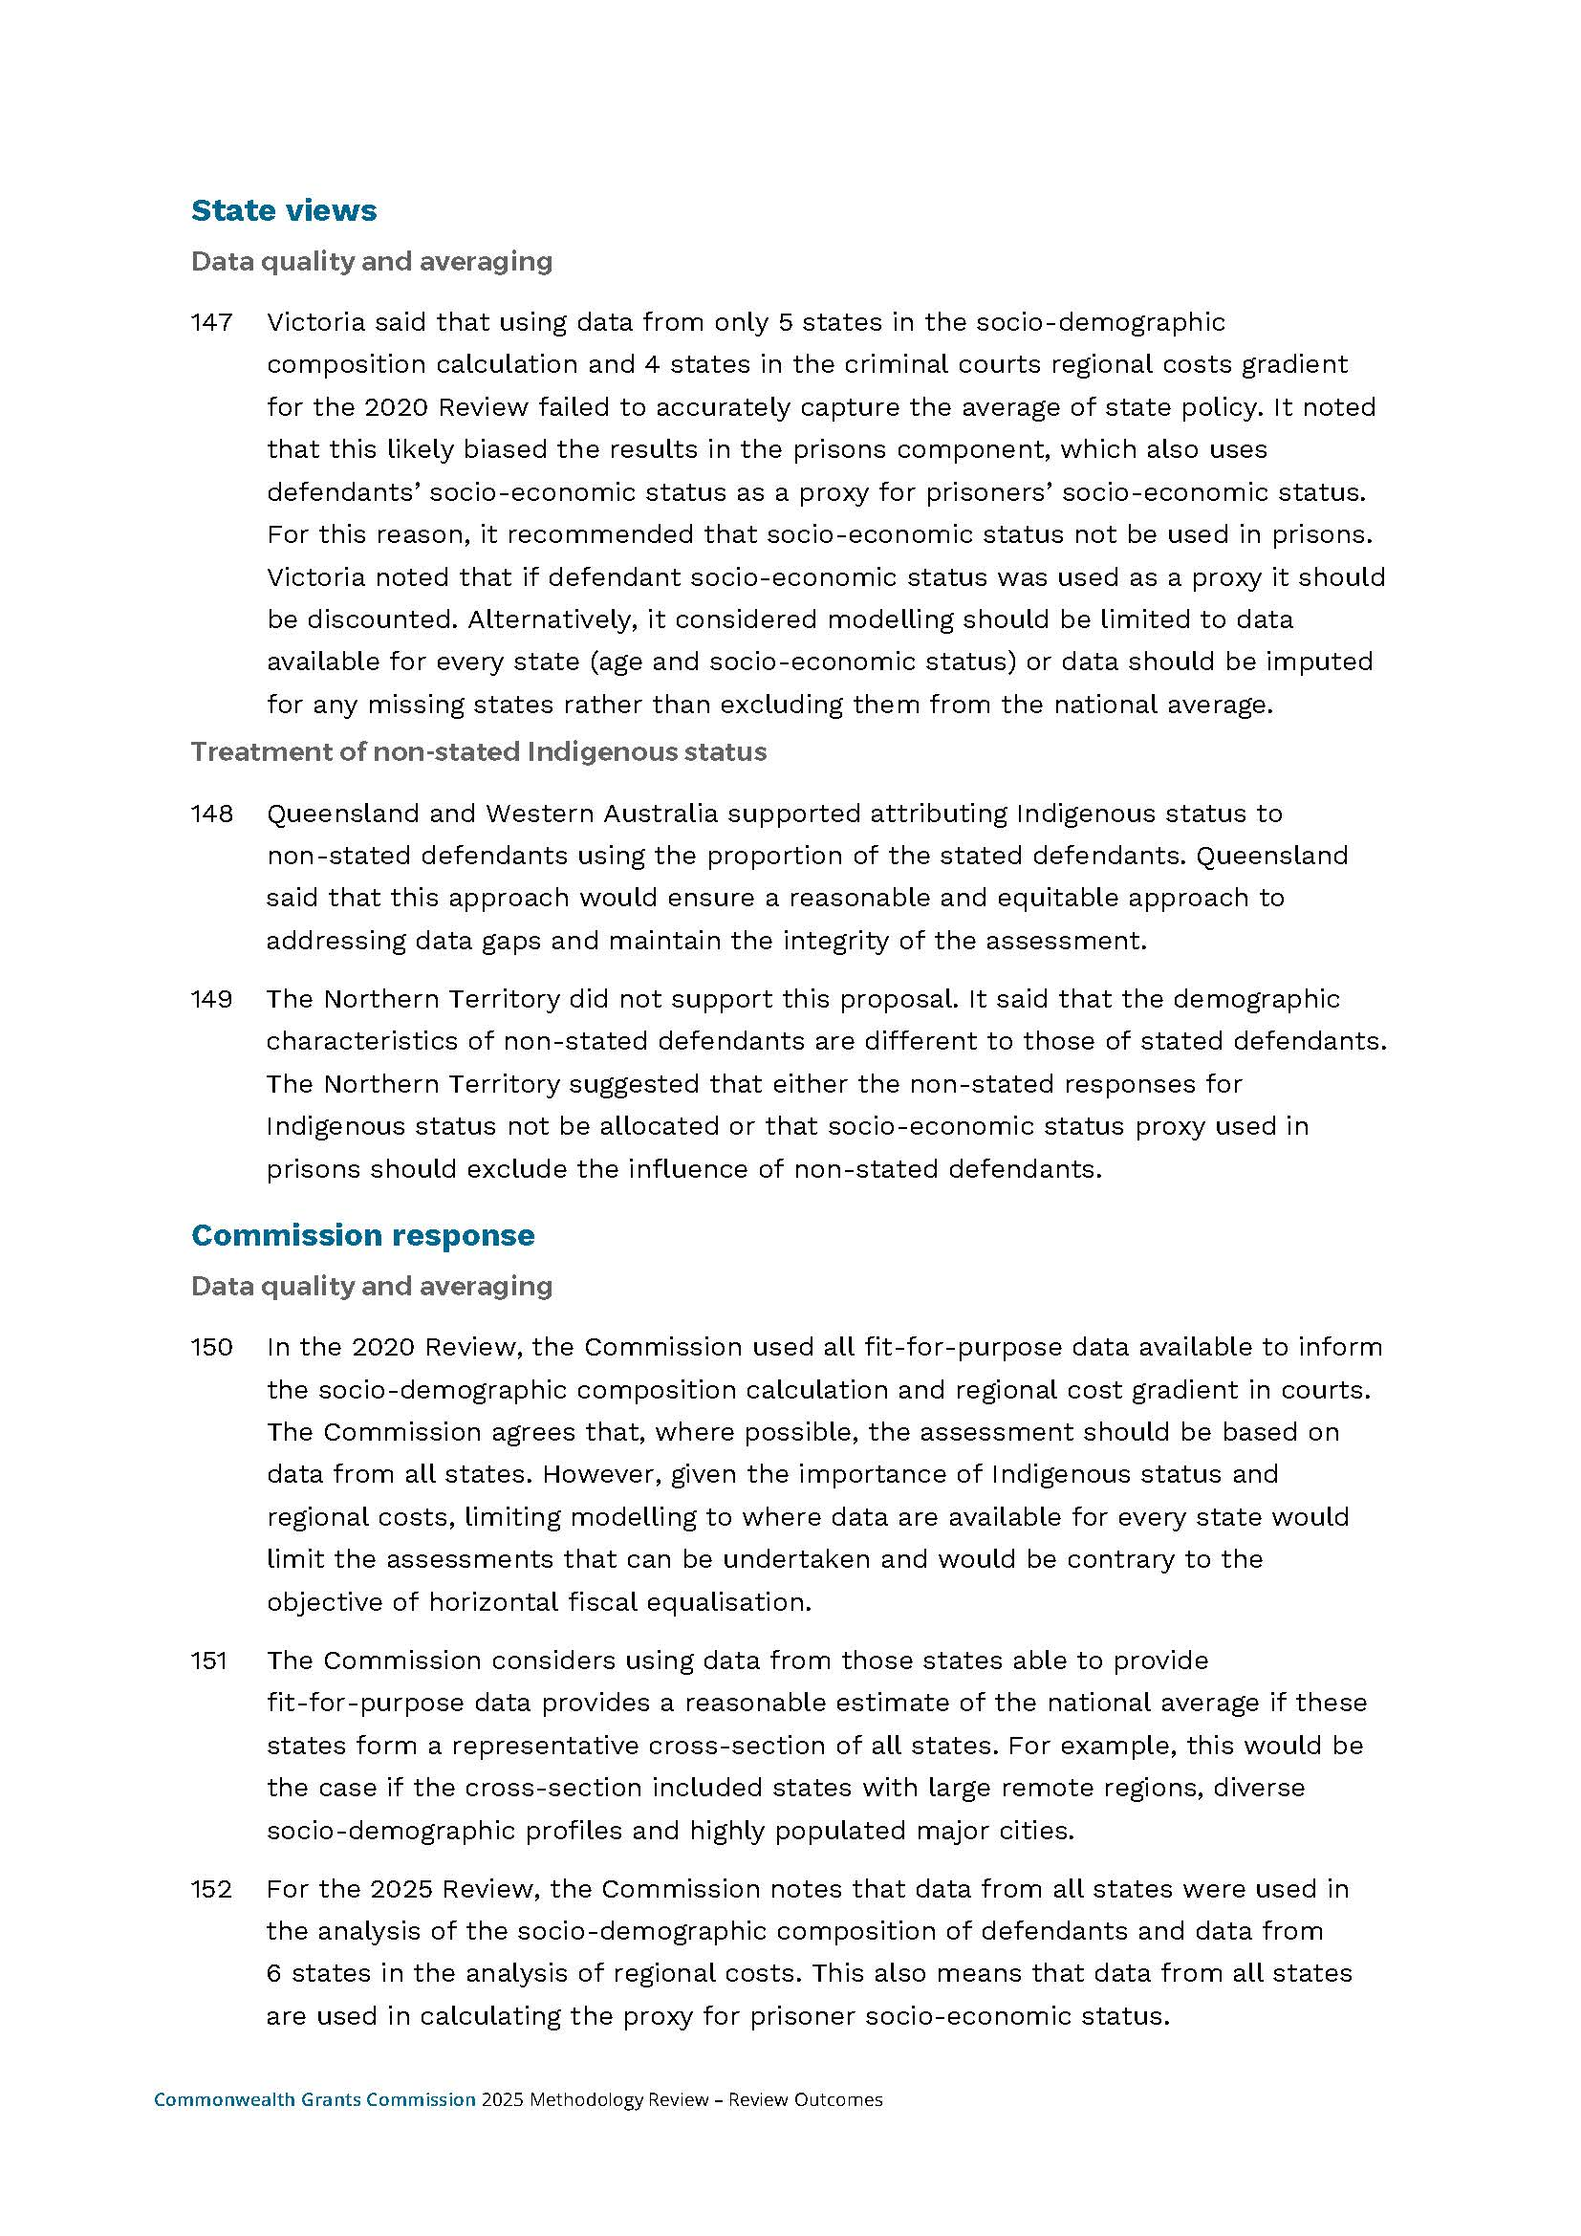
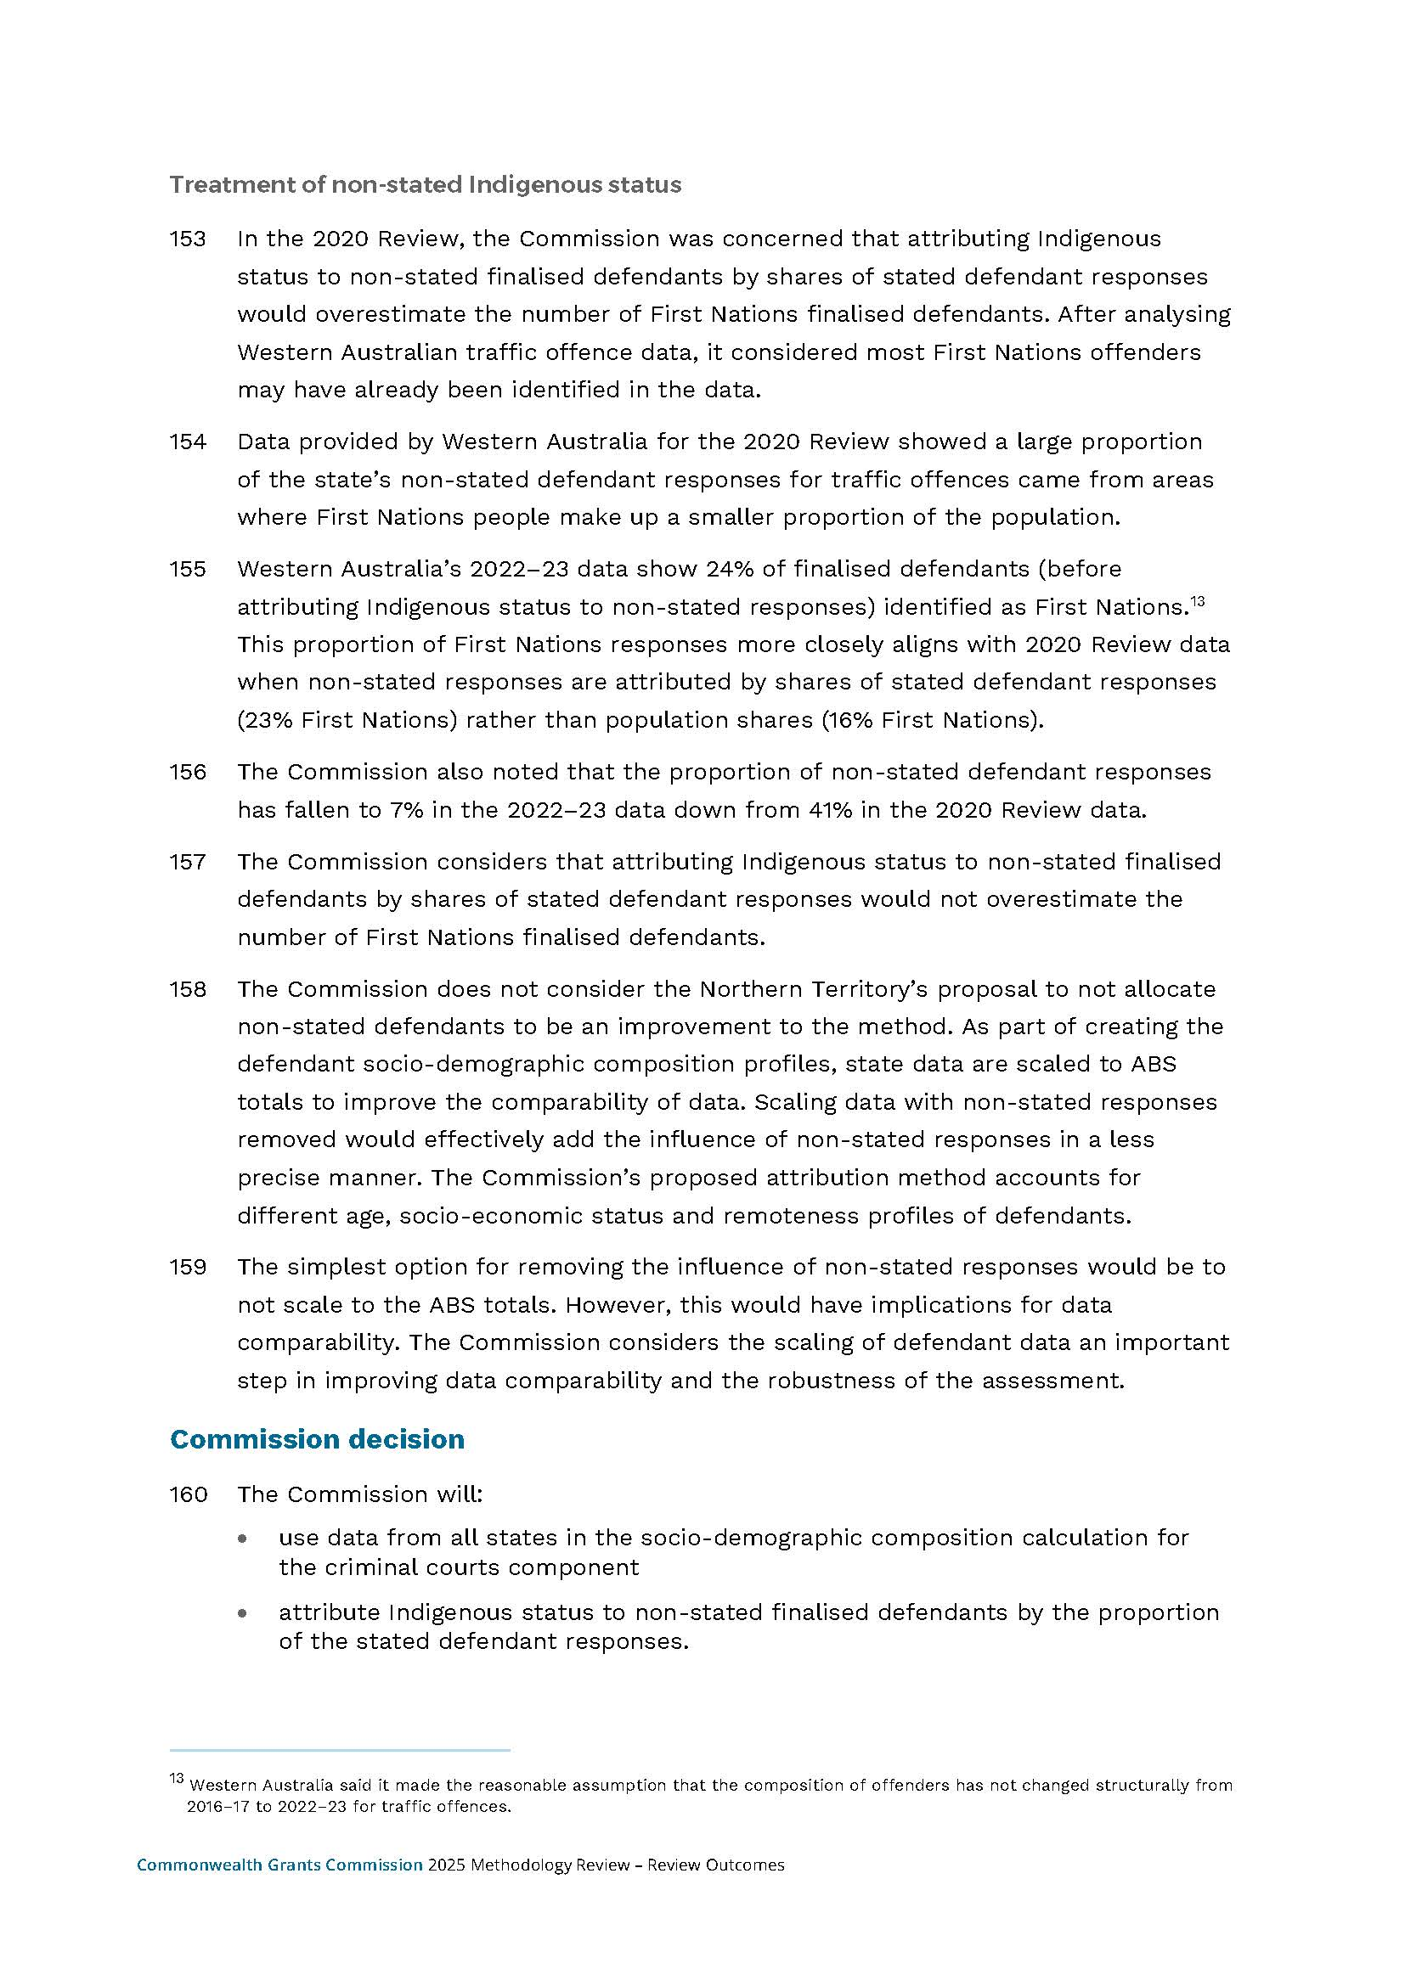
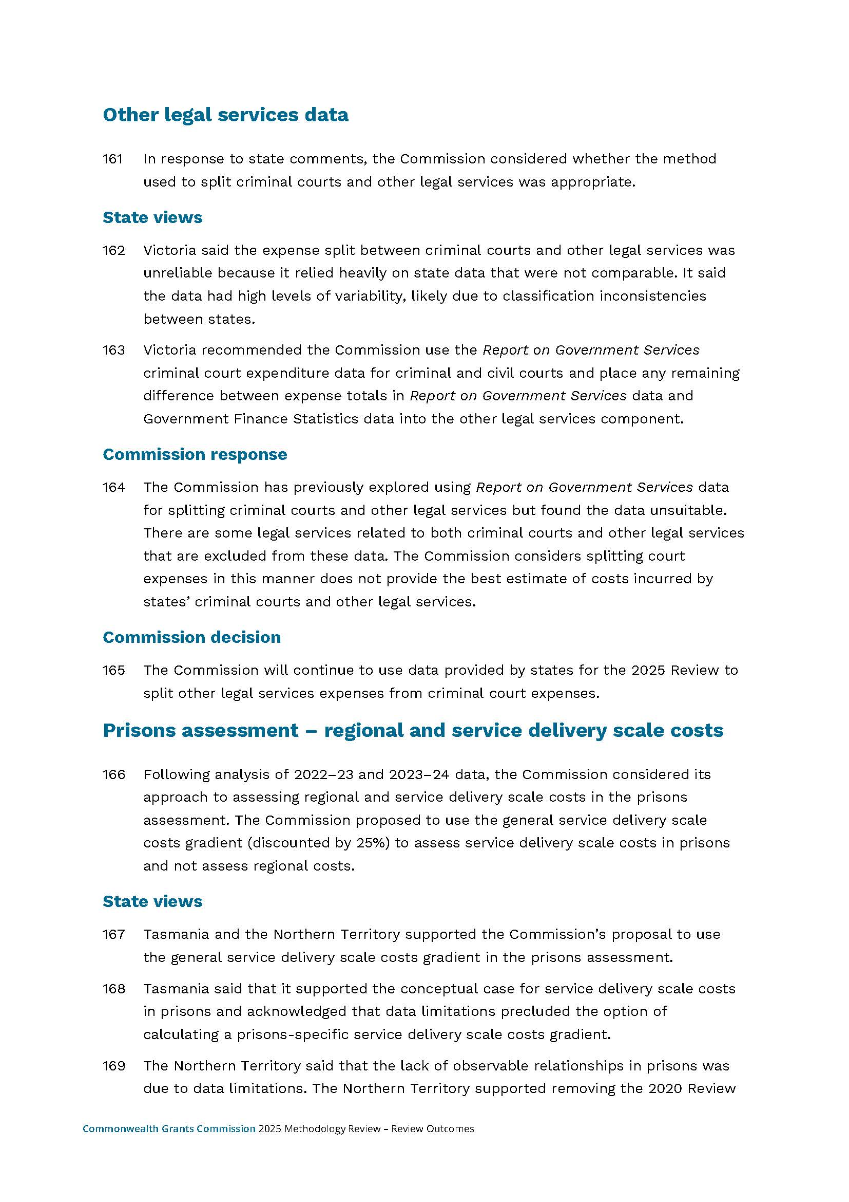
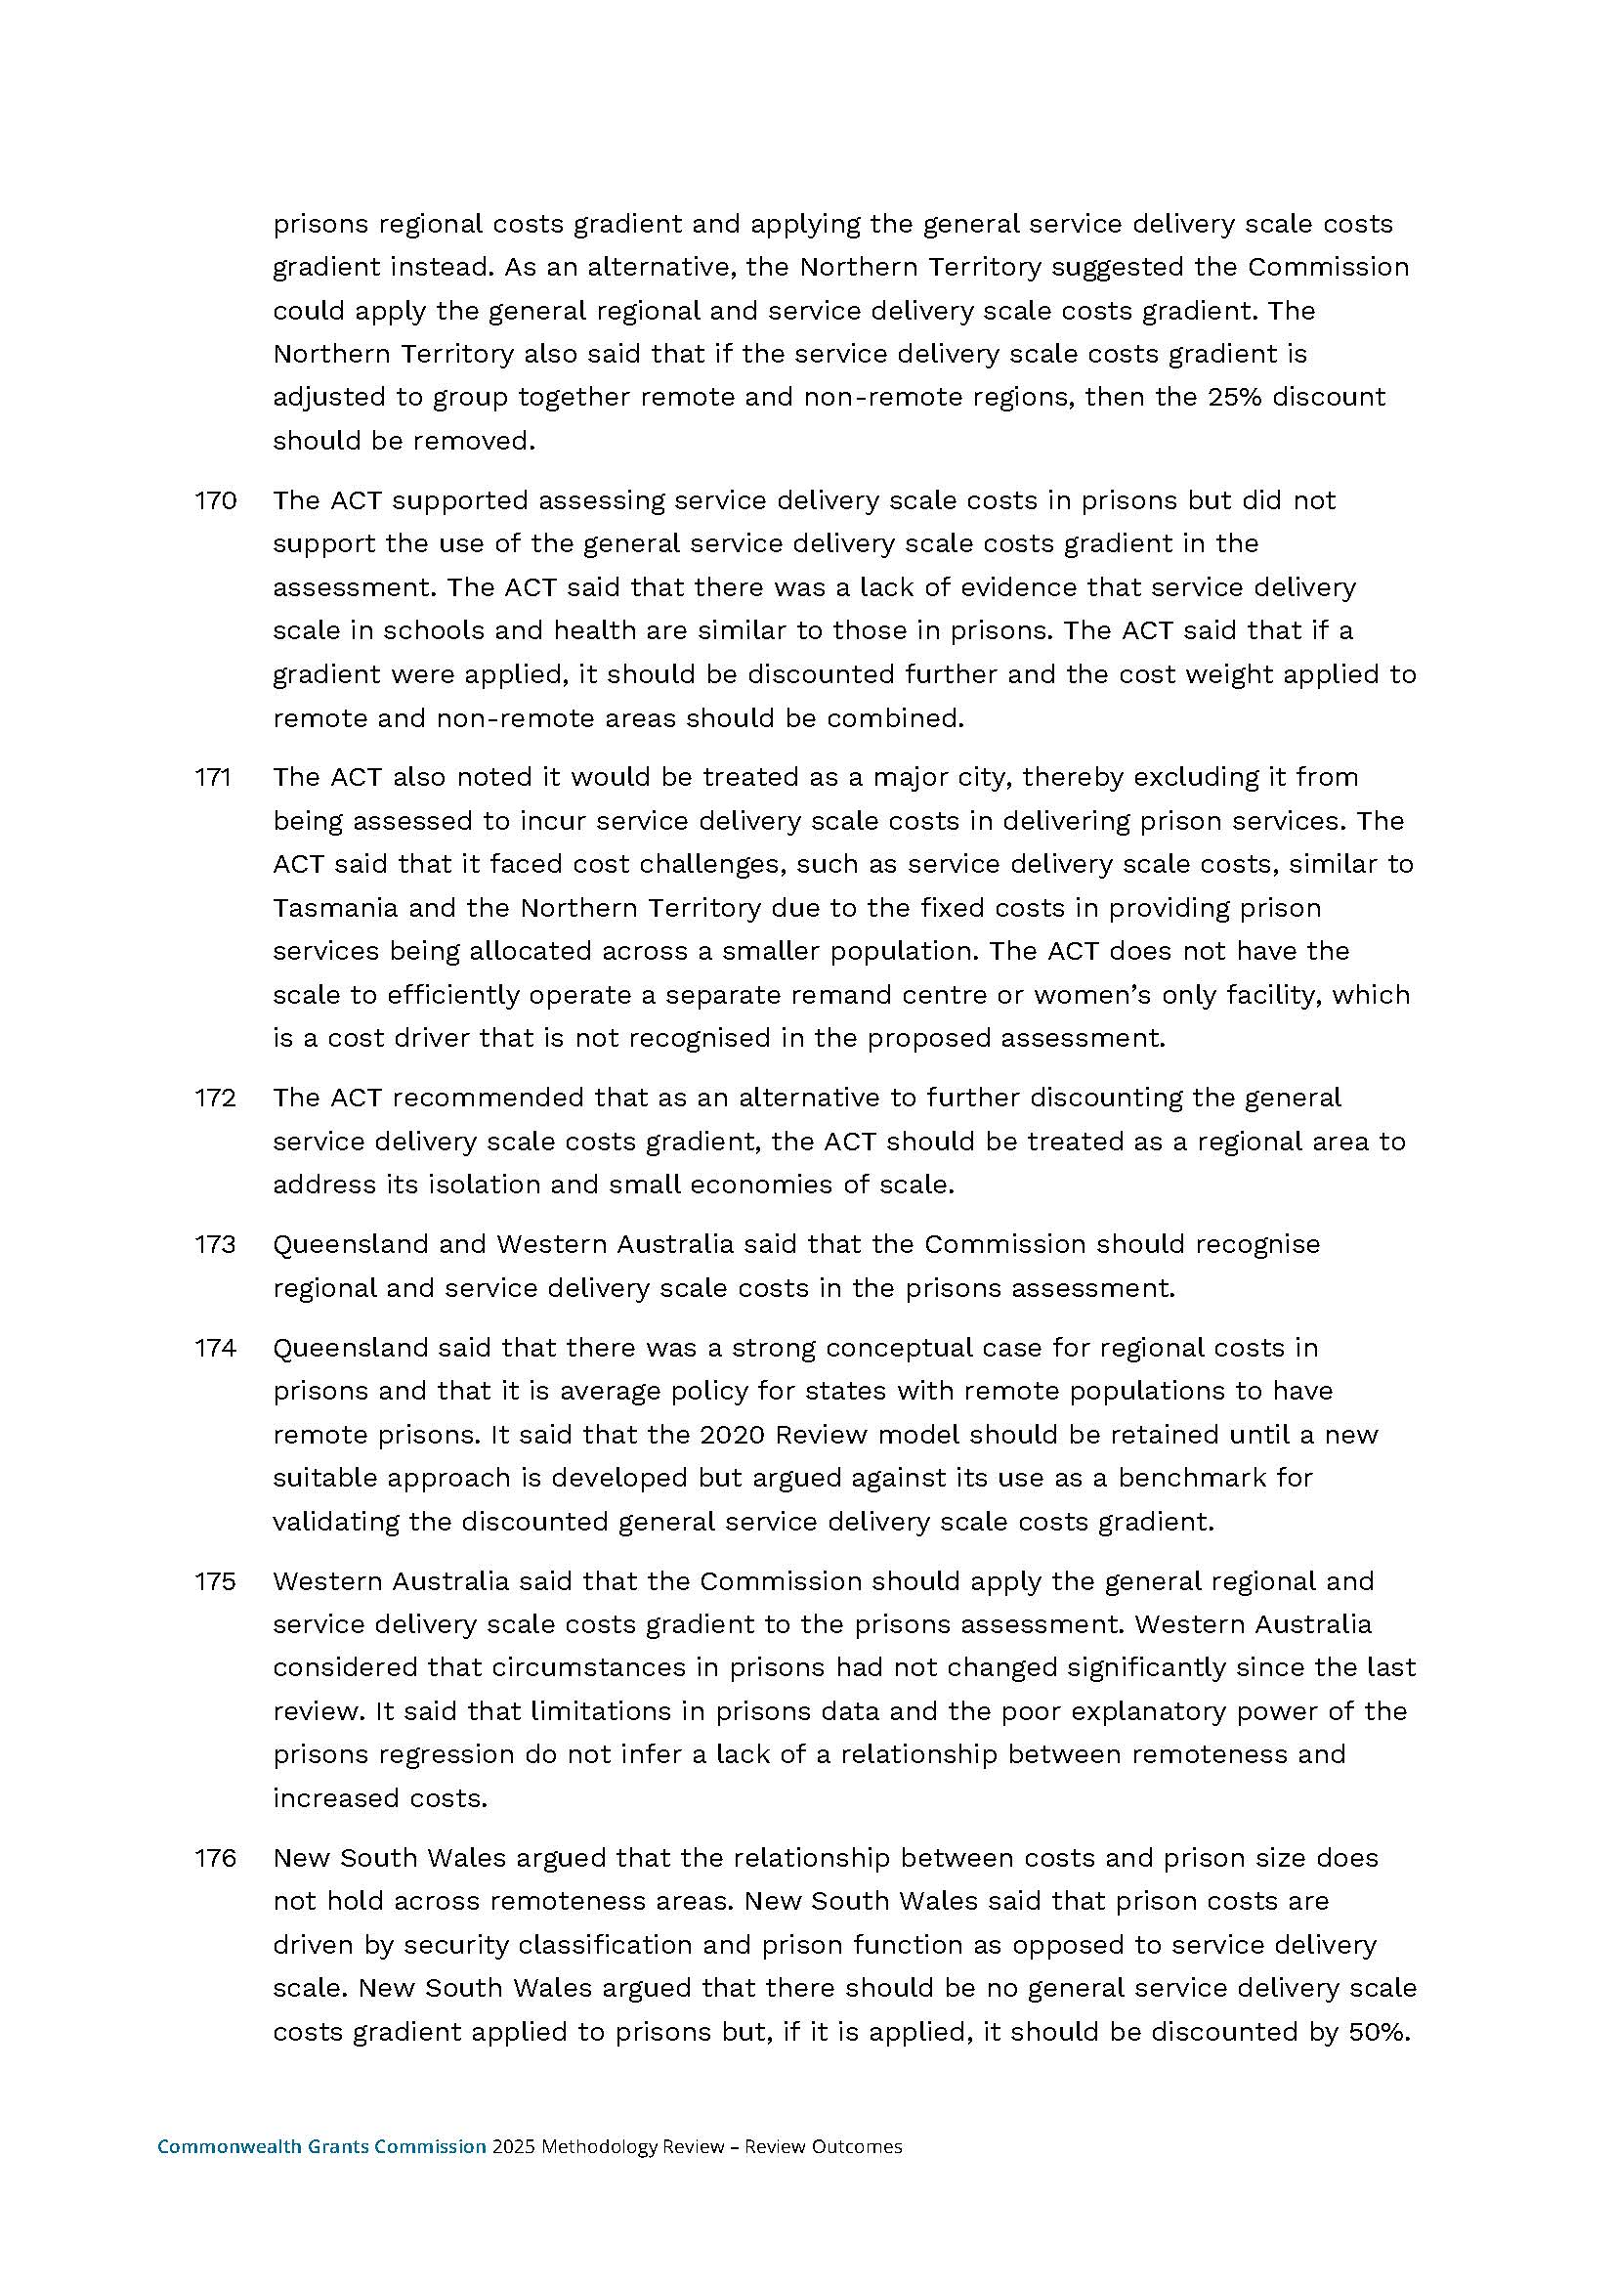
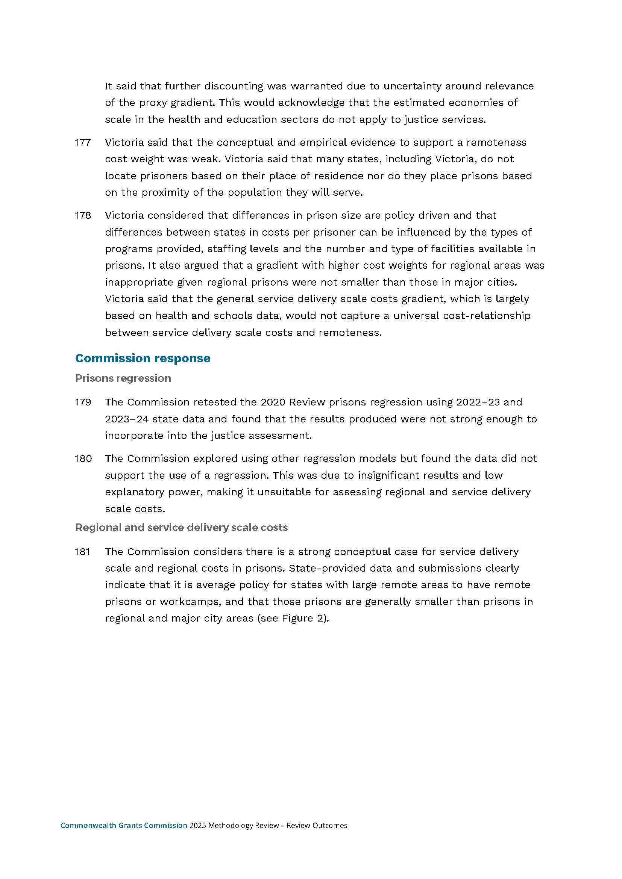
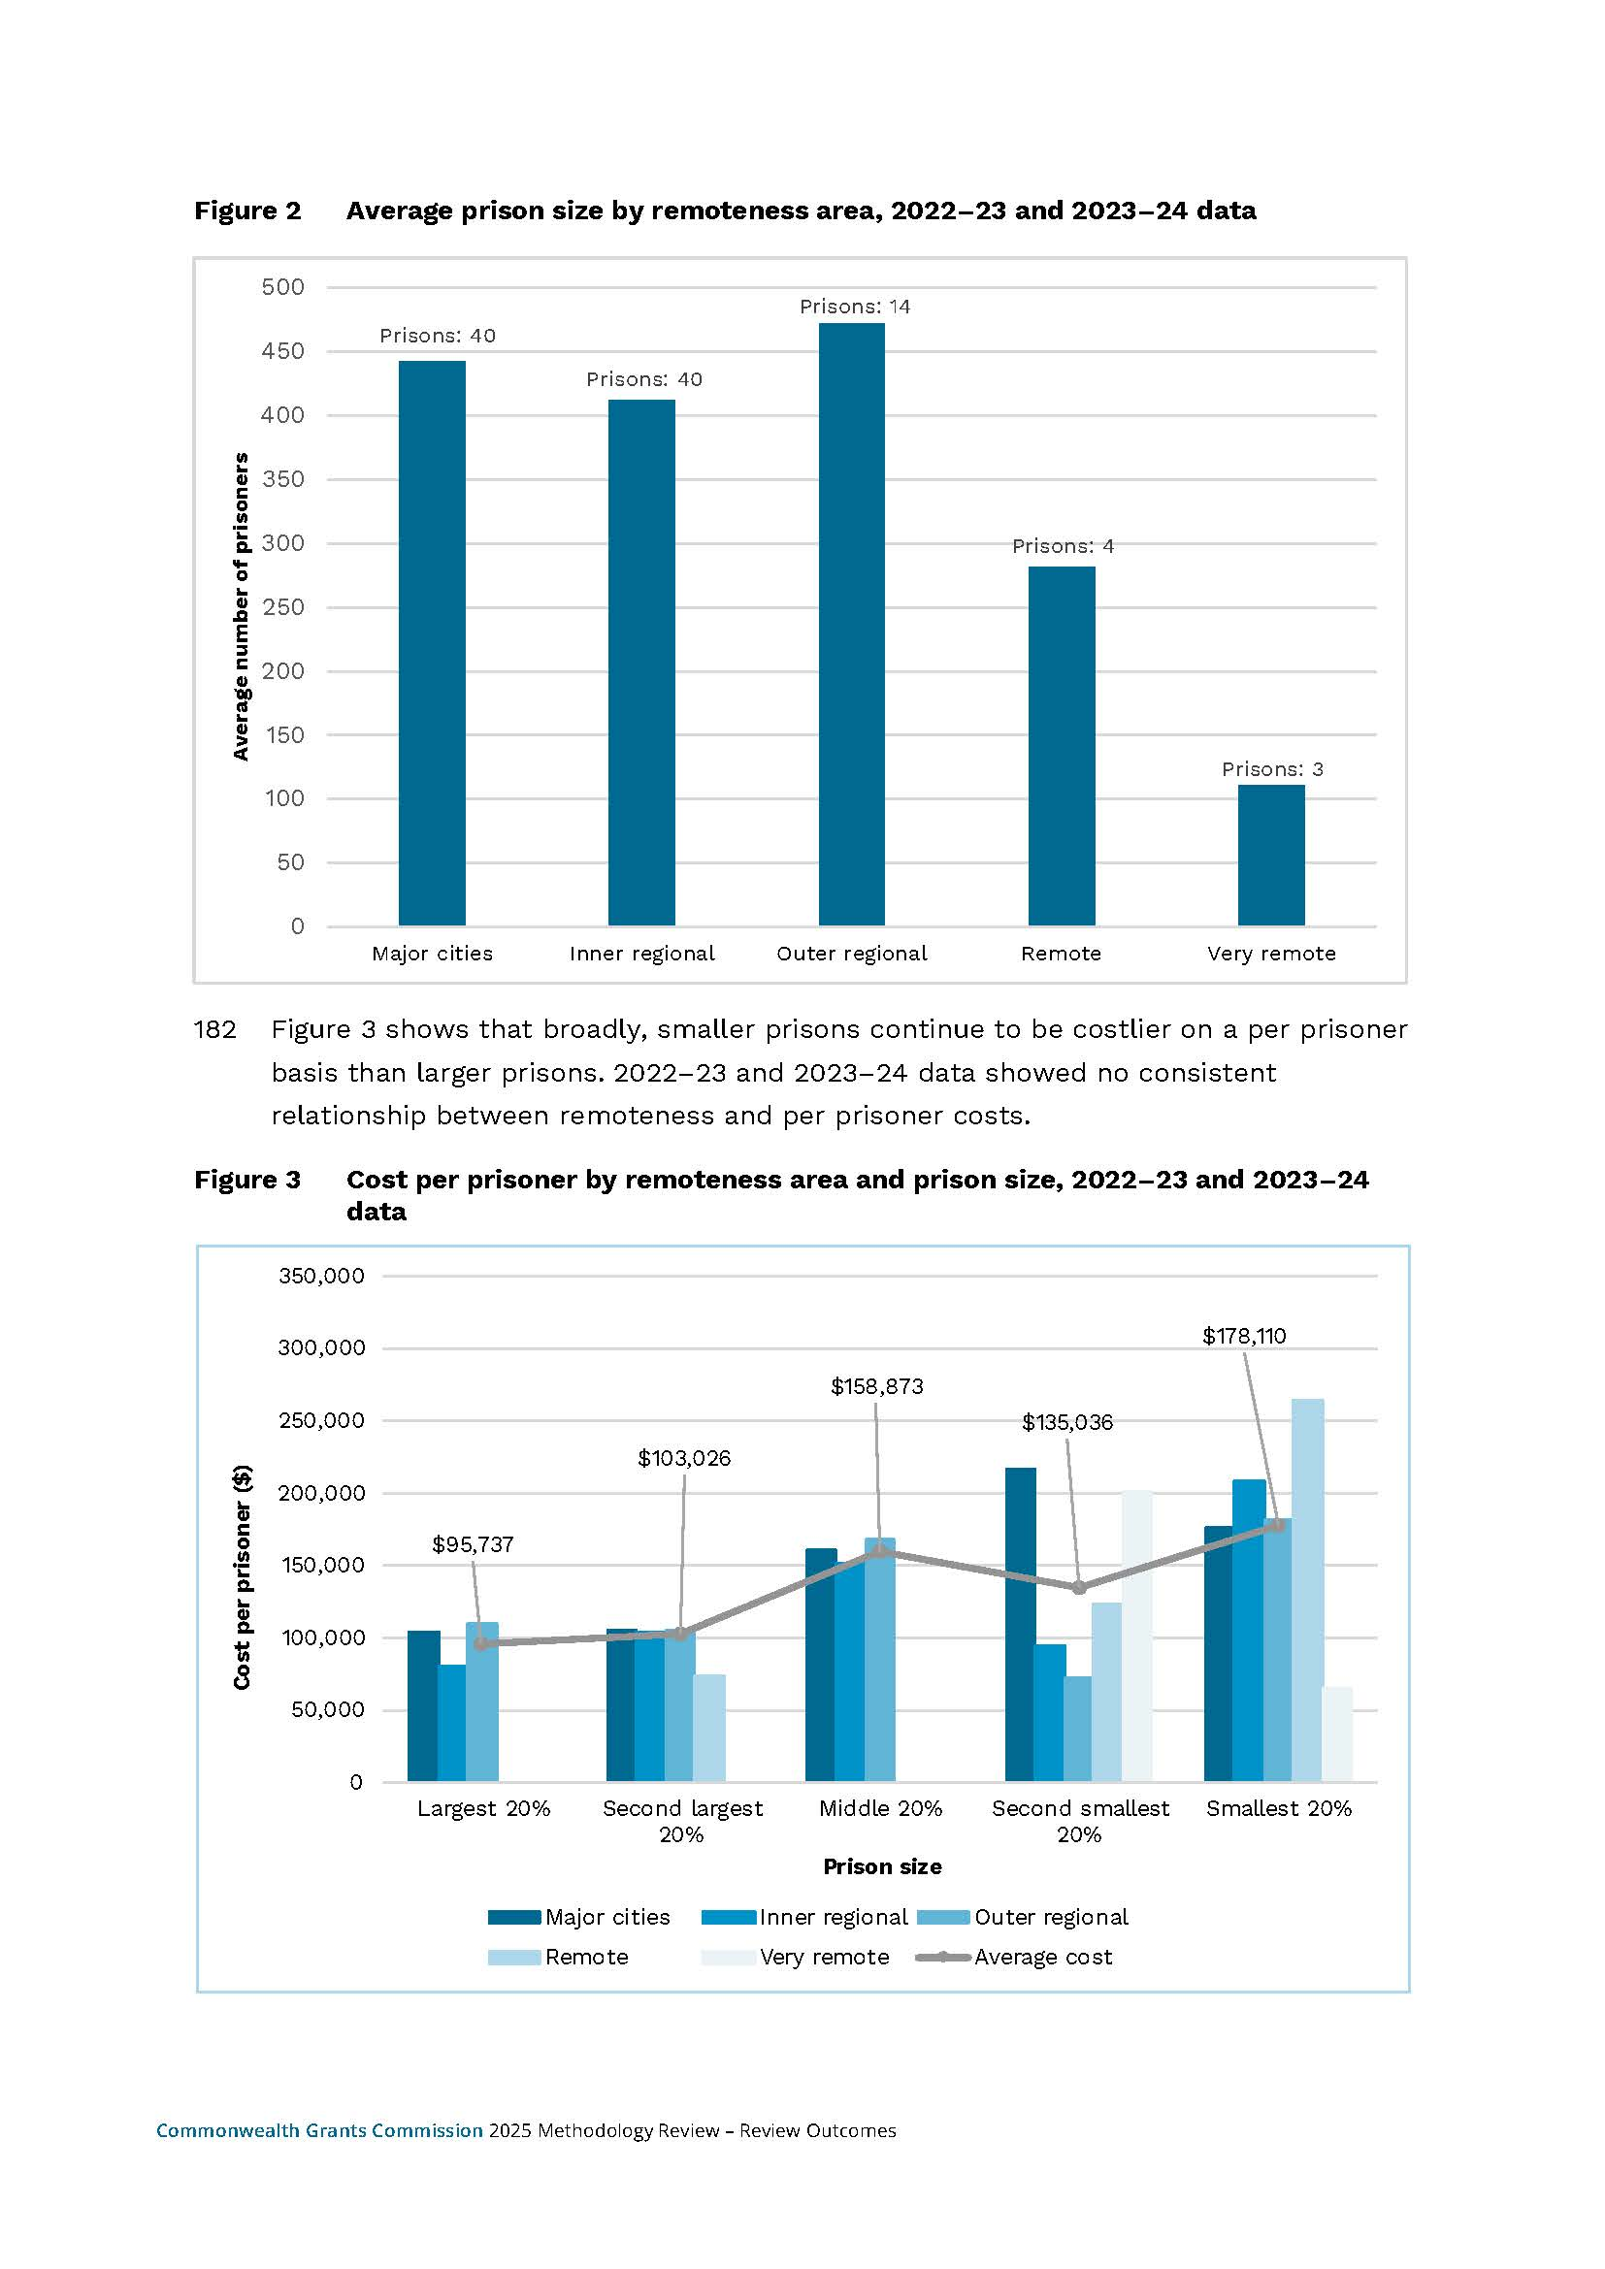
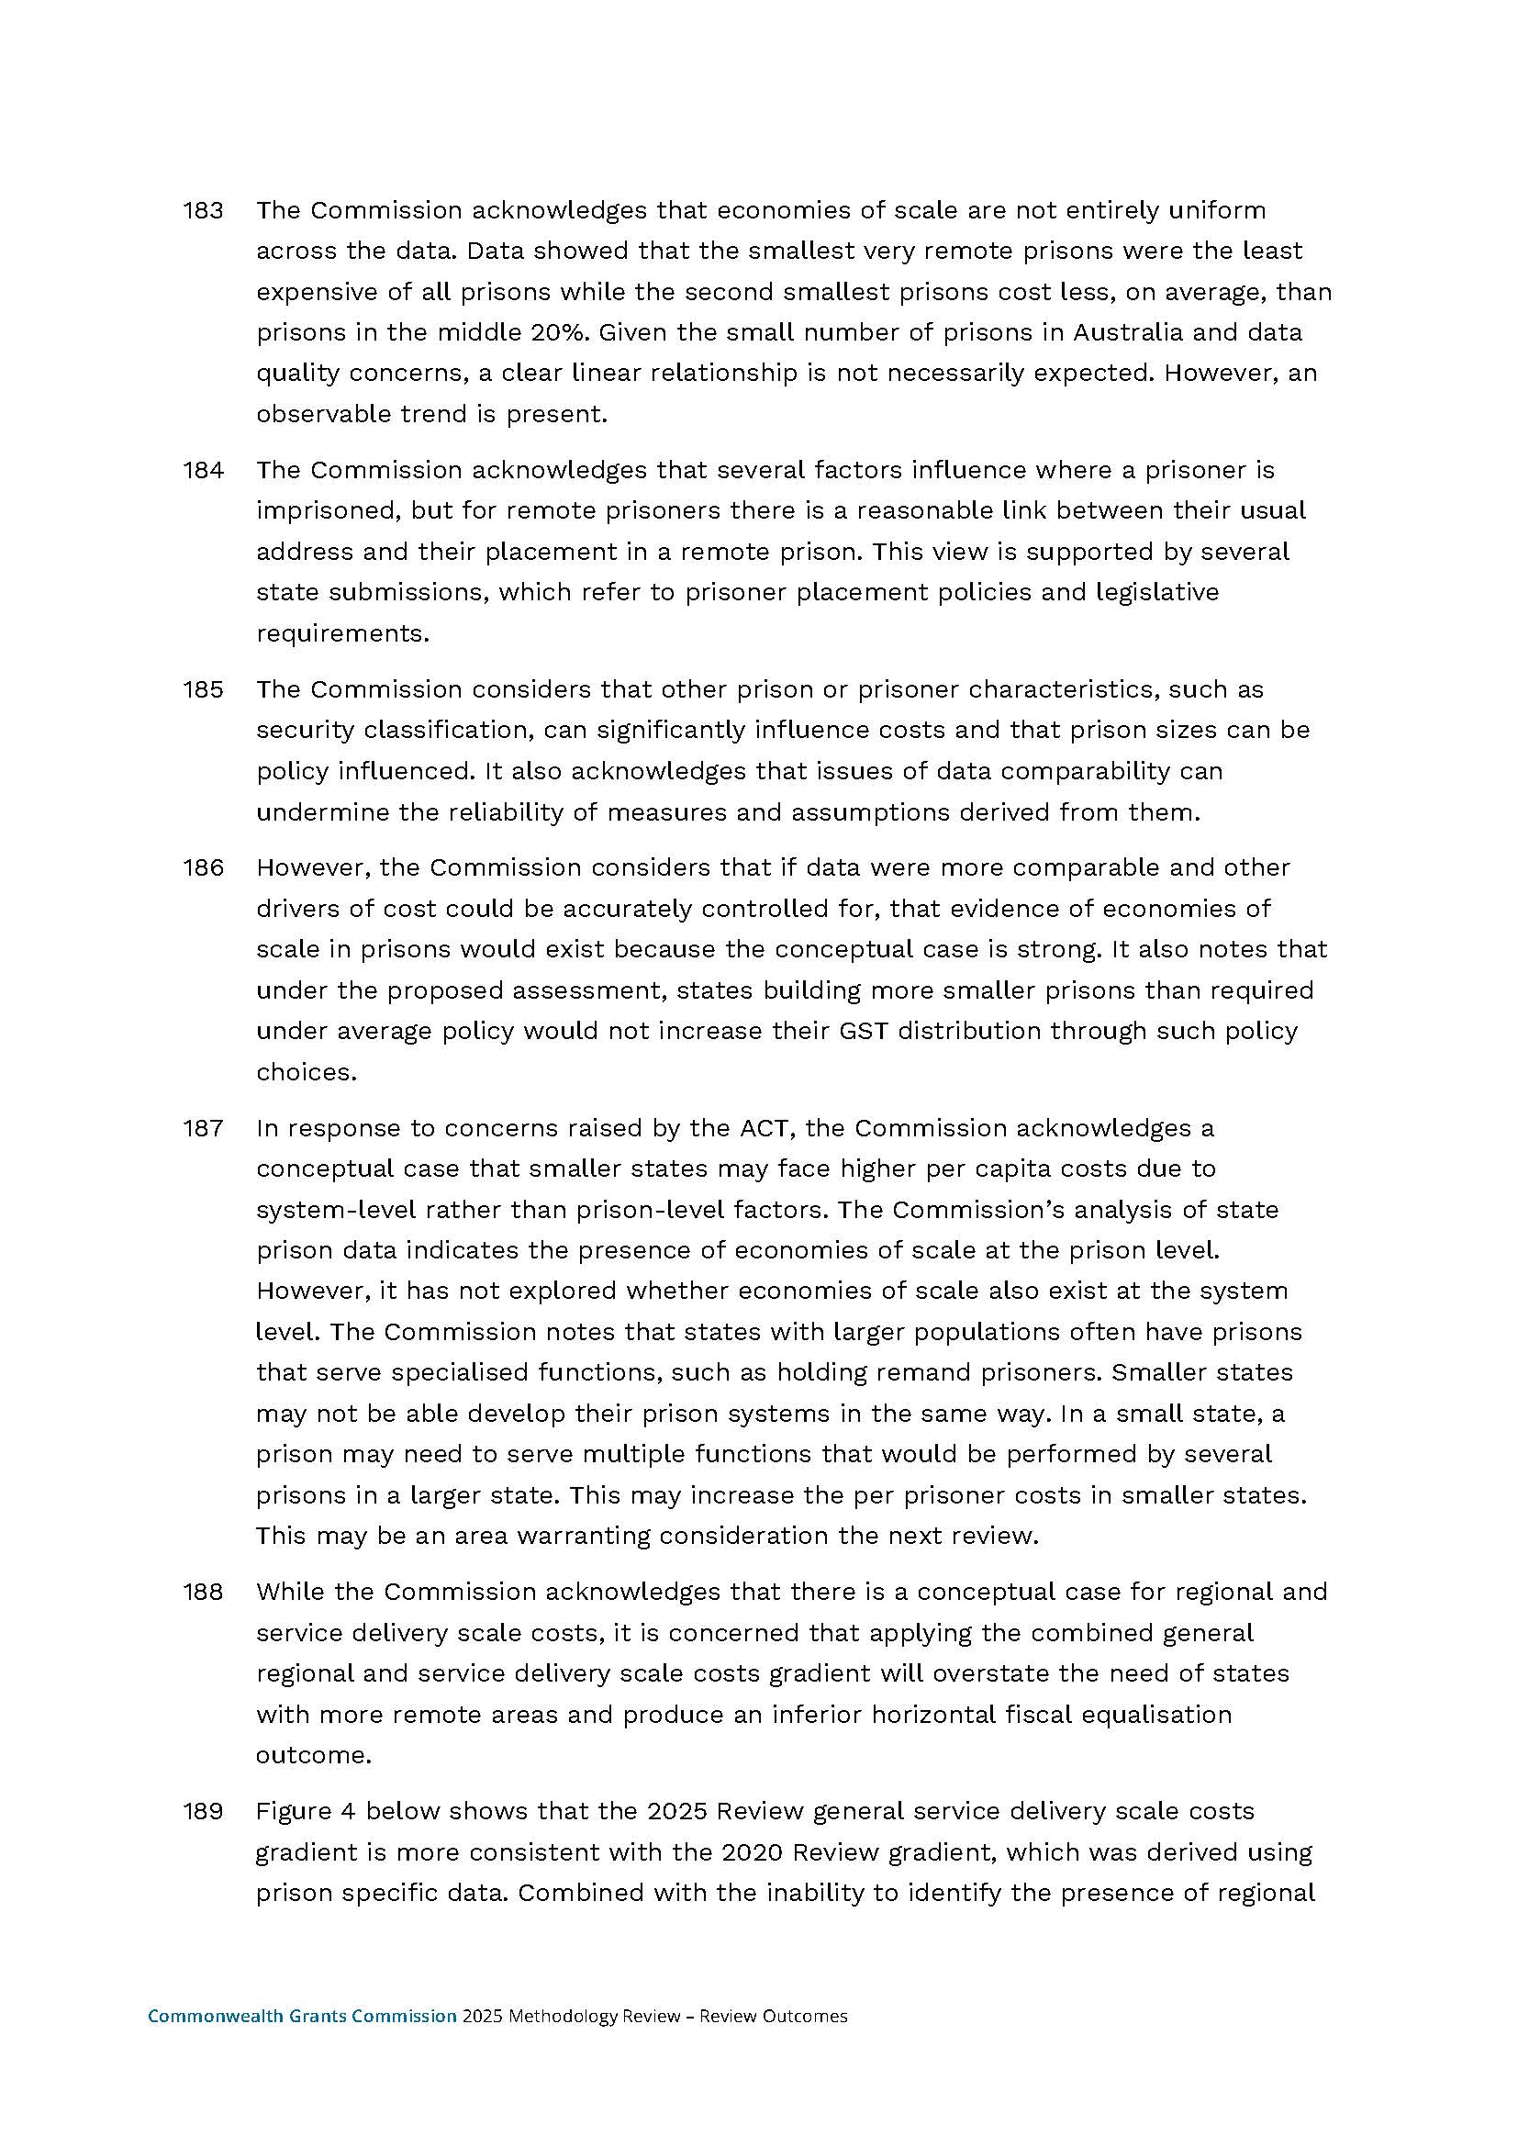
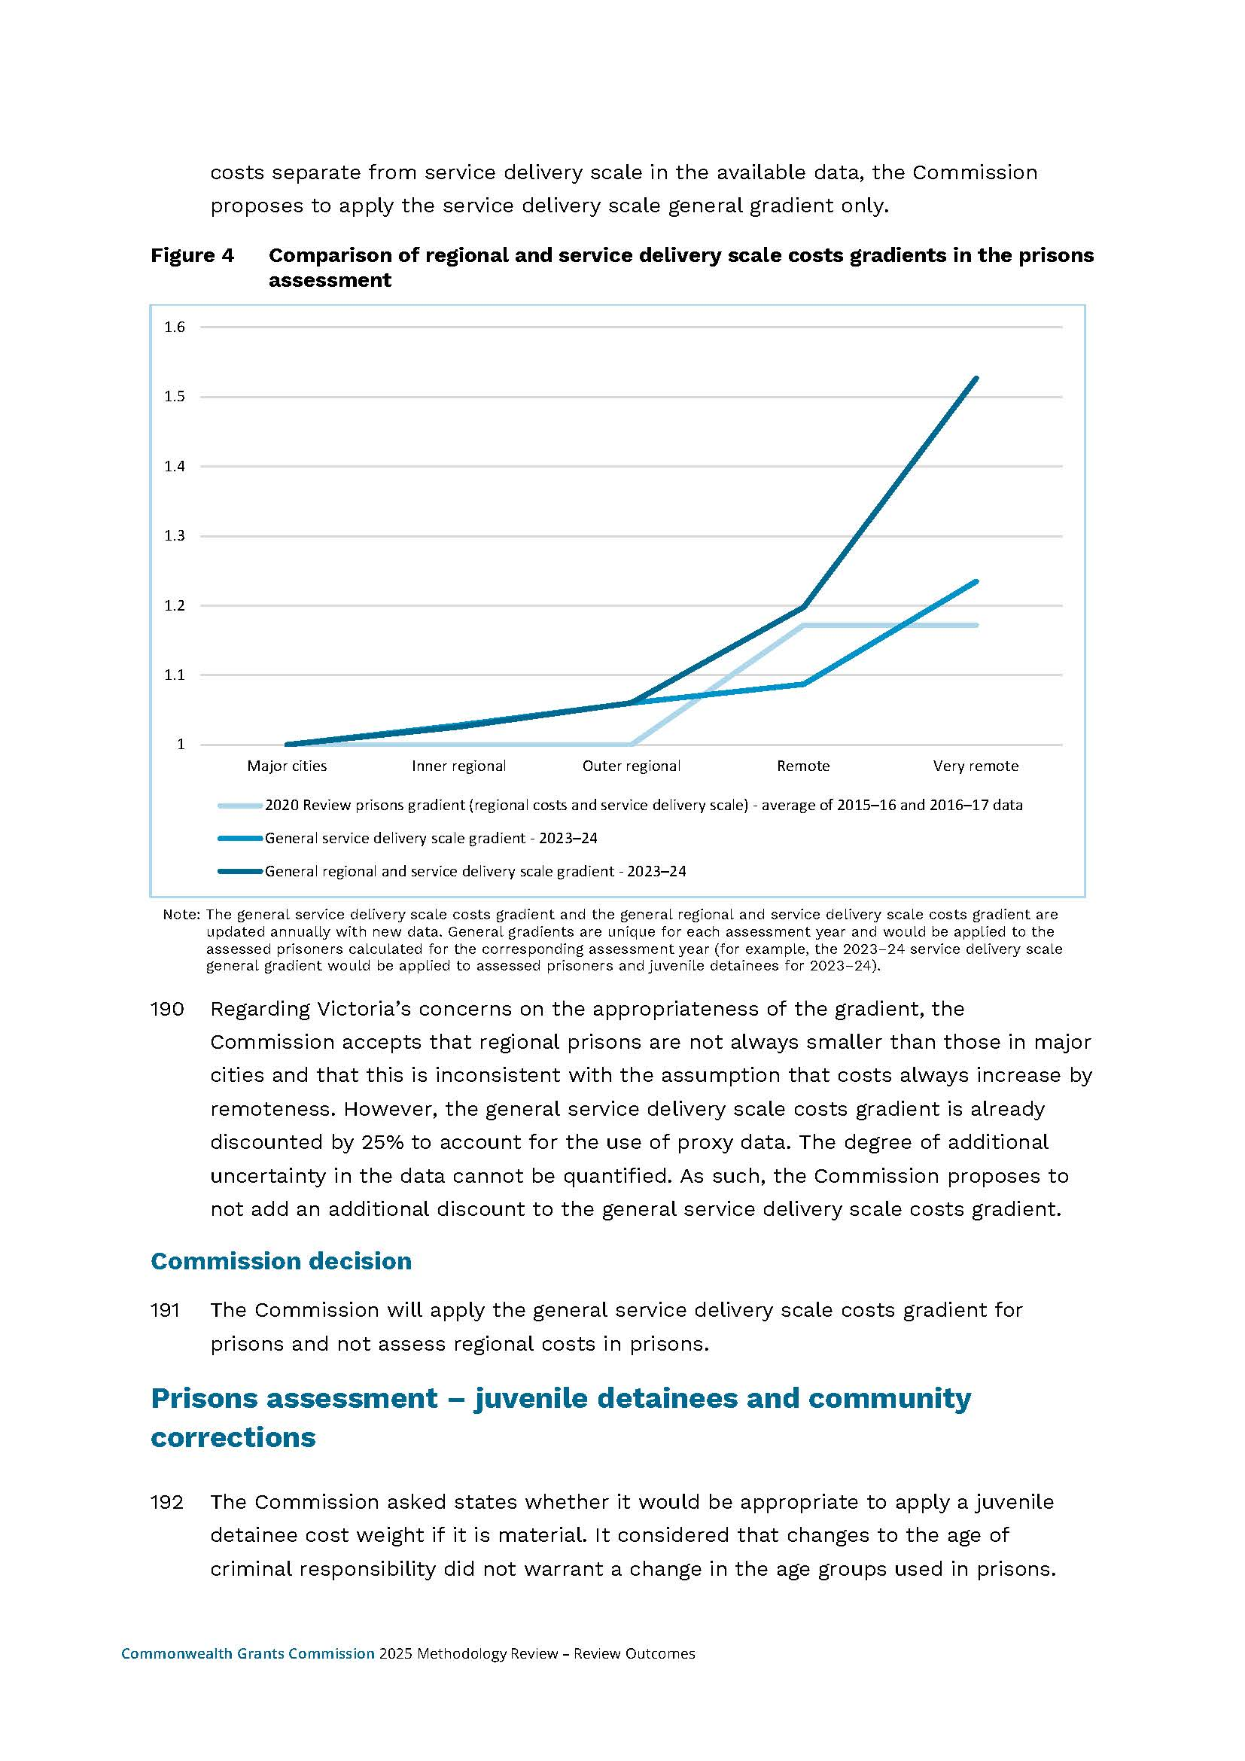
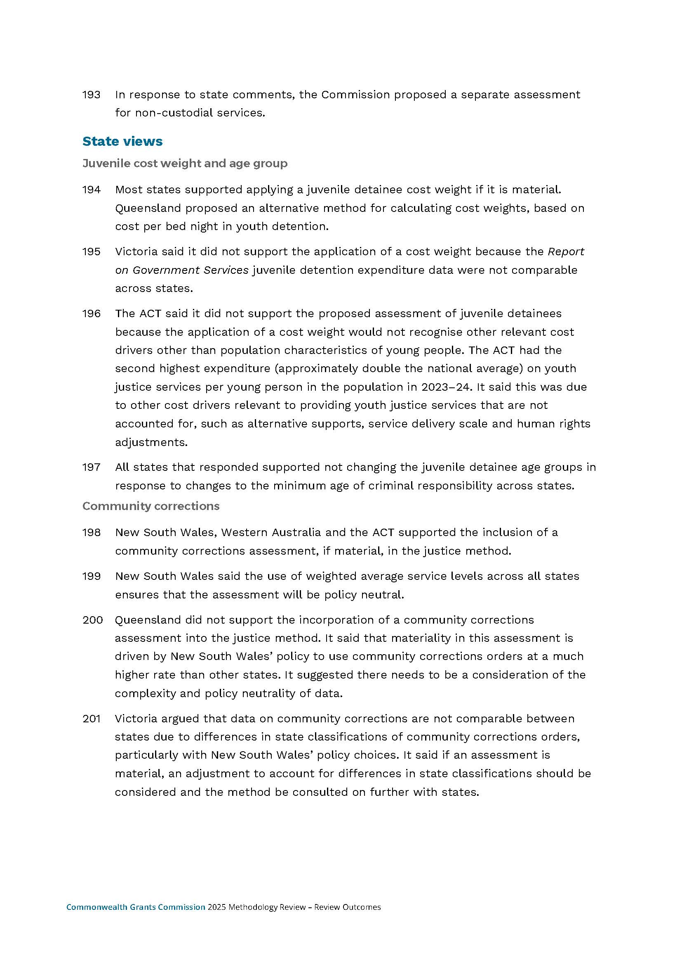
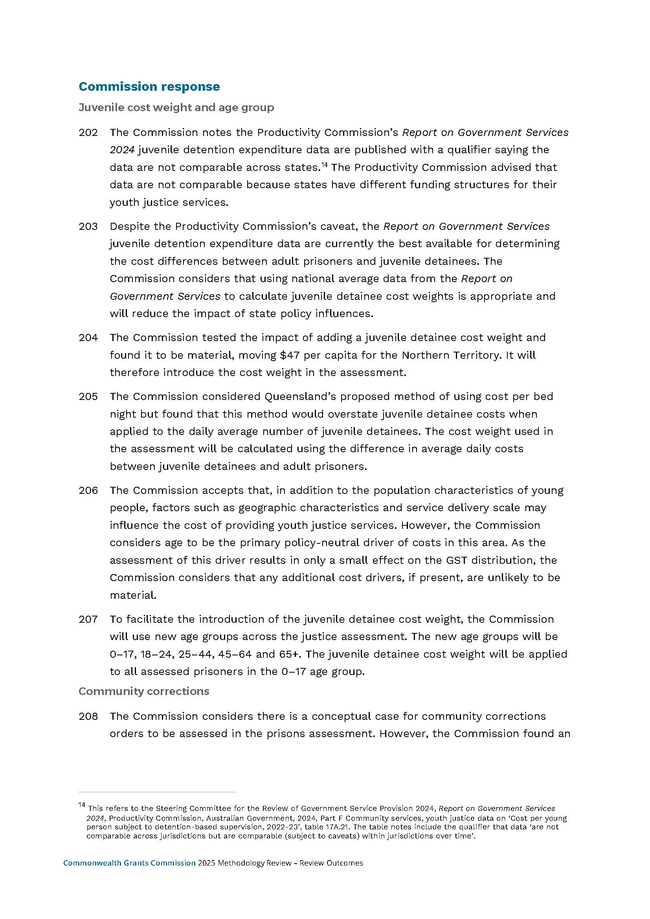
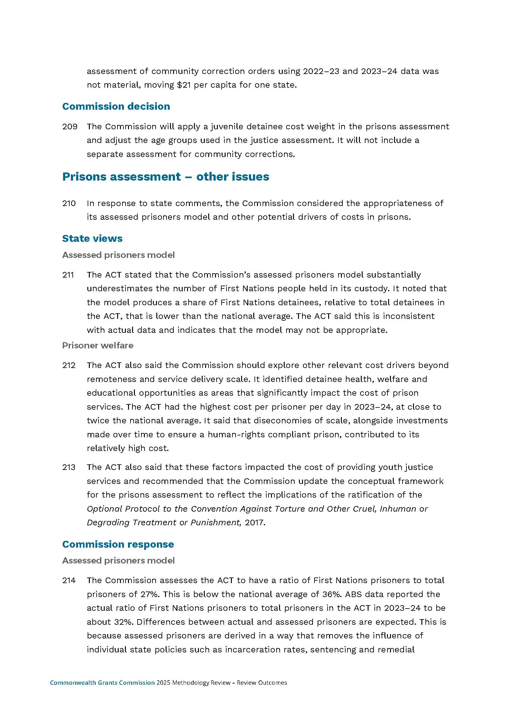
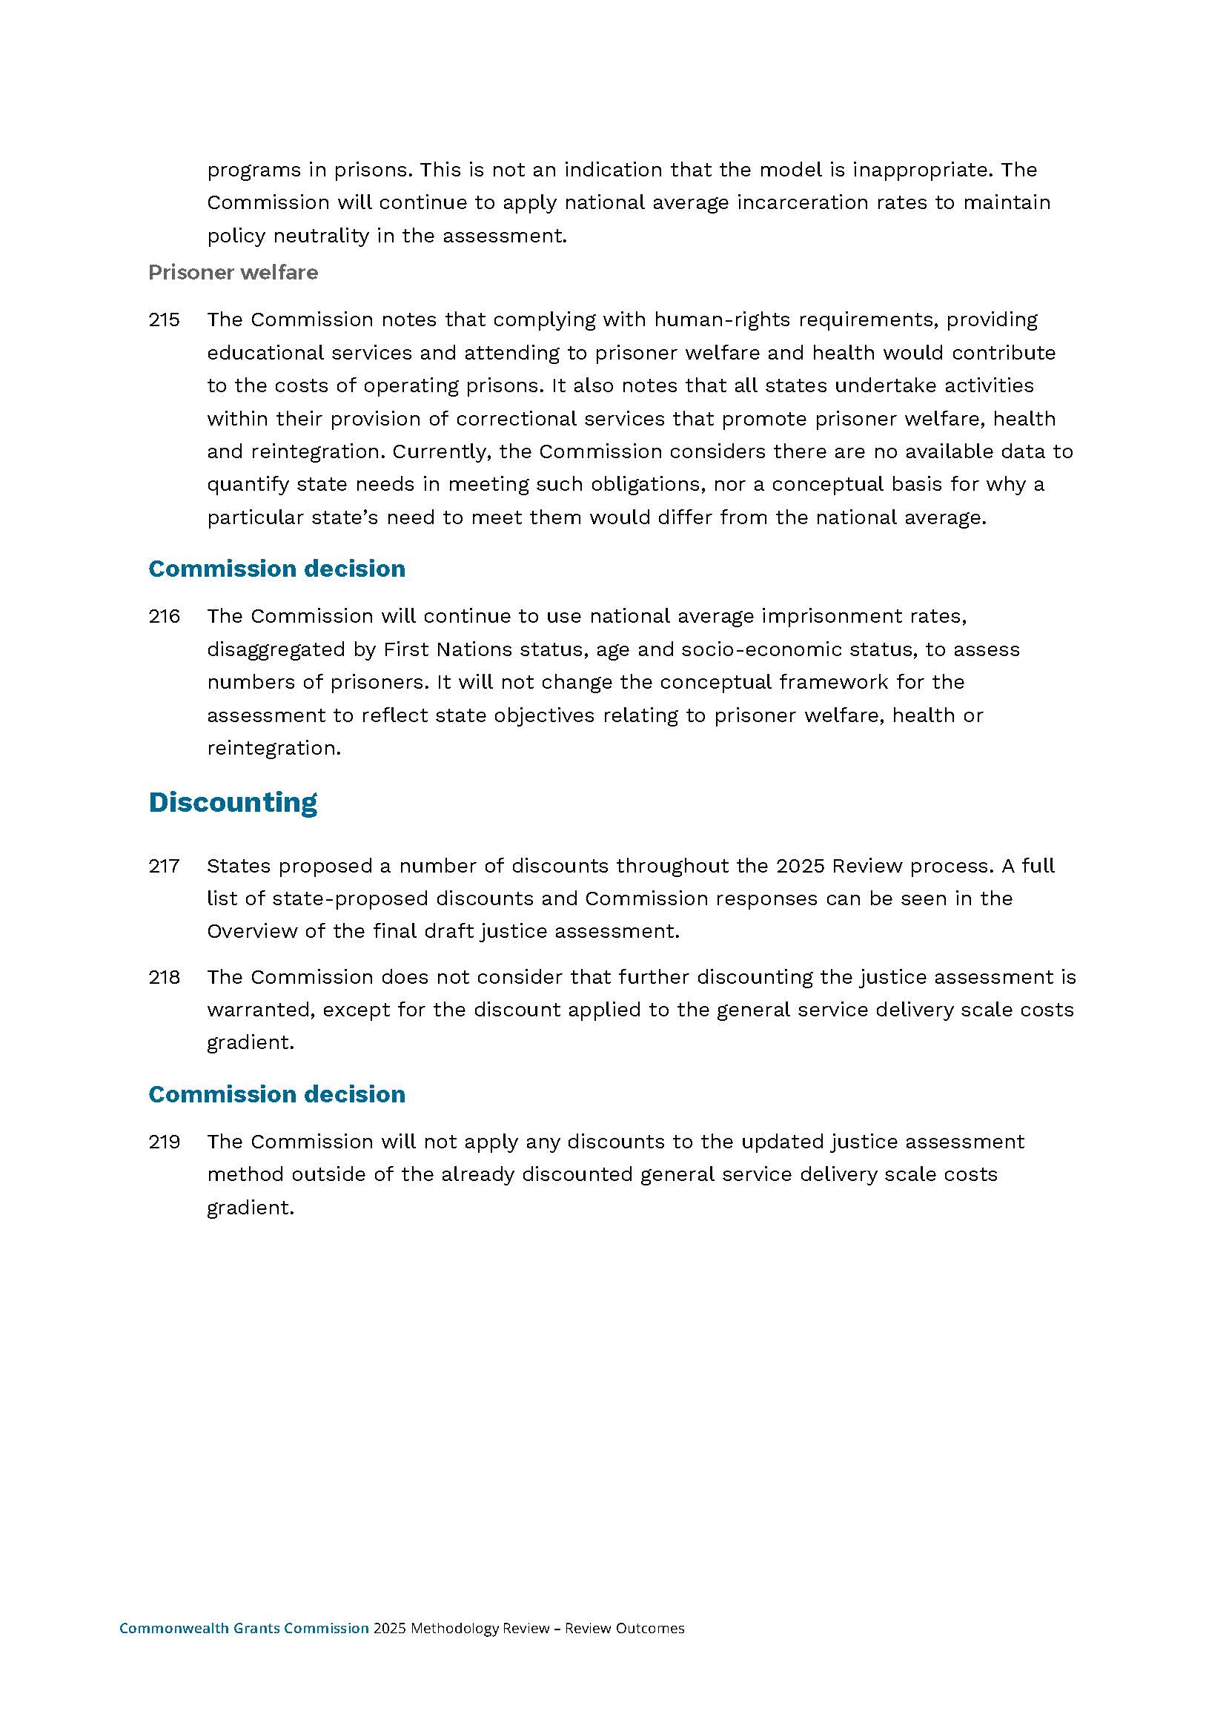
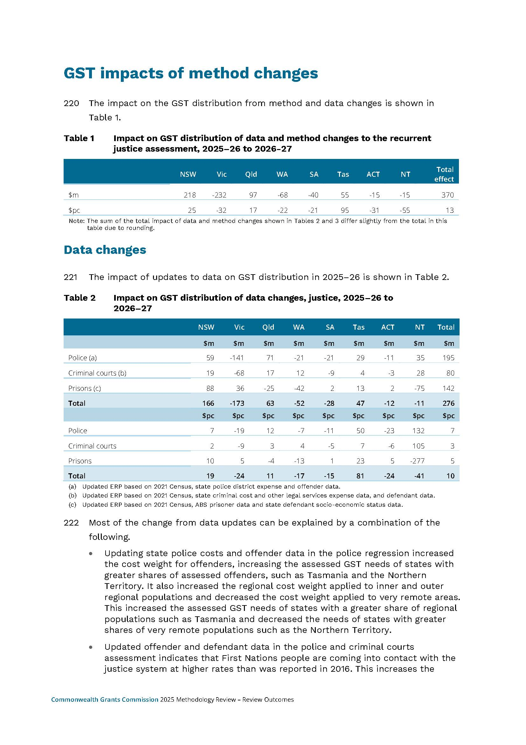
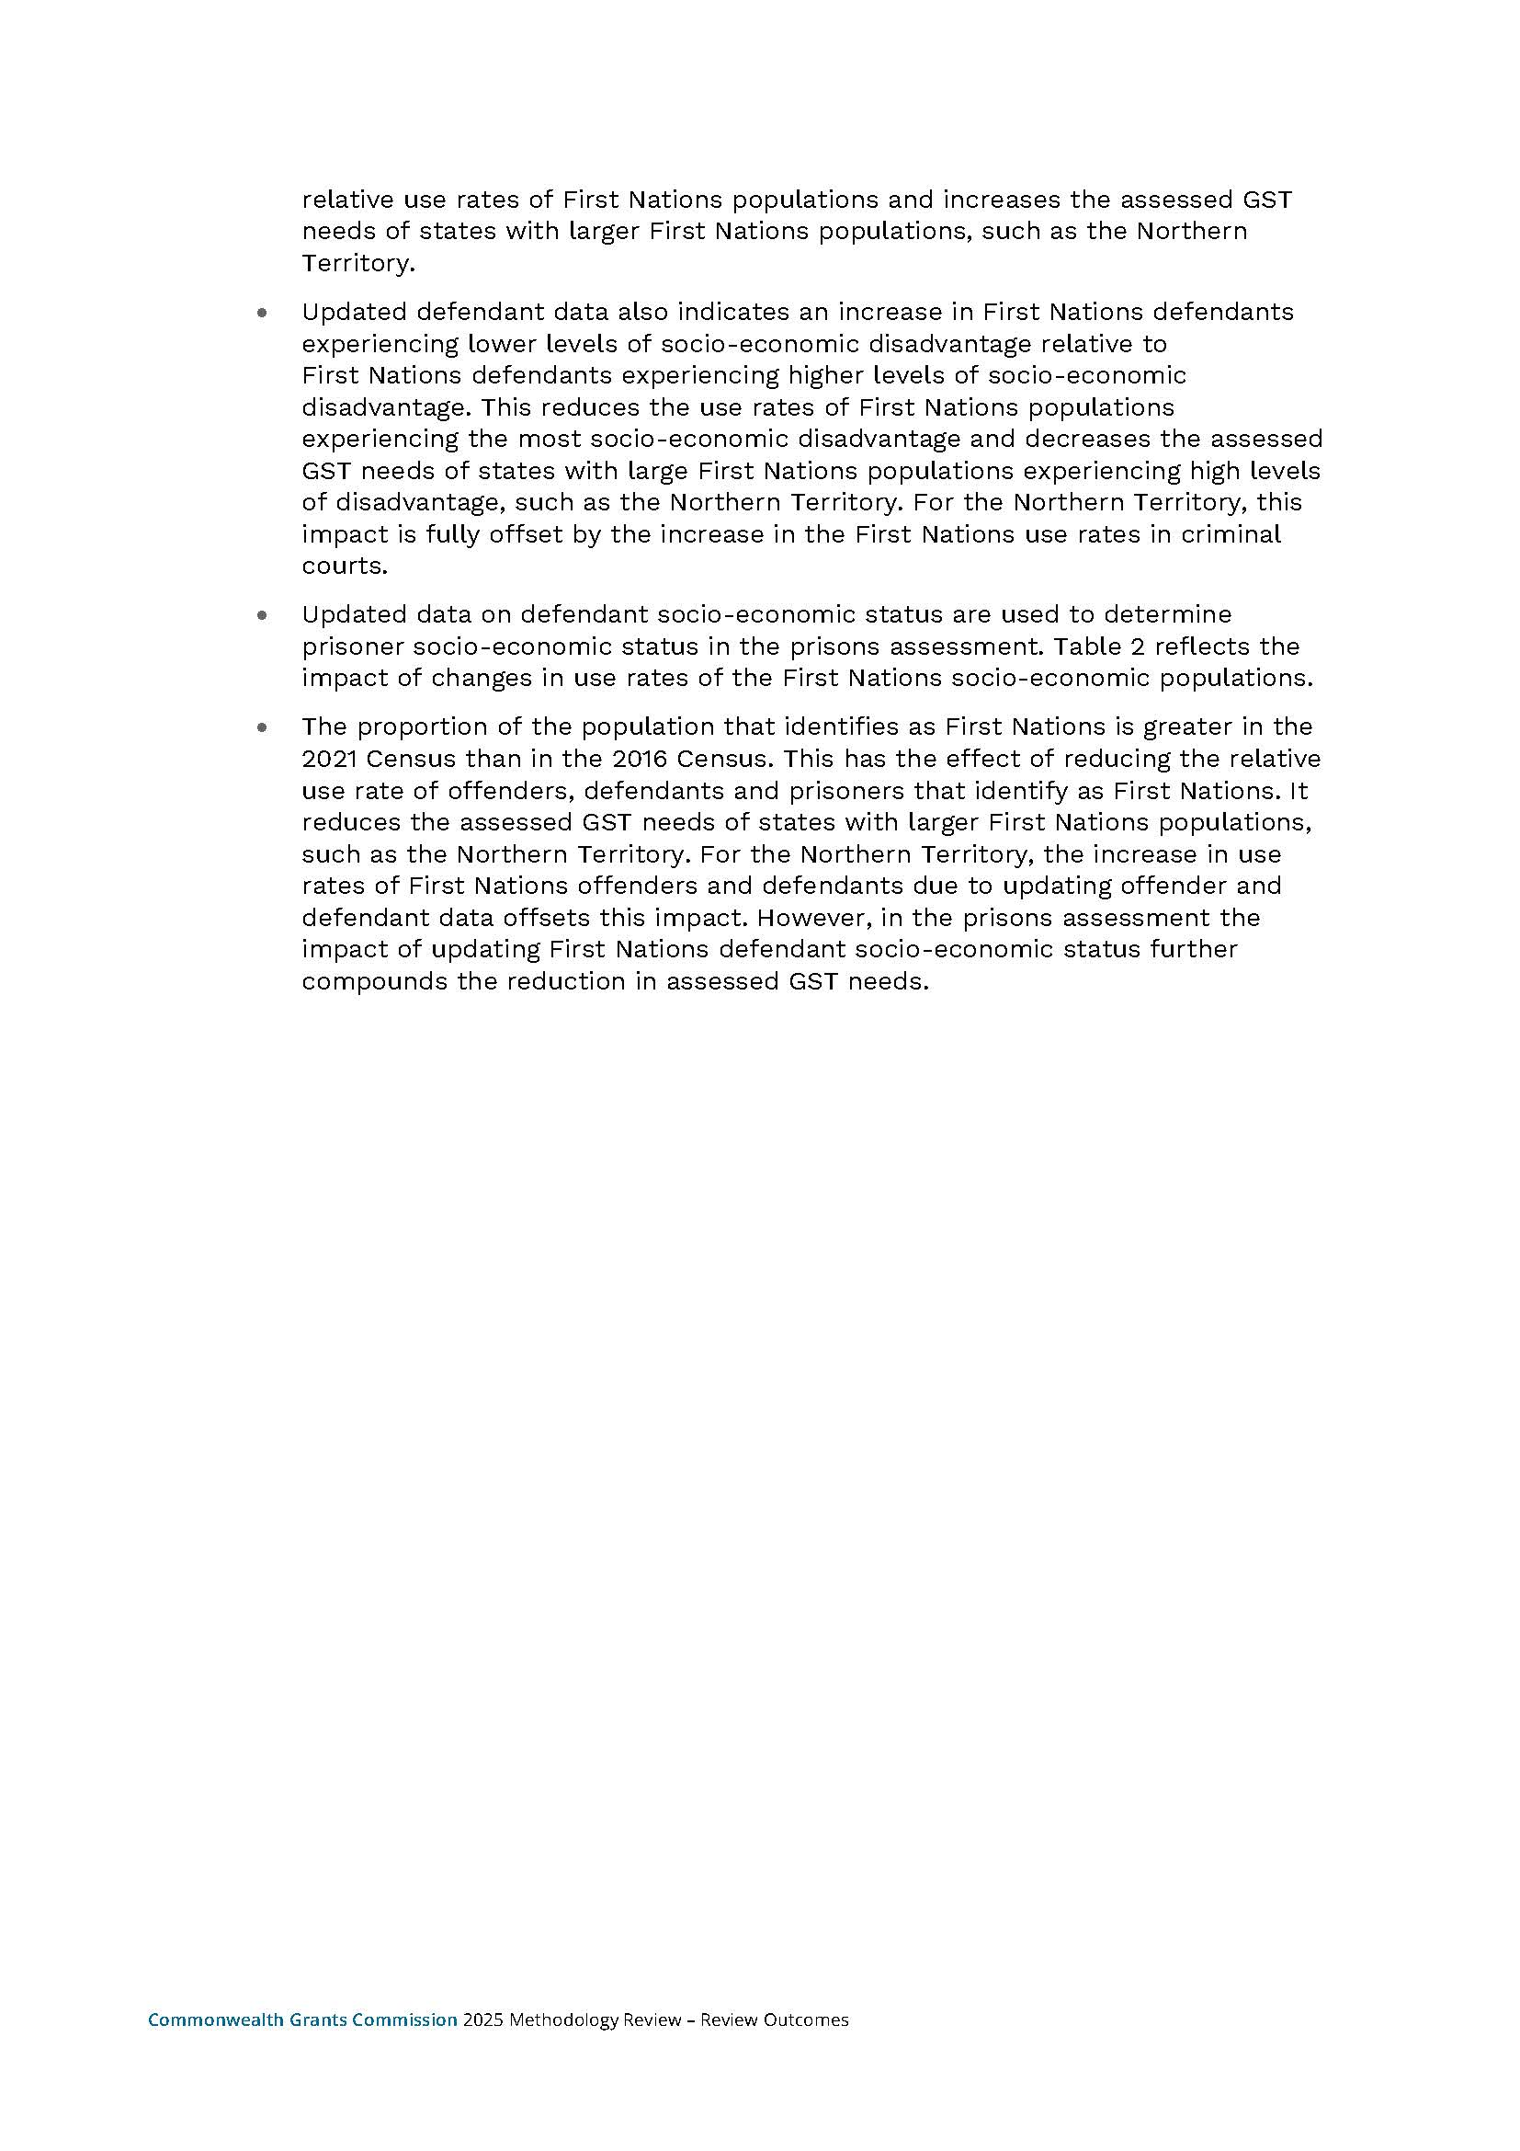
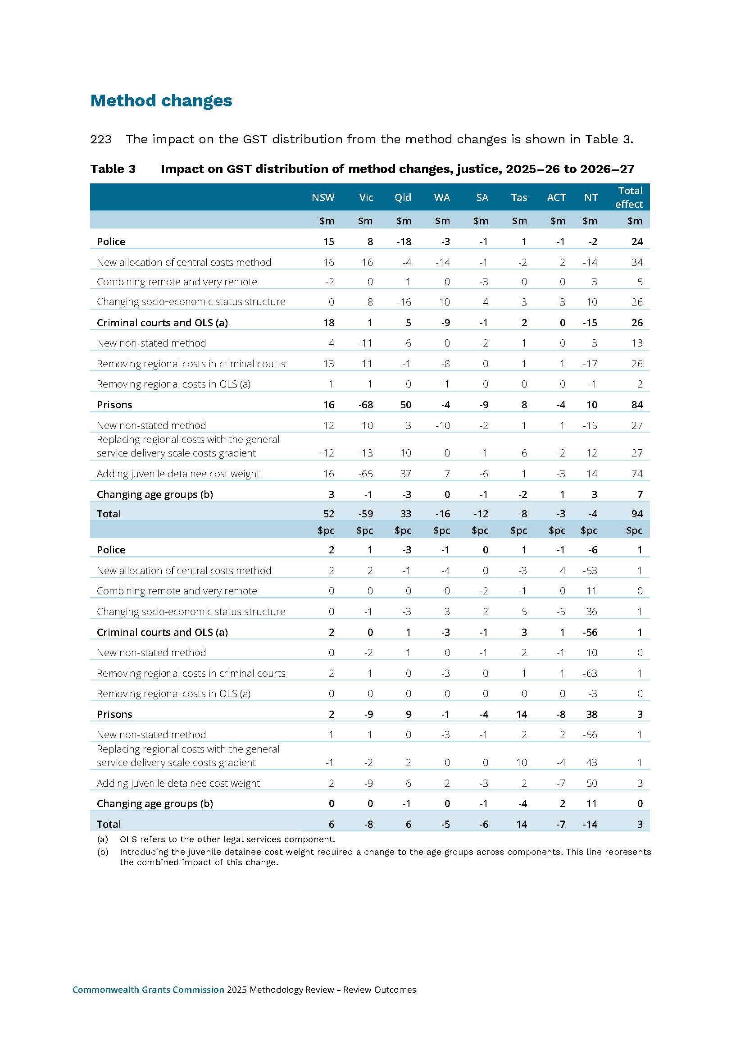
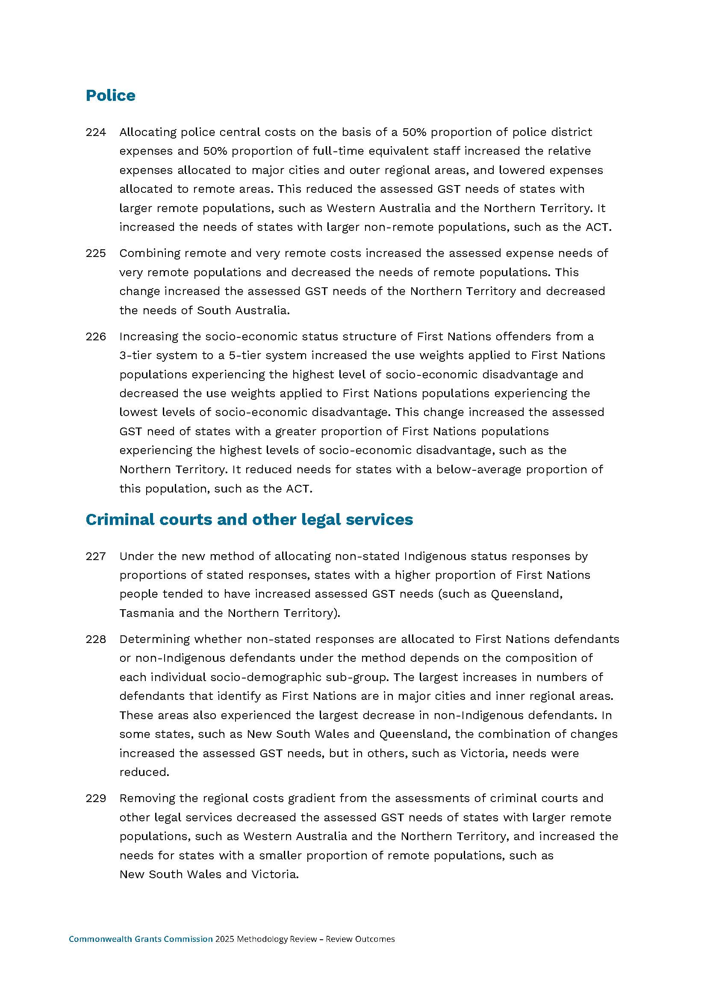
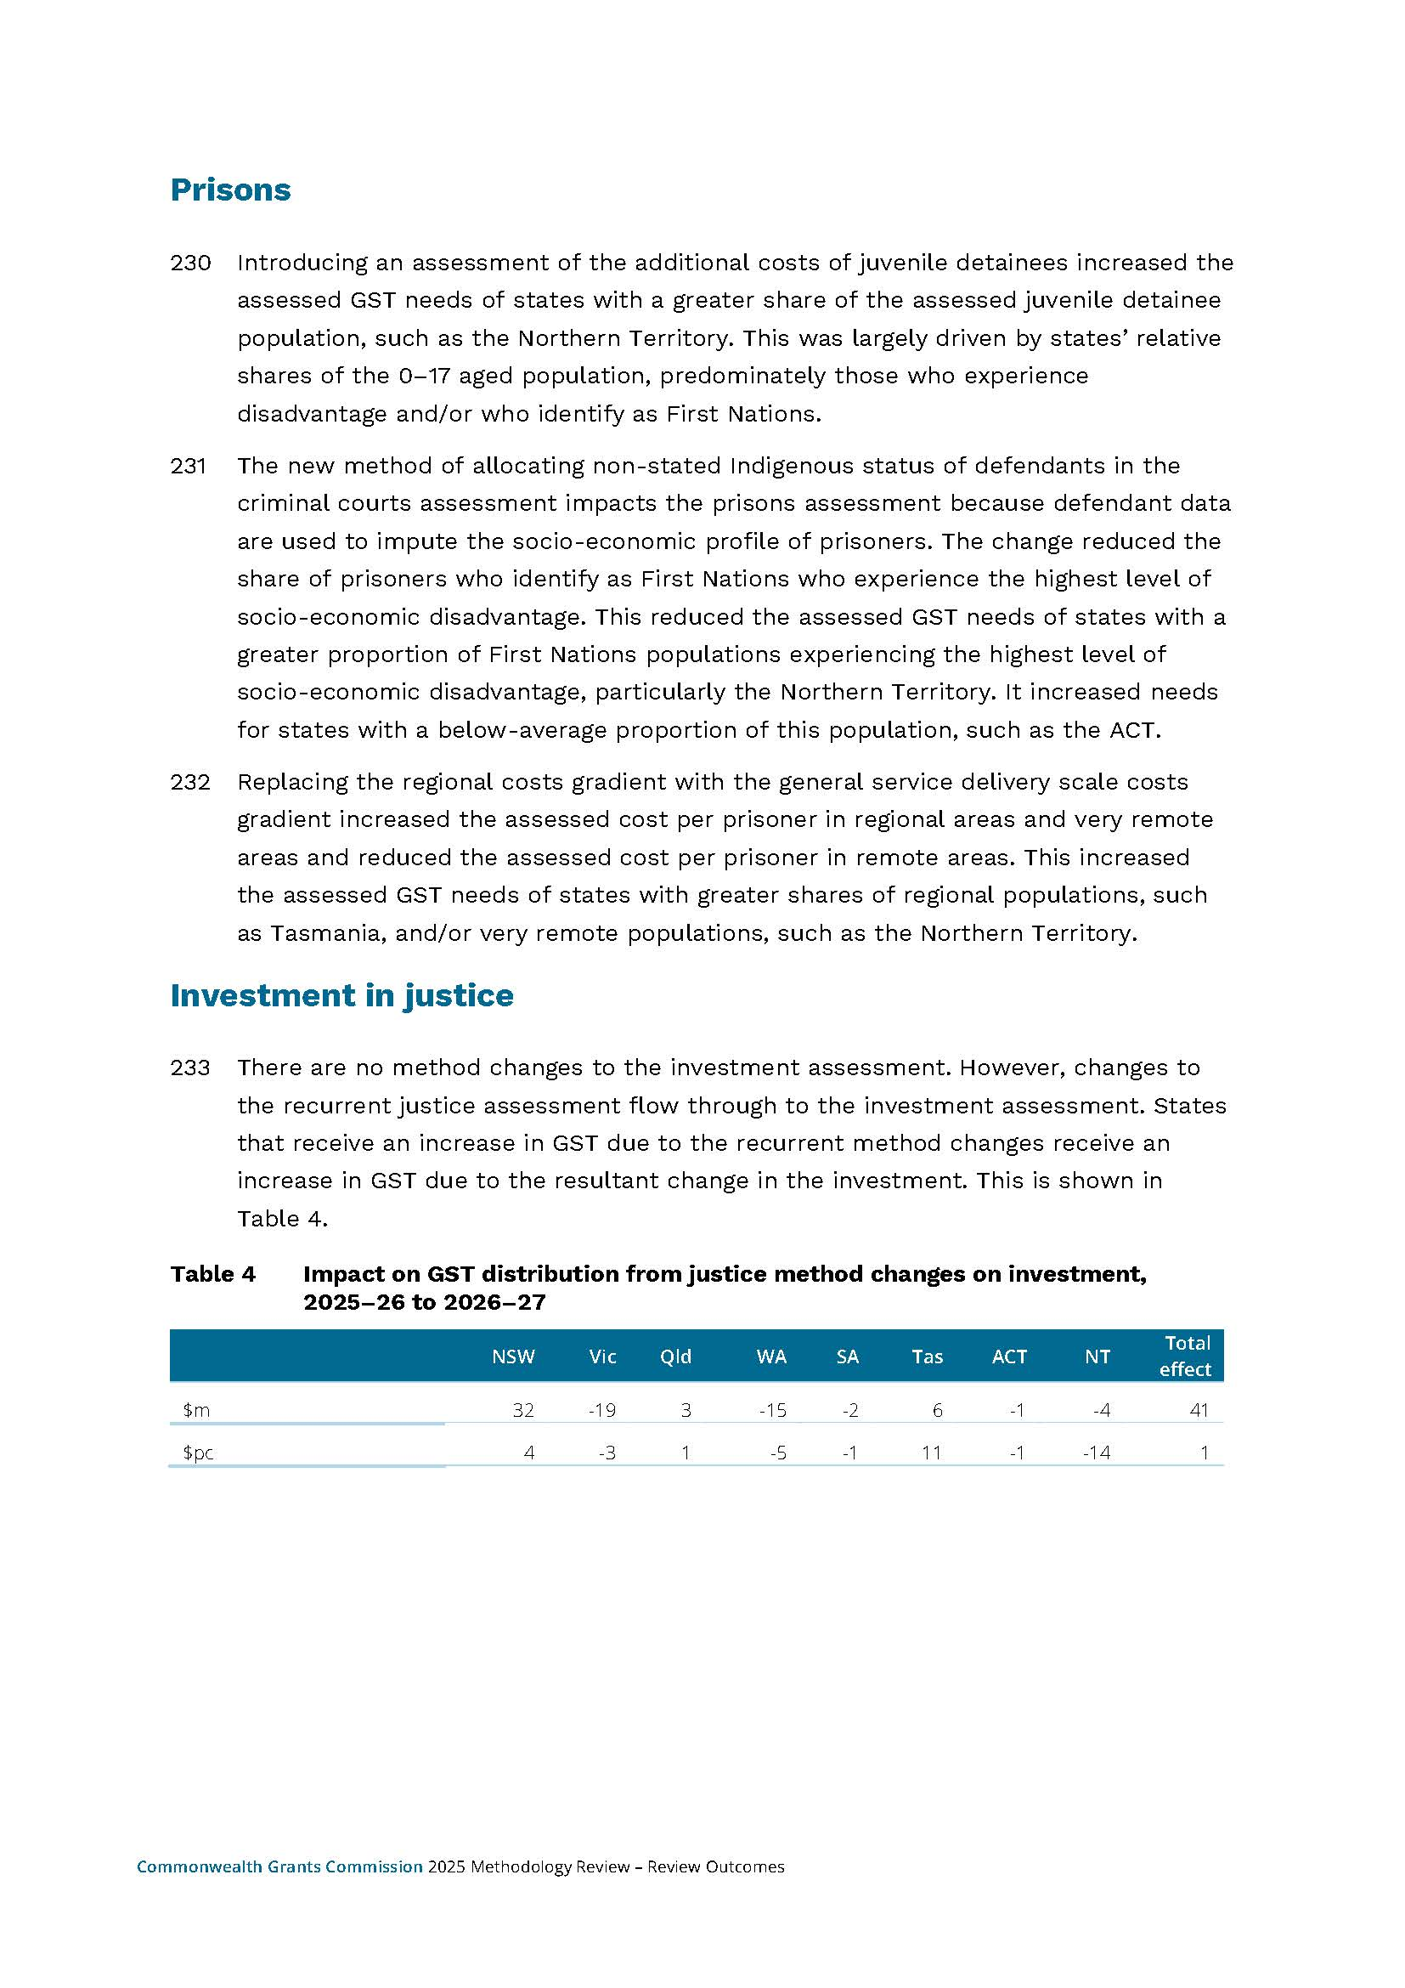
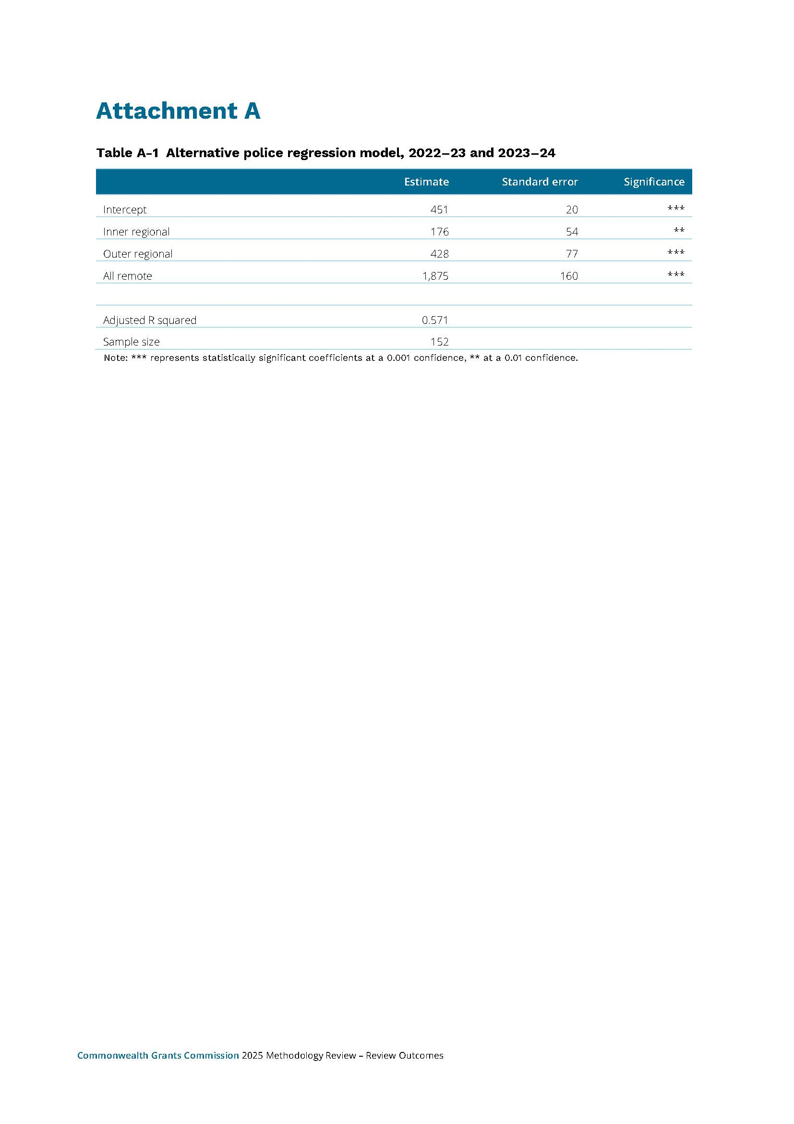
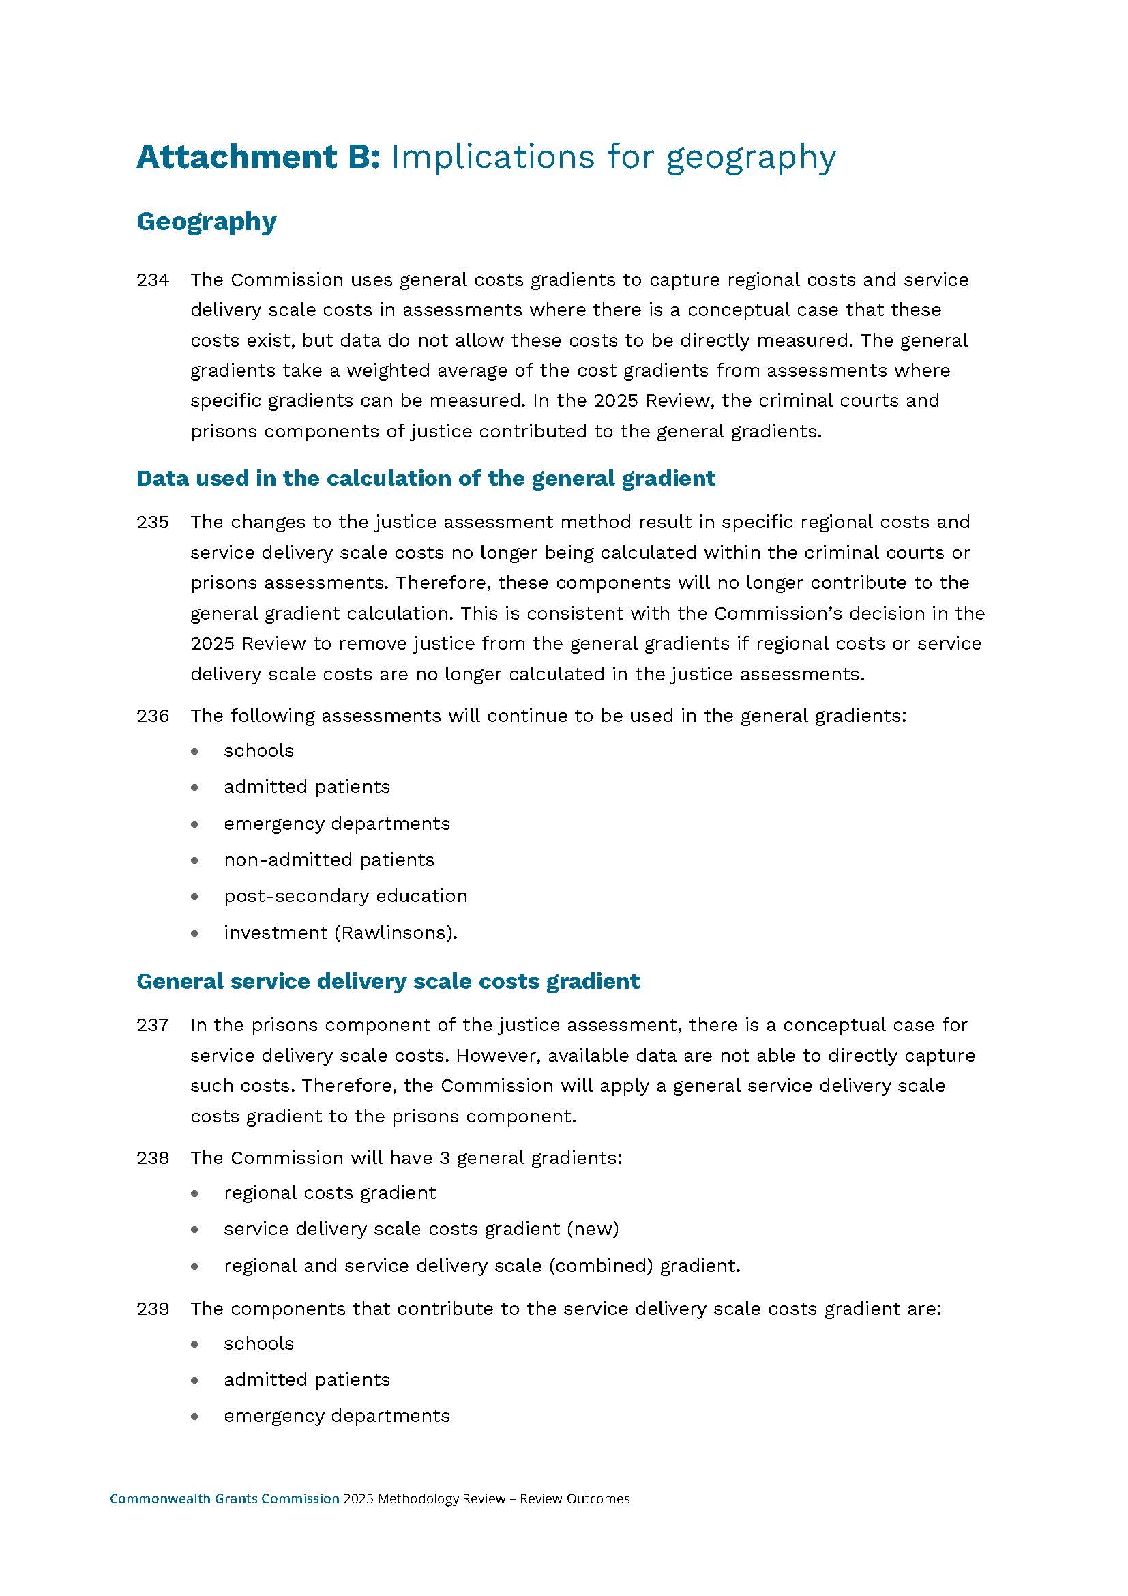
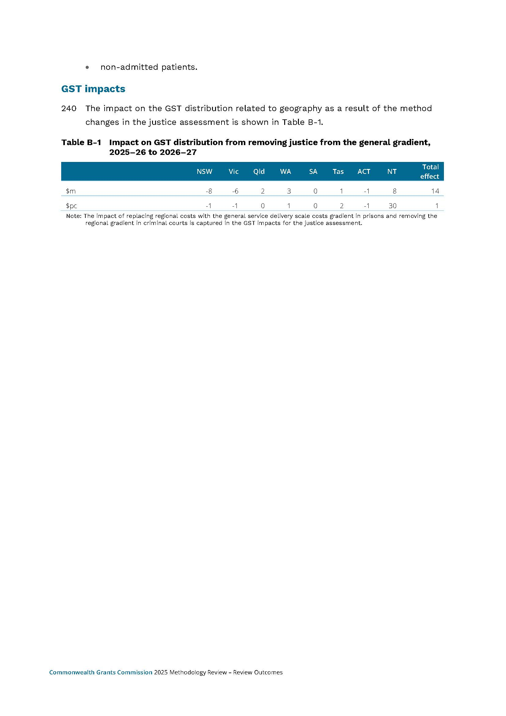

The GST pool is defined in the glossary, which is available on the Commission’s website: www.cgc.gov.au/publications/glossary.
In determining whether a state is worse off under the 2018 GST distribution legislation, consideration is given to the extent to which a state has gained from Commonwealth top-ups to the GST pool.
Commonwealth Grants Commission Act 1973; Federal Financial Relations Act 2009; Treasury Laws Amendment (Making Sure Every State and Territory Gets Their Fair Share of GST) Act 2018.
Extension of the GST No Worse Off Guarantee Agreement, 2024.
Under the Charter of Budget Honesty Act 1998, the 2026–27 Final Budget Outcome must be published no later than 3 months after the end of the financial year, that is by the end of September 2027.
The GST pool consists of revenue from the GST plus a top-up payment from the Commonwealth. See Treasury, Mid-Year Economic and Fiscal Outlook 2025–26, Appendix C, Table C.7.
These estimates are illustrative. Actual no worse off payments for 2026–27 will be calculated by the Commonwealth and will be based on the actual GST pool, pool top-ups and populations for 2026–27, which will be determined after the end of 2026–27.
The police regression coefficients will now be held constant until the next methodology review.
Commonwealth Grants Commission, New Issues in the 2026 Update, 2026.
The user populations used to assess investment needs differ between investment components. For example, the user population for investment in schools is students.
In 2025, the assessment years were 2021–‍22, 2022–‍23 and 2023–24. In 2026, the assessment years are 2022–23, 2023–24 and 2024–25.
The terms used in the paragraph are defined in the glossary, which is available on the CGC website: www.cgc.gov.au/publications/glossary.
For more information on the 2018 GST distribution legislation see: Commonwealth Grants Commission, Occasional Paper No.4: New arrangements for distributing GST, 2023.

