Justice

Overview
The justice assessment has the following components:
- police
- criminal courts
- other legal services
- prisons.
The assessment recognises that justice expense needs are influenced by the following.
- Age — states with a higher proportion of people in the 18–44-year-old age range have higher expense needs.
- Socio-economic status — states with a higher proportion of people from low socio-economic backgrounds have higher expense needs.
- First Nations people — states with a higher proportion of First Nations people have higher expense needs.
- Remoteness — states that provide services in more remote locations have higher expense needs.
- Service delivery scale — states that provide services to dispersed populations through smaller facilities have higher expense needs.
- Wage costs — states facing greater wage cost pressures have higher expense needs.

Actual state expenses
The first step in calculating assessed expenses is identifying actual state expenses. States collectively spent 9.7% of their total recurrent expenses on justice services in 2024–25. Table 1 shows expenses broken down by component and Table 2 outlines actual expenses by state in 2024–25.
Table 1 Justice expenses by component, 2024–25
 | 2024–25
 | $pc | $m
Police | 605 | 16,567
Criminal courts | 128 | 3,506
Other legal services | 119 | 3,247
Prisons | 316 | 8,654
Total | 1,168 | 31,973
Proportion of total expenses (%) |  | 9.7
Table 2 Justice expenses by state, 2024–25
 | NSW | Vic | Qld | WA | SA | Tas | ACT | NT | Total
Justice ($m) | 9,163 | 7,457 | 7,138 | 4,374 | 1,886 | 523 | 463 | 967 | 31,973
Justice ($pc) | 1,073 | 1,064 | 1,270 | 1,453 | 997 | 909 | 963 | 3,685 | 1,168
Proportion of total expenses (%) | 9.5 | 9.0 | 10.5 | 11.5 | 8.5 | 6.4 | 6.4 | 13.1 | 9.7

Structure of assessment
Table 3 outlines the drivers that influence spending needs in each component.
Table 3 Structure of the justice assessment
Component | Driver | Influence measured by driver
Police | Socio-demographic composition | Age, Indigenous status and socio-economic status influence the use and costs of services.
Police | Regional costs | The cost of providing services increases as the level of remoteness increases.
Police | Wage costs | Differences in wage costs between states affect costs.
Criminal courts | Socio-demographic composition | Age, Indigenous status, and socio-economic status influence the use and costs of services.
Criminal courts | Wage costs | Differences in wage costs between states affect costs.
Other legal services | Non-deliberative equal per capita | These expenses are not differentially assessed.
Other legal services | Wage costs | Differences in wage costs between states affect costs.
Prisons | Socio-demographic composition | Age, Indigenous status and socio-economic status influence the use and costs of services.
Prisons | Service delivery scale | Small, dispersed prisons incur additional costs.
Prisons | Wage costs | Differences in wage costs between states affect costs.
Note: This table outlines the Commission’s method for the 2026–27 application year.

Data
The data used in the assessment are outlined in Table 4.
Table 4 Data used in the justice assessment
Source | Data | Updated | Component
States | Police expenses and proceedings by district | 5-yearly during methodology reviews | Police
States | Police proceedings and defendant counts by socio-demographic composition | 5-yearly during methodology reviews | Police and criminal courts
States | Court expenses by component | 5-yearly during methodology reviews | Criminal courts and other legal services
ABS | Police proceedings and offender counts | 5-yearly during methodology reviews | Police
ABS | Geographical data to map state use and cost data into socio-economic status quintiles and/or remoteness areas | 5-yearly during methodology reviews | Police, criminal courts and prisons
ABS | Defendants finalised | 5-yearly during methodology reviews | Criminal courts
ABS | Estimated resident population counts by socio-demographic composition (for use rates) | 5-yearly during methodology reviews | Police and criminal courts
ABS | Estimated resident population counts by socio-demographic composition (for socio-economic status proxy) | 5-yearly during methodology reviews | Prisons
ABS | Estimated resident population | Annually | Other legal services
ABS | Estimated resident population counts by socio-demographic composition (for use rates) | Annually | Prisons
ABS | Estimated resident population counts by socio-demographic composition (for assessed expenses) | Annually | Police, criminal courts and prisons
ABS | Prisoner counts by socio-demographic composition | Annually | Prisons
Productivity Commission – Report on Government Services | Adult prison expenses | Annually | Prisons
Productivity Commission – Report on Government Services | Juvenile detention expenses | Annually | Prisons
Australian Institute of Health and Welfare | Juvenile detainee counts by socio-demographic composition | Annually | Prisons
Note: Data for the wage costs adjustment are also included in this assessment.
The adjusted budget data sources are outlined in the adjusted budget chapter of the Commission’s Assessment Methodology.

Incorporating 2026 Census data
Once available, 2026 Census data will be incorporated into other legal services and prisons components.
The Commission will continue to use 2021 Census-based projections of First Nations estimated residential population until new data on the socio-demographic composition of offenders and defendants are available. These data are used in the police and criminal courts components and are collected 5-yearly from states during a review.

Assessment method
The following section outlines the method for assessing state spending for police, criminal courts, other legal services and prisons. The assessment methods are informed by observed relationships in data provided by the states in the 2025 Review.

Police component
Expenses for this component cover:
- police services
- research and development — public order and safety.
The police assessment is based on the geographic distribution of state populations and the number of assessed offenders in a jurisdiction, with an adjustment for wage costs.
  - The assessment uses a regression model to estimate the national average cost for policing activities associated with:
- offenders — this is a national average per offender policing cost
- regional cost of policing — this is a per capita policing cost weight for each remoteness area, with remote and very remote areas aggregated. These cost weights are not dependent on offender numbers (it includes all costs not already captured in the national offender cost weight described above).
The cost estimates produced in the regression inform the offender and regional cost weights. The offender cost weight is applied to the number of assessed offenders in each state, while the regional cost weights are applied to the population in each remoteness area (see Figure 1).
Figure 1 Overview of the method for estimating police costs in the police regression
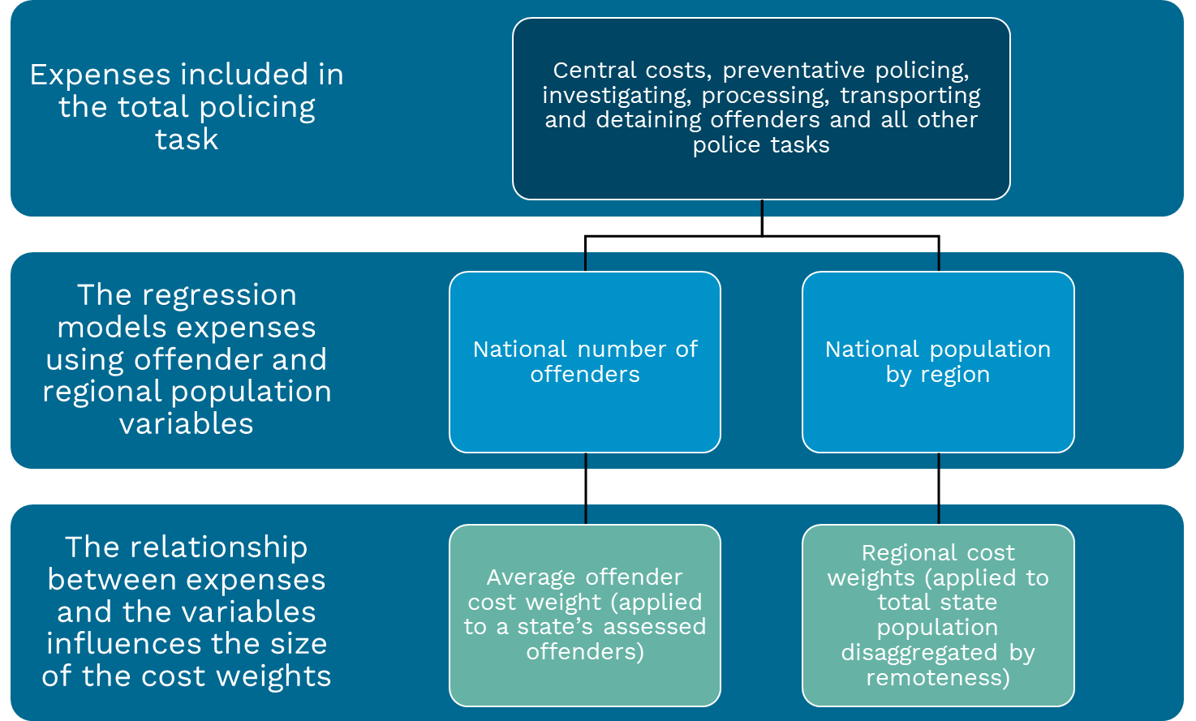
Note: Expenses and offender numbers come from state-provided data. Population comes from ABS data. State-provided proceedings are scaled to total proceedings estimated using ABS data. Expenses are also scaled to state totals in ABS’ Government Finance Statistics.

Step 1 – map state data
To inform the regression, the Commission uses a combination of state and ABS data. State data on expenditure, proceedings numbers by police district and full-time equivalent staff by police district are mapped to ABS standard geographies and population data to determine the number of residents and a regional specification for each district.
A similar process is used to assign a socio-economic status to offenders by socio-demographic composition in state proceedings data. These data are used to calculate offender use rates.

Step 2 – allocate central costs
State data on central costs are allocated to relevant police districts through a method that allocates the costs equally between shares of initial district expenses and full-time equivalent staff by police district.
Figure 2 demonstrates a simplified example of $1 million of central costs being allocated to 3 police districts. District A has $1 million in district costs and 200 full-time equivalent staff, B has district costs of $1 million and 400 full-time equivalent staff, while C has district costs of $3 million and 400 full-time equivalent staff.
The $1 million of central costs are first equally split between the 2 approaches, with $500,000 being determined by the shares of full-time equivalent staff and $500,000 being determined by shares of total district expenses. As an example, District B has 40% of all full-time equivalent staff so it will receive $200,000 ($500,000 × 0.4). As it has 20% of all district expenses District B will receive $100,000 ($500,00 × 0.2). The $300,000 total central costs that District B will receive from these 2 approaches are then added to the total district costs in District B, giving a final cost for District B of $1,300,000.
Figure 2 Allocating the costs of a central function to relevant police districts by shares of FTE (a) and police district costs
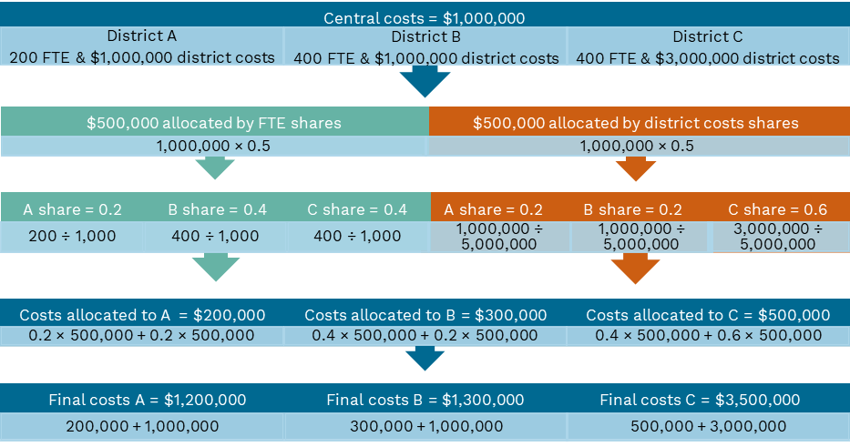
Note: Worked example based on hypothetical data.
- FTE refers to full-time equivalent staff.

Step 3 – derive offender and regional cost weights
To improve comparability and robustness, state data on proceedings numbers and expenses are scaled to reconcile with ABS data on police proceedings and expenditure. Rescaled expenses, proceedings and the population within each remoteness area are divided by the total population of each police district to obtain per capita measures required for the functional form of the regression.

Table 5 shows the cost weights produced in the 2025 Review.
Table 5 Police regression cost weights using 2022–23 and 2023–24 data
Description | Cost weight
Offender cost weight | 38.4
Regional cost weights
People living in major cities | 1.0
People living in inner regional areas | 1.6
People living in outer regional areas | 2.1
People living in remote areas | 5.7
People living in very remote areas | 5.7
Note: Cost weights presented in this table are rounded to one decimal place. Cost weights will be held constant until the next review.

Step 4 – derive offender use rates
State proceedings data are used to determine the socio-demographic composition profile of offenders. The socio-demographic composition sub-groups include a cross-classification of Indigenous status, age and socioeconomic status. In total, there are 50 socio-demographic composition sub-groups used in the police assessment. The characteristics of these sub-groups are shown in Table 6.
Table 6 Socio-demographic composition sub-groups for the police assessment
Offenders
Indigenous status | Age | Socio-economic status ^{(a)}
First Nations | 0-17 | Most disadvantaged (20%)
Non-Indigenous | 18-24 | 2nd most disadvantaged (20%)
 | 25-44 | Middle quintile (20%)
 | 45-64 | 2nd least disadvantaged (20%)
 | 65+ | Least disadvantaged (20%)
(a) An offender’s Indigenous status determines the socio-economic status index the Commission will apply. For First Nations offenders, the Commission uses the Indigenous Relative Socioeconomic Outcomes index. For non-Indigenous offenders, the Commission uses the non-Indigenous Socio-Economic Indexes for Areas index.
Once state proceeding numbers are assigned to each of the sub-groups, the number of proceedings from each state are scaled to ABS proceedings numbers to improve comparability of the data. During this process, the proportions of proceedings from each of the sub-groups are held constant.
The national average offender rate for each sub-group is then calculated as the proportion of each of the 50 sub-groups who are offenders.

Step 5 – apply cost weights

Offenders
To reflect that the number of offenders impacts the cost of the policing task, the offender cost weight is applied to assessed offenders in each state. The number of assessed offenders is derived by applying the national average offender rate for a given socio-demographic sub-population to a state’s share of such populations.
Figure 3 outlines the process for calculating assessed offender expenses for a single socio-demographic composition sub-group. This process is repeated for each of the 50 sub-groups described above with the results summed to derive assessed cost-weighted offenders for each state.
Figure 3 Method for calculating a state’s assessed cost-weighted offenders for a single socio-demographic composition sub-group

Note: Worked example based on hypothetical data.

Regional populations
To reflect that spending on the policing task increases as a state’s population becomes more remote, regional cost weights are applied directly to state populations in each remoteness area.
Table 7 illustrates how a state’s assessed regional population is calculated.
Table 7 Calculating assessed regional populations
Remoteness | Population | Cost weight | Assessed population
 | No. |  | No.
Major cities | 6,000,000 | 1.0 | 6,000,000
Inner regional | 1,700,000 | 1.6 | 2,796,139
Outer regional | 380,000 | 2.1 | 809,302
Remote | 30,000 | 5.7 | 170,825
Very Remote | 9,000 | 5.7 | 51,248
Total | 8,119,000 |  | 9,827,513
Note: Worked example based on hypothetical data. Cost weights presented in this table are rounded to one decimal place. The calculated assessed population reflects the use of unrounded cost weights.

Step 6 – derive assessed police expenses
The cost-weighted assessed offenders and populations are combined. To calculate a state’s assessed police expenses, total police expenses are multiplied by the state’s share of assessed populations. See Figure 4 for a worked example.
Figure 4 Method for calculating assessed police expenses

Note: Worked example based on hypothetical data.

Step 7 – apply wage costs
Wage costs are a significant share of the total cost of providing police services. Differences in wage costs between states have a differential effect on the cost of providing police services. The police assessment uses the Commission’s general method for measuring the influence of wage costs. Details on how this is calculated are in the wage costs chapter of the Commission’s Assessment Methodology.
As a final step, expenses are rescaled to total police expenses, giving final assessed expenses.

Criminal courts component
Expenses for this component cover:
- criminal courts
- public prosecution
- legal aid related to defendants in criminal courts
- other legal services associated with criminal courts.
The criminal courts assessment is based on a socio-demographic composition assessment of the number of finalised defendants with adjustments for wage costs.

Step 1 – calculate criminal court expenses
To calculate the total component expenses, the Commission uses state-provided data to determine the proportions of legal expenses that are related to criminal courts or other legal services. These proportions are used to split ABS Government Finance Statistics courts data into criminal court and other legal services expenses. This split assigns 51% of total court expenses in Government Finance Statistics to the criminal courts component.

Step 2 – derive defendant use rates
State data are used to determine the socio-demographic composition profile of defendants. The socio-demographic composition sub-groups include a cross-classification of Indigenous status, age and socio-economic status. There are 50 socio-demographic composition sub-groups used in the criminal courts assessment. The characteristics of these sub-groups are shown in Table 8.
Table 8 Socio-demographic composition sub-groups for the criminal courts assessment
Defendants
Indigenous status | Age | Socio-economic status^{(a)}
First Nations | 0-17 | Most disadvantaged (20%)
Non-Indigenous | 18-24 | 2nd most disadvantaged (20%)
 | 25-44 | Middle quintile (20%)
 | 45-64 | 2nd least disadvantaged (20%)
 | 65+ | Least disadvantaged (20%)
(a) An offender’s Indigenous status determines the socio-economic status index the Commission will apply. For First Nations offenders, the Commission uses the Indigenous Relative Socioeconomic Outcomes index. For non-Indigenous offenders, the Commission uses the non-Indigenous Socio-Economic Indexes for Areas index.
Note: Defendants with a non-stated Indigenous status are attributed a status based on the Indigenous status proportions of stated responses. Defendants with an unknown age or socio-economic status are not assigned to a sub-group. In effect, this treatment weights these defendants in proportion to the known characteristics of defendants.
Once state defendant numbers are assigned to each of the sub-groups, the number of defendants from each state is scaled to ABS defendant numbers to improve comparability of the data. During this process, the proportions of defendants from each of the sub-groups are held constant.
The national average defendant rate for each sub-group is then calculated as the proportion of each of the 50 sub-groups who are finalised defendants.

Step 3 – calculate assessed defendants
The number of assessed defendants is derived by applying the national average defendant rate for each of the socio-demographic composition sub-groups to that population in each state. Figure 3 provides a worked example of a similar process in the police component.
To ensure comparability of data, the courts assessment uses an estimated residential population that preserves the Indigenous status proportions reported in the 2021 Census.
Criminal court expenses for each state are assessed by multiplying its share of assessed defendants by total state expenditure. See Figure 4 for a worked example of a similar process in the police component.

Step 4 – apply wage cost factor
Wage costs are a significant share of the total cost of providing criminal court services. Differences in wage costs between states have a differential effect on the cost of providing criminal court services. The criminal courts assessment uses the Commission’s general method for measuring the influence of wage costs. Details on how this is calculated are in the wage costs chapter of the Commission’s Assessment Methodology.
As a final step, expenses are rescaled to total criminal court expenses, giving final assessed expenses.

Other legal services component
Other legal services is a non-deliberative equal per capita assessment with an adjustment for wage costs. The other legal services component includes court and legal expenses not captured in the criminal courts component.
Expenses for the other legal services component are those legal services not associated with the prosecution or defence of criminal legal cases. This covers a wide range of functions including:
- civil courts
- crown solicitors
- law reform commissions.

Step 1 – calculate other legal services expenses
To calculate the total component expenses, the Commission uses state-provided data to determine the proportions of legal expenses that are related to criminal courts or other legal services. These proportions are used to split ABS Government Finance Statistics courts data into criminal court and other legal services expenses. This split assigns 49% of total court expenses in Government Finance Statistics to the other legal services component.

Step 2 – calculate population share of expenses
Other legal services expenses for each state are assessed as its population share of the total state expenditure.

Step 3 – apply wage cost factor
Wage costs are a significant share of the total cost of providing other legal services. Differences in wage costs between states affect the cost of providing other legal services. The other legal services assessment uses the Commission’s general method for measuring the influence of wage costs. Details on how this is calculated are in the wage costs chapter of the Commission’s Assessment Methodology.
As a final step, expenses are rescaled to total other legal services expenses, giving final assessed expenses.

Prisons component
The prisons assessment is based on the number of assessed prisoners in a jurisdiction, with adjustments for service delivery scale, juvenile detainees and wage costs.
Expenses within the prisons component cover:
- prisons
- juvenile detention
- community corrections expenses such as supervision of bail, parole or home detention, program participation and community work orders.

Step 1 – derive prisoner use rates
The Commission uses ABS data on prisoners and Australian Institute of Health and Welfare data on juvenile detainees to determine the socio-demographic composition of prisoners. The socio-‍demographic groups used in the prisons component are the same as in the criminal courts component and are outlined in Table 8.
The Commission imputes prisoner socio-economic status using the socio-economic status of defendants. Data are not available to directly measure socio-economic status for prisoners.
The national average prisoner rate for each population sub-group is then calculated as the proportion of each of the 50 socio-demographic composition sub-groups who are prisoners.

Step 2 – calculate assessed prisoners
Although prisoner rates are not differentially assessed by remoteness areas, the rates for the 50 sub-groups are applied to 250 distinct population sub-groups (cross-classified by remoteness) for each state. Cross-classifying assessed prisoners by remoteness areas allows for the service delivery scale costs gradient to be applied. Figure 3 provides a worked example of a similar process in the police component.

Step 3 – apply service delivery scale costs gradient
A service delivery scale adjustment is applied to recognise the fixed costs associated with maintaining smaller, isolated prisons in remote areas. The Commission uses the general service delivery scale costs gradient (shown in Table 9), which is derived from service delivery scale costs gradients used in other assessments.
Table 9 General service delivery scale costs gradient, 2024–25
Remoteness | Cost weights
Major cities | 1.00
Inner regional | 1.04
Outer regional | 1.07
Remote | 1.09
Very remote | 1.20
Note: This table presents the costs weights for 2024–25. Cost weights are calculated annually for each assessment year and applied to the assessed prisoners of each assessment year.
To calculate a state’s weighted assessed prisoners, the cost weights derived from the general service delivery scale costs gradient are applied to the number of assessed prisoners in each remoteness area. As the general service delivery scale costs gradient is re-calculated annually, the cost weights applied to the assessed prisoners of each assessment year are different.

Step 4 – calculate juvenile detainee cost weights
The Commission uses Report on Government Services youth detention expense data and Australian Institute of Health and Welfare juvenile detainee data to determine the national average cost per juvenile detainee for each assessment year. It also uses Report on Government Services data on corrective services expenditure and ABS data on prisoner numbers to obtain the national average cost per adult prisoner by assessment year.
The juvenile detainee cost weight is calculated as the cost per juvenile detainee divided by the cost per adult prisoner. A cost weight is calculated for each assessment year.

Step 5 – apply juvenile detainee cost weights
The juvenile detainee cost weight is applied to weighted assessed prisoners in the 0–‍17 age group, giving the final weighted assessed prisoners.
A state’s expenses are calculated as its share of final weighted assessed prisoners multiplied by the total state prison expenses. See Figure 4 for a worked example of a similar process in the police component.

Step 6 – apply wage costs
Wage costs are a significant share of the total cost of providing prison services. Differences in wage costs between states have a differential effect on the cost of providing prison services. The prisons assessment uses the Commission’s general method for measuring the influence of wage costs. Details on how this is calculated are in the wage costs chapter of the Commission’s Assessment Methodology.
Expenses are then rescaled to total prison expenses, giving final assessed expenses.

GST distribution in the 2026 Update
Table 10 shows the GST impact of the assessment in the 2026 Update.
Table 10 GST impact of the justice assessment, 2026–27
 | NSW | Vic | Qld | WA | SA | Tas | ACT | NT | Total effect
 | $m | $m | $m | $m | $m | $m | $m | $m | $m
Police | -170 | -651 | 272 | 146 | -5 | 124 | -80 | 364 | 906
Criminal courts | 24 | -169 | 55 | 16 | -4 | 12 | -21 | 87 | 194
Other legal services | 6 | 2 | -6 | 5 | -7 | -2 | 3 | 0 | 15
Prisons | 22 | -692 | 241 | 101 | -33 | 41 | -59 | 380 | 785
Total ($m) | -119 | -1,511 | 563 | 268 | -49 | 175 | -157 | 831 | 1,836
Total ($pc) | -14 | -209 | 97 | 86 | -25 | 303 | -318 | 3,091 | 65
Note: Magnitude and direction of GST impact can change from year to year.

Adjusted budget calculations use ABS Government Finance Statistics data to determine actual state expenses. For further details see the adjusted budget chapter of the Commission’s Assessment Methodology. Note: the updated justice chapter in the Commission’s Assessment Methodology was released in March 2026.
The Commission estimates the use rates of offenders and defendants as the proportion of offenders and defendants by different socio-demographic groups based on state use data and ABS’ estimated resident population of the same years (see step 4 of police). New census data can capture large non-demographic changes in the number of First Nations people as was the case in the 2021 Census. However, the 5-yearly state use data would not reflect this change until they are updated.
Costs associated with higher cost offenders (those who cost more than the national offender cost weight) are also reflected in the regional cost weights.
The Commission uses ABS’ count of police proceedings as its count of offenders.
Central costs allocated by states to regions that contain multiple police district are allocated within that region using this method. Central costs recorded in specific districts are retained in the district.
2021 First Nations Census-based estimates will be used until new proceedings data are available in the next review.
The Commission uses the ABS’ definition of a finalised defendant in the assessment: ‘A person or organisation for whom all charges within a case have been formally completed so that they cease to be an active item of work for the court during the reference period’. ABS, Criminal Courts, Australia methodology, 2023-24, ABS website, 2024, accessed 24 May 2024.
This split will be held constant until the next review.
The list of assessments contributing to the general service delivery costs gradient can be found in Attachment B of the Addendum to Review Outcomes - Justice.

