Transport

Overview
The transport assessment covers state and territory (state) expenses on urban and non-urban public transport services. It has the following components:
- urban transport
- non-urban transport.
The assessment recognises that transport expense needs are influenced by the following.
- Demand — urban centres with above-average population-weighted density have higher demand for public transport, which results in higher spending needs.
- Supply — the population of an urban centre and the presence of heavy rail influence the supply of public transport services. Passenger numbers (heavy rail, bus and light rail) are used to measure the amount of public transport provided in an urban centre. Urban centres with higher passenger numbers need to provide more public transport and have higher spending needs.
- Presence of transport modes — urban centres that require ferry services have higher spending needs.
- Topography — urban areas with greater slope have higher spending needs.
- Network complexity — urban centres with greater road travel distances have higher spending needs.
- Wage costs — states facing higher cost pressures have higher spending needs.
- Regional costs — the cost of providing services increases as the level of remoteness increases.

Actual state expenses
  - The first step in calculating assessed expenses is identifying actual state expenses. States collectively spent 5.7% of their total recurrent expenses on public transport in 2022–23. Table 1 shows expenses broken down by component and Table 2 shows actual expenses by state.
Table 1 Transport expenses by component, 2022–23
 | 2022-23
 | $pc | $m
Urban transport | 604 | 15,899
Non-urban transport | 65 | 1,700
Total | 669 | 17,599
Proportion of total expenses (%) |  | 5.7
Table 2 Transport expenses by state, 2022–23
 | NSW | Vic | Qld | WA | SA | Tas | ACT | NT | Total
Transport ($m) | 7,527 | 4,594 | 2,827 | 1,536 | 744 | 107 | 222 | 41 | 17,599
Transport ($pc) | 913 | 684 | 525 | 542 | 405 | 187 | 482 | 165 | 669
Proportion of total expenses (%) | 7.6 | 5.8 | 4.8 | 4.5 | 4.0 | 1.5 | 3.5 | 0.7 | 5.7

Structure of assessment
  - The transport assessment comprises 2 components: urban and non-urban transport. Table 3 outlines the drivers that influence spending needs in each component.
Table 3 Structure of the transport assessment
Component |  | Driver | Influence measured by driver
Urban transport |  | Urban centre characteristics | Population-weighted density, use and presence of public transport modes, distance to work and topography influence the use and cost of services.
Urban transport |  | Urban population | Urban transport services vary by the share of the state population living in urban areas.
Urban transport |  | Wage costs | Differences in wage costs between states affect costs.
Non-urban transport |  | Equal per capita | Population drives the use and cost of services.
Non-urban transport |  | Wage costs | Differences in wage costs between states affect costs.
 |  | Regional costs | The cost of providing services increases as the level of remoteness increases.

Data
  - The data used in the assessment are outlined in Table 4.
Table 4 Data used in the transport assessment
Source | Data | Update |  |  | Component
Source | Data | Regression | Variables applied to coefficients | Other | Component
States | Net expense data | 5 yearly during methodology reviews |  |  | Urban transport
Geoscience Australia | Significant Urban Area slope | 5 yearly during methodology reviews | Each census |  | Urban transport
Bureau of Infrastructure and Transport Research Economics | Kilometres travelled | 5 yearly during methodology reviews | Annually, until 2026 Census data are available |  | Urban transport
ABS | Significant Urban Area and Urban Centre and Locality classifications | 5 yearly during methodology reviews | Each census |  | Urban transport
ABS | Census journey to work data (method of travel to work) | 5 yearly during methodology reviews | Each census |  | Urban transport
ABS | Square kilometre population | 5 yearly during methodology reviews | Annually^{(a)} |  | Urban transport
ABS | Census journey to work (distance to work) | 5 yearly during methodology reviews | Each census |  | Urban transport
ABS | Significant Urban Area population data |  | Annually |  | Urban transport
 | State population data |  |  | Annually | Urban and Non-urban transport
- Population-weighted density is lagged by one year. This is because ABS population data for the square kilometre grid are not available until late March.
Note: Data for the wage costs adjustment are also included in this assessment.
The adjusted budget data sources are outlined in the adjusted budget chapter of the Commission’s Assessment Methodology

Assessment method
  - The urban transport component uses a regression-based approach reflecting the conceptual drivers of urban transport costs. This is blended with state shares of urban populations.
  - The non-urban transport component is assessed using a state’s population share (equal per capita).
  - For both components, a wage cost adjustment is made to reflect differences in wage costs across states.
  - For the non-urban transport component, an additional regional cost adjustment is made to reflect the higher cost of providing transport services in remote areas.
  - For more information about these adjustments, refer to the wage costs and geography chapters of the Commission’s Assessment Methodology.
  - Figure 1 presents a stylised flow diagram of the transport assessment.
Figure 1 Stylised representation of the transport assessment
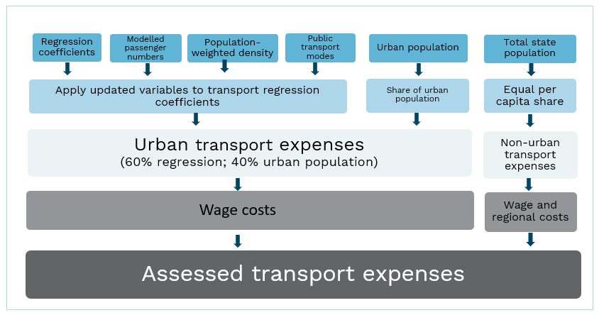

Urban transport
  - Figure 2 shows the method used to assess urban transport expenses in each state.
Figure 2 Urban transport component assessment (recurrent)
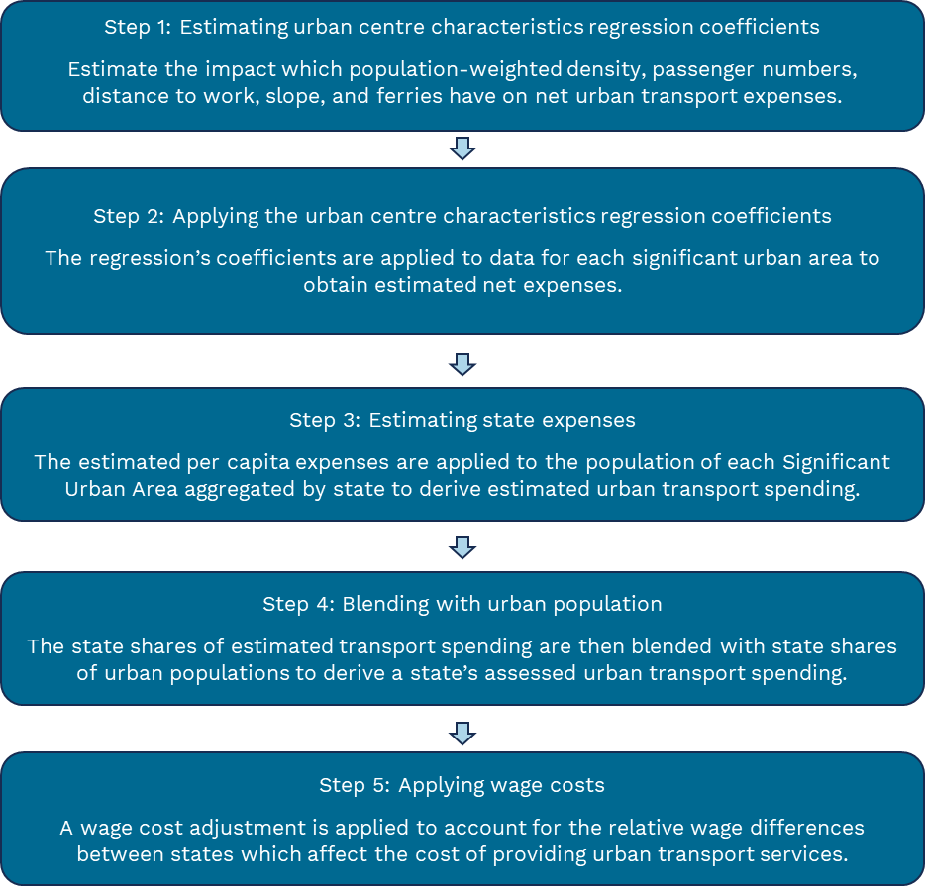

Urban centre characteristics

Step 1 - Estimating urban centre characteristics regression coefficients
  - The Commission uses a regression model to calculate the net per capita costs of providing public transport in an urban area. The regression model allows the Commission to estimate the impact of urban centre characteristics on net per capita spending on urban transport.
  - Expenses and urban characteristics are assessed based on Significant Urban Areas, defined by the ABS as urban areas with a population above 10,000 (see Attachment A).

Conceptual drivers of urban transport spending
  - The variables selected for use in the regression model are based on the conceptual drivers of urban transport spending. They are: demand for urban transport, supply of urban transport services, network complexity, topography and the presence of transport modes. To capture these characteristics, proxy variables are used.

Proxy variables to capture drivers of urban transport spending
  - Figure 3 shows the proxy variables used to capture drivers.
Figure 3 Urban centre characteristics recognised in the transport regression model and the explanatory variables used to represent them
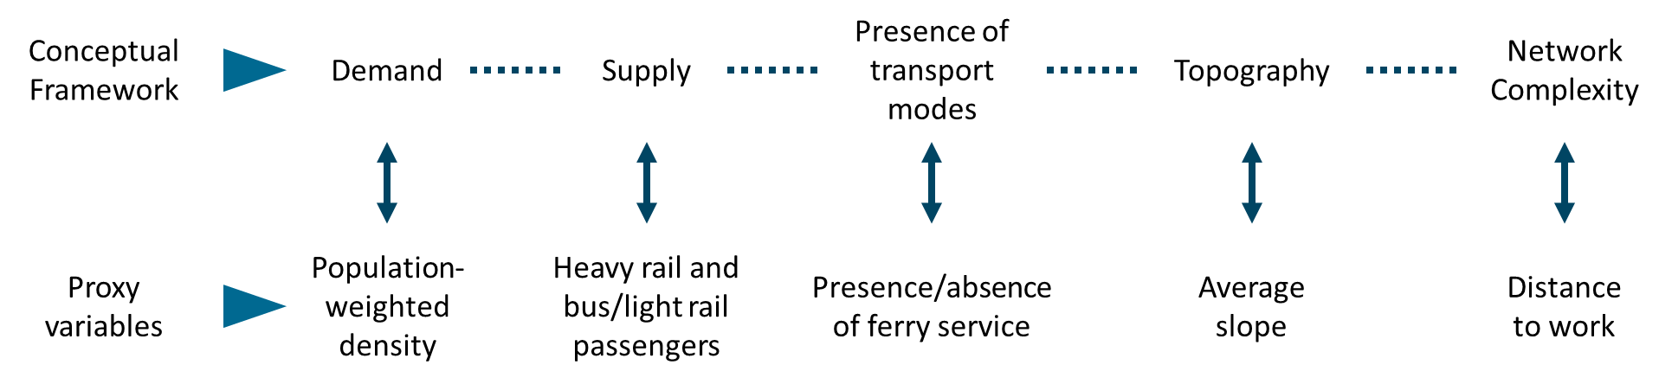
  - Demand is captured by population-weighted density. Higher density is associated with an increase in congestion on public roads, and a greater reliance on public transport. This higher demand for public transport necessitates the use of more frequent or higher capacity public transport services, which raises net expenses.
  - Supply is captured by heavy rail passenger numbers and bus and light rail passenger numbers. Heavy rail accounts for high-capacity public transport, while bus and light rail services account for low-capacity public transport. This recognises that once cities become sufficiently large, heavy rail networks are unavoidable. Bus and light rail passengers are combined into a single measure as they are substitute forms of transport.
  - Presence of transport modes is represented by a ferry dummy variable to ensure the model captures all transport modes.
  - Topography is captured by slope. Slope reflects differences in the topographic features of urban areas, which can influence transport spending.
  - Network complexity is captured by distance to work. It reflects increased costs associated with the greater complexity of transport networks. As urban cities extend, the complexity of individual trips increases, often requiring multi-modal interchanges and routes.

How variables are measured for use in the urban centre characteristics regression
  - Variables are derived for all urban areas across Australia. The assessment uses the ABS definition of an urban centre, Urban Centres and Localities contained within Significant Urban Areas. See Attachment A for more details on the specification of urban areas and methods described below.
  - Population-weighted density (${density}_{i}$). First, the population density of cells in the square kilometre grid within an urban area is calculated. The density of the cells is then weighted by their share of the urban area population. For example, if a cell has a density of 100 and a population share of 0.1, its contribution to population-weighted density is 10. The population-weighted density contribution of all cells are then combined to derive the population-weighted density of an urban area.
  - Actual passenger numbers (${pax}_{i, B+LR}$) (${pax}_{i, HR}$). Passenger numbers are estimated for bus and light rail and heavy rail separately. Use rates for each mode are calculated by taking commuter use as a proportion of total urban area population. Commuter numbers are used as they reflect peak load on urban transport systems. Use rates are multiplied by the urban area populations to obtain actual passenger numbers. For example, if a third of commuters use heavy rail, heavy rail passenger numbers are estimated to equal one third of the urban area population. To account for economies of scale in public transport provision, the log of actual passenger numbers is used.
  - Use rates are then indexed using Bureau of Infrastructure and Transport Research Economics data on passenger kilometres travelled. This adjustment will be removed if 2026 Census commuter data are incorporated into the assessment.
  - Distance to work (${dist}_{i}$). Distance to work is calculated as the shortest distance between an individual’s residence and their place of work.
  - Slope (${slope}_{i}$). First, the average slope of Urban Centres and Localities is derived using data from Geoscience Australia. The slope of these Urban Centres and Localities are then weighted by their share of the total area of a Significant Urban Area. The weighted values for the Urban Centres and Localities with the urban area are combined to calculate the average slope of the area.
  - Presence of a ferry service (${ferry}_{i}$). An urban area is identified as having a ferry service if it has a ferry service that operates wholly within the urban area.

Running the urban centre characteristics regression
  - The regression model can be specified as:
$${net exp}_{i}=β_{0}+β_{1}{density}_{i}+β_{2}ln({pax}_{i, HR})+β_{3}ln({pax}_{i, B+LR})+β_{4}{dist}_{i}+β_{5}{slope}_{i}+β_{6}{ferry}_{i}$$
  - The regression coefficients applied in the 2025 Review are provided in Table 5.
Table 5 Urban characteristics regression results, 2022–23
Variable | Coefficient
 | ($ per capita)
Intercept | -197.22
Population-weighted density | 0.16
Heavy rail passengers (logged) | 9.08
Bus and light rail passengers (logged) | 10.74
Median distance to work | 2.08
Average slope | 12.51
Ferry dummy variable | 40.45
Note: The urban transport regression uses net expense data from 2022–23.
Note: 80 urban areas with available data were used to estimate the regression.
Note

  - The regression estimates the impact of urban characteristics on the net per capita expenses in an urban area. For example, as Table 5 shows, an additional person per square kilometre in an urban area increases public transport demand and results in an additional cost of $0.16 per person.
  - 2022–23 state net expense data for each urban area are used to estimate costs associated with the drivers of need identified above. For some smaller urban areas, a minimum cost of $20 per capita is applied to account for the fixed costs associated with transport services.

Step 2 - Applying the urban centre characteristics regression coefficients
  - To obtain spending estimates, the regression coefficients are applied to the characteristics for each individual Significant Urban Area.
  - For some variables, annual data can be used to account for the changing nature of urban areas, while other variables will remain fixed until new data become available. Table 6 outlines when variables are updated and the corresponding methods.

Table 6 Updating variables applied to the regression coefficients
Variable | Updated | Method
Population-weighted density | Annually^{(a)} | Same method used in the regression
Passenger numbers | Annually | Modelled passenger numbers, indexed by BITRE (see below)
Distance to work | When new census data become available | Same method used in the regression
Slope | When new census data become available | Same method used in the regression
Ferry | When new urban ferry services begin or existing ferry services cease | Urban areas included as required
- Population-weighted density is lagged by one year. This is because ABS population data for the square kilometre grid is not available until late March.
  - The urban areas to which the regression variables are applied will be updated following the release of the next Australian Statistical Geography Standard (expected in the 2028 Update).

Modelling passenger numbers
  - To remove the potential influence of policy decisions which can affect public transport use, passenger numbers are modelled using a separate regression model. The regression model assumes there is a constant relationship between the percentage growth in urban populations (${pop}_{i}$) and the percentage growth in total passenger numbers (${pax}_{i}$). This is captured by using the logarithm of both variables in the regression. The presence of rail is represented as a dummy variable (${train}_{i}$), recognising the need for high-capacity public transport where passenger numbers are very high.
  - This model can be specified as:
$$ln\left({pax}_{i}\right)=β_{0}+ β_{1}ln\left({pop}_{i}\right) + β_{2}{train}_{i}$$
  - Consistent with the method used for estimating actual passenger numbers in the regression, Bureau of Infrastructure and Transport Research Economics data are used to index pre-pandemic data until 2026 Census data are available.

Step 3 - Estimating state expenses
  - Following application of the regression model the estimated per capita expenses for each urban area are multiplied by its population to obtain total net expenses. These expenses are aggregated by state to obtain total state net expenses.

Step 4 - Blending with urban population
  - The net expenses derived using the urban centre characteristics regression model are blended with state shares of urban populations.

  - A blending ratio of 60:40 (urban centre characteristics regression model to urban population shares) will be applied to the recurrent transport assessment in the 2026 Update. When 2026 Census commuter data are incorporated in the method for modelling passenger numbers. the blending ratio will be reduced by 10 percentage points.
  - Table 7 shows the relative shares of Significant Urban Area populations.
Table 7 State shares of urban populations, 2022–23
 | NSW | Vic | Qld | WA | SA | Tas | ACT | NT | Total
 | % | % | % | % | % | % | % | % | %
Urban population share | 31.5 | 26.2 | 20.0 | 11.1 | 6.8 | 1.7 | 2.1 | 0.7 | 100

Step 5 - Applying wage costs
Wage costs are a significant share of the total cost of providing urban transport services. Differences in wage costs between states affect the cost of providing urban transport services. The urban transport assessment uses the Commission’s general method for measuring the influence of wage costs. Details on how this is calculated are in the wage costs chapter of the Commission’s Assessment Methodology.
Expenses are then rescaled again to total urban transport expenses, giving final assessed expenses.

Non-urban transport
  - The non-urban transport assessment is based on state populations to recognise that people in urban and non-urban areas utilise non-urban transport services.
  - There are also adjustments for wages and regional costs (see Table 8).
Table 8 Non-urban transport, 2022–23
 | NSW | Vic | Qld | WA | SA | Tas | ACT | NT | Total
Equal per capital share | 533 | 434 | 348 | 183 | 119 | 37 | 30 | 16 | 1,700
Wage cost adjustment | -2 | -2 | 1 | 1 | 0 | 0 | 0 | 2 | 0
Regional cost adjustment | 2 | 0 | -2 | 1 | -1 | -1 | 1 | 0 | 0
Assessed expenses | 533 | 432 | 347 | 185 | 118 | 37 | 30 | 18 | 1,700

Transport investment

Urban transport
  - The urban centre characteristics regression model used in the assessment of urban transport recurrent expenses is also used in the urban transport investment assessment.
  - The urban centre characteristics regression model is blended with urban population-squared at a ratio of 70:30. Unlike urban population in the recurrent assessment, population-squared is not used to account for data limitations in the model. It is used to recognise the linear relationship between assets per capita and urban transport asset needs. This suggests that, compared with recurrent costs, infrastructure costs grow at a faster rate as population increases.

Non-urban transport
  - Investment in non-urban transport is distributed based on state populations.

GST distribution in the 2026 Update
Table 9 shows the GST impact of the recurrent transport assessment in the 2026 Update.
Table 9 GST impact of the transport assessment, 2026–27
 | NSW | Vic | Qld | WA | SA | Tas | ACT | NT | Total effect
 | $m | $m | $m | $m | $m | $m | $m | $m | $m
Urban transport | 1,018 | 524 | -707 | -188 | -283 | -213 | -47 | -105 | 1,542
Non-urban transport | -1 | -2 | 0 | 3 | -2 | 0 | 0 | 2 | 6
Total ($m) | 1,017 | 522 | -707 | -185 | -284 | -213 | -46 | -103 | 1,539
Total ($pc) | 116 | 72 | -122 | -59 | -148 | -369 | -93 | -383 | 55
Note: Magnitude and direction of GST impact can change from year to year.

Attachment A

Regression — urban centre characteristics
In the 2020 Review the Commission engaged a consultants, Jacobs and Synergies economic consulting, to identify a measure of urban transport needs. The model proposed by the consultants and adopted by the Commission identifies the effect of urban centre characteristics on the level of net per capita expenses.
The model of urban transport characteristics is specified below.
$${net exp}_{i}=β_{0}+β_{1}{density}_{i}+β_{2}ln⁡({pax}_{i, HR})+β_{3}ln({pax}_{i, B+LR})+β_{4}{dist}_{i}+β_{5}{slope}_{i}+β_{6}{ferry}_{i}$$
Where ${net exp}_{i}$ is net per capita state expenses on public transport by urban centres.
- Population-weighted density (${density}_{i}$) is a proxy used to represent demand for public transport. It is calculated as the sum of density of each square kilometre grid in all Urban Centres and Localities within a Significant Urban Area weighted by the grid’s population share of the Urban Centres and Localities in the Significant Urban Area.
- Median commuter distance to work (${dist}_{i}$) is a proxy representing network complexity. It is derived using 2021 Census data on the distance travelled (shortest path of the road network) between an individual’s usual residence and place of work.
- Mean land slope (${slope}_{i}$) represents the topography of urban centres, as measured by the average mean slope of the urban areas. The data was generated from a spatial analysis process developed by Geoscience Australia.
- The natural logarithm of passenger numbers by public transport mode $({pax}_{i,HR}$ and ${pax}_{i,B+LR}$) is a proxy which accounts for the supply of public transport. Heavy rail passengers are considered separately from bus and light rail passengers.
- A dummy variable is included to control for the presence or absence of ferry services as a mode of transport (${ferry}_{i}$).
Table A-1 shows the coefficients applied in the 2025 Review.
Table A-1 Urban centre characteristics – regression coefficients, 2025 Review
Variable | Coefficient | Standard error | Significance | P value
 | ($ per capita)
Intercept | -197.22 | 41.51 | <0.001 | 0.00001
Population-weighted density | 0.16 | 0.03 | <0.001 | 0.00001
Heavy rail passengers (logged) | 9.08 | 4.82 | <0.1 | 0.0636
Bus & light rail passengers (logged) | 10.74 | 8.03 |  | 0.1852
Median distance to work | 2.08 | 3.67 |  | 0.5733
Average slope | 12.51 | 5.98 | <0.05 | 0.0400
Ferry dummy variable | 40.45 | 46.76 |  | 0.3898
Note: The level of significance is only shown for variables which have a p-value less than 0.1 (they are statistically different from zero).

Measure of urban areas
The ABS definition of an urban centre, Urban Centres and Localities contained within Significant Urban Areas, is used to define urban areas for the purposes of the transport assessment.
The Commission defines urban areas that have a highly integrated labour market with a neighbouring capital city as satellite cities. These cities are included as a part of the larger urban area in our calculations.
A Significant Urban Area is considered a satellite to a capital city if:
- it has a relatively high outside dependency index value (that is, a high proportion of people working outside the Significant Urban Area)
- it has a relatively high dependency to the capital city index value (that is, a high proportion of people working within the capital city Significant Urban Area).
To calculate these indices the Commission uses ABS journey to work data. A matrix is constructed detailing where people reside and work in each Significant Urban Area. The proportion of total people which work outside of the urban area, and the proportion of people in the urban area which work in the capital city are calculated. Figure A-1 shows the relevant indices for each Significant Urban Area.
Figure A-1 Satellite cities, 2021 Census
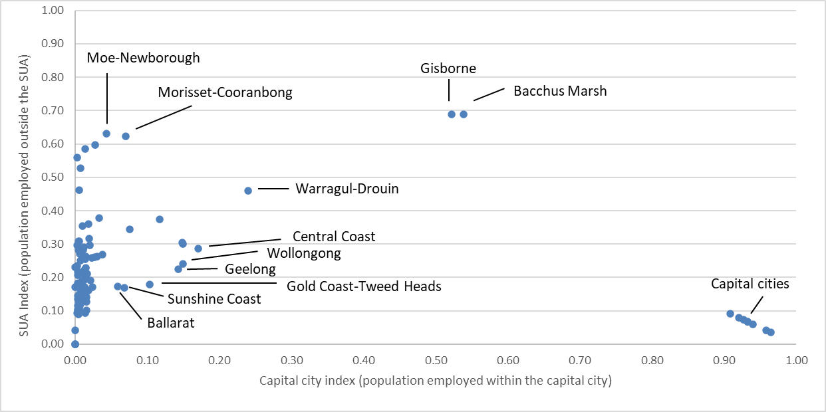
In the 2021 Census Bacchus Marsh and Gisborne meet the criteria for satellite cities. They have been amalgamated with Melbourne.

Population-weighted density
To calculate population-weighted density the Commission uses the ABS population grid and boundary files. While the square kilometre grid is fixed and both the Significant Urban Area and Urban Centre and Locality boundaries do not change between census years, the population files are updated annually.
The square kilometres and associated populations are included in the measure if over 50 percent of the square kilometre is within the Urban Centre and Locality. This approach avoids issues of double counting as square kilometres are only allocated to a single Urban Centre and Locality. Urban Centres and Localities are used instead of Significant Urban Area boundaries to ensure that sparsely populated areas on the fringes of Significant Urban Areas did not distort the density measure.
The density of each square kilometre area is then weighted by its relative share of the total Urban Centre and Locality population. The weighted densities of the square kilometres are then aggregated to obtain the population-weighted density of the entire Significant Urban Area.

Passenger numbers
To obtain the passenger numbers used in the regression the 2016 Census actual passenger number data are adjusted by an index based on Bureau of Infrastructure and Transport Research Economics data to obtain 2022–23 equivalents. Bureau of Infrastructure and Transport Research Economics data on passenger kilometres travelled is available for each state capital city, which is used to obtain indices for each Significant Urban Area in a state. 2021 Census passenger numbers are not appropriate for use because they are impacted by the COVID-19 pandemic. Passenger data used in the regression will remain fixed until the next review.
The passenger numbers applied to the regression coefficients are modelled to remove policy influences. A regression model is used to account for the changing nature of public transport use as cities grow in size. The regression model can be specified as:
$$ln({pax}_{i})=β_{0}+ β_{1}ln({pop}_{i}) + β_{2}{train}_{i}$$
Use rates for trains and bus/light rail passengers are then applied to the estimated total public transport passengers to obtain modelled passenger numbers for each Significant Urban Area.
Once fit-for-purpose 2026 Census data are available, likely for the 2028 Update, the Bureau of Infrastructure and Transport Research Economics adjustment will be removed. Passenger numbers will continue to be modelled using a regression.

Distance to work
The ABS calculates distance to work by taking the shortest distance by road between a persons reported home address and usual work address. During the 2021 Census, the ABS released guidance advising people working at home due to COVID-19 restrictions to write the address they would normally work at. Therefore, the Commission considers the 2021 data are suitable for use in the 2025 Review.

Adjusted budget calculations use ABS Government Financial Statistics data to determine actual state expenses. For further details see the adjusted budget chapter of the Commission’s Assessment Methodology.
Tables in this chapter, unless otherwise stated, use 2022–23 data. Note: the updated transport chapter in the Commission’s Assessment Methodology was release in March 2026.
Blending was introduced in the 2020 Review to account for the inherent limitations in the model relating to the use of proxies and limited data. The blending shares are outlined below from paragraph 40.
The model assumes the supply of public transport services (measured using passenger numbers) is equal to demand (measured using population-weighted density).
Urban Centres and Localities are used as the sub-areas within Significant Urban Areas.
This adjustment was introduced in the 2025 Review to address the continued use of 2016 Census commuter data in the model. 2021 Census commuter data could not be incorporated into the assessment because they were impacted by COVID-19 restrictions.
The assessment will be updated with 2026 Census data if they are deemed fit for purpose. Data are likely to be available for the 2028 Update.
2021 Census journey to work data are used. Because census respondents were required to provide their usual place of work, the Commission considered these data were not impacted by COVID-19 restrictions.
Ferries that operate between Significant Urban Areas are not considered to be operating urban transport services. In the 2025 Review, 6 urban areas were identified as having an urban ferry service, Sydney, Melbourne, Brisbane, Perth, Newcastle-Maitland and Hobart.
Costs are applied to populations in urban areas.
Blending was introduced in the 2020 Review to account for limitations in the model relating to the use of proxies and limited data.
In the 2025 Review the blending ratio was temporarily increased by 10 percentage points to 65:35. This was to recognise data issues arising from COVID-19 which necessitated the continued use of older data. This increase will be revisited when fit-for-purpose 2026 Census data are available. This is likely to be the 2028 Update. See the transport chapter of Review Outcomes for more details. In the 2026 Update, the blending level was increased by a further 5 percentage points because the Commission was unable to update the urban centre characteristics regression with a second year of net expense data as it committed to in the 2025 Review. See 2026 Update New Issues for more details.
The blending ratio in the urban transport investment assessment includes the 5 percentage point increase introduced in the 2026 Update. See 2026 Update New Issues for more details. It does not include the temporary 10 percentage point increase that was applied to the recurrent assessment in the 2025 Review. This is because investment decisions were not as strongly affected by COVID-19 restrictions as recurrent spending.
See the investment chapter of the Commission’s Assessment Methodology for full description of the investment assessment methodology and the GST impacts.
Jacobs and Synergies Economic Consulting, Urban Transport Consultancy Stage 2, Commonwealth Grants Commission, 2019.
The method recommended by the consultants to calculate population-weighted density was revised by the Commission in the 2025 Review.
Population-weighted density used in the regression is fixed at 2022–23 levels. Population-weighted density applied to the regression is updated yearly with a lag of one year.
Alternative approaches, including allocating square kilometres to urban areas based on where the centre of the square kilometre is placed resulted in implausibly high population-weighted density for some smaller Significant Urban Areas.

